Cover Sheet with First and Last Name, SEIP, plus any design, quote, or personalization

Personal Statement

Resume

Career Plan

Final Reflection Paper < Click link for prompts.

* TEN ARTIFACTS on the following pages *

Insert a photo if possible, and write what the artifact represents - why it is important to you or what it reveals about you. Insert one artifact per page, or add a visual break between two per page.

You will not be able to use physical artifacts left in your homeroom file.
Please recreate a digital version of each artifact, or just explain it without any picture or physical item.

You will eventually get your physical artifacts and portfolios back (date tba).
* Five to ten quality artifacts will be accepted.

Delete all directions on this doc! Make sure your essays and artifacts are on this document
then save it as a pdf. File> Print> Save as PDF> Save > Downloads.

Email your SEIP PDF to: seip@barabooschools.net

Turn it in to your homeroom teacher too.

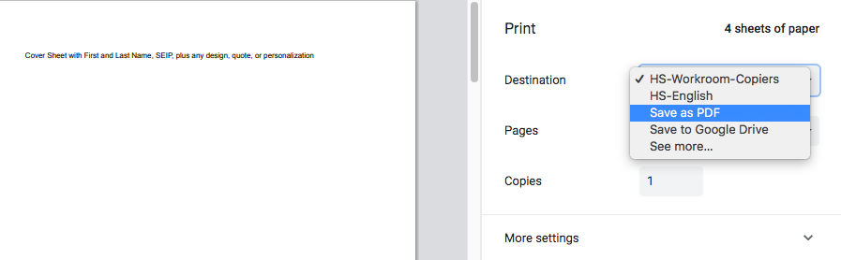

Google Meet Interviews will be May 11 - May 22, 2020.

In addition to talking about all the work in your portfolio,
be prepared to answer questions like these:

1. How are you feeling about your upcoming graduation?
2. What are your plans following graduation?
3. Select a sample of work from your portfolio. What was the purpose of the work, and what did you learn
from the work/activity?
4. Which skills and abilities gained from your high school experience will help you after graduation? What
do you think you can improve upon?
5. Looking back over your kindergarten (or when you started in Baraboo) through high school educational
experience in Baraboo, what would you identify as strengths of that experience? Likewise, what could
have made your experience better?
6. What is one positive takeaway and one frustration from your remote learning experience?
Thank you for your resilience in these unprecedented times.

Artifact 1
Date of activity:

Activity (Description or Name of Artifact):

Why did you include this artifact?

Artifact 2
Date of activity:

Activity (Description or Name of Artifact):

Why did you include this artifact?

Artifact 3
Date of activity:

Activity (Description or Name of Artifact):

Why did you include this artifact?

Artifact 4
Date of activity:

Activity (Description or Name of Artifact):

Why did you include this artifact?

Artifact 5
Date of activity:

Activity (Description or Name of Artifact):

Why did you include this artifact?

Artifact 6
Date of activity:

Activity (Description or Name of Artifact):

Why did you include this artifact?

Artifact 7
Date of activity:

Activity (Description or Name of Artifact):

Why did you include this artifact?

Artifact 8
Date of activity:

Activity (Description or Name of Artifact):

Why did you include this artifact?

Artifact 9
Date of activity:

Activity (Description or Name of Artifact):

Why did you include this artifact?

Artifact 10

Date of activity:

Activity (Description or Name of Artifact):

Why did you include this artifact?

