**************************************************************************************************************
Do not include any text in these first 2 pages of instructions in your official RFP. Include only “Scope of Services” and all appendix language beginning on Page 3.

Disclaimer: EducationSuperHighway (ESH) is providing this template for informational purposes only and not as legal advice. ESH is not licensed to practice law and cannot provide legal advice. This template is not intended to substitute for your judgment. You assume full risk and responsibility for the use of or reliance on this template or any information you obtain from ESH. ESH does not guarantee that the template will adequately meet your needs, and you are solely responsible for your use of this template and any RFPs you issue. For example, ESH’s template likely will not, and ESH makes no representations or warranties that this template will, cover all of the state and local procurement rules that may apply to your RFPs. By using any part of this template, you agree that ESH is not liable for any consequences from such use. If you have any questions or concerns about the contents of your RFP you should obtain legal counsel.

Additionally, E-rate terminology and policies can change EVERY YEAR. Therefore, this template may not be accurate for use in future years. Make sure you obtain an updated version before the start of each funding year.

Instructions to applicant (District)
Replace all [highlighted] text with language specific to your district. If there is any non-highlighted text that does not match your existing network or requirements, change or delete it. This document is meant to be a template for you to customize to meet your needs; EducationSuperHighway encourages you to modify the sections to make it your own.

If you have any questions about how to fill out this template, please contact EducationSuperHighway for guidance.

Evaluation Criteria
There are example criteria included at the end of the RFP. Please choose the weights and categories depending on the district’s requirements. If comparing different categories of service (lit vs dark), compare all proposals within a category to choose a “winner” per category. At the very end, compare the “winner” of each category based on your criteria to determine the overall winning bid.

If you do not know how to determine evaluation criteria or perform a bid evaluation, please contact EducationSuperHighway for assistance

Additional sections to include in your RFP:
This “Scope of Services” is one of several sections of your overall RFP. This language should be inserted into your district’s “boilerplate” RFP template. It is highly encouraged to include a question period and one or more site survey-walkthroughs as part of the timeline in the previous boilerplate sections. It is highly suggested to allow for more than a 30 day window for the RFP, especially for more complex bids. USAC is recommending a 60-90 day response window in applicant training. If you are unfamiliar with your district’s procurement rules or any legal language normally used in procurements, you should consult your business manager or superintendent for assistance.

When answering vendor questions, if a material change is made to the applicant requirements – adding a site; adding a bandwidth level; adding a map; detailing a demarc location-this is likely to be considered a “cardinal change” – the RFP due date must be changed to accommodate a minimum 28 day bid period from the date this change is made”
Corresponding Form 470
Your RFP must be attached/uploaded to a corresponding Form 470 that requests the SAME services as laid out in this RFP. If this template is used in full, the following service requests should be on your Form 470 with the same quantity and bandwidth reflected in your RFP*:
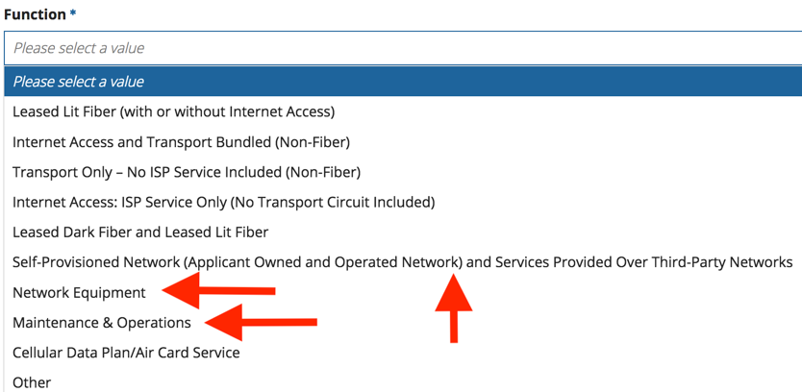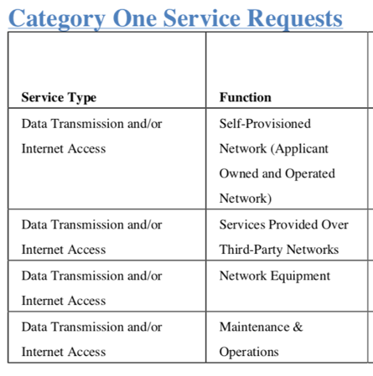
*There are limitations to the speeds you can enter into the service request fields on the Form 470; if you are unable to enter the exact minimum/maximum speed you are requesting; you should select the closest available speed. For example, if your minimum requested speed is 250 Mbps, you should select 200 Mbps on the Form 470; if your maximum requested is 3 Gbps you should enter 5 Gbps, etc.

Additionally, if you are requesting the payment plan for the non-discounted portion of any special construction charges, this must also be reflected on your Form 470.

Please note: While operations services associated with dark fiber and self-provisioned fiber are eligible for Category 1 funding, this RFP template does not include language requesting them.

Important notice if you intend to request any state matching funds for special construction
As part of state match review for a special construction project, USAC’s review process will also consider compliance with the FCC’s long-term per student bandwidth goals. The FCC adopted these standards as part of the E-rate Modernization Orders. As a result, districts that wish to be funded for additional FCC E-rate match funding are expected to adhere to the following requirement: A district must be able to prove that the WAN connections being built will be able to scale to the long-term bandwidth of 10 Mbps per student.
- For services delivered over third party networks, your RFP and form 470 should request a higher standard port bandwidth that includes this amount as your maximum. You should sign a contract with flexible terms allowing you to scale to this bandwidth during the life of the contract:
If you are requesting | You should also request they can scale to
100 Mbps circuits | 1 Gbps
1 Gbps circuits | 10 Gbps
10 Gbps circuits | 40 Gbps

- For self-provisioned fiber, you should purchase equipment that can scale to this bandwidth. If you intend to use existing equipment to light the fiber, you should be prepared to prove that your equipment can scale.

Do not include any text above this line in RFP language. Include only “Scope of Services” and all appendix language below
**************************************************************************************************************SCOPE OF SERVICES

[School district name], hereafter referred to as Applicant, is requesting proposals for Self-Provisioned Network (Applicant Owned and Operated Network) and Services Provided Over Third-Party Networks for delivery of wide area network (WAN) services to the district. Service is expected to originate at the district hub site and be delivered to the eligible service locations. All locations, with addresses and demarcation points, are listed in the attached pricing sheet. The new service is being planned to begin on July 1, 2019 which represents the expiration of the current leased WAN service.

Section 2: Service Requests
- Applicant is seeking bids for 4 services. Respondents may one, all, or any combination of options. See Section 3 for requirements of each solution.
  - The first service is for services provided over third-party networks. This is an E-rate Category 1 service option defined as point-to-point broadband service delivered over a service provider or other third party owned network. This service option is to represent any technology neutral third-party transport mediums including both fiber and non-fiber options. The service is a fully managed service, with the service provider supplying the equipment, provisioning the bandwidth and providing technical support/management of the service.
  - The second service is for a self-provisioned (applicant owned and operated) fiber network.
  - The third service is for Category 1 network equipment to place any self-provisioned network solutions into service.
  - The fourth service is for maintenance & operations on any self-provisioned network solutions.
- Network Design and Construction Routes
  - Applicant will consider traditional network designs (such as hub and spoke) or alternative proposals. The applicant’s stated decision criteria (outlined in the RFP) will be used to determine if an award is made as-a-result of this RFP. The applicant has, in accordance with E-rate guidelines, rated cost of service as the highest weighted factor in its decision criteria.
  - Due to current and future bandwidth needs, respondents are encouraged to provide dedicated infrastructure to Applicant. Designs are encouraged to utilize the private fiber approach, where there exists no other aggregation or third-party equipment on fiber strands between sites and modulating equipment at each site is dedicated to Applicant and not shared in any way with other customers. If this is not possible, then designs should limit the use of shared infrastructure as much as possible.
  - Respondents should clearly illustrate proposed network design and construction routes.
  - Applicant is not advocating or mandating any preconceived network design or construction route and leaves this decision up to the vendor to present their best solution while recognizing the cited termination locations.
- Special Construction
  - In E-rate terminology, special construction refers to the upfront, non-recurring costs associated with the installation of new fiber to or between eligible entities.
    - Special construction and service eligibility for reimbursement have changed starting funding year 2016. See the Federal Communications Commission E-rate modernization order 2 (WC Docket No. 13-184) (https://www.fcc.gov/document/fcc-releases-order-modernizing-e-rate-21st-century-connectivity) for more information.
  - Special construction charges eligible for Category One support consist of three components:
    - construction of network facilities
    - design and engineering
    - project management
  - If no new fiber is being installed, then any installation costs are considered standard non-recurring costs (NRC).
    - For services provided over third-party networks solutions requiring special construction, this means that the costs associated with building the infrastructure are considered special construction and the costs associated with the network equipment required to activate the service are a standard NRC.
    - For self-provisioned network solutions, equipment required by the Applicant to light the fiber are not considered special construction.
  - Special Construction Payment Plan Option
    - The applicant requests that the respondents consider allowing Applicant to pay the non-discount share of special construction costs (portion of costs that are the responsibility of the applicant) to be paid in equal [annual or monthly] installments over [one, two, three, four] years from Funding Year 2019 to Funding Year 2022 inclusive. Responses must include agreement or non-agreement of this request.
  - Excess fiber strands for special construction projects
    - Self-Provisioned Networks
      - Applicant understands and adheres to E-rate guidance that any cost allocation is for any unlit strands that will be used exclusively by the district in the future. There will be no third-party use of these excess strands.
    - Services provided over third-party networks
      - To the extent that the winning service provider installs additional strands of fiber for future business ventures, the winning service provider assumes full responsibility to ensure those incremental costs are allocated out of the special construction charges to the district in accordance with FCC rules and orders.
      - If, after the issuance of the FCDL, USAC or the FCC determines that the winning service provider did not cost allocate those charges associated with the additional strands, Applicant will not be responsible for reimbursing the winning vendor and the winning vendor will assume all responsibilities deemed ineligible by USAC.
    - For examples of cost allocation, please see document in Appendix A as prepared by the State E-rate Coordinators’ Alliance (SECA).

Section 3: Solution Specifications
- Services Provided Over Third-Party Networks
  - Applicant must have dedicated, symmetrical transport bandwidth of [100 Mbps, 1 Gbps, 10 Gbps] between the designated endpoints.
  - The solution must be scalable to [1 Gbps, 10 Gbps, 40 Gbps].
  - Contract options are requested for [12 month, 36 month and 60 month] terms of service.
  - As stated above, this request is technology neutral and for a fully managed service.
  - Bids are required to include all services and components necessary to make the service operational.
    - Respondent may offer services either themselves or through 3rd party subcontractors.
    - If respondent intends to use 3rd party subcontractors to deliver a part or all of the service, this should be clearly indicated in the response.
  - Each respondent is required to complete the attached pricing sheet with this RFP.
    - Special construction, monthly recurring cost, and any additional non-recurring costs are required to be broken out and listed separately.
    - Respondents are free to propose alternate pricing terms provided they have also included pricing in the requested format.
    - No increased pricing will be allowed during the term of the quoted special construction, NRC, and MRC rate in each pricing cell of the matrix.
  - If an increase in bandwidth is requested during the contract period the contract does not renew.
  - All solutions must adhere to the following Service Level Agreement (SLA) terms:
    - The provider will make all reasonable efforts to ensure 99.99% network availability of each circuit.
    - .25% frame/packet loss commitment
    - 3ms network latency commitment
    - 4ms network jitter commitment
    - There is no right of provider to limit or throttle the capacity of the circuit at any time for any reason.
    - Vendor stated commitment is to respond to any outage within two (2) hours and a four (4) hour restoration of service.
    - Network operations center: Solution will provide customer support functions including problem tracking, resolution and escalation support management on a 24x7x365 basis. Customer has the right and is encouraged to call concerning any problems that may arise relative to its connection with vendor provided services.
    - Trouble reporting and response: Upon interruption, degradation or loss of service, Customer may contact Vendor by defined method with a response based on trouble level. Upon contact from the Customer, the Vendor support team will initiate an immediate response to resolve any Customer issue. Customer will receive rapid feedback on trouble resolution, including potential resolution time.
    - Escalation: In the event that service has not been restored in a timely manner, or the Customer does not feel that adequate attention has been allocated, the Customer can escalate the trouble resolution by request. A list of escalation contacts will be provided when implementation schedule is completed.
    - Resolution: The Customer will be notified immediately once the problem is resolved and will be asked for verbal closure of the incident.
    - Trouble reporting, escalation and resolution: A detailed trouble reporting, escalation and resolution plan will be provided to the district.
    - Measurement: Time starts from the time the Customer contacts vendor and identifies the problem. Credits for outages of a certain duration or longer will be identified.
    - Reports: Upon request, an incident report will be made available to the Customer within five (5) working days of resolution of the trouble.
    - Link performance per segment: The service will maintain the proposed link performance throughout the term of the contract.
    - Historical uptime: Provide aggregate uptime statistics for your proposed service in the geographic area encompassing Applicant.
- Self-Provisioned Network
  - Applicant must have [twelve (12) strands (6 pair)] of singlemode fiber built from the hub to each eligible entity location.
  - Applicant intends to light [two (2) strands (1 pair)] to each site in the first year. USAC rules stipulate the following when any constructed strands will remain dormant in the first funding year in which they are constructed:
    - It must be proven that it is more cost effective to install the higher strand count cable than one containing the exact number of strands being lit in the first year. OR
    - Cost allocation must be performed to list the percentage of cost of fiber material that will remain unlit as ineligible charges.
    - See Appendix A, Part 2, Section A for examples.
  - Each respondent is required to complete the attached pricing sheet with this RFP.
  - Applicant desires a fully “turn-key” project so respondents should provide explanation for Applicant’s involvement in the process including ownership and sourcing of permits, etc.
  - Specifications for a newly constructed fiber infrastructure are contained in Appendix B: OSP Installation Specifications.
  - Selected respondent and its subcontractors will provide all project management to accomplish the installation of all project work as outlined in Appendix B.
  - Respondent is responsible for all necessary paperwork and obtaining all permits including but not limited to rights of way, easements, and pole attachments.
  - The respondent will provide engineer(s), certified on selected fiber system specifications and procedures to manage all phases of project as outlined in this proposal. This includes ordering and managing the bill of materials as outlined in Appendix B, directing and managing cable placement and restoration, directing and managing splicing crews and providing detailed documentation at the end of the project.
  - Selected respondent and its subcontractors will develop a project management plan, which will include a milestone chart. The milestone chart will outline any critical path events and then track these with the appropriate agency/organization whether; selected respondent, subcontractor or the district.
- Maintenance & Operations
  - Applicant requires on-going maintenance of the fiber on self-provisioned fiber solutions that includes routine maintenance and inspection, as well as unscheduled break/fix maintenance.
  - Contracts and price quotes are requested for [36 month and 60 month] terms of service. Each respondent is required to complete the attached pricing sheet with this RFP.
  - Maintenance on self-provisioned fiber is being bid as a separate service and may be bid by anyone, even if they are not bidding on any fiber or network services.
  - Respondent may offer maintenance services either themselves or through 3rd party subcontractors. In the case that maintenance is subcontracted out to a 3rd party, the respondent must hold and manage the subcontract and is ultimately responsible for the SLA.
  - Respondent shall maintain the applicable fiber seven days per week, twenty-four hours per day.
  - Upon notification from the district of a malfunction relating to the applicable fiber, respondent shall respond to such malfunction within two (2) hours and thereafter proceed to correct the malfunction with reasonable diligence.
  - Respondent should include an overview of maintenance practices including:
    - Routine maintenance and inspection
    - Scheduled maintenance windows and scheduling practices for planned outages
    - Marker and handhole inspection and repair
    - Handling of unscheduled outages and customer problem reports
    - What service level agreement is included and what alternative service levels may be available at additional cost
    - What agreements are in place with applicable utilities and utility contractors for emergency restoration
    - Repair of fiber breaks and mean time to repair
    - Replacement of damaged fiber and fiber that no longer meets specifications
    - Post repair testing
    - Policies for customer notification regarding maintenance
    - Process for changing procedures, including customer notification practices
    - Process for moves, adds, and changes
    - Process for responding to locate requests
- Category 1 Network Equipment
  - Applicant requires network equipment with installation and configuration to place circuits into service at [1Gbps or 10Gbps] once the self-provisioned network is available.
  - Network equipment should be [equipment make/model] or equivalent and must include all necessary licenses and/or software.
    - Any proposals for equivalent equipment must include an explanation outlining how the proposed equipment offers the same functionality as the example make and model.
  - Proposals should include an explanation of whether or not the proposed equipment supports higher bandwidths for future scalability and the ease of upgrading (e.g. a new SFP versus a new line card)
  - Each respondent is required to complete the attached pricing sheet with this RFP. If any part of the equipment cost is ineligible for Category 1 funding, this must be identified. Respondents must clarify equipment eligibility with USAC before submitting proposals.
  - Network equipment may be bid as a stand-alone service by anyone, even if they are not bidding on any fiber service.

Section 4: General Terms for All Proposals
- Failure to include any requested information noted as required by the respondent is grounds for disqualification.
- Description of Proposal
  - Respondent’s proposal should include all sites for the option bid. If the respondent bids leased dark fiber or leased lit fiber – all sites must be included in the bid. Failure to include all sites in a bid option could be considered ground for disqualification.
  - Respondent will provide a description of their proposal for all services and solutions.
  - Description will include an overview of the proposal, any deviations from the requested architecture, design or requirements, assumptions made, and other detail Applicant may find useful or necessary (or could differentiate the solution from a competing proposal).
- Timeline
  - For each response, respondents must include a timeline for bringing all sites online.
  - Proposals requiring little to no special construction should be able to bring all sites online by the July 1 start of the funding year.
  - For solutions requiring special construction, a schedule of bringing sites online must be included with an explanation of how this timeline shifts if the date of the E-rate funding commitment shifts.
- Demarcation
  - All solutions must terminate service or infrastructure in the demarcation point at each address specified in the pricing sheet.
  - Solutions bringing service to the property line but not to the demarcation point are not acceptable.
  - Respondent must specify specific demarcation setup included in base fees, e.g. wall mounted CPE and CAT6a handoff, rack mount patch panel, etc.
- Network Diagram
  - For each response, respondents must include a network diagram displaying the paths to be used to serve each endpoint.
  - Diagrams must show if circuits are routed through any aggregation hubs, equipment, or third-party facilities between hub site and each endpoint.
  - For self-provisioned responses, diagrams must include identification of aerial vs. buried fiber segments, detailed drawings showing fiber and equipment locations, and any other pertinent details (See Appendix B for more details).
- References
  - For each response, respondent must provide 3 references from current or recent customers (preferably K-12) with projects equivalent to the size of Applicant.
  - If respondent responds to more than one service request, provide 3 references for each.
- E-rate Program Integrity Assurance (PIA) Review
  - If their solution is chosen, respondents are required to promptly provide Applicant with any information being requested as part of PIA review.
  - Vendors may assist applicants with preparing funding requests or responding to PIA questions and may speak directly with PIA reviewers.
  - For all responses that include special construction, the respondent agrees to, by submitting its bid, produce all construction labor, construction materials and other cost information requested during PIA review.
  - All responses must agree, in writing, to this section with a yes or no answer. Answering no or failure to answer at all is grounds for disqualification.
- Required Notice to Proceed and Funding Availability
  - Applicant will follow the purchasing policies of the Applicant Board and requirements and procedures of the FCC’s E-rate program as administered by the Universal Service Administrative Company to be eligible for all available funding.
  - The implementation of any associated contracts resulting from this competitive bid process will be dependent on the district's’ issuance of a written Notice to Proceed.
  - E-rate funding notification alone will not signify Notice to Proceed. The district will have the right to allow the contract to expire without implementation if appropriate funding (including any state matching funds for special construction projects) does not come available.

Section 5: Evaluation Criteria
- Self-Provisioned Network (Applicant Owned and Operated Network) and Services Provided Over Third-Party Networks
% Weight | Criteria
Must be highest weighted criteria | E-rate eligible recurring and one-time circuit costs¹
Applicant to provide percentage | Complete bid submission²
Applicant to provide percentage | Ability to support requirements of this RFP³
Applicant to provide percentage | Proposed contract terms and conditions⁴
Applicant to provide percentage | Service reliability and dedicated infrastructure⁵
Applicant to provide percentage | E-rate ineligible recurring or one-time costs⁶
Applicant to provide percentage | Provider references⁷

- Maintenance & Operations
% Weight | Criteria
Must be highest weighted criteria | E-rate eligible costs¹
Applicant to provide percentage | Complete bid submission²
Applicant to provide percentage | Ability to support requirements of this RFP³
Applicant to provide percentage | E-rate ineligible costs⁶
Applicant to provide percentage | Provider references⁷

- Category 1 Network Equipment
% Weight | Criteria
Must be highest weighted criteria | E-rate eligible costs¹
Applicant to provide percentage | E-rate ineligible costs⁶
Applicant to provide percentage | Compatibility with existing network infrastructure⁸

- Criteria Explanation
  - E-rate eligible costs: the total cost of ownership for the eligible components of the proposed service. Total cost of ownership takes into account all one-time and recurring costs. Note that E-rate eligible costs refers to the pre-discount cost of the solution, not the post-discount portion of costs that are the responsibility of the Applicant. This criterion must be the highest weighted per E-rate program rules.
  - Complete bid submission: Bids concisely address Applicant’s requirements, as set forth in the RFP, and do not contain a significant amount of corporate boilerplate marketing information
  - Ability to support requirements of this RFP: proposed solution clearly meets Applicant’s requirements and needs
  - Proposed contract terms and conditions: Proposed contract has flexibility and terms desired by Applicant
  - Service reliability and dedicated infrastructure: Solution provides dedicated infrastructure for Applicant’s service with no shared equipment or routing of traffic through aggregation hubs.
  - E-rate ineligible costs: Any costs of the proposed service that are not eligible for E-rate funding. This does not refer to the post-discount portion of eligible costs that are the responsibility of the Applicant.
  - Provider references: response included K12 references that were similar in size and scope
  - Compatibility with existing network infrastructure: proposed equipment is easily compatible with the existing equipment used by the Applicant.

Appendix A

E-rate Special Construction
Excess Strands - Cost Allocation Scenarios
Funding Year 2018
Prepared by the State E-rate Coordinators’ Alliance
October 23, 2017

- LEASED LIT FIBER AND LEASED DARK FIBER

- Excess Strands for Applicant’s Future Use

If the service provider installs additional strands for the applicant’s exclusive future use in a leased dark fiber or leased lit fiber special construction project, and if the applicant can show documentation that buying a cable containing the number of strands placed in the fiber system for the applicant’s future use is more cost effective then buying a fiber cable with the number of strands the applicant plans to place into service the first year, no cost allocation of the excess strands is required and no other special construction charges would need to be cost allocated.

If the service provider installs excess strands for the applicant’s exclusive future use in a leased dark fiber or leased lit fiber special construction project where the excess strands will remain dormant until they are lit for the applicant in the future, and if the applicant cannot show that it is not more cost effective than buying the exact number of fiber strands being lit in the first year, the applicant must cost allocate the costs associated with the excess strands only. No other special construction charges would need to be cost allocated.

- Excess Strands for Service Provider’s Future Use

For lit services special construction and leased dark fiber special construction, if the service provider wishes to place extra strands in the build for its own use, the E-rate applicant must cost allocate the cost of the service provider-owned extra strands, as well as all incremental costs of those extra strands from the special construction E-rate funding request. It is not a pro-rata share, but an incremental cost calculation that must be backed by detailed documentation.

Example 1 from Funding Year 2018 USAC Fiber Training Slides applies:

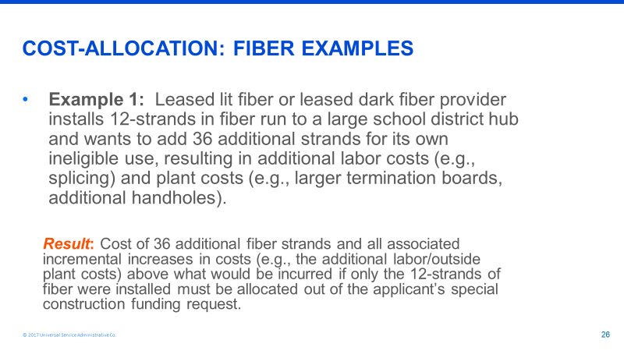

Applicant’s should seek documentation from the provider which outlines the added incremental costs attributable to designing, managing and constructing a fiber system with a 48-strand cable instead of a 12-strand cable. Such costs should include (but are not limited to):

- Splice Labor. If any fibers over the applicant’s fibers are spliced, the labor for these additional splices must be cost allocated.

- Splice Enclosures are placed to protect splices. If any fibers over the applicant’s fibers are spliced and require an enclosure, the enclosures for these additional splices must be cost allocated.

- Fiber Installation Labor. This represents the incremental cost of pulling a larger cable through the buried conduit.

- Structured materials installation. This represents the additional cost of burying a larger conduit to support the additional fibers.

Note that the costs associated with installing a larger cable strand than what is required by the applicant are ineligible and the service provider should not include such costs in their special construction billing to the applicant but should be prepared to show evidence during PIA review that it did not charge the applicant for these incremental costs.

Figure 1: Here is a table outlining some possible incremental costs:

Item | 12 Strand cable construction | 48 strand cable construction | Cost Allocation Amount that service provider should remove from the special construction request
Fiber Cable | 38 cents per foot | $1.04 per foot | 66 cents per foot
Design and Engineering | $2.12 per foot | $2.42 per foot | 30 cents per foot to depict additional splices at A and Z locations
Project Management | $1.18 per foot | $1.18 per foot | 0
Splice labor* | $11.00 per splice | $11.00 per splice | $11 per splice over 12 splices at any splice site
Splice enclosures** | $205 per enclosure | $205 per enclosure | $205 per enclosure for every enclosure over 12
Fiber Patch Panel | $71.43 per panel | $218.60 per panel | $147.17 per panel
Conduit and other structured materials | 1.25” conduit required  $1.95 per foot  Handhole (40,000 lb rated) $2695 per unit  Fiber Marker $30 per unit | 1.5” conduit required  $2.35 per foot  Handhole (40,000 lb rated) $2695 per unit  Fiber marker $30 per unit | 40 cents per foot  No cost difference for handhole  No cost difference per marker
Fiber Installation Labor *** | 25 cents per foot | 28 cents per foot | 3 cents per foot
Structured Materials Installation (conduit, markers, handholes)**** | $2.85 per foot | $3.10 per foot | 25 cents per foot
Markers | Place every 500’ | Place every 500’ | No cost difference
Handholes | Place every 1000’ | Place every 1000’ | No cost difference

- SELF-PROVISIONED (APPLICANT-OWNED) FIBER:

There are different cost allocation rules that apply, depending on whether fiber is only being purchased and used by:

- A single, eligible entity (school or library)
- A consortium of all eligible entities
- A consortium of eligible and ineligible “NON-public sector, municipal entities”
- A consortium of eligible and ineligible “public sector, municipal entities”

- Single, Eligible School or Library

- If the applicant installs the exact number of fiber strands that they will light in the first year, and no extra fibers are installed, all fiber strands and special construction charges are eligible and no cost allocation is required.

- If the applicant installs more fiber strands than it will light in the first year, E-rate will pay for the number of strands being lit in the first year, but not the additional strands. No cost allocation is required for the special construction charges. E-rate applicants can only receive E-rate funding for self-provisioned fibers that are lit within the funding year. If they request excess strands that will remain dormant until the applicant lights the excess strands for their exclusive future use, then they would need to cost allocate the cost of the unlit stands in the applicable funding year.

If the applicant can show documentation that buying a cable containing the number of strands placed in the fiber system for the applicant’s future use is more cost effective then buying a fiber cable with the number of strands the applicant plans to place into service the first year, no cost allocation for excess strands by the applicant is required.

Example 2 from the Funding Year 2018 USAC Fiber Training Slides applies:

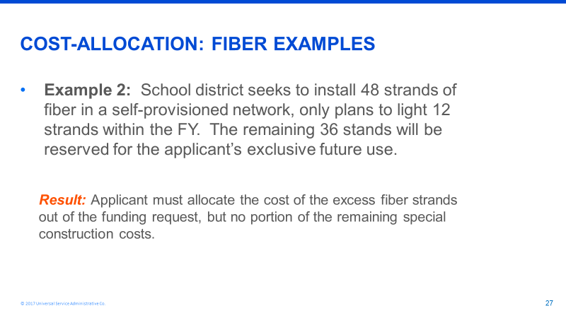

Item | 12 Strand Cable | 48 Strand Cable | Cost Allocation Amount that applicant should remove from the one-time special construction reimbursement request
Fiber Cable | $.38 per foot | $1.04 per foot | $.66 per foot

- Consortium Comprised of All E-rate Eligible Entities

As with Example 2, all fiber (lit and unlit in the first year) must be dedicated to only eligible entities only and the cost of strands not lit in the first year must be cost allocated.

- Consortium of Eligible and Ineligible Entities (NON-public sector, municipal)

If the eligible entity purchases and installs fiber for the usage of the eligible entities and the ineligible (non-public sector) entities, the funding request will be denied. E-rate funded self-provisioned fiber is exclusive owned by the E-rate applicant consortium and is for the exclusive use of the E-rate eligible applicant.

In this case, Example 3 from the Funding Year 2018 USAC Fiber Training Slides applies:

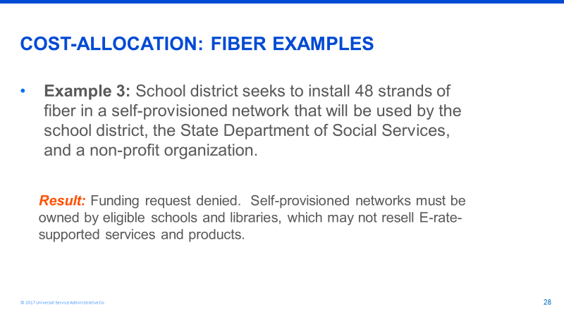

- Consortium of Eligible Entities and Ineligible “Public Sector, Municipal Entities”

For a self-provisioning consortium that includes a public-sector partner, the special construction cost-allocation rules are the same as the Leased Lit Fiber services with special construction or Leased Dark Fiber services with special construction. The cost of the ineligible fibers must be deducted from the funding request, but only the incremental costs related to labor, materials, engineering, project management, and design must be cost allocated.

For the purposes of E-rate, “public sector partner” is defined as health care providers and public sector (governmental) entities, including, but not limited to state colleges and universities, state educational broadcasters, counties and municipalities.
For this type of consortium, Example 4 from the Funding Year 2018 USAC Fiber Training Slides applies:

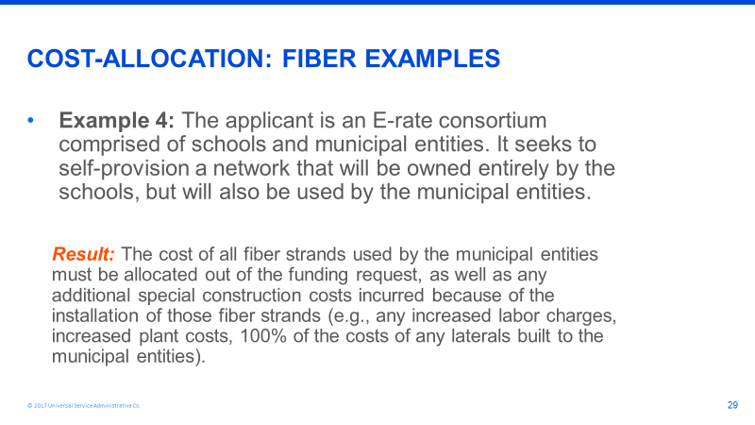

Note: The eligible applicant should be prepared to show evidence during PIA review that it has deducted all incremental costs associated with design, engineering, project management, construction, procurement of fiber and procurement of structured materials of the larger strand cable when compared to the costs associated with design, engineering, project management, construction, procurement of fiber and procurement of structured materials of the fiber strand cable only used by the eligible applicant.

Appendix B: OSP Installation Specifications

Material Requirements
- Material will comply with those standards as established by UL or NEMA and shall be commercial grade. All materials will be new and free from defects.
- Selected contractor and its subcontractors will provide all material management to ensure that the project remains on track according to the project milestones,
- All due caution will be exercised in transporting and off-loading all materials to prevent any damage during shipping or placement. Any damage to any materials after their initial receipt and inspection by the respondent will be the sole responsibility of the respondent, who will replace such damaged materials at no additional expense to the district.
- Buried conduit shall be EMT (Electrical Metallic Tubing) multi-duct with at least three innerducts. EMT fitting shall be gland or set screw type, and each conduit shall be equipped with a graduated pull tape or rope.
- Unless specified by right-of-way owner, crossings will be two conduits, PVC-Sch 40 or better.
- The exact requirements for location and type of conduit within the building shall be verified with building owner.
- All Hand Holes shall be (State) DOT approved, 45,000 lb. load rated CDR or comparable enclosures on roadways and railways, and pedestrian rated hand holes for non-roadways and railways.
- Large-radius sweeps shall be provided where required for offset or change in direction of conduit. Bend radius rating of the cable must be adhered to for all conduit bends, pull boxes, and hand holes.
- Fiber must be single-mode with the following specifications:
  - TU‐T G.652.C/D compliant
  - Maximum Attenuation @ 1310nm: 0.34 dB/km
  - Maximum Attenuation @ 1385nm: 0.31 dB/km
  - Maximum Attenuation @ 1550nm: 0.22 dB/km
- Connector types should be LC unless otherwise specified by the district.
- Any warranties associated with the fiber and any other outside plant materials must revert to the district as the fiber owner upon completion of construction,

Specifications
Survey
- Comply with all ordinances and regulations. Where required, secure permits before placing or excavating on private property, crossing streams, pushing pipe or boring under streets and railways. Pre-survey shall be done prior to each job.
- Respondent will locate underground lines of third parties in cable route area

Permits and Traffic Control
- The respondent must adhere to all applicable laws, rules and requirements and must apply for permits to place infrastructure per specification per county or city ordinance applicable to where the infrastructure is being placed.
- All traffic control, in accordance with local, state, county, or permitting agency laws, regulations, and requirements, will be the respondent’s responsibility. The respondent’s construction schedule will take into consideration sufficient time for the development and approval of a traffic control plan.
Tracer Wire Installation
- Tracer wire shall be placed with all conduit installed unless armored or traceable cable is used. The respondent will provide the tracer wire and shall install, splice and test (for continuity) the tracer wire. If the tracer wire is broken during installation, the wire should be repaired and tested for continuity after repair.
- For multi-duct installation, install a 5/8” X 8” copper clad ground rod in the hand-hole located on public right–of-way. Place a #12 insulated copper locate wire from the ground rod to the fiber optic termination room or to the outside of the building directly below the pull box and terminate on one side of an insulated indoor/outdoor terminal block to the master ground bar in the fiber optic termination room or place a ground rod on the outside of the building. Locate block in an accessible location. This is for “locate purposes only,” not for grounding purposes. Note on as-built where ground is placed and tag located wire as “locate wire.”
Depth of Burial
- Except where otherwise specified, the cable shall be placed to a minimum depth of 36” along roadways and 24” on private property. Greater cable depth will be required at the following locations:
  - Where cable route crosses roads, the cable shall be placed at a minimum depth of 48” below the pavement or 36” below the parallel drainage ditch, whichever is greater, unless the controlling authority required additional depth, in which case the greatest depth will be maintained.
  - Where cable crosses existing sub-surface pipes, cables, or other structures: at foreign object crossings, the cable will be placed to maintain a minimum of 12” clearance from the object or the minimum clearance required by the object’s owner, whichever is greater.

Highway, Railroad, and Other Bored Crossings
- All crossings of state or federal highways and railroads right-of-way shall be made by boring and placing a pipe casing. The cable shall be placed through the pipe casing. Country road and other roadways shall be bored, trenched, or plowed as approved by the appropriate local authority.
- All work performed on public right-of-way or railroad right-of-way shall be done in accordance with requirements and regulations of the authority having jurisdiction there under.
- Respondent shall give all notices and comply with all laws, ordinances, rules and regulations bearing on the conduct of the Work as drawn.
- Where the cable route crosses railroad right-of-way, the cable shall be placed at a minimum depth of 60” below the railroad surface or 36” below the parallel drainage ditch, whichever is greater, unless the controlling authority requires additional depth, in which case the greatest depth will be maintained.
Cable Markers
- Cable markers shall be placed within 48 hours of cable installation. Unless the right-of-way or property owner specifies otherwise, cable markers shall be placed at all change in directions, splices, fence line crossings, at road and stream crossings, and other points on the route not more than 1,000 feet apart.
- In addition, on highway right-of-way, the markers shall be located at the highway right-of-way line. Markers shall always be located so that they can be seen from the location of the cable.

Hand Holes
- Hand holes will be placed in accordance with standard industry practice following the specifications provided in the construction plans, typical drawings, and detail drawings. Special attention and planning must be exercised to ensure accessibility by other groups after construction has been completed.
- All hand holes unless otherwise stipulated by the drawings will be buried with 12” to 18” of cover at final grade.
- Immediately after placement, the soil around and over the hand hole will be tamped and compacted. Should any washouts occur, the respondent will be responsible for correcting the problem immediately without additional cost to the district.
- After cable placement, all ducts will be sealed.
- All splice hand holes/manholes will be grounded
- A minimum of 100’ coil of cable shall be left in each hand hole/building for splicing use.

Splicing
- Fiber to fiber fusion splicing of optical fibers at each point including head ends is required.
- Complete testing services, such as end to end, reel testing, and splice loss testing, ORL, power meter/laser source testing and WDM testing is required.
- Individual splice loss will be 0.10 dB for single-mode unless after 3 attempts these values cannot be achieved, then the fibers will be re-spliced until a splice loss within 0.05 dB of the lowest previous attempts is achieved. Splice loss acceptance testing will be based on the fusion splicer’s splice loss estimator.
- All cables to buildings shall be fusion spliced within a minimum of 50’ of entering a building at a location to be determined by the owner with an existing single mode fiber and terminated at customer’s rack.

Aerial Plant
- District is open to aerial fiber runs using existing utility poles, but respondent must adhere to pole owners’ requirements for clearances, spans, grounding, guys and attachments.

Testing Cable
- The respondent shall be responsible for on-reel verification of cable quality prior to placement.
- Completed test forms on each reel shall be submitted to the district.
- Respondent assumes responsibility for the cable after testing. This responsibility covers all fibers in the cable.
- The respondent shall supply all tools, test equipment, consumables, and incidentals necessary to perform quality testing.
- The cable ends shall be sealed upon completion of testing.
- In addition to splice loss testing, selected respondent will perform end-to-end insertion loss testing of single-mode fibers at 1310 nm and 1550 nm from one direction for each terminated fiber span in accordance with TIA/EIA-526-7 (OFSTP 7). For spans greater than 300 feet, each tested span must test to a value less than or equal to the value determined by calculating a link loss budget.

Restoration
- All work sites will be restored to as near their original undisturbed condition as possible, all cleanup will be to the satisfaction of the district and any permitting agencies.
- Respondent shall provide a brief description of restoration plan in the response, with the expectation that a more detailed restoration plan will be delivered prior to construction beginning.
- Work site restoration will include the placement of seed, mulch, sod, water, gravel, soil, sand, and all other materials as warranted.
- Backfill material will consist of clean fill. Backfilling, tamping, and compaction will be performed to the satisfaction of the district, the representative of any interested permitting agency, and/or the railroad representative.
- Respondent will be responsible for any restoration complaints arising within one year after the district’s final acceptance.
- Excess material will be disposed of properly.
- Debris from clearing operations will be properly disposed of by the respondent/subcontractors as required by permitting agencies or the railroad. Railroad ties, trees, stumps or any foreign debris will be removed, stacked, or disposed of by the respondent as per requirements by other interested permitting agencies, and/or the district.
- Road shoulders, roadbeds, and railroad property will be dressed up at the end of each day. No payment for installation will be permitted until cleanup has been completed to the satisfaction of any permitting agencies, and/or the district.
- Site clean-up will include the restoration of all concrete, asphalt, or other paving materials to the satisfaction of the other interested permitting agencies, and/or the district.

Documentation
As-built drawings will include:
- Fiber cable routes
- Drawings, site drawings, permit drawings, and computerized design maps and electronically stored consolidated field notes for the entire route must include:
  - Verification of as-built and computerized maps
  - Splicing locations
  - Optical fiber assignments at patch panels
  - Optical fiber assignments at splice locations
  - Installed cable length
  - Date of installation
  - Aerial installation documents should include
    - Pole attachment inventories
    - Pole attachment applications
    - Pole attachment agreements between respondent and other utilities
    - GPS points of reference for utility poles
    - Photo images of poles to which fiber is attached
  - Underground installation documents should include
    - Conduit design and detailing
    - Manhole detailing
    - Preparation of all forms and documentation for approval of conduit construction and/or installation,
- Fiber details will include:
  - Manufacturer
  - Cable type and diameter
  - Jacket type: singlemode
  - Fiber core and cladding diameter
  - Fiber attenuation per kilometer
  - Fiber bandwidth and dispersion
  - Index of refraction
- OTDR documentation will include:
  - Each span shall be tested bi-directionally from endpoint to endpoint.
  - Each span’s traces shall be recorded and mapped. Each splice loss from each direction and the optical length between splices as well as any of the information required by Span Map.
  - Reel acceptance
  - Individual fiber traces for complete fiber length
  - Paper and computer disk records of all traces
  - Losses of individual splices
  - Anomalies
  - Wavelength tests and measurement directions
  - Manufacturer, model, serial number, and date of last calibration of OTDR
- Power Meter documentation will include:
  - Total link loss of each fiber
  - Wavelengths tested and measurement directions
  - Manufacturer, model, serial number, and date of last calibration for all equipment used

References, Standards, and Codes
Specifications in this document are not meant to supersede state law or industry standards. Respondents shall note in their response where their proposal does not follow the requested specification to comply with state law or industry standard. The following standards are based upon the Customer-Owned Outside Plant Design Manual (CO-OSP) produced by BICSI, the Telecommunications Distribution Methods Manual (TDMM) also produced by BICSI, ANSI/TIA/EIA and ISO/IEC standards, and NEC codes, among others.

It is required that the respondent be thoroughly familiar with the content and intent of these references, standards, and codes and that the respondent be capable of applying the content and intent of these references, standards, and codes to all outside plant communications system designs executed on the behalf of the district.

Listed in the table below are references, standards, and codes applicable to outside plant communications systems design. If questions arise as to which reference, standard, or code should apply in a given situation, the more stringent shall prevail. As each of these documents are modified over time, the latest edition and addenda to each of these documents is considered to be definitive.
Table 1 — References, Standards, and Codes
Standard/Reference | Name/Description
BICSI CO-OSP | BICSI Customer-Owned Outside Plant Design Manual
BICSI TDMM | BICSI Telecommunications Distribution Methods Manual
BICSI TCIM | BICSI Telecommunications Cabling Installation Manual
 | Customer-Owned Outside Plant Telecommunications Cabling Standard
TIA/EIA - 568 | Commercial Building Telecommunications Cabling Standard
TIA/EIA - 569 | Commercial Building Standard for Telecommunication Pathways and Spaces
TIA/EIA - 606 | The Administration Standard for the Telecommunications Infrastructure of Commercial Buildings
TIA/EIA - 607 | Commercial Building Grounding and Bonding Requirements for Telecommunications
TIA/EIA - 455 | Fiber Optic Test Standards
TIA/EIA - 526 | Optical Fiber Systems Test Procedures
IEEE 802.3 (series) | Local Area Network Ethernet Standard, including the IEEE 802.3z Gigabit Ethernet Standard
NEC | National Electric Code, NFPA
NESC | National Electrical Safety Code, IEEE
OSHA Codes | Occupational Safety and Health Administration, Code of Federal Regulations (CFR) Parts 1910 - General Industry, and 1926 - Construction Industry, et al.

