WFPL Resource Additions

Facilitator Instructions

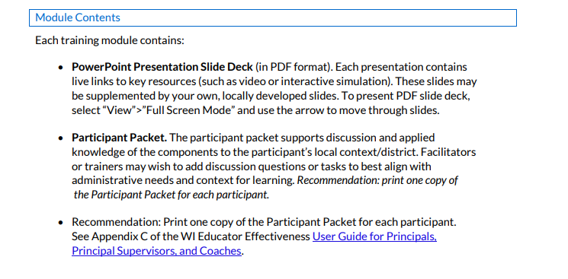
Add the following bullet after Participant packet, and link to the form.
- Facilitator Feedback Form. Use the same form for all modules.

Resource landing page on website:

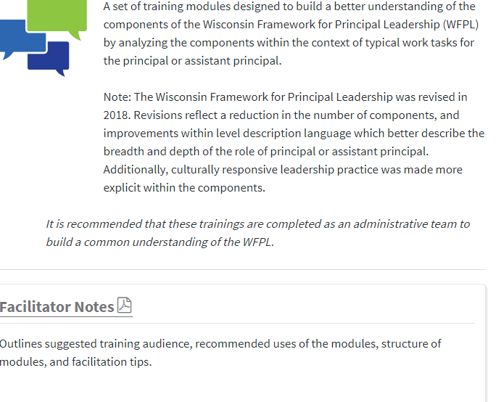
The following statement, or one like it should go on this web page, in either of these two locations.
Feedback is important to the resource improvement process! Please provide WFPL module feedback here (link to form)

