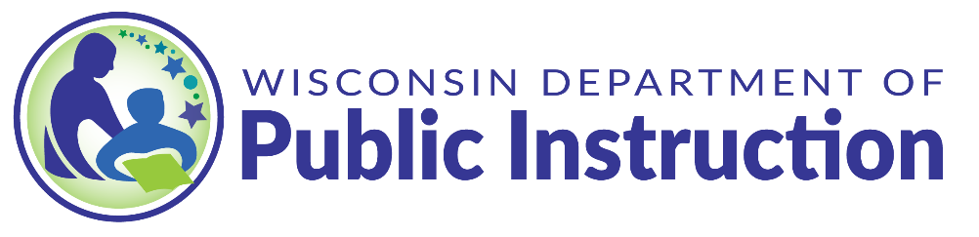

The purpose of this template it to assist Local Education Agency (LEA)s in fulfilling the public reporting requirement of the Elementary and Secondary Education Act (ESEA) that requires districts provide information publicly on each federally required assessment, other state required assessments, and if feasible, district required assessments. Districts may adapt this information to meet the requirement and the needs of their local stakeholders. While the LEA may review and adjust the entire table to meet their local needs, specific attention should be given to the sections highlighted in green that are unique to the district. Although the Wisconsin Department of Public instruction recommends using this template, it is not mandatory, and LEAs are encouraged to use what works for them to meet the needs of their community and schools and fulfill the ESEA requirement: Sec. 1112(e)(2)(B).
Please delete the instructions above this line prior to publishing your LEA’s template.
The US Department of Education, State of Wisconsin, and the (Insert District Name) each require a variety of assessments for a variety of purposes. Below is a list of the assessments, their subject matter, purpose, mandate, and if possible, time spent to schedule and take the assessment, and distribute results. Please direct any questions you have on these or other assessments to our District Assessment Coordinator: (insert contact information).
Assessment | Subject matter and grade levels assessed | Purpose and use of the assessment | Law or policy requiring the assessment | Time students will spend taking the assessment | Schedule for the assessment | Schedule and format for sharing results
Wisconsin Forward Exam | - Grades 3-8 in English language arts (ELA) and mathematics  - Grades 4 and 8 in science,  - Grades 4, 8, and 10 in social studies | The Forward Exam gauges how well students are doing in relation to the Wisconsin Academic Standards and how well districts and the state are supporting students to meet those standards. | Every Student Succeeds Act (ESSA) and Wisconsin State Statute 118.30 | The Forward Exam is untimed. https://dpi.wi.gov/assessment/forward/resources#timing | The Forward Exam is administered annually in the spring. See: https://dpi.wi.gov/assessment/forward/calendar | Students receive individual reports. https://dpi.wi.gov/assessment/forward/data#availability
Dynamic Learning Maps (DLM) | - Grades 3-11 in ELA and mathematics  - Grades 4, 8-11 in science  - Grades 4, 8, and 10 in social studies | DLM assesses the academic progress of students with significant cognitive disabilities. It is administered online. | Every Student Succeeds Act (ESSA) and Wisconsin State Statute 118.30 | DLM test is untimed. | DLM is administered annually in the spring. See: https://dpi.wi.gov/assessment/dlm/calendar | Students receive individual reports and learning profiles.  https://dpi.wi.gov/assessment/dlm/data
PreACT Secure | - Grades 9 and 10 for reading, English, mathematics, and science | PreACT Secure can be used to predict future ACT scores and possible areas of strength and challenges. | Wisconsin State Statute 118.30 | PreACT Secure assessments take 2 hours, 50 minutes to complete, including breaks.  https://dpi.wi.gov/assessment/PreACT/Resources#test-times | PreACT Secure is administered annually in the spring. See:  https://dpi.wi.gov/assessment/PreACT/calendar | Students receive individual reports.  https://dpi.wi.gov/assessment/PreACT/data
ACT with Writing | - Grade 11 for reading, English, mathematics, science, and writing | ACT with Writing helps students understand what they need to learn next to build rigorous high school course plans and identify career areas that align with their interests. It can be used for college enrollment, scholarships, and NCAA eligibility requirements. | Every Student Succeeds Act (ESSA) and Wisconsin State Statute 118.30 | ACT with Writing takes 3 hours, 55 minutes to complete, including breaks. https://dpi.wi.gov/assessment/act/resources#ACT%20resources | ACT with Writing is administered annually in the spring. See: https://dpi.wi.gov/assessment/act/calendar | Student Score Reports are available online and mailed 5-8 weeks after the assessment. https://dpi.wi.gov/assessment/act/data
ACCESS | - Grades K-12, English language proficiency for students identified as English learners (ELs) | ACCESS allows educators, ELs, and families to monitor EL’s progress in acquiring academic English in the domains of speaking, listening, reading, and writing. | Every Student Succeeds Act (ESSA) and Wisconsin State Statute 115.96(1) | The ACCESS test is untimed, and students have the time needed to produce scorable content. ACCESS typically takes 1-4.5 hours to complete, depending on grade and test format. | ACCESS is administered annually in the winter. See: https://dpi.wi.gov/assessment/ell/calendar | Individual Score Reports are available electronically in the spring or summer and paper copies are mailed early the next school year. https://dpi.wi.gov/assessment/ell/data#timing
Assessment of Reading Readiness | - Grades 4K-2 for reading readiness | Districts must assess fundamental reading skills in order to inform and identify students with reading needs. Districts are required to provide interventions or remedial services to address the needs consistent with the state standards in reading and language arts. | Wisconsin State Statute 118.016 | This information is dependent on what assessment the district chooses [To be completed by district] | Reading Readiness assessments must be administered at least annually in the required grades. | This information is dependent on what assessment the district chooses [To be completed by district]
National Assessment of Educational Progress (NAEP) | - Grades 4 and 8 for reading and mathematics (only if the school is selected to participate) | NAEP assessment results help produce the Nation’s Report Card. NAEP is a survey given each year to a sample of schools selected to participate. Districts that receive Title-I funds agree to have schools participate. | Every Student Succeeds Act (ESSA) | Students typically spend 1.5-2 hours to complete the NAEP, depending on grade and test format. | Each sample school has one test date, between the last week of January and the first week of March. | Results are reported at the state and national levels. https://nces.ed.gov/nationsreportcard/
Assessment | Subject matter and grade levels assessed | Purpose and use of the assessment | Law or policy requiring the assessment | Time students will spend taking the assessment | Schedule for the assessment | Schedule and format for sharing results
Insert Local Formative or Summative Assessment Information on this line and below | Insert Local Formative or Summative Assessment Information on this line and below | Insert Local Formative or Summative Assessment Information on this line and below | Insert Local Formative or Summative Assessment Information on this line and below | Insert Local Formative or Summative Assessment Information on this line and below | Insert Local Formative or Summative Assessment Information on this line and below | Insert Local Formative or Summative Assessment Information on this line and below

