Reply to attn of: MW S&CNP: SA 09-03 May 22, 2002

Subject: FY 02 School and Community Nutrition Program Policy Memorandum #02-26

Purchases of Locally Produced Foods in the School Nutrition Programs

State Directors
Child Nutrition Programs

Section 4303 of the Farm Security and Rural Investment Act of 2002 adds a new paragraph (j) at the end of section 9 of the Richard B. Russell National School Lunch Act pertaining to purchases of locally produced products. The provision requires the Secretary to encourage institutions participating in the school lunch and breakfast programs to purchase locally produced foods, to the maximum extent practicable.

We are asking you to encourage school food authorities participating in the National School Lunch and School Breakfast Programs to purchase locally produced foods, to the maximum extent practicable, along with other foods. This provision does not absolve school food authorities of their obligation to adhere to all applicable procurement requirements. School food authorities should be reminded that all purchases must be made competitively, consistent with Federal and State procurement laws and regulations. Purchases of this type would generally qualify as small purchases under procurement requirements and therefore may be procured using informal procedures. School food authorities should check with their administering State agency to determine appropriate small purchase requirements and with their State Department of Agriculture for more information on locally produced foods.
This is a good time of year to encourage the purchase of locally produced products and to encourage the planning for next school year’s purchase of such products. Most regions in the country have an abundance of locally produced fruits, vegetables, herbs and nuts to enhance the meals served to children. Additionally, studies by the U.S. Department of Health and Human Services, U.S. Department of Agriculture (USDA), and the National Academy of Sciences suggest that due to the phytochemical content of fruits and vegetables, as part of a diet that is low in fat, saturated fat and cholesterol and that contains plenty of whole-grain breads and cereals, may decrease the risk of heart disease and cancer. Since a variety of fruits and vegetable can be purchased locally, this fits into our overall goal of providing nutritious, well-balanced meals to children.
In the summer of 1997, USDA began a comprehensive effort to connect small farms to the school meal programs. The “farm to school” initiative encourages small farmers to sell fresh fruits and vegetables to schools and encourages schools to buy this wholesome
produce from small farmers. A copy of “Small Farms/School Meals Initiative”, a step by step guide on how to bring small farms and local schools together, is available to assist you in your efforts to purchase locally produced foods at www.fns.usda.gov/cnd/Lunch/SmallFarms/small.pdf.

Please contact our office if you have questions.

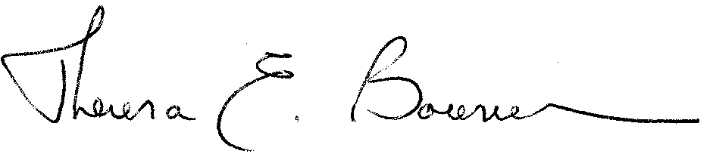

THERESA E. BOWMAN
Regional Director
Special Nutrition Programs

