Autumn 2009 Newsletter of the Wisconsin Talking Book and Braille Library

Introducing: Wisconsin Talking Book and Braille Library!
The next time you call the library you might hear something a bit different. The person answering will say "Hello, Wisconsin Talking Book and Braille Library."
The reason for this is because the library is changing its name this fall. After careful consideration we have decided to change our name to the "Wisconsin Talking Book and Braille Library." Our telephone number will stay the same, as will our mailing address and email address - you will still even find the old name on applications and pamphlets for a while.
We are doing this for a number of reasons. First, it puts the emphasis on the services of the library, rather than the disabilities of its users. We feel this is especially important, as often people do not even know that they qualify for our service. Secondly, it also puts us more on par with other libraries like us around the country. The fact that the name change is happening now is no accident; the name change coincides with our digital transition from cassette books to digital books, which are easier to use and have superior sound quality.
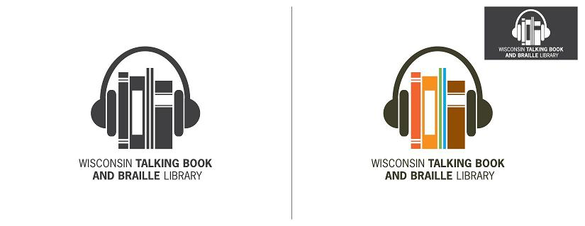
With the name change we are also doing a marketing campaign across the state, with ads on radio, in newspapers and on buses--if you find one, let us know! We will even have a new logo - a pair of headphones on upright books, like bookends. Please feel free to let us know what you think of our new name and logo - we are very interested to hear what you think.

Digital Transition - Fall Update

Accompanying our name change are the new digital talking books and players. Our first players were delivered to veterans in September, with more to follow every month. As soon as veterans and centenarians get their players, we will go down the waiting list of other patrons, so call us at 1-800-242-8822 to add your name to the list. Ask us also for information about how you can download any of the 16,000 digital books and create your own library. Remember that we will go on using cassettes for books and magazines for years to come, so don't send back your cassette player!

For the first year or so, digital books on cartridges from the National Library Service will be in short supply, so the Wisconsin Library is duplicating its own digital books. Beth Wisniewski, our circulation supervisor, has already duplicated several thousand copies of books in high demand so that we will be ready with books when more of our patrons have digital players. Bill Graczyk, Reader Advisor, enlisted the help of two other libraries to create a complete set of all the NLS digital books on our local server so that we can quickly meet the demand for books without having to download them one by one.

Choice Magazine Now Free as Digital Download from NLS

Reconnect with an old friend or meet a new one - CHOICE Magazine Listening is available for free digital download from the Library of Congress' National Library Service for the Blind and Physically Handicapped.

Produced six times a year, each issue contains unabridged articles from quality publications such as National Geographic, Smithsonian, Sports Illustrated, and the New Yorker.

The articles, short stories, poetry and interviews are selected from more than 100 magazines and other periodicals. The selections are read by professional voice talent from the studios of the American Foundation for the Blind in New York. The recording is human voice, not synthetic text-to-speech.

CHOICE Magazine Listening is available free of charge only to people who are blind, or are experiencing vision loss or have other disabilities that limit or prevent reading standard print.

CHOICE continues to be released on four-track cassette tape for those who prefer that format. Contact the Wisconsin Library for more information.

Atención HispanoHablantes!
(Or: Attention Spanish Speakers!)

As of October 2009 there is a new Spanish language magazine subscription available for all of our Spanish-speaking patrons. It is called "Vanidades" (Vanities) and is a general-interest women's magazine with an emphasis on style. It is currently one of the most popular Spanish language magazines available.

So if you speak Spanish make sure to sign up, or if you have a friend who does, please tell them about Vanidades or any of our Spanish language magazines on cassette. They are available for free subscription and include: "People en Español," "Buena Vida" and "National Geographic en Español." We also offer many books in Spanish as well. Whether you are a native speaker or just looking to brush up - check one out today!

Seeking Outreach Opportunities

In our daily contact with patrons, we often hear positive remarks about our Talking Book service. Those who love to read do not have to let their visual or physical limitations stop them from reading. In an effort to better serve our patrons, increase public awareness and reach out to those who are eligible for the program, we are seeking your help for outreach opportunities.

Please inform us or give out our contact number if you know of any groups or organizations whose members would benefit from our program or be interested in learning more about us. Depending on the location, the library would either send a speaker to give a free presentation about our library services or mail an information packet. We are also interested in outreach opportunities like health fairs or senior fairs where we can set up an information table or booth. Due to time constraint and distance, we may not be able to fulfill all requests for a presentation or participation as a vendor, but we would be more than happy to send out brochures and applications for the Talking Book service.

Your assistance in getting the word out about our library services is very much appreciated. It is because of people like you that our Talking Book service continues to grow. So, please feel free to pass on our name or if you would like we can send you brochures or other information to hand out as well.

KEEPING "COZY" ON A COLD EVENING

Many of our patrons prefer books with no sex, violence or strong language. Here is a list of authors who write "cozy" puzzle mysteries and other gentle fiction. Please call the library if you want to try one of these authors.

Nancy Atherton | (Aunt Dimity series)
Laurien Berenson | (Melanie Travis series)
Jennifer Chiaverini | (Elm Creek Quilters series)
Laura Childs | (Theodosia Browning / Tea Shop mystery series)
Diane Mott Davidson | (Culinary mystery series)
Janet Evanovich | (Alexandra Barnaby NASCAR mystery series)
Joanna Fluke | (Hannah Swenson catering mystery series)
Sarah Graves | (Home Repair is Homicide mystery series)
Carolyn Hart | (Claire Mallory bookseller mystery series)
Kate Jacobs | (Friday Night Knitting Club mystery series)
Elinor Lipman | (no series, but many stand-alone novels)
Emilie Richards | (Shenandoah Album series)

Congratulations!
Office Assistant II Becky and her husband welcomed daughter Abigail Georgia on 08/14/09. Mother and daughter are beautiful, healthy, and happy. If you get Becky on the line when calling us make sure to offer her congratulations.

Go Green!
If you are interested in receiving the newsletter electronically via email, please call or email the library to be put on the list. Our email address is lbph@milwaukee.gov. Don't forget the newsletter is also available through Newsline, a newspaper by telephone service. For more information on Newsline call the library at 1-800-242-8822.

Wisconsin Talking Book and Braille Library
813 West Wells Street
Milwaukee, WI 53233-1436
1-414-286-3045 (in Milwaukee)
1-800-242-8822 (in Wisconsin)
1-414-286-3102 (FAX)
lbph@milwaukee.gov (e-mail)
http://talkingbooks.wi.gov (website)
https://webopac.klas.com/wi1aopac (on-line public access catalog)

