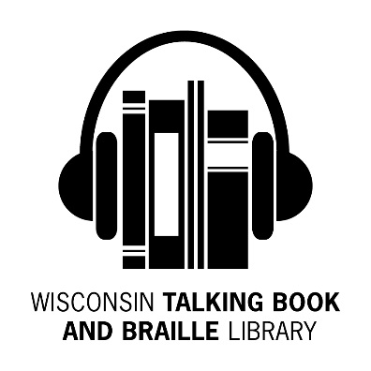

*Bulletin Board*

*Spring 2017 Newsletter*

***What’s Been Happening at WTBBL!***

Hello Readers!

Becky, WTBBL’s Outreach Librarian, was out on parental leave for a few months after she and her husband welcomed a bouncing baby boy, Simon Alexander, November 18, 2016.

Frequent phone callers have likely missed talking to Sarah on the phone. Sarah has left WTBBL for a promotion in another City department. The Library hopes to have her vacancy filled by the time you receive this newsletter.

WTBBL was honored to be Wisconsin Department of Public Instruction’s March 2017 Library of the Month! Read more at: badgerlink.dpi.wi.gov/bulletin/2017/03/library-month-talking-book-and-braille-library

The Library of the Month is a celebration of Wisconsin libraries chosen by DPI’s BadgerLink team.

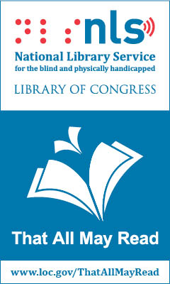

Every other year, a National Library Service Network Consultant makes a site visit to WTBBL. This year, we were pleased to welcome Pamela Davenport on April 18th and 19th. The WTBBL staff enjoyed showing

Pam WTBBL and appreciated her insights from her visits to other states.

In this newsletter, look for a list of new Wisconsin books produced by ABLE (Audio & Braille Literacy Enhancement).

Stay warm. Keep reading and talking about us to your friends, *Linda*

***Summer Reading Program***



Calling all school age children and teens that use WTBBL or are eligible to use WTBBL—join the WTBBL Summer Reading Program! The 2017 theme is Build a Better World!

Read as many hours as you wish from June 5th to September 2nd. The more you read, the more prizes you will earn. One lucky reader will receive a $50 gift card to Culver’s! Please contact Becky at [ramanz@milwaukee.gov](mailto:ramanz@milwaukee.gov) or 414-286-6918 to sign up.

***Braille Games***

For more than a decade, blind and visually impaired children and adults have taken part in a unique intergenerational activity to improve their braille skills and celebrate how braille brings a world of information to their fingertips. On April 28th, 77 children and adults participated in the 15th Annual Braille Games at the Milwaukee Public Museum. The event is a collaboration of WTBBL, ABLE, Vision Forward Association and the Milwaukee Public Museum.

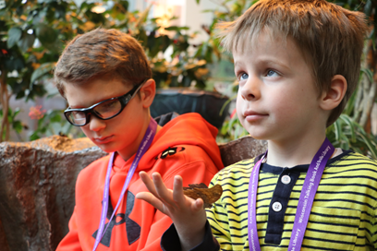

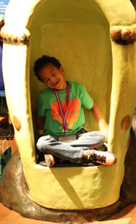This year’s theme was “Braille is an Adventure.” Children participated in interactive braille activities integrated into museum exhibits in the Butterfly Vivarium and Garden, the Costa Rican Rain Forest area, and The Third Planet (where the dinosaurs are found!).

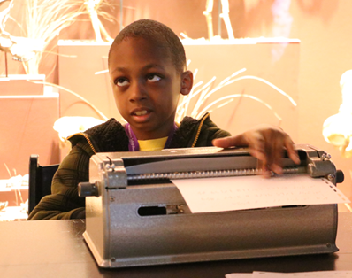

“Braille Games is such an important opportunity for blind children to use braille in a fun and interactive way while being mentored by blind adults who are self-sufficient and independent. These mentors share their skills in reading and writing braille while talking about their studies in college and their professions. It’s crucial for blind children to know the vast array of opportunities available to them in adulthood,” said Cheryl Orgas, Executive Director for ABLE.

***Biographies on Wisconsin Residents***

Wisconsin is or was home to a great many athletes, actors, musicians, historians, and other celebrities over the years.

Here are some books on people of interest:

* DB28109 **Spencer Tracy, Tragic Idol** by Bill Davidson (1987)
* DB33709 **O’Keeffe and Stieglitz: An American Romance** by Benita Eisler (1991)
* DB35765 **Frank Lloyd Wright** by Meryle Secrest (1992)
* DB51916 **Liberace: An American Boy** by Darden Asbury Pyron(2000)
* DB58404 **The Wilderness World of John Muir** by John Muir (2001)
* DB63340 **Escape! The Story of the Great Houdini** by Sid Fleischman (2006) For Grades 5-8
* DB63857 **The Pursuit of Happyness** by Chris Gardner (2006)
* DB66868 **The Chris Farley Show: A Biography in Three Acts** by Tom Farley (2008)
* DB77447 **My Lunches with Orson: Conversations Between Henry Jaglom and Orson Welles** by Henry Jaglom (2013)
* DBC04731 **Leaders of the Pack: Starr, Favre, Rodgers and Why Green Bay’s Quarterback Trio is the Best in NFL History** by Rob Reischel (2015)
* DBW09399 **A Liberal in City Government: My Experiences as Mayor of Milwaukee** by Frank P. Zeidler (2005)
* DBW09405 **Unintimidated: A Governor’s Story and a Nation’s Challenge** by Scott Walker (2013)

***Viewing Your Library Account***

WTBBL’s Web OPAC is found at: [webopac.klas.com/wi1aopac](https://webopac.klas.com/wi1aopac/). By visiting the site and entering your login and password, you can view and update your library account.

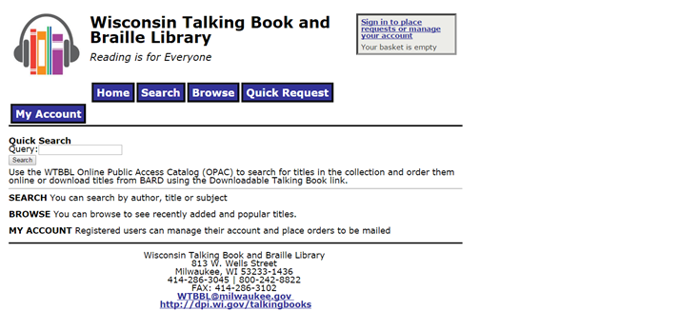

Some of the information you can see or modify on your library account includes:

* The date you joined WTBBL
* Number of items and titles of books you currently have checked out
* Number of items and titles you have on your request list
* Number of items and titles you have on your reserve list
* Titles of magazines you subscribe to
* Contact info including address, phone number, email address, and alternate contacts
* Likes and dislikes including authors, subjects, narrators, and series
* Reading history

If you would like to make any changes with your likes or dislikes, please contact WTBBL by phone or email. We would be happy to update your preferences, change your magazine subscriptions, or update your contact info.

***WTBBL Outreach***

Summer will be here soon and hopefully the warm weather will arrive any day now. WTBBL is signing up to exhibit at events throughout the state. Please keep WTBBL in mind when scheduling exhibitors for resource fairs, conferences, and local events. We also provide speakers for support groups, nursing homes, senior centers, schools, and libraries.

Here are some of the many events on the WTBBL Outreach schedule:

- 9th Annual Wisconsin VisionWalk in Milwaukee on Sunday, May 21st

- 27th Annual Aging Well Conference at

UW-Parkside on Friday, June 2nd

- Beaver Dam Senior Expo on Wednesday, May 17th

- 15th Annual 60 Plus Expo in Janesville Thursday, May 11th

- 29th Annual Senior Americans Day at

UW-Eau Claire on Tuesday, June 6th

Please contact Becky, WTBBL’s Outreach Librarian, to schedule a speaker or ask WTBBL to exhibit at your event. You can contact Becky at 414-286-6918 or email [ramanz@milwaukee.gov](mailto:ramanz@milwaukee.gov).

***WTBBL Adult Book Club***

On Tuesday, April 4th, we discussed the book **Rosemary: The Hidden Kennedy Daughter** by Kate Clifford Larson

(DB83946 / Available on BARD). Some book club members knew a fair amount about the Kennedys but were intrigued to learn more about Rosemary and her role in the Kennedy family. It was difficult to read about Rosemary’s lobotomy and her isolation from her family.

We were curious to learn more about Rosemary living at St. Coletta in Jefferson, Wisconsin for the bulk of her life. For further reading, the book **The Missing Kennedy: Rosemary Kennedy and the Secret Bonds of Four Women** by Elizabeth Koehler-Pentacoff (DBC08191 / Available on BARD) tells about Rosemary’s time spent at St. Coletta.

On Tuesday, June 20th, we will discuss **A Man Called Ove** by Fredrik Backman (9 hours 7 minutes) DB84392 / Available on BARD.

- Ove has always been a grumpy man, and when he loses his wife and his job, he decides to commit suicide. But a lively family of new neighbors and a stray cat might give Ove a reason to keep living. First published in Swedish in 2012. Human Relationships—Fiction. Bestseller.

On Tuesday, August 15th, we will discuss **My Lucky Life In and Out of Show Business** by Dick van Dyke (7 hours 40 minutes) DB74349 / Available on BARD

Eighty-four-year-old Van Dyke examines his successful acting career, which included movies **Mary Poppins** and **Chitty Chitty Bang Bang** and his sitcom **The Dick Van Dyke Show**. The father of four also recounts dealing with his alcoholism and leaving his childhood sweetheart for his agent's secretary. Autobiography. 2011.

The book club meets on the phone using a toll free phone number, every other month on a Tuesday. There are two sessions from which to choose: **1:30 to 2:30 pm or 6:30 to 7:30 pm**. The same book is discussed at both sessions.

For more information or to sign up, please contact Becky at 414-286-6918 or email [ramanz@milwaukee.gov](mailto:ramanz@milwaukee.gov).

***Cassettes are Obsolete***

Just a friendly reminder that WTBBL no longer circulates RCs (recorded cassettes). If you still have your yellow cassette player and are not using it, please return it to WTBBL. We would be happy to mail you a cardboard box with prepaid postage so you can return the yellow cassette player. If you have any overdue RC cassettes in green plastic cases, please return those as well.

***Do You Enjoy British Series?***

If you enjoy watching some of the great historical British series shown on PBS, you should give these books a try.

* If you are a fan of the TV shows **Inspector Morse, Lewis,** and **Endeavour**, you should read or reread the 13 books in the **Inspector Morse** series by the late, great Colin Dexter.
* If you enjoy watching Vicar Sidney Chambers’ exploits on **Grantchester**, read the **Grantchester Mysteries** by James Runcie. The series has five books thus far containing short stories (Books 1-3 DB81328 and Books 4-5 DB85171).
* If you like **Home Fires** and are interested in learning more about the role of the ladies in the Women’s Institute, read **Home Fires: The Story of the Women’s Institute in the Second World War** by Julie Summers (DB82601).
* If you want to learn more about the true stories behind **Call the Midwife,** read the three memoirs by Jennifer Worth (DB76915 **Call the Midwife: A Memoir of Birth, Joy, and Hard Times**; DB86108 **Shadows of the Workhouse**; and DB86063 **Farewell to the East End**).
* If you miss new episodes of **Downton Abbey**, read the biography of Lady Almina by Fiona Carnarvon which inspired the series (DB75167 **Lady Almina and the Real Downton Abbey: The Lost Legacy of Highclere Castle**).
* If you enjoy the **Father Brown** mystery stories, WTBBL has a collection of G.K. Chesterton’s **Father Brown** (DB17062).

***2017 NASCAR Schedule***

You may request a braille copy of the 2017 NASCAR schedule. This document includes the schedules for the NASCAR Cup, the NASCAR Xfinity Series, and the NASCAR Camping World Truck Series. Please contact WTBBL if you are interested in requesting a copy.

***Facebook Pages***

Wisconsin Talking Book and Braille Library and the National Library Service for the Blind and Physically Handicapped have Facebook pages. Log onto Facebook, find and like us today!

***New Wisconsin Titles Available***

ABLE (Audio & Braille Literacy Enhancement) has produced more Wisconsin books for your reading pleasure. These titles will also be available on BARD.

Recent additions include:

* **DBC04732** **Green Bay Packers : Trials, Triumphs, and Tradition** by William Povletich

- This is the history of the NFL's only small-town franchise - and the only franchise owned by fans - the Green Bay Packers. The Packers' creative and profitable management has been led by names such as Lambeau, Lombardi, Holmgren, and Rodgers.

* **DBC04738 Dead Hot Mama** by Victoria Houston

- The mystery heats up in Loon Lake when pals Police Chief Lew Ferris and Doc Osbourne team up on the discovery of two snowmobilers buried underneath icy waters and a woman's body in a snowdrift. **Dead Hot Mama** is number 5 in the **Loon Lake Fishing Mystery Series.**

* **DBC08195** **Juliette Kinzie : Frontier Storyteller** by Kathe Crowley Conn

- Biography of the frontier storyteller, Juliette Kinzie. Part of the **Badger Biographies Series.**

* **DBC08210 Mountain Wolf Woman: A Ho-Chunk Girlhood** by Diane Young Holliday

- Biography of the Mountain Wolf Woman, a member of the Ho-Chunk tribe of Wisconsin, describing her life, traditions, and native customs at the turn of the twentieth century. Part of the **Badger Biographies Series**.

* **DBC08225 No Struggle, No Progress : A Warrior's Life from Black Power to Education Reform** by Howard Fuller

- Biography of Howard Fuller, former Superintendent of Milwaukee Public Schools in Wisconsin, and his struggle in reforming the nation's schools.

* **DBC08239** **Ringside Seat: Wisconsin Politics: The 1970s to Scott Walker** by Tim Cullen

- Former Wisconsin State Senate Majority Leader Tim Cullen explains the history of Wisconsin politics; the huge changes that occurred during his tenure as State Senator; and, how the current governor Scott Walker's direction is wrong for Wisconsin.

* **DBC08240 Skunk Hill: A Native Ceremonial Community in Wisconsin** by Robert A. Birmingham

- This is the little known story of the Native tribal community and preservation of Skunk Hill in Wood County, Wisconsin.

***Words About WTBBL***

Every now and again we get some kind words about WTBBL that stand out. We’re going to start sharing some of them in the Newsletter, so look for them!

“These talking books are changing her life. Thank you so much for everything you do.”

--Colleen T.

“It is wonderful that you offer this service. He is a war veteran and worked hard all his life. He just in the last few years has lost his sight. I think this will really lift his spirits.”

--Karen W.

“Not to be able to read when you enjoy reading was a big loss but hearing talking books has been a joy in my life.”

--Gloria S.

“I am singing the library’s praises to all who will listen.”

--Eunice W.

“My thanks and appreciation for getting my talking book requests to me and bringing me some relief in my boring days.”

--James S.

“Your service and dedication are phenomenal and so appreciated.”

--Jerome W.

***I’m Going To Sit Right Down and Write You a Letter…***

Please be sure to paste an address label or write your name and address on order forms and correspondence you send to

WTBBL. Occasionally, we receive someone’s order list without identifying information on it and cannot add the choices to their account.

Also good to know, is that order forms can be sent for free via the United States Postal Service, by writing FREE MATTER FOR THE BLIND OR HANDICAPPED in the spot where you would affix a stamp.

Because WTBBL materials and mail are sent through the United States Postal Service, please allow 7 or more days for items to reach us. Contact us a week before moving South for a few months or before you want extra books for the holiday break.

***In Person***

If you or someone you designate are near the Milwaukee Central Library and WTBBL, we will be happy to set aside materials for you or give a tour. It is helpful if you contact us ahead of time, so that we can supply directions and have materials ready.

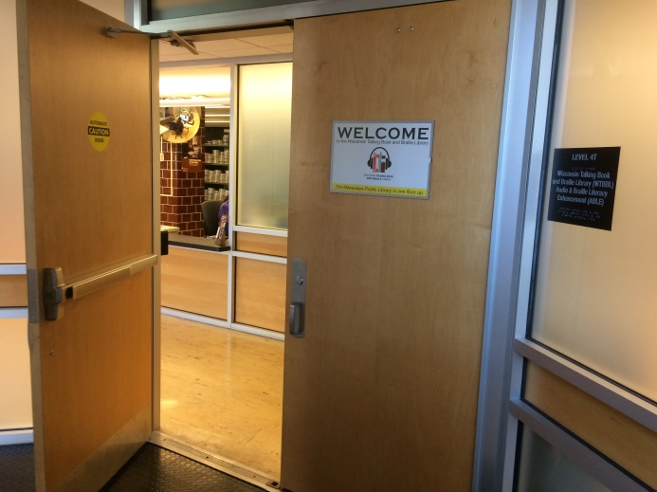

|  |  |  |
| --- | --- | --- |
| Wisconsin Talking Book and  Braille Library  813 W. Wells St.  Milwaukee, WI 53233-1436 |  | FREE MATTER FOR THE BLIND OR HANDICAPPED |

***Holiday & Post Office Closings***

BULLETIN BOARD is available in large print, braille and audio editions, and is also available electronically via email and through *NFB-NEWSLINE®*, a newspaper by phone service.

Wisconsin Talking Book and Braille Library (WTBBL)

813 W. Wells Street

Milwaukee, WI 53233-1436

1-800-242-8822 (in Wisconsin)

1-414-286-3102 (FAX)

[wtbbl@milwaukee.gov](mailto:wtbbl@milwaukee.gov) (email)

[dpi.wi.gov/talkingbooks](http://talkingbooks.dpi.wi.gov/)



May 29th WTBBL Closed (Memorial Day)

July 4th WTBBL Closed (Independence Day)

September 4th WTBBL Closed (Labor Day)

October 9th No Mail (Columbus Day)

November 10th No Mail (Veterans Day)

November 23rd & 24th WTBBL Closed (Thanksgiving)

December 22nd-25th WTBBL Closed (Christmas Eve & Christmas Day)

December 29th-January 1st, 2018

WTBBL Closed (New Year’s Eve & Day)