Summer 2010 Newsletter of the Wisconsin Talking Book and Braille Library
Digital Machines and Accessories
If you still have not received a digital player, please call our office at 1-800-242-8822 or email us atlbph@milwaukee.gov to order yours today!

Also, if you are interested in learning how to download books and magazines from a home computer please contact our office for more information.

Even if you do not have a computer or internet access, you may have a loved one who does and is willing to help you.

If you have already received your digital player, you may be interested in some of the accessories available for the player.

Currently we have two items available for free loan: a headphone adaptor and a USB flash drive port adaptor. If you would like either of these items please call the library.

The headphone adaptor works with our large "ear-muff" style headphones. You plug the headphones into the adaptor and the adaptor into your player.

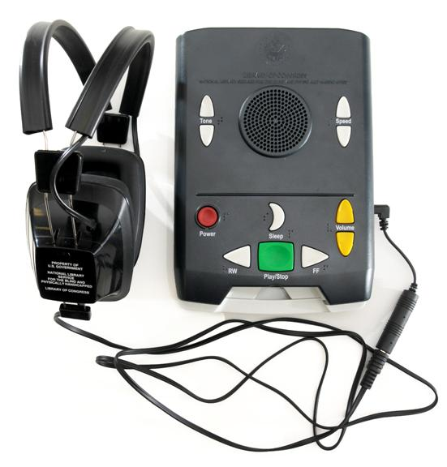
If you do not have headphones and would like a pair please let us know and we will send you the headphones and adaptor at the same time, otherwise if you received headphones for your cassette player you can use the same pair with the adaptor on your digital player. If you do not like headphones that cover your entire ear, you can always use your own which are available at most retailers. Below is a picture of headphones similar to what we send out and the adaptor.

For those of you who are downloading your own books and magazines from BARD, we are also offering a USB flash drive port adaptor. What is that exactly? Well, currently you can download items onto a flash drive (also called a USB drive, a stick drive, a thumb drive, etc.) and you can plug the drive into the side your digital player. Some are finding that their drive sticks out too far and is a nuisance. This new adaptor allows you to plug the drive in at a ninety degree angle, which reduces the potential for damage to the drive and machine. Below is a picture example of the adapter in use.
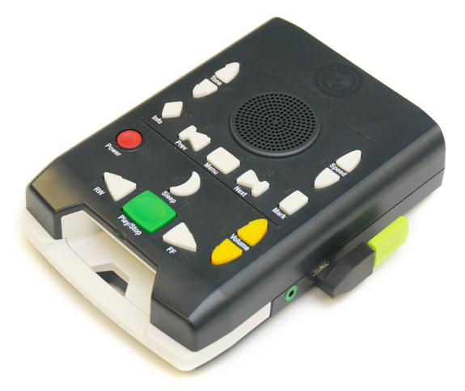

There are also other accessories available for use with the digital player, but these do have a cost and need to be purchased from a vendor not affiliated with the library. These items are a carrying case for your digital player and for those who do not want to use a flash drive, a digital cartridge and cable.

A specially designed carrying case has been created for digital players. The case protects the machine while still leaving access to the cartridge slot, buttons, and USB port. It also comes with a shoulder strap.

The Library does not provide these cases and if you choose to purchase one it is yours to keep even if you return your machine. The official name of the carrying case is the Executive NLS/BPH Case. The case costs $39.95 and can be purchased from one of two sources.

The first is Executive Products Inc. It can be ordered online at www.ExecutiveProductsInc.com or you can call them at 1-818-833-8822.

You can also purchase the case from the Perkins School for the Blind. It can be ordered online atwww.perkins.org or you can call them at 617-972-7308 or email them atPerkinsProducts@Perkins.org.

For those who are downloading from BARD and would prefer to have their own digital cartridges, Perkins School for the Blind is also selling cartridges and cables. They offer two cartridge sizes (1GB costs $10.99 and 2GB costs $11.99) and a USB cable, which is needed to connect the cartridge to your computer, for $5.00.

Again items can be ordered online at www.perkins.org or you can call them at 617-972-7308 or email them at PerkinsProducts@Perkins.org. Cartridges are also available from the American Printing House. They sell a 2GB for $12.00 and the USB cable for $5.00 as well. You can order online at www.aph.org or order toll-free by calling 1-800-223-1839.

Again, the cartridges, USB cable and carrying case are items that you purchase on your own. They are not necessary to use the machine, but can enhance your reading pleasure. You must contact the organizations directly to order items.

New Regional Librarian for Wisconsin
The Wisconsin Talking Book and Braille Library has a new Regional Librarian. Enid Gruszka comes to us as a former Branch Manager for Milwaukee Public Library. Enid has worked for MPL for 15 years. Enid grew up in Cleveland, Ohio and relocated to Madison to attend college. She completed her library degree at UW and moved to Milwaukee to begin her public library career. Enid enjoys talking to patrons on the phone who are passionate about the new digital player! Enid is thrilled to be working in a department with staff that is so dedicated to providing this valuable service. In her spare time, Enid enjoys walking her dog, rummage sales, vegetarian cookery and, of course, reading a good book.

Thank you to our volunteers!
The Wisconsin Chapter of the AT&T Pioneers repair and service our recorded cassette players. The volunteers who live across the state put in over 2,300 hours of work from September 2008-October 2009.

The students of Carol Lerand of Bay View High School in Milwaukee assist WTBBL with mailings and other office projects. The student volunteers put in nearly 500 hours of work from September 2009-June 2010.

Welcome back Telephone Pioneer Bill Jermain Jr. who is reestablishing his workshop in Milwaukee repairing our playback equipment.

We are deeply grateful for all the hard work and dedication of our volunteers!

Parlez-vous...? Sprechen sie...? Habla espanol...?
Are you a non-english language reader?

The Library supplies most of its non-English language readers with books in their favorite language through interlibrary loan sources. If you wish to read books in a non-English language, please ask for the booklist for your language from the Wisconsin Talking Book and Braille Library. WTTBL has many Spanish language talking books already in stock. Talking Books supplied from either the Wisconsin Library or from the interlibrary loan sources are checked out for 60 days and are returned to the library via the postage-free mailing cards on each book's mailing box.

Reminders
In order for us to better serve you please remember to rewind your VHS tapes and audio cassette tapes. This saves staff time and helps us do our job more efficiently.

A digital book cannot be rewound. Simply pull the book out of the player and return it. It will start right from the beginning for the next patron!
If you have your digital player, please keep your cassette player as only a portion of our collection is currently available in the digital format.

If your cassette player isn't functioning properly please let us know. If we cannot troubleshoot the problem over the phone we will send you a replacement machine.

We charge no overdue fees at WTBBL but the books do have a loan period of two months. Please return your books in a timely fashion.

Wisconsin Summer Library Program
The Wisconsin Talking Book and Braille Library has a booklist of accessible titles to go with the themes of the 2010 Summer Reading Program.

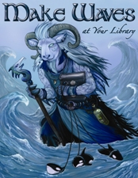
"Make a Splash-READ" is the theme of the children's summer reading program and "Make Waves at your Library" is the theme of the young adult reading program.

To access the booklist go to- http://pld.dpi.wi.gov/pld_slp

BULLETIN BOARD is published four times a year by the Wisconsin Talking Book and Braille Library. It is available in large print, Braille, and audio-cassette editions. The Wisconsin Talking Book and Braille Library makes no recommendations or endorsements concerning any products or services which may appear in this publication.
Wisconsin Talking Book and Braille Library
813 West Wells Street
Milwaukee, WI 53233-1436
1-414-286-3045 (in Milwaukee)
1-800-242-8822 (in Wisconsin)
1-414-286-3102 (FAX)
lbph@milwaukee.gov (e-mail)
http://talkingbooks.wi.gov (website)
https://webopac.klas.com/wi1aopac (on-line public access catalog)

