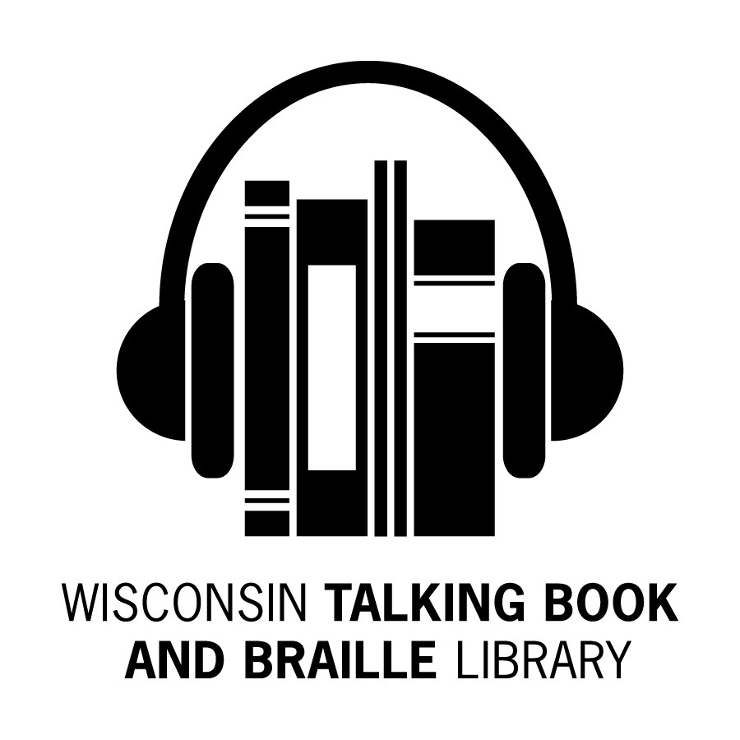
Bulletin Board
Summer 2015 Newsletter

What’s Been Happening at the WTBBL!

Hello Readers,

Are you familiar with ABLE (Audio & Braille Literacy Enhancement)? WTBBL contracts with ABLE to produce our Wisconsin audio recordings and braille titles. ABLE started in the Milwaukee Central Library building as Volunteer Services for the Blind and Visually Handicapped (VSVH) in 1965.

To celebrate their golden milestone and the opening of a digital recording studio, ABLE will host a 50th Anniversary Celebration on Tuesday, September 29th, 2015. Celebration details will be found at www.ablenow.org/. More information about the new recording studio will be in the next newsletter.

WTBBL’s locally produced/downloaded DBs (green DBs and grey cases) are being sent out with braille labels. You might not have noticed because they will look the same as those produced by NLS. WTBBL ordered the new printers, computer software and labels (the same type that NLS uses) to enable braille readers to identify the DBs upon receipt. WTBBL may need some time to relabel previously downloaded titles.

NLS has begun adding some “locally produced” audio recordings to the BARD database. The titles have DBC or DBN prefixes. They are available from WTBBL on digital cartridge or can be directly downloaded from BARD.

WTBBL is proud to announce that our first approved recording: DBC04701 A Tale of Two Soldiers: The Unexpected Friendship Between a WWII American Jewish Sniper and a German Military Pilot by Max Gendelman is now available.

Alert! WTBBL will stop circulating books and magazines on cassette at the end of 2015.

Keep reading and talking about us to your friends,
Linda

WTBBL on Facebook

WTBBL has a Facebook page to share news, photos, reviews and updates about the library. Log into Facebook, find Wisconsin Talking Book and Braille Library and like us today!

WTBBL Outreach

This summer WTBBL has exhibited at a number of exciting events including the Aging Well Conference at UW-Parkside, Milwaukee Recreation’s Annual SeniorFest, the Ozaukee County Senior Conference, the Monroe County Low Vision Support Group, and the WPA’s Parkinson’s Disease Symposium.

This fall we are excited to share information about WTBBL at more events. Look for WTBBL at the Milwaukee County Zoo Senior Celebration, Walk MS in Oshkosh, the Institute on Aging’s Annual Colloquium on Aging in Stevens Point, the Assistive Technology Fair at Lambeau Field, the Beloit Senior Fair, the Family and Professional Caregiver Conference in Fond du Lac, and the Wisconsin Library Association Conference in Madison.

WTBBL is happy to exhibit at resource fairs, conferences and veterans’ events and may be able to provide speakers for events at schools, support groups, nursing homes, senior centers, and libraries throughout the state.

WTBBL Adult Book Club

On June 23rd, the WTBBL book club discussed the book Unbroken: A World War II Story of Survival, Resilience, and Redemption by Laura Hillenbrand (DB072129). This was the first time the book club met at 1:30 pm and 6:30 pm. We had two great discussions about the life of Louis Zamperini, the Japanese

soldiers and POW camps in WWII, the author’s personal journey to write this non-fiction book, and key plot points of the book.

Joining the WTBBL book club is fun! The book club meets by phone using a toll free phone number. You talk with interesting people. You read books that you may not consider otherwise. It can be fun to chitchat about books, upcoming area events, tips and tricks to help in everyday life, and common interests.

Our next book club meeting will be on August 18th from 1:30 pm to 2:30 pm and from 6:30 pm to 7:30 pm. Both book clubs will read the same book and discuss it at different times on the same day. We will discuss the book The Museum of Extraordinary Things by
Alice Hoffman (DB078515 / Available on BARD).

The remaining 2015 book club dates and titles are:

October 13th: The Girl on the Train by Paula Hawkins (DB080635 / Available on BARD)

December 1st: The Light Between Oceans by M. L. Stedman (DB075192 / Available on BARD)

The book club will continue in 2016.

For more information or to sign up to participate in the book club, please contact Becky at 1-414-286-6918 or ramanz@milwaukee.gov.

Phil DiMeo’s Journey from Sighted to Insightful

For more than fourteen years, local author Philip DiMeo, a talented cartoonist and social worker, led a double life—masquerading as a fully sighted person while becoming blind. On April 18th, Phil DiMeo discussed his book Binoculars: Masquerading as a Sighted Person at Boswell Books in Milwaukee. This event was co-sponsored by Audio & Braille Literacy Enhancement (ABLE) and the Wisconsin Talking Book and Braille Library. ABLE has produced this digital book for our patrons to enjoy. You may request DBC04702 if you would like to read this book.

New Wisconsin Titles Available

ABLE (Audio & Braille Literacy Enhancement) has produced more Wisconsin books for your reading pleasure.

Here are the recent additions:

- DBW09404 MacArthur Memorial Week, June 3-7, 2014, Milwaukee, Wisconsin: Duty, Honor, Country
by The Veterans Community Relations Team

- To commemorate the 50th Anniversary of General MacArthur’s death and the 35th Anniversary of the dedication of a statue honoring his service in MacArthur Square, Milwaukee once again honored the

General with a second MacArthur Memorial Week from June 3-7, 2014. This event booklet commemorates the five-day event and includes historical and biographical information about the General.

- DBW09424 The Great Peshtigo Fire: An Eyewitness Account
by Peter Pernin

- This is an eyewitness account of the devastating Peshtigo, Wisconsin fire of 1871, which burned 2400 square miles and killed more than 700 people. This remains one of the deadliest fires in US history.

- DBW09426 Odin’s Promise
by Sandy Brehl

- This historical novel set in World War II is about a girl and an elkhound in a village in western Norway during the German occupation. It is recommended for readers ages 10 and older.

- DBW09429 Seams Unlikely
by Nancy Luedtke Zieman

- Nancy Zieman, star of the long-running PBS "Sewing With Nancy" television program, has permanent Bell's palsy and talks about it in this autobiographical book. Nancy and her husband took her passion for sewing and created a multi-million dollar business in Beaver Dam, Wisconsin.

- DBW09435 The Heart of Things: A Midwestern Almanac
by John Hildebrand

- In these wry, sharply observed essays which form a remarkable book of days, John Hildebrand charts how life in home, town and countryside overlap. Hildebrand lives in northwestern Wisconsin.

- DBW09437 Dead Renegade: Loon Lake Fishing Mystery, bk. 10
by Victoria Houston

- "Doc" Osborne stumbles upon human remains in the basement of an antique store, involving himself in a cold case murder and a hot string of burglaries, while trying to stop a child predator from striking again.

- DBW09436 Dead Tease: Loon Lake Fishing Mystery, bk. 12
by Victoria Houston

-Midwest Clinic CEO John McNeil is involved with 26-year-old Jen Williams. Jen’s body is found with a single stab wound through the heart and McNeil’s wife is suspected.

- DBW09438 Dead Insider: Loon Lake Fishing Mystery, bk. 13
by Victoria Houston

- Loon Lake, Wisconsin becomes the focus of a murderous scenario that links a murder to the race for the U.S. Senate by a woman who is heir to a Northwoods’ fortune.

Cassette Books and Players

It is time to say goodbye to the old and embrace the new!

The National Library Service (NLS) has ceased production and distribution of the cassette book collection and players.

All cassette service from this point on will only be for titles not available in DB format. WTBBL will stop sending out books on cassette at the end of the year.

Magazines on cassette distribution will also be ending. WTBBL will be introducing a new process for distribution of these and other “new” digital magazine titles. The next newsletter will contain more information about this.

NLS continues the Analog-To-Digital program, digitizing many of the books originally produced in the cassette (analog) format. The converted titles can be downloaded from BARD or requested on cartridge from WTBBL. The digital book collection (DB) far surpasses the cassette collection in both quality and quantity.

Please return your cassette player now if you are no longer using it. If you no longer have the original box, contact us and we will be happy to send you one.

First Locally Produced Recording Available on BARD

We are pleased to announce that WTBBL has its first locally produced recording on the NLS BARD service.

DBC04701 A Tale of Two Soldiers: The Unexpected Friendship Between a WWII American Jewish Sniper and a German Military Pilot by Max Gendelman

- This memoir is about the unlikely friendship formed between an American Jewish G.I. and trained sniper for the US Army, and a German Luftwaffe pilot during WWII. Unrated.

In the past, patrons from other Talking Book libraries who wanted to listen to a WTBBL-produced book would need to have their library’s interlibrary loan service request a copy from us. Now patrons and Talking Book library staff can download this book directly from the BARD site. WTBBL will have more BARD titles when production in ABLE’s new digital recording studio begins.

Gentle Romances Catalog

Good news if you enjoy reading romance novels. NLS has created a bibliography of gentle romances available in audio and braille formats. These books do not contain explicit sex, violence, or strong language.

If you are interested in Regency period London, Amish communities, NASCAR races, or the paranormal worlds of time

travel and vampires, you can find such romance stories in this catalog.

Bestselling authors such as Janet Evanovich, Debbie Macomber, Stephenie Meyer, Nicholas Sparks, Danielle Steel, and Lori Wick are included in this large print catalog.

Foreign Language Materials

Did you know you may request books in other languages?

The National Library Service (NLS) also offers recorded books in many foreign languages. WTBBL has compiled annotated lists of digital books offered in French, German, and Russian.

NLS offers over 500 titles in Spanish in audio or braille formats.

NLS offers four magazines in foreign languages:

- Das Beste aus Readers Digest (German)
- France-Amerique: Le Journal Francais des Etats Unis (French)
- People en Español (Spanish)
- Vanidades (Spanish)

Foreign language books may be available on the BARD download website or may be ordered from WTBBL. If you want more information about titles or languages offered, please contact WTBBL.

BARD News, Tips, and Tricks

- NLS released the Android BARD app this summer. The app will work on versions 4.1 and newer. It is available at the Google Play store.

- The BARD Mobile How-to Series videos (www.youtube.com/playlist?list=PLpAGnumt6iV7Aap_-C8b-8pR_HCxnh_Ls) give instructions on how to read an audiobook, navigate an audiobook, manage downloads, use basic gestures with TalkBack, the Android screen reader service, and how to use the VoiceOver function with Apple devices.

- If you move or change email addresses, log into your BARD account and choose the Update Account Settings link that is located about two-thirds of the way down the BARD Main Page. This will take you to a page of options, including a link to Change Your Email Address. Once you change your email address/user ID, you will be required to reset your password to protect the security of your account.

Carnegie Awards Winners

The Andrew Carnegie Medals for Excellence in Fiction and Nonfiction were established in 2012 to recognize the best fiction and nonfiction books for adult readers published in the U.S. in the previous year. The awards are named in honor of the nineteenth-century American philanthropist Andrew Carnegie in recognition of his deep

belief in the power of books and learning to change the world. A JOINT INITIATIVE OF CARNEGIE CORPORATION OF NEW YORK AND THE AMERICAN LIBRARY ASSOCIATION

Andrew Carnegie Medal for Excellence in Fiction 2015 Finalists:

- DB079182 All the Light We Cannot See by Anthony Doerr

- Through the intertwined stories of a sightless French girl and a German soldier, Doerr masterfully and imaginatively re-creates the harsh conditions in WWII-torn France and the strictly controlled lives of the military occupiers.

- DB080260 Nora Webster
by Colm Tóibín

- In Tóibín’s remarkably subtle, witty, and affirming story, the Ireland of four decades ago and the conundrums women faced are beautifully evoked through events in the three-year widowhood of fortysomething Nora Webster.

- DB078213 On Such a Full Sea
by Chang-rae Lee

- As young Fan searches for her missing boyfriend in an America devastated by climate change and a pandemic, Lee brilliantly imagines extreme survival tactics, psychological trauma, and the resurrection of art and its solace.

Andrew Carnegie Medal for Excellence in Nonfiction 2015 Finalists:

- DB080035 Just Mercy: A Story of Justice and Redemption
by Bryan Stevenson

- Stevenson, founder of the Equal Justice Institute in Montgomery, Alabama, delivers a passionate account of the ways our nation thwarts justice and inhumanely punishes the poor and disadvantaged.

- DB078463 The Sixth Extinction: An Unnatural History by Elizabeth Kolbert

- Kolbert combines travel adventures, lucid science, and informed and awestruck descriptions of natural wonders, from rainforests to the Great Barrier Reef, to forthrightly address the deleterious impact our use of fossil fuels is having on the very fabric of life.

- DB079881 Thirteen Days in September: Carter, Begin, and Sadat at Camp David by Lawrence Wright

- Pulitzer Prize-winning journalist Wright presents a riveting blow-by-blow analysis of the historic 1978 meeting between Egypt and Israel brokered by then-president Jimmy Carter. A moving testament to the art of diplomacy that almost invites optimism, even as prospects for peace in today’s Middle East dim.

NFB-Newsline News, Tips, and Tricks
- The NFB-Newsline service is free and available to all WTBBL patrons. You may listen to more than 400 magazines and newspapers, the TV Guide listings, Target store ads, job listings, emergency weather alerts, and special holiday sales ads.

- NFB-Newsline is accessible via a touch-tone phone, email, internet, portable players, or an iOS Mobile App.

- You may now listen to Talking Book Topics and Braille Book Review on NFB-Newsline. Press 7 from the Main Menu; choose Magazines; select the Blind Specific category; and finally choose Talking Book Topics or Braille Book Review. Each book and its description is listed in these publications as a separate article.

- NFB-Newsline has added the magazine Guideposts. You may select the Continuous Reading Mode for the telephone access method by pressing 99. The entire magazine will be read to you from cover to cover.

Holiday & Post Office Closings

NOTE: Even if WTBBL is open, some days the Postal Service is not. Plan ahead and request a week before any holiday to ensure having enough to read.
BULLETIN BOARD is available in large print, braille and audio editions, and is also available electronically via email and through NFB-NEWSLINE®, a newspaper by phone service.

Wisconsin Talking Book and Braille Library (WTBBL)
813 W. Wells Street
Milwaukee, WI 53233-1436

1-800-242-8822 (in Wisconsin)
1-414-286-3102 (FAX)
wtbbl@milwaukee.gov (email)
talkingbooks.wi.gov
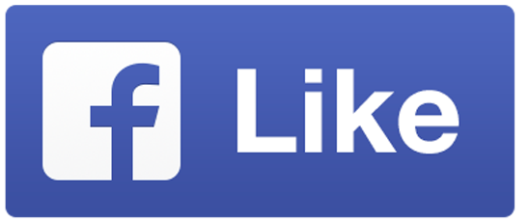

September 7th Library Closed (Labor Day)

October 12th Post Office Closed (Columbus Day)

November 11th Post Office Closed (Veterans Day)

November 26th & 27th Library Closed (Thanksgiving)

December 24th & 25th Library Closed (Christmas Eve & Christmas Day)

December 31st & January 1st, 2016
Library Closed (New Year’s Eve & Day)
Wisconsin Talking Book and  Braille Library  813 W. Wells St.  Milwaukee, WI 53233-1436 |  | FREE MATTER FOR THE BLIND OR HANDICAPPED

