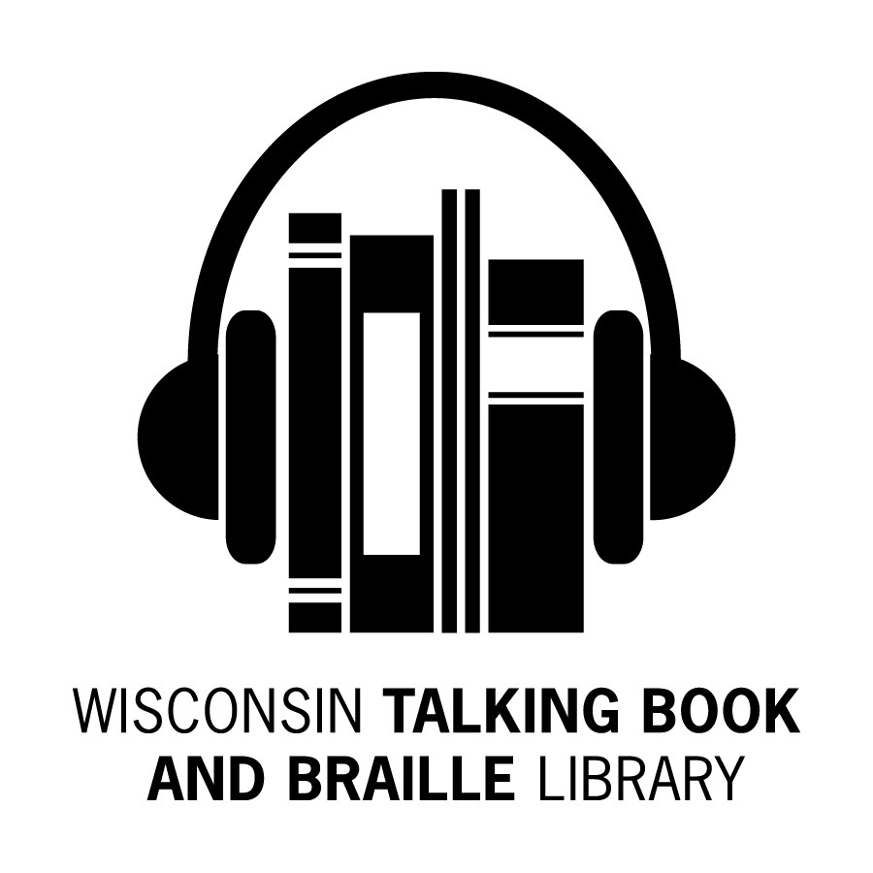
Bulletin Board Newsletter

Winter 2015

What’s Been Happening at the WTBBL!

Hello Readers!

We hope you’ve all been warm, safe and comfortable during Wisconsin’s early winter weather events.

Recently, we congratulated Emme, our Office Assistant, on her promotional transfer to the Assessor’s Office. Most likely, you will talk to a new Office Assistant on the phone by the time you receive this newsletter.

We’d like to thank the 745 respondents (10.9% of our patrons!) that completed WTBBL’s Customer Satisfaction Survey. Three respondents were selected at random to win either an umbrella or a handheld magnifier. The winners were Paul S. of Pewaukee, Luther W. of Milwaukee, and Russel S. of Oshkosh.

Some statistics from the survey:

- 67.9% rated WTBBL’s service as excellent

- 28.9% have used WTBBL services for more than 10 years

- 44.4% were referred to WTBBL by a professional
- 29.7% were referred to WTBBL by a friend or family member

Here are some survey comments:

“DELIGHTED WITH BOOK PROGRAM; MY HOUSEWORK GOES TO POT WHEN I'M LISTENING.”

“I GUESS I ALWAYS KNEW YOU EXISTED AND WHEN I BECAME DISABLED IT WAS THE FIRST THING I DID. I JUST COULDN'T GO WITHOUT BOOKS!!!”

“YOU'RE DOING A SUPER JOB - IT'S BEEN A LIFE SAVER!!!”

“I HAVE USED THE LIBRARY FOR 50 YEARS.”

“I HAVE BEEN SO THOROUGHLY ENTHRALLED WITH THE SERVICE! I AM WELL SATISFIED!”

“BEST THING I EVER HEARD ABOUT.”

“I AM VERY PLEASED WITH YOUR SERVICES. TALKING BOOKS ARE MY BIGGEST SOURCE OF ENTERTAINMENT!”

Referrals are the primary way people learn of our service. Keep reading and talking about us to your friends,

Linda

BARD App Update

Some improvements were made on the Apple BARD app. These improvements include a sleep timer, an auto lock, wish list add and wish list delete features, better support for iOS 7, and improvements to braille.

The Android app is expected in early 2015. The release was delayed due to issues with braille support.

What is BARD?

BARD stands for Braille and Audio Reading Download. The NLS BARD service allows Talking Book Library patrons to download (through use of a computer or iOS device) digital audio and web-braille books and magazines. As of 11/21/2014, there are 58,714 books in BARD, including over 11,000 in a braille readable format with a specialized computerized device. The more than 40,000 digital books and over 50 magazines available from this site are all available via digital cartridge from WTBBL, even when listed on the catalog as download only. Please check our website talkingbooks.wi.gov or give us a call if you need more information about BARD.

NLS Music Materials

WTBBL patrons may borrow music scores, books about music, and instructional music recordings from the Music Section of the National Library Service. The collection covers both classical and popular music. The Music Section does not provide music that is only for listening. You may contact your local public library to check out CDs.

The NLS Music Section does have braille books, web-braille music and books, large print music, and recordings of music instruction that include music appreciation lectures, interviews, rehearsals, and self-instruction. Music magazines are also available by subscription.

Check out the NLS Music Section’s blog, NLS Music Notes, at
blogs.loc.gov/nls-music-notes
for posts of new titles added to the collection, interviews and articles about blind and low vision musicians, and information about current music events.

To register for the NLS Music Section, contact the music librarians by calling
1-800-424-8567 or by emailing nlsm@loc.gov.

Overdue Notices and Loan Periods

If you have received overdue notices from WTBBL, please contact us. We are happy to go over your account with you. We can increase or decrease the number of books you receive throughout the year, if you like.

Digital and braille books can be checked out for two months and can be renewed once, for an additional two months.
DVDs and VHS tapes can be checked out for one month, no renewals allowed.

New Wisconsin Titles Available

ABLE (Audio Braille and Literacy Enhancement) has produced more Wisconsin books for patrons to listen to. Here are the recent additions:

• DBW09398 Third Down and a War to Go by Terry Frei
- As the first year of U.S. involvement in World War II was winding down, the Badgers climbed their way up the rankings and ultimately became one of the greatest college football teams of all time.
• DBW09403 Shotgun Lovesongs: A Novel by Nickolas Butler
- In rural Wisconsin, four men and one woman renegotiate the meaning of friendship, love and home.
• DBW09405 Unintimidated: A Governor’s Story and a Nation’s Challenge by Scott Walker
- WI Governor’s telling of the fight with public-sector unions for control of the state's financial future.
• DBW09410 The Wisconsin Road Guide to Gangster Hot Spots by Chad Lewis
- Retelling stories of 1930’s Chicago gangsters in Northern WI.
• DBW09420 My Last Step Backward by Tasha Schuh and Jan Pavloski
- A poignant memoir that inspires by a woman who confronts life from a state-of-the-art wheelchair. Winner of the National Rehabilitation Champion Award and Ms. Wheelchair USA 2012.
• DBW09421 It Happened in

Wisconsin by Mike Bie
- From his room in a nursing
home, a man looks back on his
time playing for a Midwestern
regional baseball team during the
Depression.

Resources for Downloadable Books

In addition to BARD, there are other ways you may download books. Check out any of the following resources:

Learning Ally (Subscription fee) www.learningally.org

Internet Archive (Free)
www.archive.org

Bookshare (Subscription fee)
www.bookshare.org

Kindle Reading App for your tablet, smartphone, or computer (Free)
www.amazon.com/gp/kindle/pc

Overdrive through Wisconsin public libraries (Free)
http://dbooks.wplc.info

Project Gutenberg (Free)
www.gutenberg.org

New Library Web Catalog

Please contact us if you need your login and password to access your account on our new website.

Here are some tips and tricks for navigating the new catalog website found at webopac.klas.com/wi1aopac

- MY ACCOUNT or SIGN IN TO PLACE REQUESTS or MANAGE YOUR ACCOUNT will bring up your PATRON RECORD

- QUICK REQUEST is the screen you need if you want to enter BOOK NUMBERS

- BROWSE will get you to some of the most recently added titles. Note that the older publication years are usually due to the titles having recently been converted from analog (cassette)

- SEARCH allows for the usual searches by author, title, or subject. Activate a particular search (Title, Author, or Subject) by using the dropdown box OR use quotation marks around an exact phrase, if you know exactly what you want (ex: “Gone Girl”)

- If the retrieval set is larger than one title, you will get a REFINE YOUR SEARCH box on the left side of the screen, with LINKS to limits such as: Recently Added, Availability, Medium, Subject or Reading Level

- Click on SEARCH near the top of the screen (in the string: Home > Search > Search Results) for a new search. Otherwise, your limits may be applying to the new search.

If you have any problems, please call the library when you are online with the new website and we will walk you through your query.

WTBBL Outreach

In 2014, WTBBL exhibited at resource fairs, conventions, conferences and veterans’ events and provided speakers for events at schools, libraries, support groups, nursing homes, senior centers, and libraries.

Linda Vincent, Management Librarian, attended the Wisconsin Library Association Conference in Wisconsin Dells while our Outreach Librarian, Becky Manz, had an exhibit booth. Linda and Becky spoke with many librarians from around the state about how WTBBL can benefit readers.

You may have seen us in the fall at conferences for groups such as the Wisconsin Adult Day Services Association, Fond du Lac County’s Professional and Family Caregivers, and the Saving Sight Symposium. We reached almost 22,000 people through our outreach in 2014.

If you would like WTBBL to provide a speaker at your support group or facility; to exhibit at your event; or be represented in a resource guide, please contact us.
Cassette Books and Players

The National Library Service is working on digitizing all books in the collection and is phasing out cassettes. The collection we have in digital far surpasses the cassette in both quality and quantity.

Please feel free to return your cassette player if you are no longer using it. We would be happy to send you a box to return it, if you no longer have the original box.

Biographies of Intriguing People

- DB073667 Franklin and Eleanor: An Extraordinary Marriage by Hazel Rowley

- DB071334 High Society: The Life of Grace Kelly by Donald Spoto

- DB072292 Lips Unsealed: A Memoir by Belinda Carlisle

- DB075263 The Man Who Sold the World: David Bowie and the 1970s by Peter Doggett

- DB076396 Steve Jobs: The Man Who Thought Different by Karen Blumenthal

- DB072283 Paul Harvey’s America: The Life, Art, and Faith of a Man Who Transformed Radio and Inspired a Nation by Stephen Mansfield and David A. Holland

- DB075661 Who I Am: A Memoir by Pete Townshend

- DB073080 The Genius and the Goddess: Arthur Miller and Marilyn Monroe by Jeffrey Meyers

- DB071424 Furious Love: Elizabeth Taylor, Richard Burton, and the Marriage of the Century by Sam Kashner and Nancy Schoenberger

- DB069075 Paul Newman: A Life by Shawn Levy

Orbit iBill Currency Reader

The National Library Service has partnered with the Federal Bureau of Engraving and Printing to distribute the Orbit iBill currency reader for free to blind and visually impaired individuals.

The currency reader is about the size of a credit card and uses one AAA battery. Slide the corner of the bill into a slot on the reader to have the bill scanned. Within seconds the denomination is announced. It will identify U.S. $1 through $100 bills in voice, tone, or vibration modes.

You may preorder a currency reader at this time and we will mail it to you in early 2015. Please contact WTBBL if you are interested in the currency reader.

WTBBL on Facebook
WTBBL now has a Facebook page to share news, photos, reviews, and updates about the library. Log into Facebook, find Wisconsin Talking Book and Braille Library and like us today!
Top Ten Circulating Books of 2014

- DB075615 Killing Kennedy: The End of Camelot by Bill O’Reilly

- DB075955 Kinsey and Me: Stories by Sue Grafton

- DB075192 The Light Between Oceans by M. L. Stedman

- DB077815 Takedown Twenty: A Stephanie Plum Novel by Janet Evanovich

- DB075855 Angels at the Table: A Shirley, Goodness, and Mercy Christmas Story by Debbie Macomber

- DB077346 Never Go Back: A Jack Reacher Novel by Lee Child

- DB074858 The Road to Grace: The Third Journal of the Walk Series by Richard Paul Evans

- DB076700 Best Kept Secret: The Clifton Chronicles, Volume 3 by Jeffrey Archer

- DB075093 Porch Lights by Dorothea Benton Frank

- DB076517 12th of Never by James
Patterson
What to Read Next?

You can always contact WTBBL for recommendations of new authors or series that you may enjoy. Otherwise, here are some websites that can help you find new books to read.

- Fantastic Fiction
www.fantasticfiction.co.uk

- Gnooks
www.gnooks.com

- Your Next Read

www.yournextread.com/us

- What Should I Read Next?
www.whatshouldireadnext.com

- Oprah’s Book Club: The Complete List
static.oprah.com/pdf/obc-complete-list.pdf

- LitLovers
www.litlovers.com

- Goodreads
www.goodreads.com

- Whichbook
www.openingthebook.com/whichbook

Tools and Tidbits

- If you want to start your completed book over without rewinding the cartridge, you can press the Play button twice. Do this after you hear “End of book” and it will start over.

- You can listen to old time radio programs for free through the Old Time Radio Researchers Library at www.otrrlibrary.org

- EyeNote is a free app for the iPhone, iPod, and iPad 2 that can identify U.S. paper currency. This is a great tool for the blind or visually impaired. Monetary amounts can be spoken or identified through vibrations or audible tones.

- The KNFB Reader app is now available for the iPhone, iPad, and iPod touch. This app benefits the blind, visually impaired, and print disabled users. You can snap a picture of documents of a variety of sizes, and it will save, store, and allow you to share the document with others. The app supports 13 languages at this time. The app costs $100. An Android version is in development.

- For a list of free/low cost assistive technology, check out
ods.keene.edu/index.html

Holiday & Post Office Closings

Please note even if WTBBL is open, some days the Postal Service is on holiday. Request your books a week before the holiday to make sure you have plenty to listen to over the holidays.

January 1st Library Closed (New Year’s Day)

January 19th Library Closed (Martin Luther King, Jr. Day)

February 16th Post Office Closed (Washington’s Birthday)

April 3rd Library Closed (Good Friday)

May 25th Library Closed (Memorial Day)

July 3rd Library Closed (Independence Day)

September 7th Library Closed (Labor Day)

October 12th Post Office Closed (Columbus Day)

November 11th Post Office Closed (Veterans Day)

November 26th & 27th Library Closed (Thanksgiving)

December 24th & 25th Library Closed (Christmas Eve and Christmas Day)

December 31st & January 1st, 2016
Library Closed (New Year’s Eve and New Year’s Day)
Wisconsin Talking Book and  Braille Library  813 W. Wells St.  Milwaukee, WI 53233-1436 |  | FREE MATTER FOR THE BLIND OR HANDICAPPED
BULLETIN BOARD is available in large print, braille and audio editions, and is also available electronically via email and through NFB-NEWSLINE®, a newspaper by phone service.

Wisconsin Talking Book and Braille Library (WTBBL)
813 W. Wells Street
Milwaukee, WI 53233-1436

1-800-242-8822 (in Wisconsin)
1-414-286-3102 (FAX)
wtbbl@milwaukee.gov (email)
talkingbooks.wi.gov

