1.10.2 Engaging Families in ACP

Topic: Utilize new and existing strategies to engage families in students’ ACP processes.
Prerequisite: Lesson 1.10.1

Audience: ACP Teams

Activity Goal
ACP Prep and Planning
Utilize the relationships with students’ families and other meaningful adults to engage them in multiple aspects of academic and career planning.

Background Knowledge for the Presenter
- Administrative rule PI-26 includes the following language concerning family engagement:
The school district’s long-range Education for Employment program shall include…
(b) A process used to engage parents in academic and career planning. The process shall do all of the following:
1. Inform parents in each school year about what academic and career planning services their child receives.
2. Provide parents with multiple opportunities during each school year to participate in their child's academic and career planning.
3. Update parents throughout the school year on the progress of their child's academic and career planning.

Materials Needed
• Handout – Road Map for Family ACP Engagement 1.10.2

Time Needed: 30 minutes

Procedures

- Reflect on the relationship building strategies in lesson 1.10.1, ask participants to identify the ones they feel create the most meaningful channels of engagement. Record answers on flip charts.
- Ask participants to brainstorm ways they currently engage parents in any aspect of the educational process. Rank them in order of level of parent engagement.
- Using the handout, Using the handout, Road Map for Family ACP Engagement 1.10.2, ask participants to describe opportunities that currently exist at each grade level specific to the requirements of PI 26.
- Ask participants to identify gaps in their engagement map and how they can address them. Focus should be directed at ways to improve current processes of engagement, increase scope of engagement, or brainstorm new creative ways to engage parents and their children in academic and career planning.
- Add improved/new processes in different colored ink on the Road Map for Family ACP Engagement 1.10.2 handout.

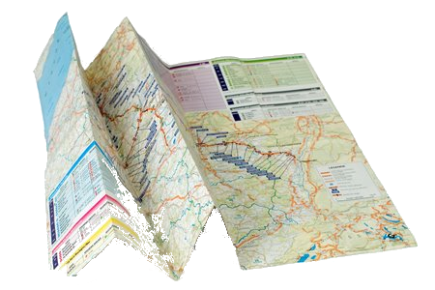
Handout 1.10.2
A Road Map for Family ACP Engagement

PI 26 Requirements
Inform parents in each school year about what Education for Employment or ACP programming services their child receives | Elementary | K  1st grade  2nd Grade  3rd Grade  4th Grade  5th Grade
 | Middle | 6th Grade  7th Grade  8th Grade
 | High | 9th Grade  10th Grade  11th Grade  12th Grade
Provide parents with multiple opportunities during each school year to participate in their child’s academic and career planning | Middle | 6th Grade  7th Grade  8th Grade
 | High | 9th Grade  10th Grade  11th Grade  12th Grade
Update parents throughout the school year on the progress of their child’s academic and career planning | Middle | 6th Grade  7th Grade  8th Grade
 | High | 9th Grade  10th Grade  11th Grade  12th Grade

