1.11 ACP as part of the Individual Education Program (IEP): Working with Students with Disabilities

Topic: How to integrate ACPs with IEPs and PTPs when working with students with disabilities
Prerequisite: None

Audience: ACP Teams/General and Special Education Staff

Activity Goal:
ACP Prep and Planning
Understand how to assist students with disabilities to participate in the ACP process and incorporate the information from their ACPs when developing annual and postschool goals for the IEP, including development of the PTP.
Background Knowledge for the Presenter
- Wisconsin has been a national leader in education because our values include the importance of a high-quality public education. Our vision is that all students, including those with IEPs, will graduate prepared for college and a career. This includes the promotion of a College and Career Ready IEP process (CCR IEPs).
- Students with IEPs require both the academic and functional proficiencies needed in order to demonstrate independence, self-determination, critical thinking, collaboration, leadership, creativity, responsibility, and persistence.
- CCR IEPs provide a framework for IEP teams to explore beliefs and attitudes regarding students with disabilities, build knowledge and skills in order to evaluate and plan special education services, and examine systems and practices which support students, families, and educators.

- CCR IEP Five Beliefs
- High Expectations
2) Culturally Responsive Practices
3) Student Relationships
4) Family &Community Engagement
5) Collective Responsibility

- CCR IEP Five Step Process
1) Understand Achievement
2) Identify Effect of Disability
3) Develop Goals
4) Align Services
5) Analyze Progress
- DPI has resources to support the implementation of CCR IEPs available on our website:
https://dpi.wi.gov/sped/college-and-career-ready-ieps/resources

- In Wisconsin, IEPs for students with disabilities aged 14 and above must include an appropriate Postsecondary Transition Plan (PTP). The PTP in Wisconsin is an on-line application designed to meet all special education requirements that teachers use with students to ensure the transition plan portion of the IEP is in place. The PTP must contain measurable postsecondary goals in the areas of education and training and employment that are updated each year based on an age-appropriate transition assessment. Transition planning includes having the student identify their strengths, interests, needs, and skills (PINS). There is PTP page on the DPI website, including a demo that anyone can use to learn about the PTP:
https://dpi.wi.gov/sped/about/state-performance-plan/indicators/13-transition
https://apps4.dpi.wi.gov/PTPDemo/Pages/DistrictMenu.aspx

- The ACP process is a part of the annual age-appropriate transition assessment for students with disabilities. Beginning in the 2017-18 school year, the transition assessment section of the PTP includes a prompt for the IEP team to review contents of the ACP for the student as part of the transition plan development. A crosswalk of requirements for both ACP and the PTP is posted on the DPI website:
https://dpi.wi.gov/sites/default/files/imce/acp/conference/SpecEd-ACP-IEP%20PTP%20Legal%20Requirements%20Crosswalk.pdf

- The PTP also includes the student’s course of study and the transition services that will be provided to the student to support movement toward postschool goals. There are six categories of transition services including, 1) job exploration, 2) work-based learning, 3) postsecondary education planning, 4) work readiness skills for home, 5) work readiness skills for community, and 6) self-advocacy instruction. The ACP process is listed as an actual transition service in the first category of job exploration. The full list of transition service options listed in the PTP can be found at: https://dpi.wi.gov/sites/default/files/imce/sped/pdf/tran-ptp-transition-services.pdf

- The bottom line is that students with IEPs have the same goals as all other students to prepare for the future as they go through school. Teachers and other school staff working with students to engage in the process of academic career planning should talk to the student’s special education case manager to understand the support strategies that will be helpful to the student. Some students with disabilities may need just a little extra help, such as a quiet space or more time, to complete ACP activities. Others might need more intensive support, such as reading questions, explaining options, and finding visuals to represent the meaning of information about certain jobs and colleges. Two resources helpful for understanding postschool goals in the areas of education and employment are available at:
https://www.witig.org/wstidata/resources/postsecondary-education-english-fillable_1409758548.pdf
https://www.witig.org/wstidata/resources/employment-english-fillable_1409758463.pdf

- The most important people in the ACP process are the student with the disability her/himself and family members. The activities offered at the end of this lesson support self-direction and self-determination in the ACP and transition planning processes. Two good resources for understanding the connection between self-determination and accomplishing postschool goals can be accessed at:
https://www.witig.org/wstidata/resources/anewwayofthinking-web_1403032065.pdf
https://www.witig.org/wstidata/resources/self-determination-english-fillable_1409758661.pdf

- A student may also have outside agencies, such as the Division of Vocational Rehabilitation (DVR) and adult service agencies involved in planning, paying for, and providing transition services. The process of seeking and obtaining outside services for transition is outlined in the following resource:
https://www.witig.org/wstidata/resources/adult-services-english-fillable_1409758339.pdf

- U.S. Department of Education has information about transition planning and services on this site: https://www2.ed.gov/about/offices/list/ocr/transitionguide.html

- By the end of this lesson, participants should have
  - Increased understanding of the relationship between ACP and the IEP/PTP
  - Improved understanding of legal requirements of ACP and PTP and how schools can support both
  - Increased knowledge about resources available for fostering self-direction in both the ACP and PTP processes when working with students who have disabilities

Materials Needed:
- Handout – Table of ACP Components (1.11A)
- Handout - Action Ideas to Integrate ACP and the IEP/PTP for Students with Disabilities (1.11B)
- Sample PTPs
  - Megan - https://www.witig.org/wstidata/resources/megan-medically-fragile-home-bound-ptp-example_1490206576.pdf
  - Holly - https://www.witig.org/wstidata/resources/holly-high-school-significant-disabilities-1490206401_1490631634.pdf
  - Significant Disabilities Scenarios and PTPs- https://www.witig.org/wstidata/resources/handout-ptp-and-students-with-significant-disabilities--revision-with-wioa_1490208017.pdf
- Transition-focused Lesson Plans
https://www.witig.org/wisconsins-self-directed-transition-planning-lesson-plans.html
- WiTransition Planning App and Sample Report
Link to app - https://www.witig.org/witransition-app.html
Link to sample report - https://www.dropbox.com/s/se7uhkiybf9z0mz/Helen%27s%20Sample%20App%20Plan%20%281%29.pdf?dl=0
- Self-directed Transition Planning Tool: an aid to help students and their support teams discuss employment goals:
http://www.letsgettoworkwi.org/wp-content/uploads/2015/07/LGTW-Transition-Planning-Tool-June-2015.pdf

Time Needed: 90 – 120 minutes (Can be completed in 2 sessions of 45-60 minutes versus 1 block of 1 ½ to 2 hours. If dividing this lesson into 2 sessions, complete procedures 1-3 during the first session and procedures 4-6 during the second).

Procedures
- Print or make PTP examples available to participants electronically. Divide into pairs or small groups with one sample each to read. Ask participants to make notes about the information contained in the PTP and how the plan is similar and different to the ACP process.

- Using handout 1.12A, Table of ACP Components, ask participants to discuss the elements of the ACP that are also reflected in the IEP/PTP then discuss the following questions in pairs or small groups:

  - Since an ACP will be developed prior to the initial PTP for a student, what portions of the ACP relate directly to the information needed for PTP development?
  - How can ACP and IEP/PTP teams work together to ensure student and family engagement in both processes?
  - What ideas do you have to make sure the ACP and IEP/PTP for a student with a disability are aligned and supporting goal setting and attainment?

- Print or make electronically available the transition-focused lesson plans using the link above. Using the scope and sequence tab within the lesson plan page, participants could have the opportunity to choose the topic or topics of greatest interest to them. Ask participants to review the content of just 1 lesson plan (divide them among the group) in pairs or small groups and discuss the following questions:

  - What does the lesson(s) have to do with student engagement in planning for the future?
  - How does the lesson(s) plan support both ACP and PTP development?
  - How will the content created by the student be reflected in her/his ACP and PTP?

- Have participants walk through the questions in the WiTransition planning app. Print or make electronically available the sample app report for Helen. In pairs or small groups discuss:

  - What relevance does use of the app have for student preparing for life after high school?
  - How is the app related to both the ACP and PTP processes?
  - How do you think the app report could be used by a student and her/his team?
  - In what ways might the app be useful for students without identified disabilities?

- Print or make electronically available the Self-directed Transition Planning Tool. In pairs or small groups, have participants review each section and discuss the following questions:

  - What portions of the tool are related to ACP?
  - What portions are related to the PTP?
  - How does the tool help engage students and family members in planning?
  - Do you think this tool would collect useful information for teachers supporting student with ACP and PTP development? If so, in what ways?
  - How does the tool support employment goal-setting?

- Using handout 1.12B, ask participants to list action ideas for engaging students with disabilities and their family members in the ACP process based on the information and resources provided.

Notes:

Action Ideas should be steps your school team can take to include students with disabilities and their family members in the process of ACP development. In addition, action steps should be designed to ensure alignment of the student’s ACP with the IEP/PTP.

Tool, Steps, People Involved: In this section of the planning form, write down what resources you will use, the ways you will use them, and who will be responsible to implement the steps. Collaboration between general and special educators is a vital aspect of including and engaging students with disabilities and their family members.
Expected Outcome: In the last column of the planning form, write down what you expect to see happen for students with disabilities as they are engaged in ACP and IEP/PTP processes. Think about how you will know if you are achieving the outcomes you expect. Plan to reconvene your team at a later date to discuss whether or not your school/district is succeeding in the objective to fully engage students with disabilities and their families in the process of planning for the future.
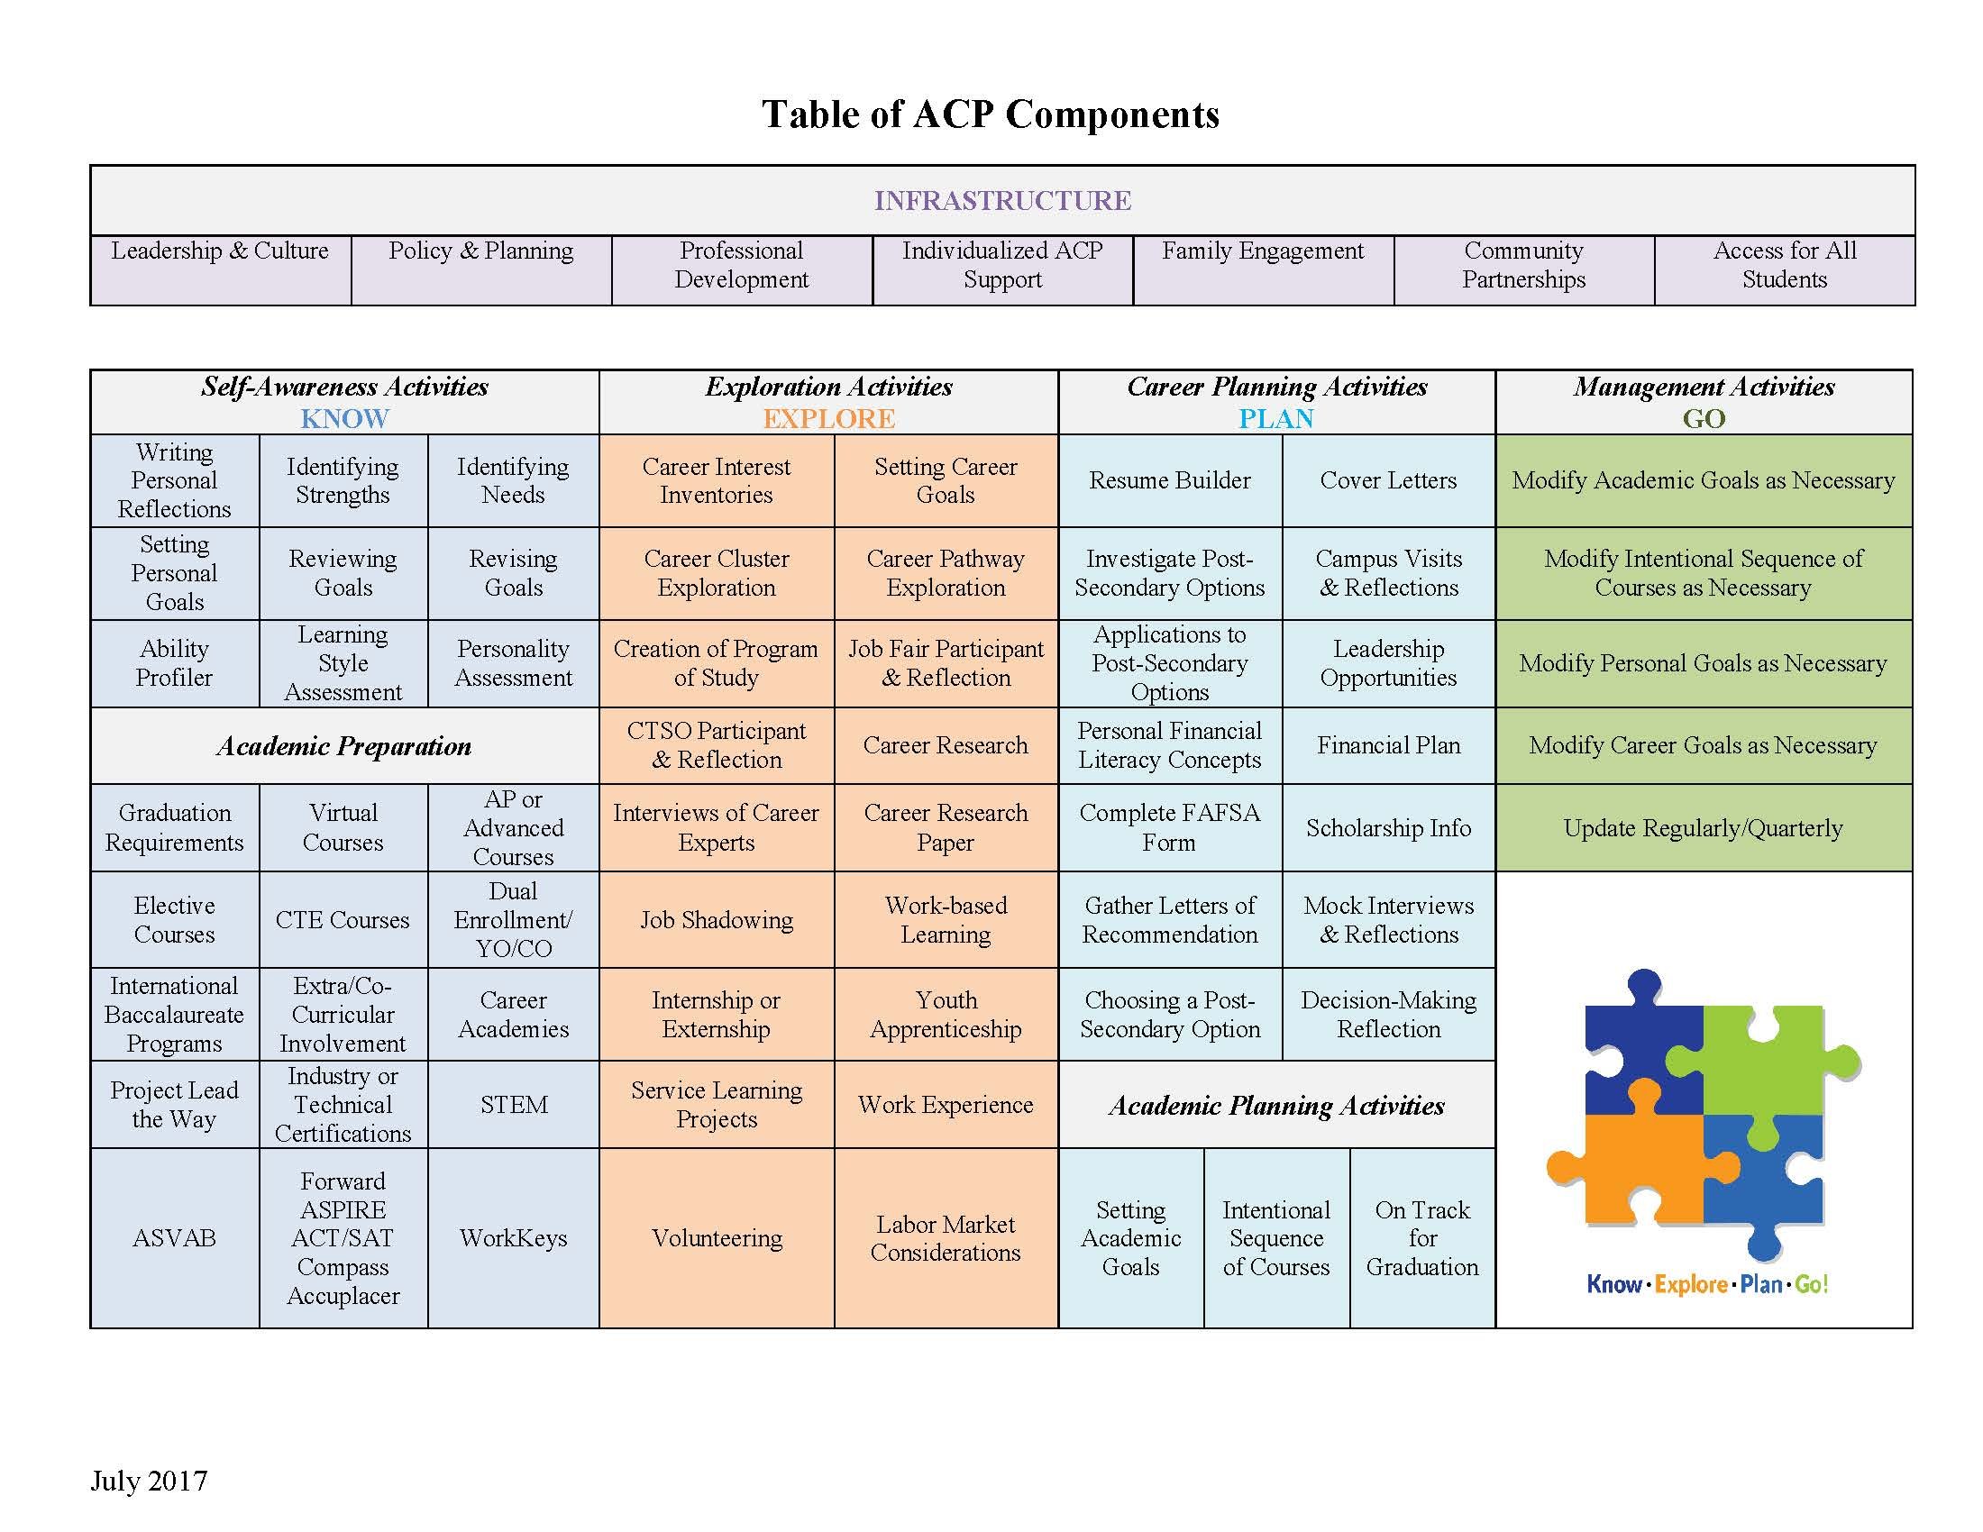
Handout 1.11A
Handout 1.11B
Action Ideas to Integrate ACP and the IEP/PTP
for Students with Disabilities

Action Idea: | Tool, Steps, People Involved: | Expected Outcome & Measurement:

