  - Mapping Your Academic and Career Journey
Topic: Mapping your ACP Timeline and Academic and Career Journey

Prerequisite: None

Audience: All Staff

Activity Goal
ACP Preparation & Planning.
Understand your academic and career journey to articulate the importance of ACP preparation and planning for students.

Background Knowledge for the Presenter
- Having a career strategy is important. It can help students manage the direction they want their career to take, the job skills and knowledge they will need, and how they can get them. The following five steps will aid an individual in planning for their future: http://careers.vic.gov.au/exploration/a-fair-workplace
- Step 1: Self-assessment helps students understand their personal and career goals, their interests, preferences, strengths and weaknesses.
- Step 2: Consider their career options and identify which available roles fit their interests and abilities.
- Step 3: Decide on their career goals.
- Step 4: Develop and implement a career strategy.
- Step 5: Review and adjust their career strategy.

- When facilitating career development, the University of California, Berkley Counseling and Psychological Services Department suggests that having a clear vision of our end goal is the key factor in accomplishing any goals that we set. The student’s vision is a “picture” of what they aspire to – and what inspires them – in their work life. Articulating their vision statement for their career is the first step in helping them eventually reach their career goals.

- As participants complete the ACP Timeline and Journey activities below, the presenter may want to suggest more questions to promote visioning, encourage deep thinking, and assist in creative thinking. http://hr.berkeley.edu/development/career-development/goal-setting/career-plan-vision
- How do you define career success? Are you achieving some level of success in your current job? What job will help you achieve complete success?
- What would you want to do today if all your bills were paid and you had relatively unlimited cash reserves?

- What would you like others to say about your career accomplishments and the types of impacts you left with the people you worked with?
- What would your career be like if you had the power to make it any way you wanted?
- If absolutely no obstacles stood in the way, what would you most like to attain in your career?
- Who are the people you most admire? What is it about them or their careers that attract you to them? Is there something about what they have or do that you want for your career vision?
- Imagine yourself in the future at a point in which you have achieved great career success. What is it that you have accomplished? What does your life look like?
- Do you feel as though you have a gift or calling? How can you share this gift, or best answer the call in a way that will fulfill you?
- What’s the one activity you most love? Is it part of your career? If not, how can you make it part of your career?

Materials Needed
• Handout My Academic and Career Planning (ACP) Timeline (1.1A)
• Handout My Academic and Career Journey (1.1B)
• Video – The Four Year Plan https://www.youtube.com/watch?v=ZIRdST_Dc0M

Time Needed: 30-45 minutes

Procedures

- Begin the activity asking the question, “What did you want to be when you were in 7th grade?” Tell participants to consider “why or why are they not” what they said they would be in 7th grade- as you transition to the next step.

- Ask participants to illustrate a timeline on the handout My Academic and Career Planning Timeline (1.1A) of their academic and career journey. The timeline should answer the question: “How did you get to where you are today?” Things to think about: important activities, significant milestones, path-changing events, mentors or important adults, etc. Ask participants to share this with the person next to them.

- Using handout Your Academic and Career Journey (1.1B), ask participants: where you stumbled or took a “fork in the road.” If you could do it over, what would you have changed? Who did you lean on for advice along the way? Who do you still lean on for career advice? Was there a point in your journey when you could have benefited from the advice of others, or in researching a plan to implement? What advice would you have given your younger self? Were there academic and career planning services that you wish you would have received when you were in middle or high school? Ask participants to share with a partner.

- Show the video The Four Year Plan - https://www.youtube.com/watch?v=ZIRdST_Dc0M

- After the video, ask participants if they have experienced a similar conversation with someone they know, or with their child. Is there a difference between students who intentionally follow the carefree path of the student in the video, and with those who end up in similar situations by accident or lack of though/planning? Ask participants to share their thoughts in a small group.
  - NOTE: While the video is humorous, it is not meant to imply that students who go to ‘university’ without a plan are ‘wrong’. Rather use it to generate discussion on implications of no plan.

- Ask participants: As an educator, if you were to mentor a student like the young adult in the video, what would you tell them?

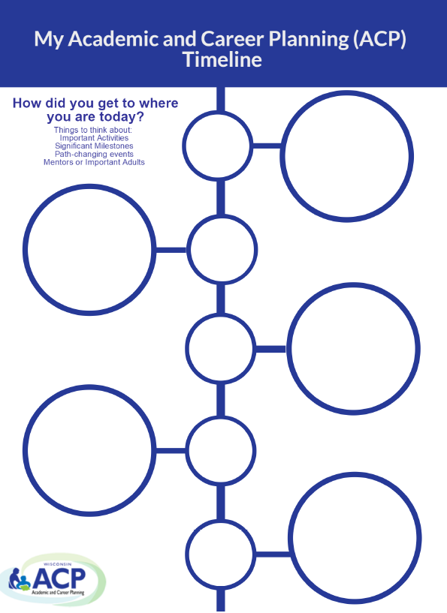
Handout 1.1A
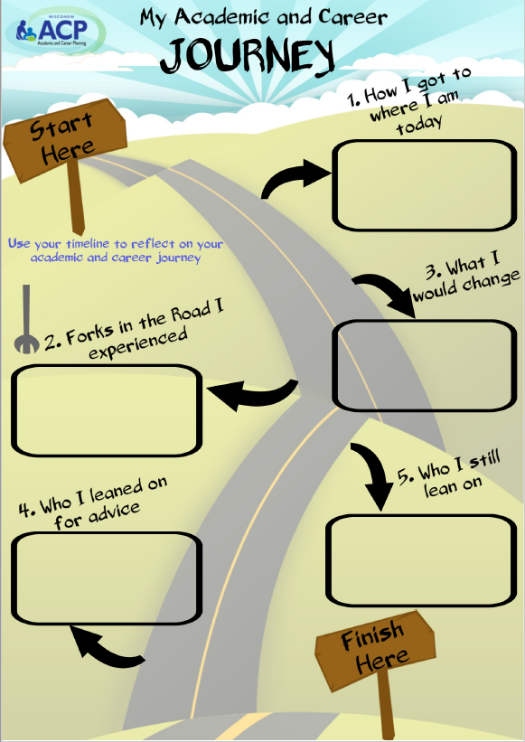
Handout 1.1B

