CESA ACP Coordinator Contacts
Cesa Partners are designated by DPI to lead local collaboration on assistance for ACP Implementation, including connections to other educational and collaborative programming

CESA | Designee | E-mail | Phone Number
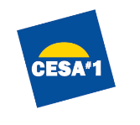 | Kathy Eidsmoe | keidsmoe@cesa1.k12.wi.us | 262-787-9500
 | Julee Derdske | Julee.dredske@cesa2.org | 608-566-3460
 | Deb Goold | dgoold@cesa3.org | 608-822-2147
 | Tom Martin | tmartin@cesa3.org | 608-822-2154
 | Jessica Sloan | jsloan@cesa4.org | 608-786-4848
 | Joel Mindham | mindhamj@cesa5.org | 608-745-5481
 | Heather Fish | fishh@cesa5.org | 608-745-5490
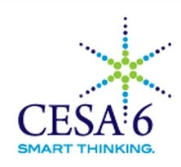 | Tania Kilpatrick | tkilpatrick@cesa6.org | 920-236-0531
 | Kari Mueller | kmueller@cesa6.org | 920-236-0580
 | Michelle Ring-Hanson | mringhanson@cesa7.org | 920-617-5632
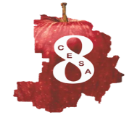 | Lynn Aprill | laprill@cesa8.org | 920-855-2114 ext. 226
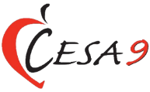 | Teri Phalin | tphalin@cesa9.org | 715-453-2141
 | John Goodman | goodman@cesa10.k12.wi.us | 715-720-2033
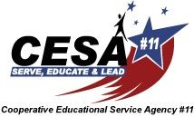 | Brenda Kretzschmar | brendak@cesa11.k12.wi.us | 715-986-2020 ext. 2117
 | Andy Eaton | andye@cesa12.org | 715-682-2363

