Course: Personal Finance OR Independent Living Course

Career Planning & Budgeting Project (500 Points Possible)

Part I: PowerPoint Slides

My Chosen Career: (50 points) _________ of 50
  - Occupation: Explain your chosen occupation and include all areas listed below in order to full credit for this section.
- My Chosen Career
  - What career cluster does your occupation fit into? (visit www.wicareerpathways.org)
  - What is your chosen occupation and why did you pick this career?
  - How is your chosen career tied to the following six areas as they pertain to YOU as an individual: interests, values, personality characteristics, aptitude, skills, and learning style?

- What This Job is All About
  - Explain the location for this line of work (big city, rural, etc.)
  - Explain in detail what this job is all about, including responsibilities of this job.
  - What specific skills are needed in order to be successful in this occupation?
  - What do you believe will be rewarding about this occupation?
  - What may be some challenges or frustrations associated with this occupation?

- Working Conditions
  - What is the typical workday like for an individual who has chosen this career?
  - Would the individual work inside or outside?
  - Would the individual work during the day or varying work shifts?
  - Would the individual work weekends or holidays?
  - Would the individual work with any specialized equipment or machinery?

- Outlook for This Career
  - Does the future look bright for this career?
  - The chart showing specific percent of growth or decline must be shown!

Skills, Training, and Education: (50 points) _________ of 50
  - Skills, Training, and Education: List specific information about the technical college, university, military training, etc. including:
- Training Facility
  - Where you went to school (or military training facility, etc.)
  - Explain why you chose this particular technical college, university, or area of the military.
  - List sample clubs or organizations you could join.
  - Be sure to add pictures to receive full credit.

- Course of Study
  - What you majored in (or perhaps major and minor) or other information, such as military training or apprenticeship studies
  - Specific course offerings (listed by semester with total credits if applicable)
  - Tuition and/or Training Fees
  - What is the cost of training for this occupation, if applicable? (Example: Tuition if you are attending a technical school or university or apprenticeship fees if you are going that route.)
  - If you are pursuing a post-secondary degree, you must accurately show the total cost of tuition on a slide; this amount will NOT include room and board.
- Attach information from the training facility (technical school, university, or military site) listing the specific courses or training you will need to reach your occupational goals.
- Attach information regarding tuition and fees associated with the training if applicable.

Salary of this Occupation & Calculating Net Pay: (50 points) _________ of 50
  - Occupational Salary:
- List two sources on a PowerPoint slide to explain how you calculated the income for this job. One source will be www.wicareerpathways.org and other suggested sites are www.salary.com, (which allows you to enter job title and zip code) or www.indeed.com. Be careful choosing the amount of pay and remember that you are five years out of high school.
  - Workforce—Factor in five years of occupational experience if you entered the workforce after graduating from high school.
  - Military Training—Five years experience and training and use www.todaysmilitary.com
  - Technical School or Associate Degree—Factor in the number years you would have worked after receiving your degree.
  - Bachelor’s Degree—Factor in one or fewer years of experience.
- Attach the printout from www.wicareerpathways.org justifying your annual income.
- Attach a printout from your second source showing the annual income for your chosen job.
- Attach a printout indicating the growth or decline % for the job outlook.

  - Net Pay: (Refer to the next page for a print screen illustration of this site).
- Website: Log onto www.paycheckcity.com and select “Salary” link
- Tax Year: 2019 and the state is Wisconsin (even if you’ll be residing in another state)
- Annual Income: (As determined two sources & previously agreed upon with instructor)
- Pay Frequency: Monthly
- Filing Status: Single and one exemption for federal and state (do not round withholding)
- Voluntary Deductions: Each of the following deductions will be exempt from Federal, FICA, and State. You MUST select each of these boxes for the deductions!
  - Deduction #1: According to the benchmark 2016 Employer Health Benefits Survey released in 2016 by the Kaiser Family Foundation and the Health Research and Educational trust (HRET): The average annual premiums for employer-sponsored health insurance are $6,435 for single coverage and $18,142 for family coverage. The report states that of this amount the worker contribution is $94 a month or $1,129 annually for single coverage. (Family coverage is $440 per month or $5,277 annually.) Using this data, you will be responsible for $94.00 per month for a single person. Be sure you enter $94.00 as a fixed amount for your monthly health insurance deduction.
  - Deduction #2: Based on current information (American Dental Association at www.ada.org), the average dental insurance premium for a single individual is $30 per month. Assuming the employer will pay 50% of the premium, the coverage would cost $15 for the employee. Be sure you enter $15.00 as a fixed amount for your monthly dental insurance deduction.
  - Deduction #3: 401K Retirement ($75 - $200 suggested per pay month) and based on your annual income. This deduction is strongly suggested, but not required.
- Attach the printout from the www.paycheckcity.com site.
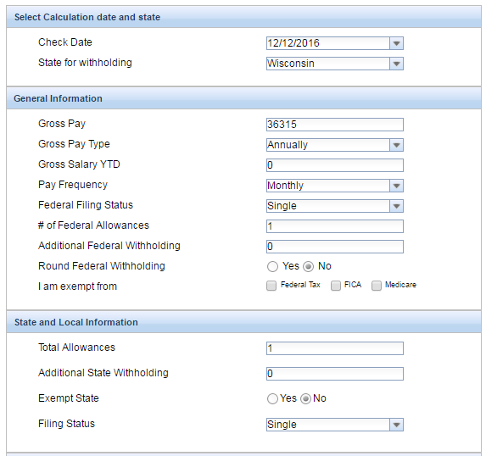
Be sure you choose Wisconsin!

$ $
What happened to my pay?

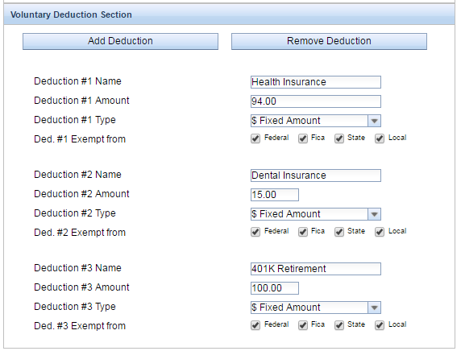
Example shows monthly net pay of $2,164.81

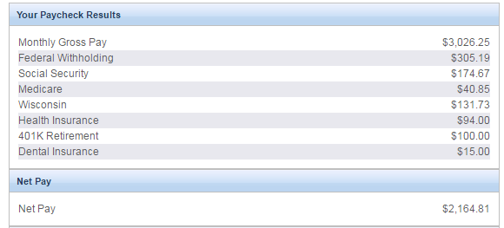
Pay Yourself First! (35 points) ________ of 35

  - Importance of Saving: Before budgeting for your fixed and flexible expenses, it is imperative you PAY YOURSELF FIRST ☺! Your goal should be 10% of your net income!
  - List the monthly contribution to your 401K retirement account if applicable.
  - Determine the amount you will place into savings on a monthly basis.
  - Illustrate how your savings (or amount transferred annually to a certificate of deposit or other form of investment) will grow. According to www.rcu.org site the current savings rate is .53% and the certificate of deposit rates are as follows: 6-month @ .85%, one-year @ 1.05%; 18-month @ 1.15%; 30-month @ 1.50%; and 4-year plus CD is currently at @ 1.75% APY.
  - List any other investment strategies (such as purchasing land) in this section.

Housing: (35 points) _________ of 35
  - My Dream Home/Apartment:
- Explanation of the dwelling of your choice and how or why you chose that particular home or apartment. Give us a virtual tour of the dwelling if possible and/or use LOTS of pictures!

- You may want to show the location of your apartment (or home) in relation to your place of work or other points of interest near the dwelling (such as parks, theatres, sports and entertainment places, shopping centers, etc.)

  - Can I Afford My Apartment (or home)?
- Renting: You must show the amount of rent as a percent of your net pay, as it cannot exceed 30% as a general rule. (Example: $500 rent / $1,800 total net pay per month = .277 or 28%)

- Amenities: Explain any amenities as well as any items are included in the rent (such as heat, sewer and water, garbage removal, etc. if anything applies.)

- Purchasing a Home: If you choose to purchase a home, you will receive extra credit if you accurately illustrate the total cost of your mortgage (including interest). When purchasing a home, the general rule (as outlined in Chapter 13 of our text) is the cost of the home should not exceed 2.5 times the amount of your gross income. This calculation needs to be shown in the PowerPoint, as well as the amount of your mortgage as a percent of your net pay.

- Property Taxes: If you are purchasing a home, you are required to budget for property taxes. In many cases the amount of property taxes will be listed on the website where you located the home. If not, please speak to me for further assistance in determining an estimated amount based on your residential area.

- Attach information regarding your apartment or home.

Insuring my Dream Home or Apartment: (5 points) _________ of 5
  - Renter’s Insurance: According to the National Association of Insurance Commissioners (www.naic.org 2016) the average cost for annual renter’s insurance policy is between $15 and $30 per month. Therefore, we will use $22.50 per month (which is the median amount in this range).

  - Homeowner’s Insurance: Based on current information from a local insurance company, please estimate property insurance coverage of .25 cents per square foot for a yearly premium.
Transportation: (35 points) _________ of 35
  - Vehicle Specifics:
- Explain the automobile of your choice and why you chose that particular auto (include pictures)
- List the following: year, make, model, mileage, special features and miles per gallon.
- Attach detailed information about your auto.

  - Vehicle Payment: (Based on fall 2016 interest rates from Royal Credit Union website)
- 2012 or newer model vehicles are: 36-month @ 1.98%; 48-month @ 2.50%; 60-month @ 2.50%; 72-month loan ($10,0000 minimum) @ 3.99%; 2008-2011 model vehicles are: 36-month @ 1.98%; 48-month @ 2.50%; 60-month @ 2.50%; 72-month ($10,000 minimum) @ 3.99% and the vehicles year 2011 and older are 24-month @ 1.98%; 36-month @ 1.98%; 48-month @ 2.98%; 60-month @ 2.98%
- Illustrate your monthly payment in the PowerPoint, which will be based on the principal borrowed, interest rate and terms of the loan. The information on the slide must also include the total cost of the auto loan after paying off your vehicle.
- Attach information from a lending institution calculating your monthly vehicle loan amount.

Vehicle Insurance: (20 points) _________ of 20
  - Vehicle Insurance:
- Vehicle insurance and coverage amounts need to be listed, including liability, comprehensive, collision, and the deductible amount you chose. Of course, don’t forget to list the monthly premium. Research and compare automobile insurance rates. Two common insurance sites are www.progressive.com and www.geico.com
  - Do NOT use your real name, Social Security number, etc.
  - DO change your date of birth so that you are five years older than you are right now.
  - DO use the city and state in which you intend to reside in for this project.
  - DO NOT use a minimum insurance coverage we discussed in class; have adequate liability.
- Attach information regarding the automobile insurance coverage quoted by a company.

All Other Expenses (100 points) ________ of 100
  - Include ALL expenses and organize the expenses in the PowerPoint as the budget spreadsheet is organized (by category) with a total for each section. This will allow the audience to follow your presentation. Refer to the budget spreadsheet sample for specific categories. Example: The “food expense” must be divided into separate categories (groceries, lunches, snacks, dining out, etc.)

  - Student Loan: If you are continuing your post-secondary education, you must list student loan as a line item—even if you are fortunate enough to pay for it all in advance or have it covered for you and that amount is zero. If you anticipate borrowing money for post-secondary education, you MUST list a monthly student loan payment. The Federal Stafford Loan has a fixed interest rate of 6.8% and the Federal PLUS loan has a fixed rate of 8.5%. Refer to the student loan article we discussed in class for additional information.

  - Medical Expenses: According to the Health Research and Educational Trust (HRET) report, forty-nine percent (58%) of covered workers with a single plan paid at least $1,000 out-of-pocket annually for the deductible before their insurance coverage plan paid toward their health care bills. Factor in both your anticipated health insurance deductible and what you may pay annually based on your current medical conditions in order to accurately budget for medical expenses.

  - Summary Slides: Include final slides listing totals per category as listed on the spreadsheet. You must also show: “Monthly Net Income LESS Total Monthly Expenses” = __________________.
Part II: Summary and Spreadsheets

Project Summary: (25 points) _________ of 25
  - Complete a typewritten summary and reflection of what you learned by completing this career and budgeting project. Be sure to include what obstacles you overcame along the way and what you gained from completing this project. This should be a thorough summary of this project!

Budget Spreadsheet: (25 points) _________ of 25
  - Attach the final budget spreadsheet (listing monthly net income, fixed expenses, and variable expenses) to the summary. This spreadsheet must be signed by a parent or guardian to receive full credit with the intent it is signed after you have discussed the individual amounts with the adult. Of course, all expenses listed on the spreadsheet must be listed on the corresponding PowerPoint and vice versa.

Debt-to-Income Spreadsheet: (20 points) _________ of 20
  - Complete the debt-to-income spreadsheet. According to www.saygoodcredit.com and other sites, the total of an individual’s debt should NOT exceed 36% of gross income.

Part III: Professionalism & Documented Sources

Overall Professionalism: (20 points) _________ of 20
  - PowerPoint was free of grammatical and spelling errors.

  - PowerPoint was professional (i.e. consistency within slides, slides were not cluttered with information, and graphics were used appropriately).

  - Sources were listed at the end of the PowerPoint.

  - Student presented to the audience in a professional manner.

Appendix of Sources: (30 points) _________ of 30
Attach the following sources IN ORDER to receive full credit:
- Attach information from the training facility (technical school, university, or military site) listing the specific courses or training you will need to reach your occupational goals.

- Attach information regarding tuition and fees associated with the training if applicable.

- Attach the printout from www.wicareerpathways.org justifying the amount of your annual income.

- Attach a printout from your second source showing the annual income for your chosen job.

- Attach a printout indicating the growth or decline % for the job outlook.

- Attach the printout from the www.paycheckcity.com site.

- Attach information regarding your apartment or home.

- Attach detailed information about your auto.

- Attach information from a lending institution calculating your monthly vehicle loan amount.

- Attach information regarding the automobile insurance coverage quoted by a company.

