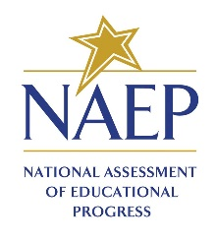
School Announcement

Templates

Initial morning announcement
Good morning, students and teachers. I am excited to announce that our school has been selected to participate in the 2021 National Assessment of Educational Progress, also known as NAEP. It is the largest continuing and nationally representative assessment of what students across the country know and can do in a variety of subjects. Some of our 4th-graders have been selected to take math and reading assessments. To those who have been selected for this important test, you have all our support, and I have NO doubt that you will represent us well! More details to follow as we move closer to our school’s assessment day. Thank you in advance for your involvement.

Morning announcement used in month leading up to NAEP assessment (possibly read once per week or biweekly)
Good morning, students and teachers. The countdown to NAEP testing is underway. We are only ___ days away from NAEP Day [on X Date] when some of our 4th-graders will sit to take this important assessment to measure our nation’s educational progress. Students and teachers if you have any questions please reach out to ____our school’s NAEP coordinator or ____our student liaison. Thank you.

Morning announcement for day of NAEP assessment
Good morning, students and teachers. NAEP Day is finally here! I would like to remind everyone that, today, some of our 4th-graders will participate in the National Assessment of Educational Progress (NAEP). Teachers, please be sure to release those students 5 minutes before the assessment is scheduled to begin. For those students who are participating, please report to your designated locations on time and bring a book to read or schoolwork in case you finish early. You are playing an important role in our nation’s ability to measure what students across the country are learning. What’s more, by taking the assessment, you are impacting the future of education for the students that follow you. Do your best and good luck. Thank you.

