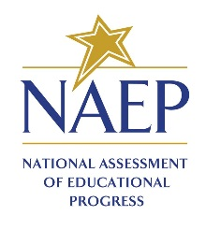
Notification Letter

For Students

Dear Student:
Congratulations! You have been selected to participate in this year’s National Assessment of Educational Progress, also known as NAEP. As a participant, your test results will be part of what’s called The Nation’s Report Card. It is the most important assessment of what students from across the country know and can do in a variety of subject areas. It is different from our state assessments because it represents students across the country, not just those here in Wisconsin.
Not every student is selected to take NAEP, but you have been chosen to represent thousands of your peers in this important assessment. Your participation will provide a snapshot of what students from across the country have learned in school, which in turn will inform major decisions about how to improve the education system in the United States. In short, it’s important that you take part and give it your best effort!
You will take a mathematics or reading assessment at [time, date, location] with other selected students. NAEP takes about 2 hours, and you don’t need to study for it. Please bring a book or schoolwork to complete in case you finish the assessment early. Upon completion of the assessment, you will receive a Certificate of Community Service. Your scores will be anonymous and will NOT affect your grades or academic record in any way.
If you have any questions or would like to review sample questions, please ask [insert name of school contact person]. He/she will be happy to help. You can also visit http://nces.ed.gov/nationsreportcard/students for more information.
We are fortunate that our school has been selected to participate in NAEP and we are excited to have you take the assessment. We know that you will do your best and help us accurately represent the achievement of our students.
Sincerely,

(School Principal)

