This home study provides information on the new CACFP Meal Pattern.
All new meal pattern changes must be implemented by October 1, 2017.
All foods that no longer meet CACFP requirements cannot count
as creditable components within your meals and snacks.

Meal Component Changes
CACFP MEAL PATTERN CHANGES
There are now 5 meal components instead of four:
Milk, meat/meat alternates, vegetables, fruits, and grains
- Fruits and Vegetables are now separate components at lunch, supper, and snack

MILK

New Requirements

A one month transition period to switch from whole milk to low fat or fat-free is allowed. You may claim reimbursement for meals served to children 24-25 months of age that include whole milk and mixtures of other unflavored milks.

1 Year Olds
- Whole unflavored milk is required
- Flavored milk cannot be served, including flavorings such as syrup or flavored milk powders

2 - 5 Year Olds
- Unflavored low-fat (1%) milk or fat-free (skim) milk is required

6 Years Old and Older
- Unflavored low-fat (1%) or fat-free (skim) milk is required
- Flavored milk must be fat-free (skim). If adding syrup or flavored milk powder, the milk must be fat-free (skim) milk only

Note: Programs with mixed age groups must serve the correct milk type for each age group:

Non-dairy Beverages
Non-dairy beverages served for non-medical, special dietary requests must be nutritionally equivalent to cow’s milk.

Ages 1 through 5: Must be unflavored

Ages 6 and older: May be unflavored or flavored

READ ME

IMPORTANT:
2% milk is NOT creditable and must not be served to participants of any age

Breastmilk
Breastmilk may be served to children past the age of 1. You may claim reimbursement when a mother breastfeeds at your home or when expressed breastmilk is provided to the child on-site. Your program must provide all of the other required meal or snack components.

Water
Programs must offer water to participants at different times throughout the day. For very young children, this may require visual cues such as showing the cup or pitcher while offering the water.
- Water is not part of a reimbursable meal, and it cannot be served in place of milk.

MEAT/MEAT ALTERNATE (M/MA)

Meat or meat alternates may substitute the entire grains component at breakfast a maximum of three times per week.
One ounce of M/MA will credit as 1 serving of grains

See the chart below for M/MA ideas you can serve at breakfast and the required minimum serving size of the foods for each age group.

 | Ages 1- 2 years  and 3-5 years | Ages 6-12 years and 13-18 years
Minimum amount of M/MA required at breakfast | ½ ounce equivalent | 1 ounce equivalent
Beans | 1/8 cup | 1/4 cup
Cheese | 1/2 ounce | 1 ounce
Cottage or ricotta cheese | 1 oz. (1/8 cup) | 2 oz. (1/4 cup)
Eggs | 1/4 large egg | 1/2 large egg
Lean meat, poultry or fish | 1/2 oz. | 1 oz.
Nut butters | 1 Tablespoon | 2 Tablespoons
Tofu, firm/extra firm | 1.1 oz. (1/8 cup) | 2.2 oz. (1/4 cup)
Yogurt (regular and soy) | 2 oz. (1/4 cup) | 4 oz. (1/2 cup)
PROCESSED MEATS

NOT REIMBURSABLE:
- Bacon, imitation bacon products and salt pork

REIMBURSABLE:
- Items labeled ‘fresh pork sausage’ or ‘fresh Italian sausage” may be credited (see page 1-45 of the Food Buying Guide)
- Turkey bacon and sausage products must have a CN label or Product Formulation Statement

Tofu is now creditable as a meat alternate. It is only creditable for children ages 1 and older. It cannot be served to infants as part of a reimbursable meal.
Tofu

Crediting Tofu:
- Must be commercially prepared
- 2.2 oz. (1/4 cup) of tofu, containing at least 5 g of protein = 1.0 oz. M/MA
- Must be easily recognized as a meat substitute. For example, tofu noodles are perceived as a grain; therefore are not creditable as a meat alternate.
- Meat substitute products made from tofu, such as links, sausages, crumbles, patties, soy burgers, chik patty, etc., require a Child Nutrition (CN) Label or product formulation statement (PFS) to verify the food item contains the minimum protein requirement
Creditable Examples | Non Creditable Examples
Tofu (such as silken, soft, firm, and extra firm) | Tempeh, seitan, and soy cheese (no standard of identity)
Chunks of tofu in casseroles, stir fry or omelets | Tofu incorporated into drinks, such as smoothies, or other dishes to add texture

Yogurt

New Requirement

Only looking at the amount of sugar on the nutrition facts label will not determine if the yogurt is creditable. You must look at the serving size and Total Sugars.

Yogurt must contain no more than 23 grams of total sugars per 6 ounces.

There are two methods for determining if the yogurt meets the sugar limit:
- Sugar limits chart
- Sugar calculation

Choose one method to determine the sugar amount.
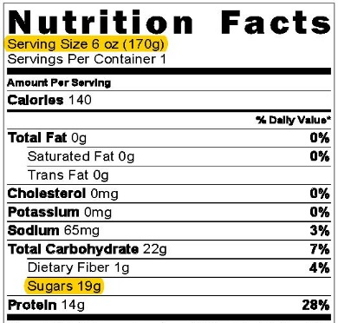
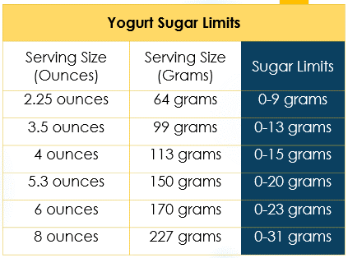
Sugar Limits Chart

Step 1: Find the Nutrition Facts Label on the package

Step 2: Identify the Serving Size

Step 3: Find the amount of Sugars

Step 4: Find the serving size in the chart to see if sugar is within limits
See following example

Example: Sugar Limit Chart - Serving Size in Ounces
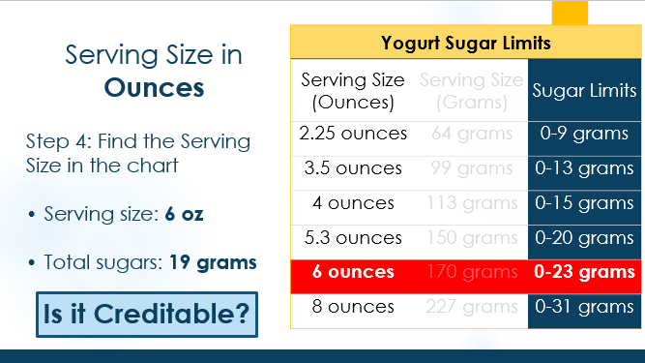
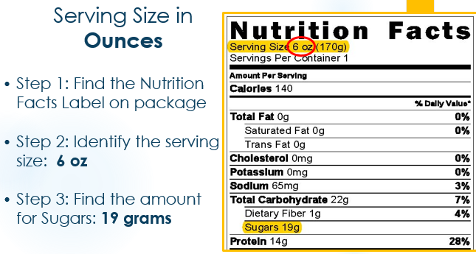
NOTE: Use same steps below when yogurt serving size is in grams & use the Serving Size (Grams) column.
- The yogurt is creditable because 19 grams is between 0-23 grams
Sugar Calculation
When a yogurt’s Nutrition Facts Label lists a serving size not on the Sugar Limits Chart, you must do a calculation to determine if it is within the sugar limits threshold:
If number is equal to or less than the threshold below, the yogurt is creditable:
- Ounces: 3.83
- Grams: 0.135

- Find the Nutrition Facts Label on the package
- Divide the grams of Sugars by the Serving Size in grams or ounces

Example: Sugar Calculation - Serving Size in Ounces
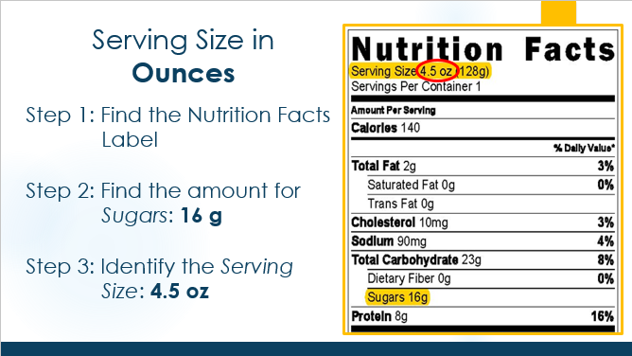
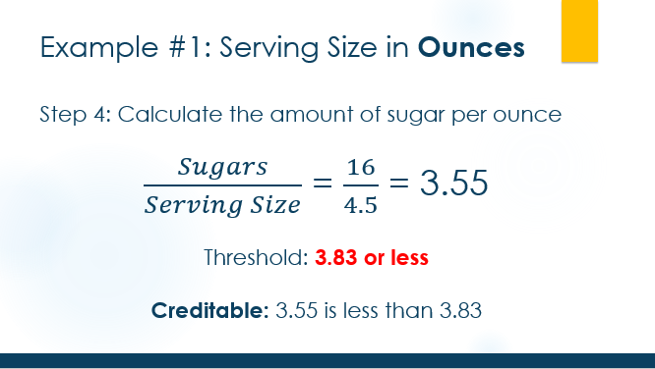
NOTE: Use same steps below when yogurt serving size is in grams & use the Grams threshold
- The yogurt is creditable because 3.55 is less than 3.83

- When purchasing large containers of yogurt (i.e. 32oz), use the serving size on the Nutrition Facts Label, as this may be smaller, i.e. 6 or 8 oz. and compare to the Sugar Limits Chart.
Soy Yogurt is now creditable for participants 1 year and older
- 4 ounces = 1 oz. of M/MA
- No more than 23 grams of total sugars per 6 oz.

- If the Nutrition Facts Label lists “one container” as the serving size, check the front of the package to see how many ounces or grams are in the container to determine if yogurt meets the sugar limits.

Tools for Determining if Yogurt is Creditable
- USDA Resource - Yogurts: Sugar Limit Chart for most portion sizes
- Sugar in Yogurt & Cereal Handout: Sugar Limit Chart and Thresholds for ounces and grams
- Methods to determine Sugar Amounts Handout: Calculator to determine sugar limits in yogurt
FRUITS AND VEGETABLES
FRUITS AND VEGETABLES

New Requirement

Lunch & Supper
Allowed | Allowed | Not Allowed | Not Allowed
Chicken | Chicken | Chicken | Chicken
Carrots | Carrots | 2 servings of Carrots | Kiwi
Broccoli | Apples |  | Apples
WG Bun | WG Bun | WG Bun | WG Bun
1% milk | 1% milk | 1% milk | 1% milk
Fruits and vegetables are separate components at lunch, supper and snack. A vegetable is required at lunch and supper.

Separate Vegetable & Fruit Components

- Breakfast: No Change. Vegetables and fruits remain combined as one meal component.

- Lunch & Supper: Change. Vegetables and fruits are separate meal components.
Snack
Allowed | Not Allowed | Now Allowed
Kiwi | Carrots | Strawberries
Carrots | Celery | Bananas
- A vegetable and a fruit, or two different vegetables must be served. Two fruits cannot be served.

- Snack: Change. A fruit and a vegetable can be served as the two required components.
  - Items from two different components must be served, therefore, two fruits or two vegetables cannot be served.

 | Ages (years)
 | 1- 2 | 3-5 | 6-18 | Adults
Breakfast | ¼ cup | ½ cup | ½ cup | 1 cup
Lunch & Supper
Vegetables | ⅛ cup | ¼ cup | ½ cup | ½ cup
Fruits | ⅛ cup | ¼ cup | ¼ cup | ½ cup
Snacks
Vegetables | ½ cup | ½ cup | ¾ cup | ½ cup
Fruits | ½ cup | ½ cup | ¾ cup | ½ cup
Vegetable & Fruit Serving Size Requirements

The minimum serving sizes for vegetable and fruit components provided in the table must be served.

When two vegetables are served at lunch/supper, the serving size of the second vegetable must be at least the same serving size as the fruit component it replaced.
- 1 cup raw leafy greens (e.g. lettuce) = ½ cup veg
- ½ cup cooked greens = ½ cup vegetables
- ¼ cup dried fruit (e.g. raisins) = ½ cup fruit

New Requirement

Juice (vegetable or fruit) can only be served at one meal or snack per day even if meals and snacks are served to different groups of participants.

Examples:
- Your program serves different groups of children. One group only receives a breakfast and lunch, and the other group only receives a lunch and PM snack. You can only serve juice at one meal or snack that day, for example breakfast. While some of the participants will not be served breakfast, you cannot serve juice at PM snack to the other group later in the day.

- Your program serves the same menu items at multiple snacks (AM and PM snack) to different groups of children, juice may only be served at one of those snacks.

- Pureed fruits and vegetables when served in a smoothie are considered juice. This counts as serving juice once per day.

GRAINS

This section was previously called breads and grains; in the updated meal pattern this component is called Grains.
Breakfast Cereals

New Requirement

All breakfast cereals (ready-to-eat, instant, and regular hot cereal) must contain no more than 6 grams of total sugar per dry ounce.
- You cannot mix creditable cereals that meet sugar limits with non-creditable cereals that are above the sugar limits in order to meet sugar limit requirements.

Two ways to determine if a cereal meets the sugar requirements:
- Use the WIC Approved Breakfast Cereals List – all WIC cereals meet sugar limits. If cereal is on this list, it meets sugar limits and is creditable.
- If a cereal is not on the WIC approved cereal list, you must do a calculation to determine if the breakfast cereal is within the sugar limits threshold:
  - Find the Nutrition Facts Label on the cereal package
  - Divide the grams of Sugars by the Serving Size in grams
If the number is less than 0.212, the breakfast cereal is creditable.

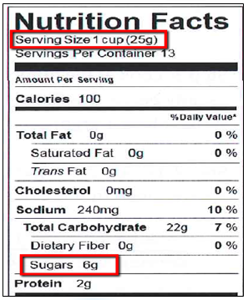
Sugar Calculation Example

This cereal is not creditable because 0.24 is more than 0.212.

At the bottom of the Sugar in Yogurt and Cereal handout is a reference of
the sugar limit threshold for cereals.

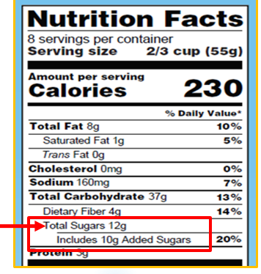
The Nutrition Facts Label will change by July 2018.
The new label includes Total Sugars and Added Sugars.
When you complete the sugar calculations (for both cereals and yogurt), use the Total Sugars amount.

Grain-Based Desserts

New Requirement

Grain-based desserts (GBD) are not creditable and cannot be served to meet the grains component.
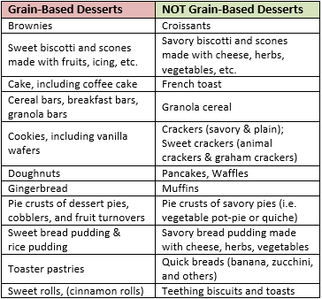
- Left column: GBDs that cannot be served
- Right column: Other grains that can be served

Store-bought Grain-Based Desserts
Some foods may not be easily identified as grain-based desserts:
- A cookie may be called a “breakfast round”
- A granola bar may be called a “breakfast bar or flat”
When searching for grains, ask,
“Is this food thought of as a grain-based dessert?”
If yes, then it is a grain-based dessert.
- Even if the item is whole grain-rich, it is still NOT creditable

Homemade Grain-Based Desserts
Even if made with healthy ingredients or less sugar, homemade GBDs, are NOT creditable.
CACFP programs cannot make these GBD recipes to credit as the grains component

Grains Chart and Food Buying Guide
The CACFP Grains Chart has been updated to not include GBDs. Be aware, the Grain/Bread Chart in the Food Buying Guide (FBG) applies to all Child Nutrition programs (NSLP, SFSP) and includes GBDs.

Whole Grain Rich (WGR) Foods

New Requirement

At least one grain per day must be whole grain-rich. This is not required for the infant meal pattern.

WGR foods are those that contain 100% whole grains, or at least 50% whole grains, and the remaining grains in the food are enriched.

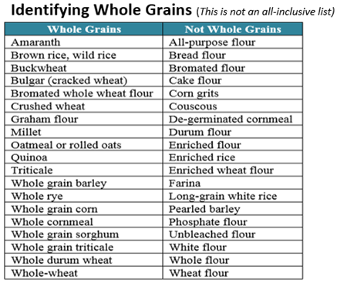
What is a whole grain?
- The word “whole” or “whole grain” is before the grain’s name:
  - Whole grain corn, whole rye, whole wheat, whole grain barley

- Grains that do not have the word “whole” before the name, but are 100% whole grain:
  - Quinoa, brown rice, wild rice, rolled oats and oatmeal, berries and groats
Examples of grains that are whole grain and not whole grain

Read the Ingredients
It is important to read the ingredients because some products may not be whole grain or creditable. The first two examples below are products that appear to be whole grain but are not. The third example is not whole grain or enriched, so it is not a creditable grain.

Not Whole Grain
Manufacturers include words on the front of the package that may seem like they are whole grain, such as multi-grain, stone-ground, bran, seven-grain, made with whole wheat or 100% wheat, but they are not 100% whole grain.
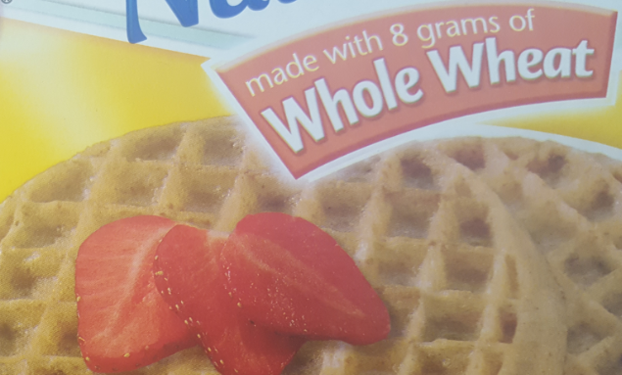
Example 1: ‘Made with 8 grams of Whole Wheat’. This product is not whole grain because:
- “Made with” does not indicate the product is 100% whole wheat
- The first grain ingredient (after water) is enriched flour – which is not whole grain

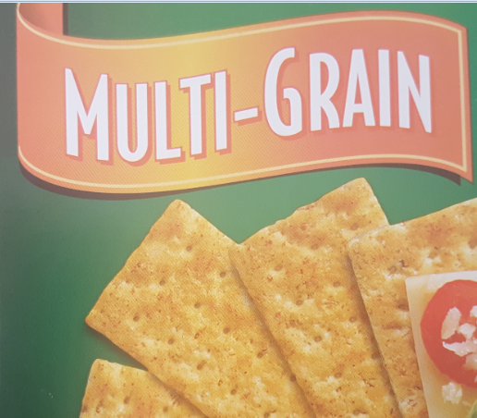
Example 2: ‘Multi-grain’. This product is not whole grain because:
- ‘Multi-Grain’ tells you there are multiple grains. The grains could be whole grains or enriched, or a combination of both
- The first grain ingredient is enriched flour – which is not whole grain
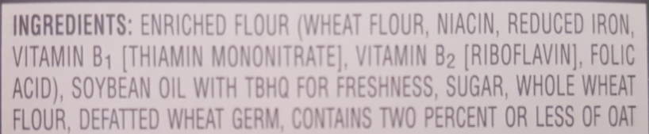

Non-Creditable Grains
To be creditable, a grain must be whole grain or enriched.

Example 3: This product is not creditable and may not be served as the grain component because:
- Durum wheat semolina is not a not whole grain
  - It does not have “whole” before its name
- It is not enriched because
  - The ingredients do not say “enriched”
  - There are no vitamins or minerals listed in the ingredients

For durum wheat to be creditable it must:
- Be “whole durum wheat” (see example)
- Say “Enriched durum wheat”
- Include vitamins or minerals in the ingredients

Determining WGR Foods

Follow the steps below to determine if a store-bought grain product is WGR:
Product label says 100% Whole Grain or 100% Whole Wheat
(Examples on the right)
OR

Product is a whole grain (brown rice, quinoa, oatmeal, etc.)
NO
YES
Product is WGR!

Read the Ingredient List:
Ingredients: Whole-wheat flour, water, enriched unbleached wheat flour, yeast, sugar, wheat gluten
A whole grain is the first ingredient or is the second ingredient, with water as the first ingredient
NO
YES
Product is WGR!

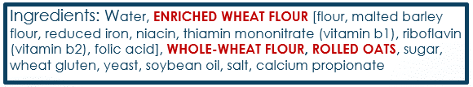
Read the Ingredient List:

An enriched grain is the first ingredient or second ingredient, with water as the first ingredient AND

There is one or no other whole grains listed lower in the ingredient list
Example
There are multiple whole grains listed lower in the ingredient list
OR

YES

YES

If the first grain ingredient is enriched, the item is creditable and may be served, but may not be counted as the WGR item because the weight of the enriched grain is more than the whole grain

Obtain a Product Formulation Statement from the manufacturer. The weight of the whole grain ingredients is 50% or more of the total grain ingredients

NO

YES
Product is WGR!

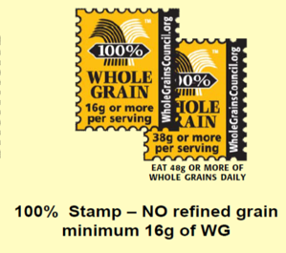
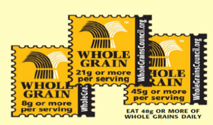
Whole Grain Stamps may not be used to determine a product as WGR. These products may contain non-enriched refined flour.

Store-bought Combination Foods (i.e. pizza, corn dogs, fish sticks, chicken nuggets, etc.)
The breading may count as the WGR item if a Child Nutrition (CN) label or Product Formulation Statement (PFS) is on file (at least until the end of the day).
- The CN label or PFS will indicate if the item is WGR or not:
- If the CN label or PFS says, “oz. equivalent grains” = WGR
- If the CN label or PFS says, “bread” or “bread alternate” = not WGR

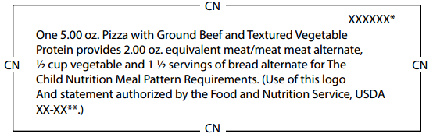
WGR
Not WGR

Homemade Items
To determine if a homemade item is WGR, look at the grains in the recipe. If 50% or more of the grains are whole grain, the item is WGR.
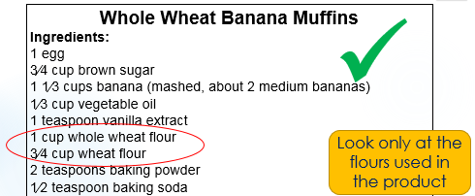
1 cup whole wheat flour = whole grain
¾ cup wheat flour = not whole grain

Look only at the grains in the product
This item is whole grain rich, because at least 50% of this product is whole grain

Menu Planning: Serving WGR Items Each Day
Each day, at least one meal or snack claimed for CACFP reimbursement must include a whole grain-rich food as the grain component. If your program:
- Only claims one meal per day (breakfast, lunch or supper) the grain must be WGR
- Only claims a snack, if one of the two components is a grain item, it must be WGR
- Claims more than one meal or snack (breakfast, lunch and snack), you may choose which meal to serve the WGR food

Store-bought combination foods: Keep the CN Labels or PFS (at least until the end of the day)

RECORDKEEPING REQUIREMENTS
Menus
Effective October 1, 2017, menu templates will be updated to reflect the new meal pattern requirements
These updates will include:
- Grains: Identification of Whole Grain Rich Foods
- Milk: Certification that the correct type of milk (whole, 1%, skim, flavored and/or unflavored) was served to the correct age group of children.

Label Documentation
Save product labels until the end of each day for your food program monitor to review with you during home visits

Retain copies of product labels (nutrition facts labels, ingredient listings, and Child Nutrition (CN) labels) for foods served to your enrolled children while in care

- Yogurt
- Breakfast Cereals (if not listed on the WIC Cereals List)
- Whole Grain Rich foods
- Tofu

- Keep recipes for home-made Whole Grain Rich items to review with your monitor during home visits.

New Requirement

COOKING METHODS

Deep-fat frying is not allowed as a method of cooking foods on-site.
DEEP-FAT FRYING:
Food is cooked by submerging in hot oil or other fat; in a deep-fat fryer or in a pan on the stove.

- On-site includes:
  - Programs that prepare its own food on-site
  - Programs that prepare its own food at a central or satellite kitchen and deliver meals to a site

Programs may continue to stir-fry, pan-fry and sauté foods.
FOODS FRIED OFF-SITE:

Store-bought Foods: Foods that are pre-fried, flash-fried, par-fried, or deep-fat fried by a commercial manufacturer may be purchased and served. These items must be reheated by a method other than deep-fat frying; i.e. baking in oven.

OPTIONAL BEST PRACTICES

Best practices reflect recommendations from the Dietary Guidelines for Americans and the National Academy of Medicine. They build on the meal pattern requirements to further improve the nutritional quality of all meals. They are optional, however, highly encouraged in order to ensure children are getting the optimal benefit from the meals served.

Best Practice: Fruits and Vegetables

Increase the total amount of vegetables and fruits served to promote consumption of more vegetables and fruits. Most Americans do not consume enough vegetables and fruits.
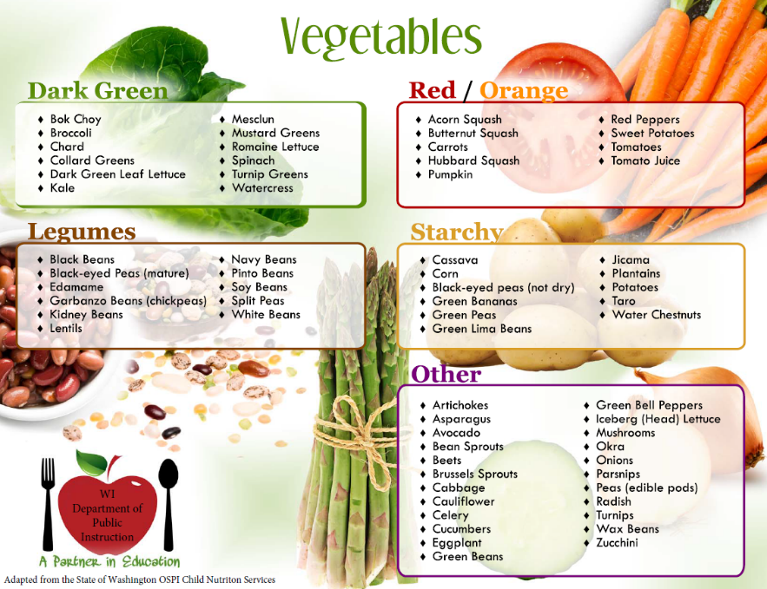
Serve at least one fruit or vegetable at snack

Serve a variety of whole fruits and vegetables (fresh, canned, frozen, or dried) in place of juice

Provide at least one serving each of the vegetable subgroups once per week

Provide at least two servings of whole grain-rich items per day to promote consumption of more whole grains. Most Americans do not consume enough whole grains.
Whole Grains

Meat & Meat Alternates

Serve only lean meats, nuts, and legumes to promote consumption of healthy proteins. Eating too many processed meats and high-fat proteins increases the risk of obesity and other health issues.
Limit Serving Pre-Fried Foods

Limit serving purchased, pre-fried foods (ex. chicken nuggets, fish sticks, corn dogs, tater tots, French fries) to no more than one serving per week.
HOMEMADE VERSIONS
- Breaded, baked chicken tenders or fish filets
- Pizza on whole grain crust with healthy toppings
- Baked potato wedges or sweet potato “fries”
- Pre-fried foods can contribute large amounts of calories and saturated fat to a meal.
Limit Serving Added Sugars

ALTERNATIVE OPTIONS
- Fruit, dried fruit or pureed fruit(s)
- Cinnamon or other spices
- Peanut butter or other nut or seed butter
- Yogurt-based dips or toppings

Avoid serving non-creditable foods that are sources of added sugars (ex. sweet toppings and mix-in ingredients).
- These foods do not add nutritional value, they increase added sugar consumption, and may encourage a taste preference for sweet foods

Seasonal & Locally Produced Foods

SOURCES OF LOCALLY GROWN FOODS

- Farms and/or Farmers’ Markets
- Community Supported Agriculture (CSA)
  - http://www.localharvest.org/csa/
- Gardens (Community, School, Center)

Incorporate seasonal and locally produced foods into meals

Participate in Farm to Early Care and Education (Farm to ECE)
- Increased access to healthy, local foods, gardening opportunities, food-based activities, and family engagement opportunities

START A GARDEN

- On a window sill in the classroom
- In a container or pot
- In a raised bed outside

Start an On-site Garden
- Kids are more likely to eat what they have grown
- Offer a setting for hands-on nutrition education, access to fresh produce, and opportunities for family engagement

CACFP INFANT MEAL PATTERN REQUIREMENTS
New Requirement

Updated infant age groups:
- Birth through 5 months
Developmentally Ready
Some infants may be ready to consume solid foods before 6 months of age and others after 6 months of age. Once an infant is developmentally ready to accept solid foods, including infants younger than 6 months, programs are required to offer them to the infant.

- 6 months through 11 months

Birth through 5 months:
Only breast milk or formula is required to be served until the infant is developmentally ready for solid foods
- Encourages exclusive breastfeeding during the infant’s first 6 months
- Helps to delay the introduction of solid foods until around 6 months when infants are developmentally ready to accept them

6 through 11 months:
- Only breast milk or formula is required to be served until the infant is developmentally ready for solid foods
- Food amounts begin with “zero” because not all infants are ready for solid foods at 6 months
  - When an infant is developmentally ready to start and eat solid foods, they must be served to the infant
  - Foods should be gradually introduced until the infant is eating a variety of foods within all required components
By 7 to 8 months of age, infants should be consuming solid foods from all food groups

New Requirement

Programs must provide ALL components, or ALL but one component, of an infant meal or snack in order to claim for reimbursement
- Parents/guardians may provide only one component of a meal or snack claimed for reimbursement

Breastmilk or Formula Only: When the infant is only consuming breastmilk or infant formula, a parent may supply expressed breastmilk, infant formula, or breastfeed on-site and the meal can be claimed.

Consuming Solid Foods:
- When the parent is supplying expressed breastmilk, infant formula, or breastfeeding on-site, the program must provide all other components in order to claim the meal.
- When the parent provides a solid food component, the program must provide all other components, including iron-fortified infant formula, in order to claim the meal.

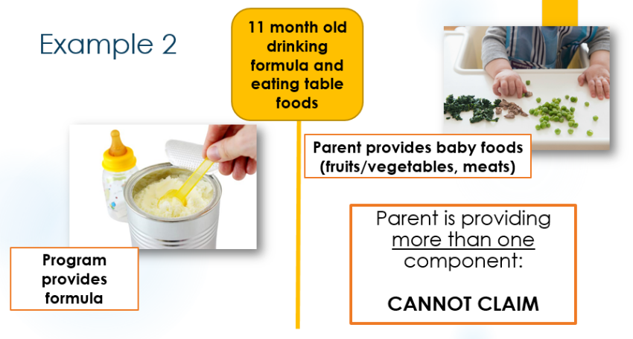
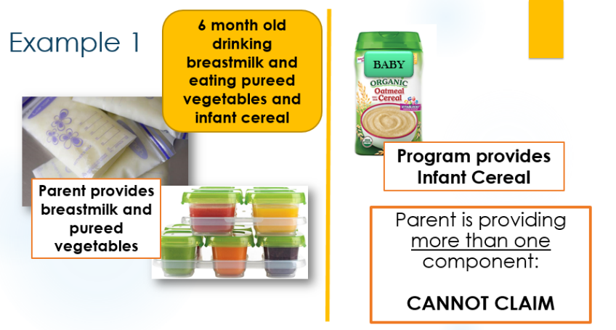
Examples of when meals/snacks cannot be claimed:

Changes to foods that can and cannot be served:
New Requirement

Breakfast
A creditable meat/meat alternate may be served in place of iron-fortified infant cereal
- Grain items (e.g. toast, pancakes, ready-to-eat cereals) cannot be served in place of iron-fortified infant cereal

Breakfast, Lunch and Supper
- Yogurt and whole eggs are creditable meat alternates. Yogurt must meet sugar limits.
- Cheese food, cheese spread, tofu and soy yogurt are not creditable

Snack
- Ready-to-eat cereals, infant puffs and iron-fortified infant cereal are creditable. Ready-to-eat cereals must meet sugar limits.
- A vegetable or fruit, or both, must be served when developmentally ready

Offering Infant Meals
All infants must be offered meals that comply with the CACFP infant meal pattern requirements. A Program may not avoid this obligation by stating that the infant is not “enrolled” in the CACFP, or by citing logistical or cost barriers to offering infant meals.

- All programs must offer a minimum of one type of Iron-Fortified Infant Formula
  - Parents may accept the type of formula you are providing, or decline and provide their own formula or breastmilk
  - Parents cannot be required to provide formula

- All programs must purchase and offer solid foods to infants
  - Parents may accept the foods you are providing, or decline and provide their own
- Parents cannot be required to provide any foods
- This applies to both age groups. Therefore, infants who start eating solid foods before 6 months of age must be offered program provided foods.
- Even if your program does not claim infant meals, formula and foods must be offered

