Questions are in the following formats:
- True/False: if false, correct the statement on the line provided
- Multiple Choice: some questions say, ‘Check all that apply’ meaning there may be more than one correct answer that needs to be circled
- Calculation: write the correct answer on the line provided

Milk

- Milk served to 1-year old children can be unflavored whole milk or unflavored fat-free milk.
  - True
  - False: Milk served to 1-year old children must be unflavored whole milk.

- If you are serving milk to a mixed age group of 1 & 2 year olds it is acceptable to serve 1% milk to all children.
  - True
  - False: The 1-year olds must be served whole milk and the 2 year olds must be served 1% or fat free.

- What type of milk can be served to children 2 years and older?
  - Skim, 1%, or 2%
  - Skim or 1%
  - 2%
  - Whole

- Flavored milk may only be served to the following age group(s):
  - Infants
  - 3-5 years
  - 6-18 years

Meat/Meat Alternate

- During the breakfast meal, programs may serve a meat/meat alternate in place of the entire grain component five times per week.
  - True
  - False: Programs may serve a meat/meat alternate in place of the entire grain component three times per week.

- Tofu and soy yogurt are creditable in the CACFP.
- True
- False: ________________________________________________________________

- Yogurt must contain no more than ____ grams of sugar per _____ ounces.
- 20 grams, 4 ounces
- 23 grams, 1 ounce
- 23 grams, 6 ounces
- 26 grams, 6 ounces

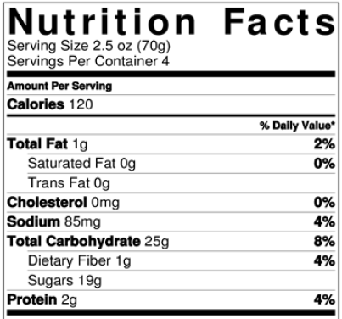
Use the Nutrition Facts Label to the right to complete the sugar calculation to determine if this yogurt meets the sugar limits.

- Write your answer here: 19 ÷ 2.5 oz. = 7.6 OR 19 ÷ 70 g = 0.271
- Ounces threshold: 3.83
- Grams threshold: 0.135

- Is this yogurt creditable?
- Yes
- No

- What documentation must you keep for yogurt until the end of the day?
- Nutrition Facts Label
- Name of item
- All of the above

- What documentation must you keep for store-bought combination foods until the end of the day (i.e. fish sticks, pizza, chicken nuggets, meatballs, ravioli)?
- Nutrition Facts Label
- Child Nutrition (CN) Label or Product Formulation Statement (PFS)
- Ingredient List
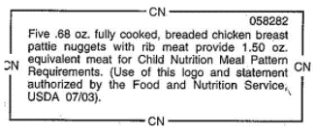
- Use the CN label to determine how much to serve to a child in each age group.
  - 1 & 2 year olds: 3.33 (4 nuggets)
  - 3-5 year olds: 5 nuggets
  - 6-18 year olds: 6.67 (7 nuggets)

Fruit and Vegetable

- A vegetable is required to be served at lunch and supper.
  - True
  - False: _____________________________________________________

- The following lunch/supper meals are claimable. Circle all that apply.
- Chicken, apples, pears, bread, milk
- Chicken, apples, carrots, bread, milk
- Chicken, broccoli, carrots, bread, milk
- Chicken, tomato soup, carrots, crackers, milk

- How many times can a CACFP program serve juice, 100% fruit or vegetable, in a single day?
  - 0 times per day
  - 1 time per day
  - 3 times per day
  - 4 times per day

- Juice may be served more than once per day if serving to different groups of participants.
  - True
  - False: Juice may be served once per day, even if serving different groups of participants.

- A claimable snack may include a fruit and a vegetable as the two components.
  - True
  - False: _______________________________________________________

Grains

- Breakfast cereals must contain no more than _____ grams of sugar per dry ounce.
  - 3
  - 5
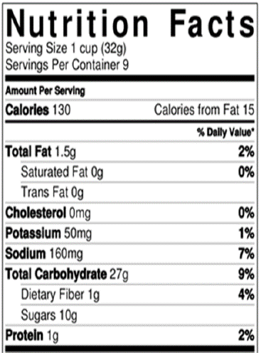
  - 6
  - 13

Use the Nutrition Facts Label to the right to complete the sugar calculation to determine if this cereal meets the sugar limits.

- Write your answer here: 10 g ÷ 32 g = 0.313
- Threshold: 0.212

- Is this cereal creditable?
- Yes
- No

- Grain-based desserts may be served at snack a max of two times per week.
  - True
  - False: Grain-based desserts cannot be served at all.

- The following are examples of grain-based desserts. Circle all that apply.
  - Cereal Bars, Granola Bars
  - Cheese Flavored Crackers, Soda Crackers
  - French Toast, Waffles
  - Muffins, Quick Breads

- Each day, at least _____ serving(s) of grains must be whole grain-rich.
  - 0
  - 1
  - 2
  - 3

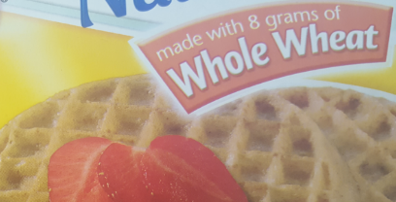
- Based on the following product packages, which items could be used as the whole grain-rich (WGR) item? Circle all that apply.

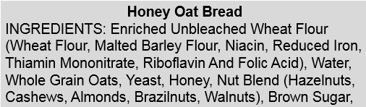
- Using the ingredients to the right, is this item WGR?
- Yes
- No: The first ingredient is Enriched Unbleached Wheat Flour which is not whole grain. There is whole grain in this product (whole grain oats), but it is the only whole grain in this product, since the whole grain oats are lower in the ingredients list; they weigh less than the enriched wheat flour and are therefore not more than 50% of the grains.
- Don’t know - need to obtain a Product Formulation Statement: If this is selected as the answer that is ok because they can request the PFS.

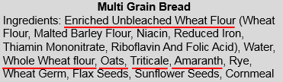
- Using the ingredients to the right, is this item WGR?
- Yes
- No
- Don’t know - need to obtain a Product Formulation Statement: The first ingredient is enriched unbleached wheat flour, then water. All the other whole grain flours listed – whole wheat, oats, triticale, and amaranth. All those whole grain flours added together may weigh more than the enriched unbleached wheat flour but we don’t know.

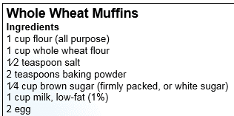
- Is this recipe WGR?
  - Yes
  - No

Cooking Methods

- Deep-fat frying cannot be used to prepare meals on-site. What is the definition of deep-fat frying? Circle all that apply.
  - Submerging foods in hot oil or other fat
  - Pan-frying in a small amount of fat
  - Stir-frying in a small amount of very hot fat

Infants

- When can a program claim an infant’s meal when the mom breastfeeds her child onsite? Circle all that apply.
  - Infant is only receiving breastmilk from mom
  - Infant is receiving breastmilk from mom and eating all program supplied foods
  - Infant is receiving breastmilk from mom and eating one or more parent supplied foods

- Once an infant is developmentally ready for and offered foods at meals, only one of the components must be supplied by the program to claim meals.
- True
- False: Programs must provide ALL components, or ALL but one component, of an infant meal or snack in order to claim for reimbursement.

- Infants who are developmentally ready for solid foods at any age must be offered program provided foods.
- True
- False: ________________________________________________________________

- The following foods are creditable in the CACFP for infants. Circle all that apply.
  - Yogurt and whole eggs
  - Cheese Food and Cheese Spread
  - Juice
  - Tofu and Soy Yogurt

- Which foods are creditable at snack for infants? Circle all that apply.
  - Iron-fortified infant cereal
  - Ready-to-eat breakfast cereals
  - Fruits and vegetables
  - Bread/Crackers

- What foods are creditable at breakfast for infants? Circle all that apply.
- Iron-fortified infant cereal
- Pancakes, waffles, toast, ready-to-eat cereal
- Eggs, yogurt, cheese
- Bananas, applesauce, sweet potatoes

- As a participant on the CACFP, even if you are not claiming infant meals, what food(s) must your program offer to all infants? Circle all that apply.
  - None, the parent can be asked to provide formula and foods
  - A minimum of one type of iron-fortified infant formula
  - Multiple types of iron-fortified infant formula
  - Iron-fortified Infant Cereal, Fruits, Vegetables, Meats, and Grains in the appropriate texture

