Provider Number: _________________ Provider Name: ________________________________________

Contact e-mail or address: ______________________________________________________________________

Directions:
- Home Sponsors: Add your specific agency instructions here.

Questions are in the following formats:
- True/False: if false, correct the statement on the line provided
- Multiple Choice: some questions say, ‘Check all that apply’ meaning there may be more than one correct answer that needs to be circled
- Calculation: write the correct answer on the line provided

Certification and Signature of Completion:
I have read the FDCH CACFP New Meal Pattern Home Study (pages 1-16) and answered the 35 questions within this Home Study Test.

Provider Signature | Date

Milk

- Milk served to 1-year old children can be unflavored whole milk or unflavored fat-free milk.
  - True
  - False: _________________________________________________________

- If you are serving milk to a mixed age group of 1 & 2 year olds it is acceptable to serve 1% milk to all children.
  - True
  - False: _________________________________________________________

- What type of milk can be served to children 2 years and older?
  - Skim, 1%, or 2%
  - Skim or 1%
  - 2%
  - Whole

- Flavored milk may only be served to the following age group(s):
  - Infants
  - 3-5 years
  - 6-18 years

Meat/Meat Alternate

- During the breakfast meal, programs may serve a meat/meat alternate in place of the entire grain component five times per week.
  - True
  - False: ________________________________________________________________

- Tofu and soy yogurt are creditable in the CACFP.
- True
- False: ________________________________________________________________

- Yogurt must contain no more than ____ grams of sugar per _____ ounces.
- 20 grams, 4 ounces
- 23 grams, 1 ounce
- 23 grams, 6 ounces
- 26 grams, 6 ounces

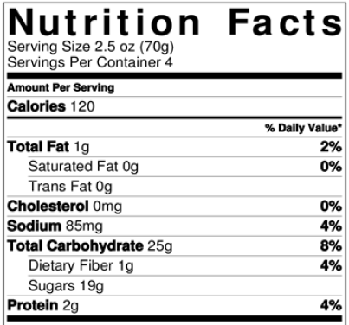
Use the Nutrition Facts Label to the right to complete the sugar calculation to determine if this yogurt meets the sugar limits.

- Write your answer here: _____________

- Is this yogurt creditable?
- Yes
- No

- What documentation must you keep for yogurt until the end of the day?
- Nutrition Facts Label
- Name of item
- All of the above

- What documentation must you keep for store-bought combination foods until the end of the day (i.e. fish sticks, pizza, chicken nuggets, meatballs, ravioli)?
- Nutrition Facts Label
- Child Nutrition (CN) Label or Product Formulation Statement (PFS)
- Ingredient List
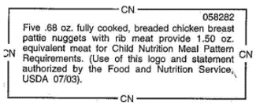
- Use the CN label to determine how much to serve to a child in each age group.
  - 1 & 2 year olds:________
  - 3-5 year olds: _________
  - 6-18 year olds: ________

Fruit and Vegetable

- A vegetable is required to be served at lunch and supper.
  - True
  - False: _____________________________________________________

- The following lunch/supper meals are claimable. Circle all that apply.
- Chicken, apples, pears, bread, milk
- Chicken, apples, carrots, bread, milk
- Chicken, broccoli, carrots, bread, milk
- Chicken, tomato soup, carrots, crackers, milk

- How many times can a CACFP program serve juice, 100% fruit or vegetable, in a single day?
  - 0 times per day
  - 1 time per day
  - 3 times per day
  - 4 times per day

- Juice may be served more than once per day if serving to different groups of participants.
  - True
  - False: _______________________________________________________

- A claimable snack may include a fruit and a vegetable as the two components.
  - True
  - False: _______________________________________________________

Grains

- Breakfast cereals must contain no more than _____ grams of sugar per dry ounce.
  - 3
  - 5
  - 6
  - 13
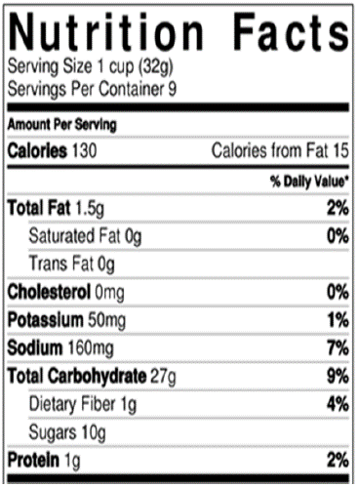
Use the Nutrition Facts Label to the right to complete the sugar calculation to determine if this cereal meets the sugar limits.

- Write your answer here: _____________

- Is this cereal creditable?
- Yes
- No

- Grain-based desserts may be served at snack a max of two times per week.
  - True
  - False: ______________________________________________________

- The following are examples of grain-based desserts. Circle all that apply.
  - Cereal Bars, Granola Bars
  - Cheese Flavored Crackers, Soda Crackers
  - French Toast, Waffles
  - Muffins, Quick Breads

- Each day, at least _____ serving(s) of grains must be whole grain-rich.
  - 0
  - 1
  - 2
  - 3

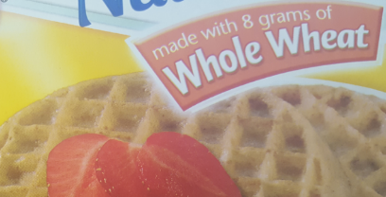
- Based on the following product packages, which items could be used as the whole grain-rich (WGR) item? Circle all that apply.

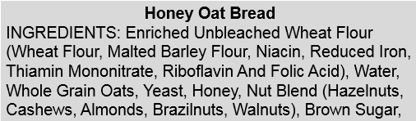
- Using the ingredients to the right, is this item WGR?
- Yes
- No
- Don’t know - need to obtain a Product Formulation Statement

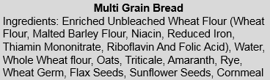
- Using the ingredients to the right, is this item WGR?
- Yes
- No
- Don’t know - need to obtain a Product Formulation Statement

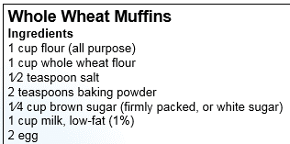
- Is this recipe WGR?
  - Yes
  - No

Cooking Methods

- Deep-fat frying cannot be used to prepare meals on-site. What is the definition of deep-fat frying? Circle all that apply.
  - Submerging foods in hot oil or other fat
  - Pan-frying in a small amount of fat
  - Stir-frying in a small amount of very hot fat

Infants

- When can a program claim an infant’s meal when the mom breastfeeds her child onsite? Circle all that apply.
  - Infant is only receiving breastmilk from mom
  - Infant is receiving breastmilk from mom and eating all program supplied foods
  - Infant is receiving breastmilk from mom and eating one or more parent supplied foods

- Once an infant is developmentally ready for and offered foods at meals, only one of the components must be supplied by the program to claim meals.
- True
- False: ________________________________________________________________

- Infants who are developmentally ready for solid foods at any age must be offered program provided foods.
- True
- False: ________________________________________________________________

- The following foods are creditable in the CACFP for infants. Circle all that apply.
  - Yogurt and whole eggs
  - Cheese Food and Cheese Spread
  - Juice
  - Tofu and Soy Yogurt

- Which foods are creditable at snack for infants? Circle all that apply.
  - Iron-fortified infant cereal
  - Ready-to-eat breakfast cereals
  - Fruits and vegetables
  - Bread/Crackers

- What foods are creditable at breakfast for infants? Circle all that apply.
- Iron-fortified infant cereal
- Pancakes, waffles, toast, ready-to-eat cereal
- Eggs, yogurt, cheese
- Bananas, applesauce, sweet potatoes

- As a participant on the CACFP, even if you are not claiming infant meals, what food(s) must your program offer to all infants? Circle all that apply.
  - None, the parent can be asked to provide formula and foods
  - A minimum of one type of iron-fortified infant formula
  - Multiple types of iron-fortified infant formula
  - Iron-fortified Infant Cereal, Fruits, Vegetables, Meats, and Grains in the appropriate texture

