

Directory Reporting
2018-2019 School Year

Instructions and Data Definitions

2018 Version 2.3
By Lorraine Gardner and Kari Tenley
DPI Division for Libraries and Technology

2018-2019 Directory Report

Data Collection Changes and Reminders
The School Directory application was new for the 2012-2013 school year, replacing the PI-1201, PI-1203, and PI-1280 forms and collecting the same information as those forms used to collect. The application allows districts, independent charter schools, and private schools to update the DPI database directly instead of submitting changes for the Department of Public Instruction (DPI) to enter. The screens in the application roughly correspond to the old paper forms cited above. Please refer to the Data Definitions for clarification regarding individual data elements.

Miscellaneous Things You Need to Know about the Application

The application does not currently handle new schools or closing schools. The schools displayed in the application are the schools which are currently open, according to the DPI database. If one of the displayed schools will be closed for the 2018-2019 school year, please let us know using the contact information below (“For Assistance Contact Us at:”). Similarly, if your district is opening a new school, please let us know.

To change a school name, please let us know the new school name by using the contact information below (“For Assistance Contact Us at:”).

Changing an address in the application requires you to type in the complete new address. You cannot change just the street address, for example.

When you change a street address, the application requires you to enter each component of the street address separately. The application puts all the components together when you click OK. This maintains the standards and abbreviations DPI has been using for street addresses in our database. The individual components each have a description in the Data Definitions section of this document. Do not enter the school name in the Building data element. The Building data element is usually for addresses in which the building name is clearer than the actual street address; e. g., “District Warehouse”.

Sort sequence is a data element which DPI used to enter and which agencies now have to enter. It determines the order in which contacts appear in the printed directory. E. g., if you have two HR people you want listed, you could choose Primary for one and Secondary for the other. As long as the one you want to appear first has a lower sort sequence than the one you want to appear second, the two contacts will appear in the correct order. E. g., Secondary will appear before #5.

If you want to look at the grade ranges served by all of your district’s schools, click on the Public Schools tab.

There are currently no edits on the email addresses you enter. DPI will default them to lower case.

Clicking on a heading above a column of information will sort the rows in ascending order by the item in the column. E. g., click Low Grade on the Public Schools screen, and the application displays all the schools in order by Low Grade. (Kindergarten grades are at the bottom.)

If you change a low grade or a high grade for a school, the change will show up in other DPI applications which are processing 2018-2019 data.

Special Education Contact(s): It is important that a special education contact be reported for each district. The special education contact will be the individual DPI will notify regarding special education issues or updates. Only one individual with primary responsibility may be listed as the director of special education or pupil services. However, an agency may list multiple assistant directors of special education. To be listed as the director of special education or pupil services or as an assistant director of special education, the individual(s) must have an 80 or 81 license. If the district utilizes special education leadership services through a CESA, CCDEB, or 66.0301 agreement, the appropriately licensed individual(s) from that agency should be listed under your LEA. As of this writing, district cannot update addresses for contacts. If individuals want to receive their mail at their CESA or some other address which is not the district office address, please let us know using the contact information below (“For Assistance Contact Us at:”). If the district does not employ a director of special education or pupil services or utilize a CESA, CCDEB, or 66.0301 agreement for special education leadership services, report the district administrator as the special education contact. If your special education director position is vacant, it is better to report the district administrator as the special education contact than to use the Vacant flag (see Position Status in the Data Definitions).

Homeless Liaison: According to the McKinney-Vento Homeless Assistance Act, each LEA must identify and report a homeless liaison. The homeless liaison will be the individual DPI will notify regarding homeless student issues or updates. Only one individual with primary responsibility may be listed as the homeless liaison. If the homeless liaison position becomes vacant for any reason, the LEA should identify a new homeless liaison and update the contact name and email in the School Directory Application. If a homeless liaison is not identified, report the district administrator until a new homeless liaison is determined. Do not leave the homeless liaison name or email address blank.

For Assistance Contact Us at:
Phone: (800) 507-5744 (You most likely will have to leave a message and wait for a DPI response.)
Helpdesk ticket: https://dpi.wi.gov/wisedata/help/request
Choose “School Directory – Enterprise” from the Application dropdown.

Technical Guide

Overview
The School Directory application collects directory-type information for Wisconsin’s K-12 agencies. The data collection establishes DPI’s public district, public school and private school universe, which is used for many other DPI data collection and public reporting purposes including:

- WISEid
- WISEdata
- WISEgrants
- the Wisconsin Student Assessment System (WSAS)
- the Wisconsin School Performance Report
- district and school report cards
- WISEstaff
- the 2018-2019 electronic Special Education Leadership Directory
- Wisconsin School Directory 2018-2019

At the end of January, DPI closes out the agency database for the current school year and starts allowing updates which take effect the following school year. After the end of January, updates will not affect historical records for the current school year. Also after the end of January, reporting can reflect all schools, districts, and independent charter schools which will be open during the upcoming school year. DPI encourages updates year-round so that mailings and emails will go to the correct people and addresses. Data present on the agency database on August 1 will appear in the Wisconsin School Directory 2018-2019.

Web Address for the Application
DPI collects agency, contact, and attribute data for K-12 agencies using a web-based application on the Internet. Staff may change agency data and may add/change/delete data for contacts and school attributes as appropriate. To get to the School Directory application, you will need your WAMS user ID and password. Please go to https://dpi.wi.gov/wise/secure-home-info. Under the heading “What is Secure Home?” click on the Secure Home link at the beginning of the first sentence. After you enter your WAMS user ID and password, click on School Directory. When you get to the page with the photos, click on Log In to Application. For districts only: The district information displays first; click on the Public Schools tab to view or change the school information.

Browser Versions
The Directory application has been tested on Internet Explorer 8 or higher, Firefox, and Google Chrome. If you need to upgrade your Internet browser, contact your agency's technical support team.

Steps to complete the Directory report
- Review the instructions (this document).
- Go to the district screen and enter the kindergarten information. (Districts and non-district charters which do not offer kindergarten do not have to enter kindergarten information.) This step does not apply to private schools.
- Go to the district screen and enter the first and last day of school for the upcoming school year. The DPI enrollment system (WISEdata) needs this information by the time ISES opens in July. This step does not apply to private schools.
- Make other additions, changes or deletions as appropriate.

Getting Started

To get to the School Directory application, you will need your WAMS user ID and password. Please go to https://dpi.wi.gov/wise/secure-home-info. Under the heading “What is Secure Home?” click on the Secure Home link at the beginning of the first sentence.

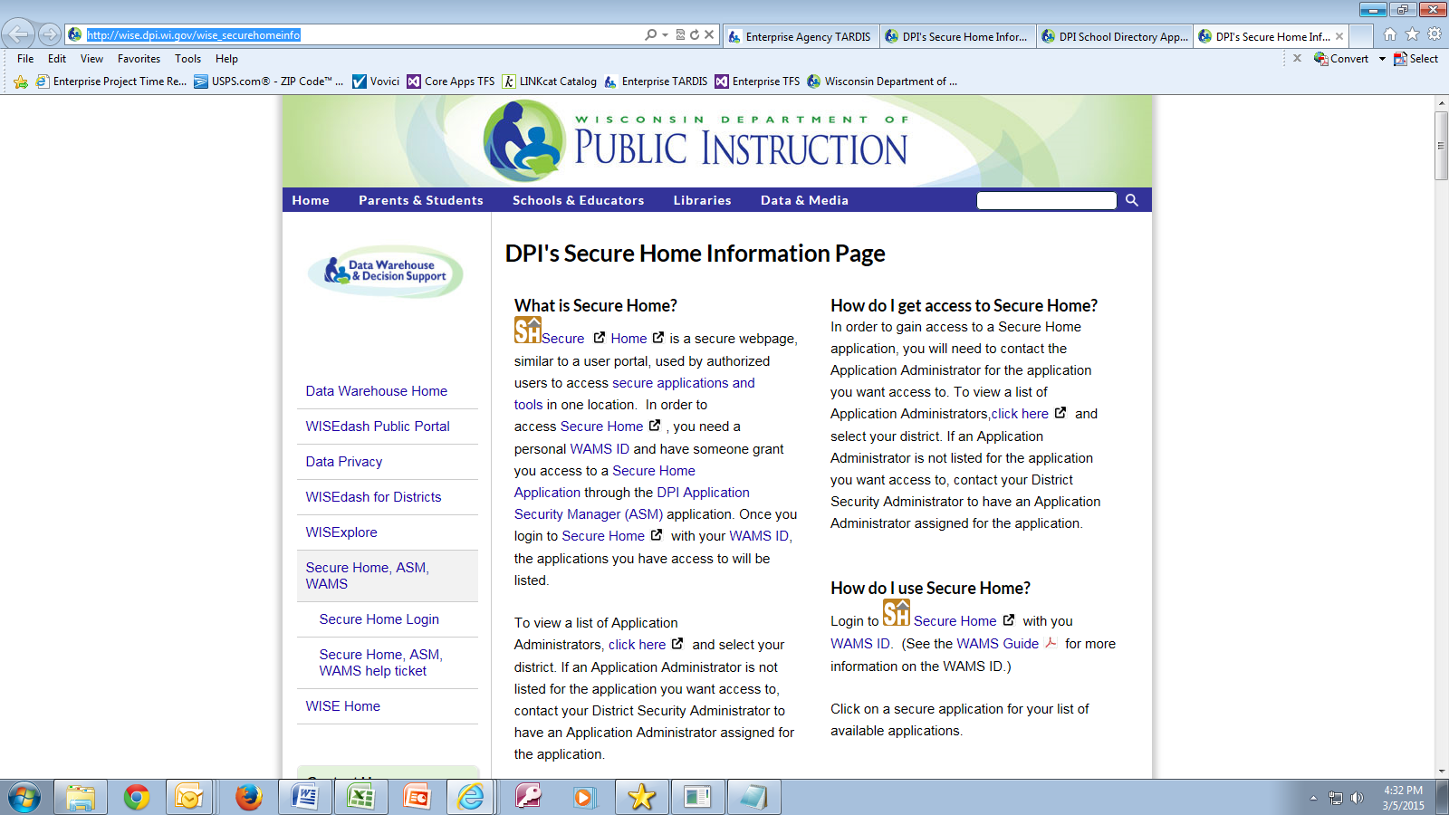

The WAMS screen will appear. Enter your WAMS user ID and password and click Login.
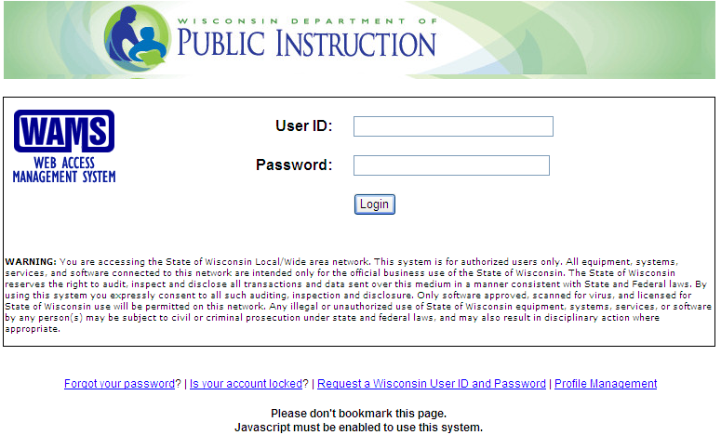

After you enter your WAMS user ID and password, click on School Directory. (If you don’t see School Directory in your menu, then you are not authorized to use the School Directory application. Please go to https://apps2.dpi.wi.gov/ldsutil/admin/lookup and select your district, independent charter, or private school to send an access request to the Application Administrator for School Directory at your district, independent charter, or private school. The Application Administrator can authorize you if appropriate.)

From the page with the photos:

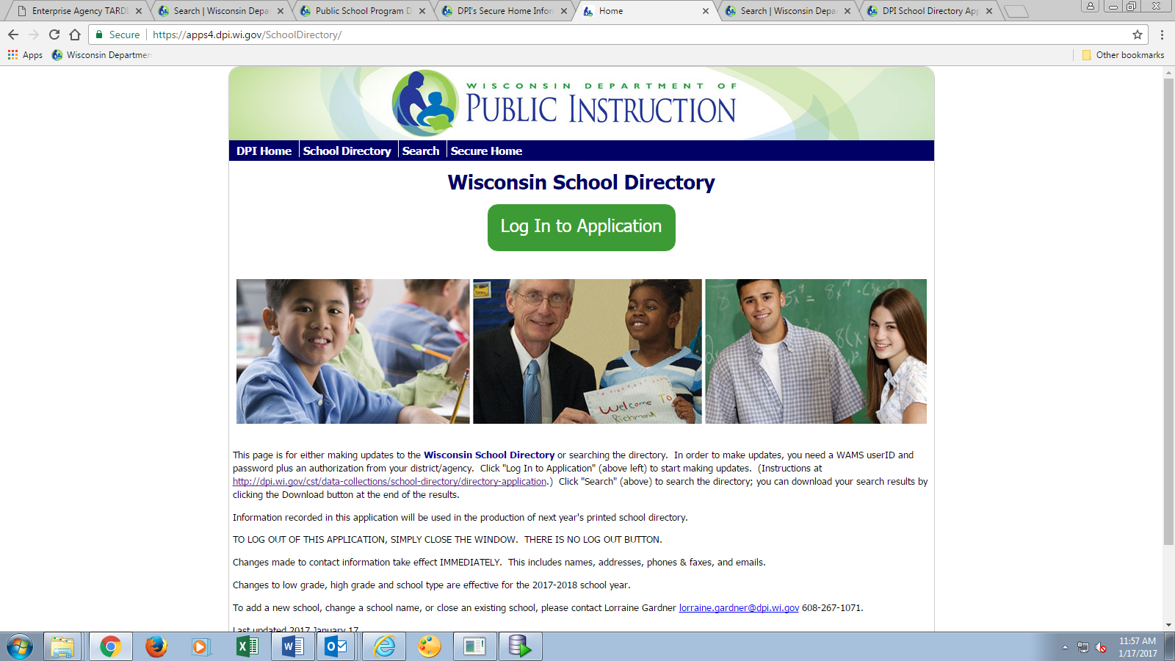
Click on Log In to Application.

For districts only: The district information displays first; click on the Public Schools tab to view or change the school information. For independent charters and private schools, there is only one page of information.

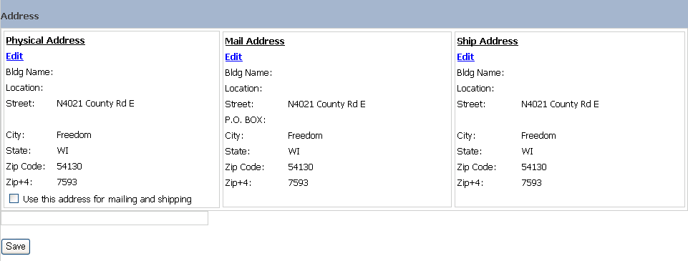
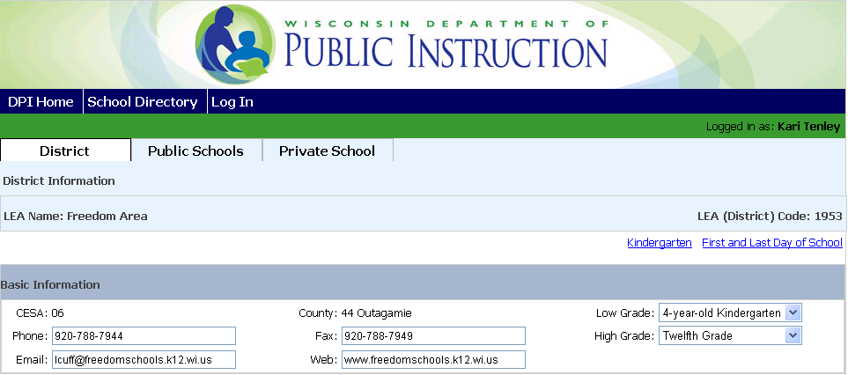
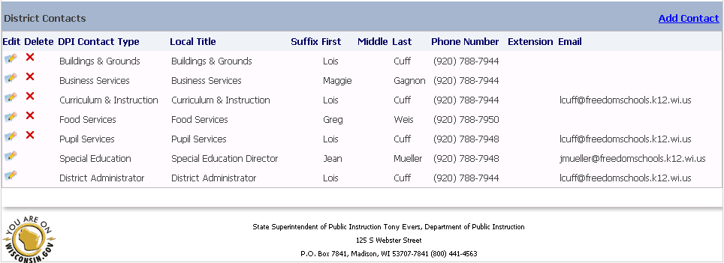

From the district page:

Select Kindergarten. This does not apply to private schools.

Note: The Kindergarten link will not appear if your district or independent charter does not offer kindergarten.

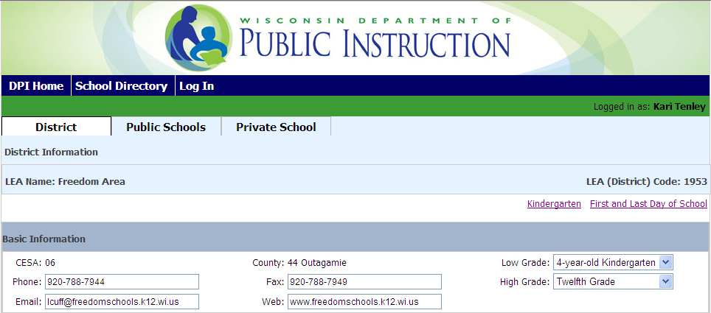

The Kindergarten page will appear.

From the Kindergarten page:

Select one option each from the 5-Year-Olds Schedule, 4-Year-Olds Schedule and the 4-Year-Olds Settings.

Type an explanation in Notes if you had to select a kindergarten option which did not exactly match your kindergarten setup.
- Click to save all changes.
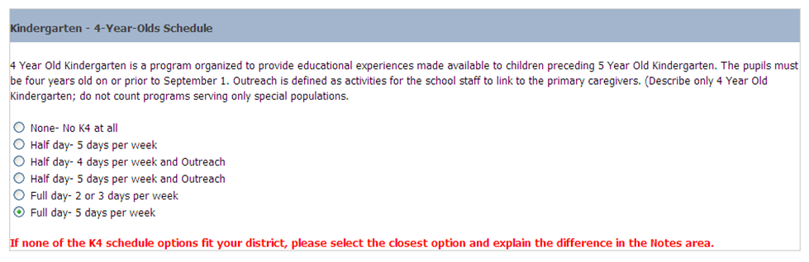
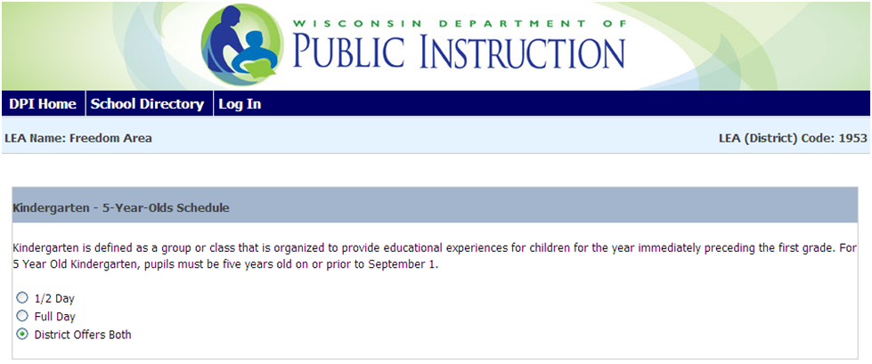
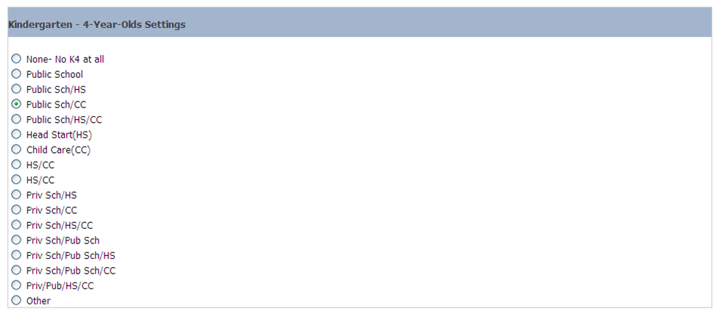
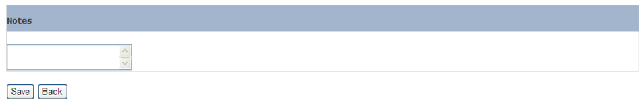
- Click to navigate back to the district page.
Type in notes here
Select One Option
Select One Option
Select One Option
Select: Save to save changes.
Select Back to go back to the district page.
.

From the district page:

Select First and Last Day of School. This does not apply to private schools.

The First and Last Day of School page will appear.

From the First and Last Day of School page:

Enter the First Day of School, Format MM/DD/YYYY (or choose from the calendar).

Enter the Last Day of School, Format MM/DD/YYYY (or choose from the calendar).
- Click to save all changes.
- Click to navigate back to the district page.

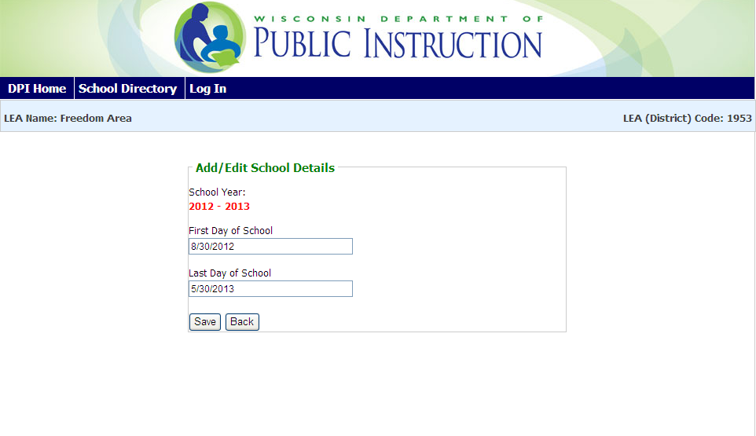
Enter First Day
Enter Last Day
Select: Save to save changes.
Select: Back to go back to the District page.

From the district page:

Update any of the Basic Information.

Update any of the Address Information.

To update address information, click on the Edit link above the address you want to change.
- Click to save all changes.

Update any of the Basic Information.
Update any of the Addresses by Selecting Edit. An Edit Address pop-up box will appear.
Click Save when finished with changes to the Basic and Address Information

Sample of Edit Address Pop-up Box

  - Enter complete address information. Note: information may vary based upon address type. For field definitions please see: Physical Address in the Data Definitions section of this document.
Click to view changes on the district page.
Click to cancel address change and return to the district page.
  - Note: in order to save changes, you must click from the district page.

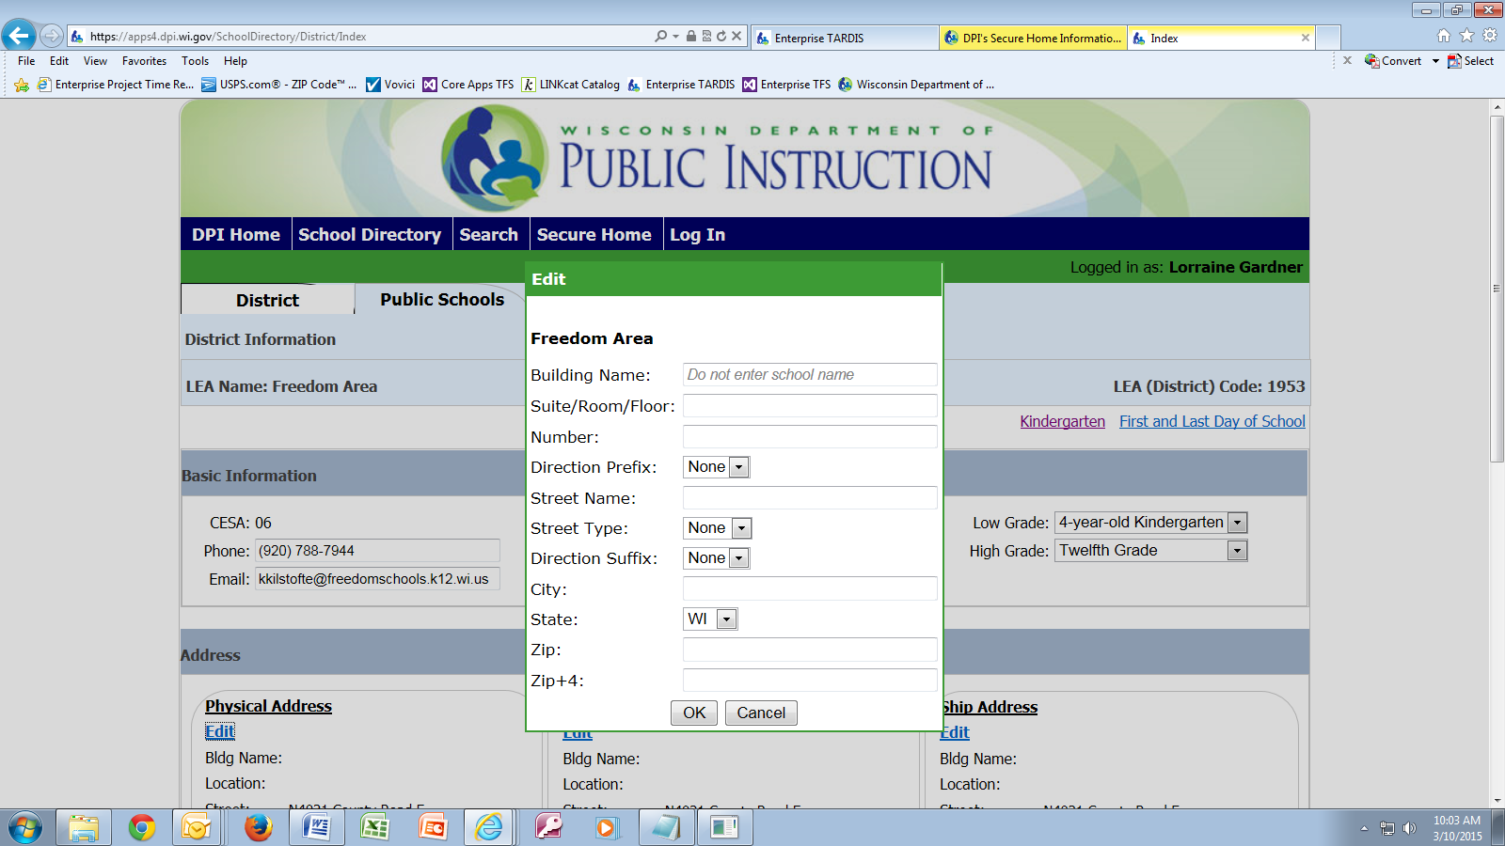

From the District page:
- Update any of the District Contacts information.
- Click t to edit current contact information.
- Click to delete a contact. District administrators, independent charter school primary contacts, and special education contacts cannot be deleted. You may edit these contacts and mark them Vacant under Position Status (see Position Status in the Data Definitions section below), but DPI would prefer that you mark them Interim under Position Status and provide interim contact information.
- Select to add a new contact.

Update District contact information using Edit icon, Delete icon or Add Contact

District Level Personnel: The required information is the contact information for the district administrator and the special education director. Other district level personnel you may include (BUT NO OTHERS) are assistant district administrator and contacts for: buildings & grounds, business services, curriculum & instruction, elementary education, food services, human resources, media/public relations, nurse, pupil services, secondary education, special education, technology, and transportation.
If a position is currently vacant but will be filled eventually, and it is a contact you would like listed in the printed directory, edit the contact and choose “Vacant” from the Position Status dropdown on the application’s Edit Contact screen.

If the district administrator position is vacant, indicate an interim district administrator. This should be the individual assigned to carry out the district administrator’s responsibilities until the vacancy is filled. Every district should have a name listed for district administrator.

School Level Personnel: The required information is the contact information for the principal. Other school level personnel you may include (BUT NO OTHERS) are assistant principal, contact person, dean of students, and teacher in charge. K4-only schools may have a coordinator if the district has a community-based K4 program.
If a position is currently vacant but will be filled eventually, and it is a contact you would like listed in the printed directory, edit the contact and choose “Vacant” from the Position Status dropdown on the application’s Edit Contact screen. If a position has been eliminated, simply click the X next to the person’s listing in the application.

Sample of Edit Contact Pop-up Box
- Enter changes to contact information.
- Click to save contact information.
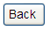
- Click to cancel contact change and return to the district page.

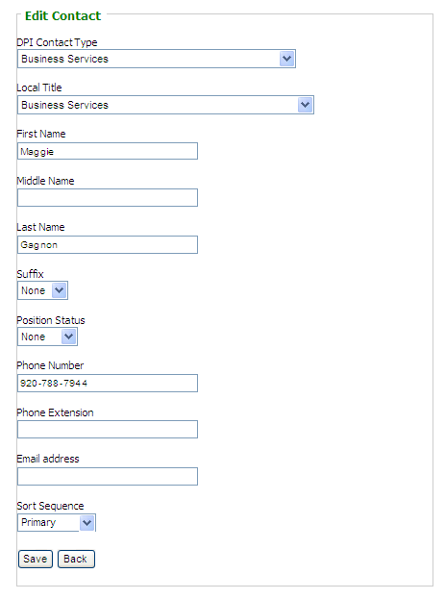
For more information on Sort Sequence please see Data Definitions.

Sample of Add Contact Pop-up Box

- Enter new contact information.
- Click to save contact information.
- Click to cancel adding the new contact and return to the district page.

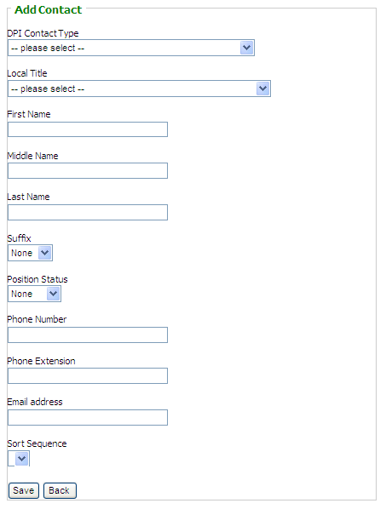
For more information on Sort Sequence please see Data Definitions.

Update Public School Information—This does not apply to private schools.

From the district page:
- Select the Public Schools tab.
- Click on the School Code (ID) of the school you want to update.
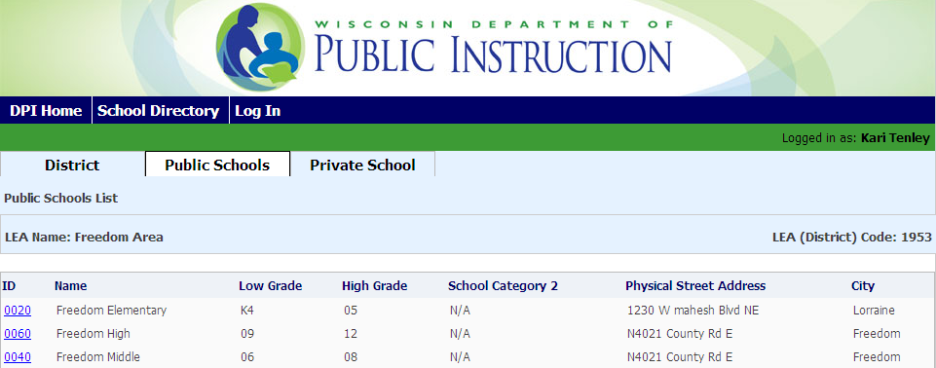

The School Details page will appear.

From the School Details page:
- Update any of the Basic Information. Virtual instruction information not shown in screen shots below.

- Update any of the Address Information.
To update address information, click on the Edit link above the address you want to change.
- Click to save all changes to Basic and Address Information.
- Update any School Contacts information.
- Click to edit current contact information.
- Click to delete a contact. The primary contact for a school cannot be deleted. You may edit the primary contact and mark it Vacant under Position Status (see Position Status in the Data Definitions section below), but DPI would prefer that you mark it Interim under Position Status and provide interim contact information.
- Select to add a new contact.

The school edits and pop-up boxes function the same as the district edits and pop-up boxes.

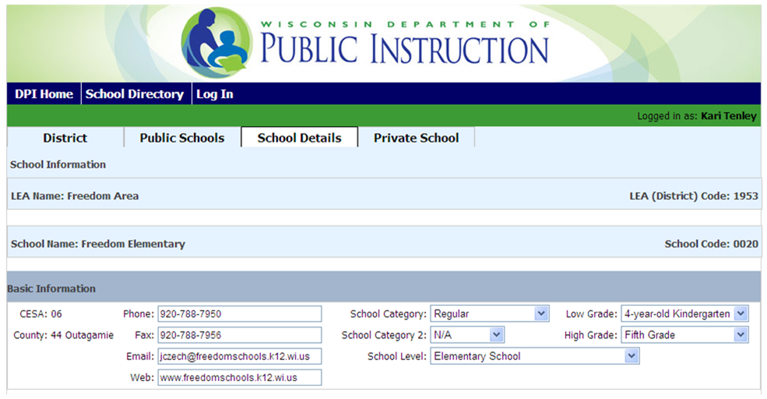
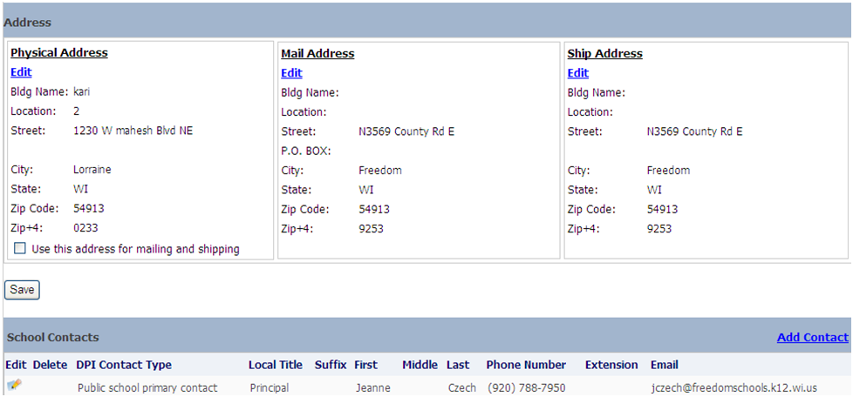
Update any of the Basic Information.
Update any of the Addresses by selecting Edit. An Edit Address pop-up box will appear.
Update School Contacts information using Edit icon, Delete icon or Add Contact

Click Save when finished with changes to the Basic and Address Information.
To return to the Public Schools list in order to edit other schools from the School Details Page:

Select the Public Schools tab.
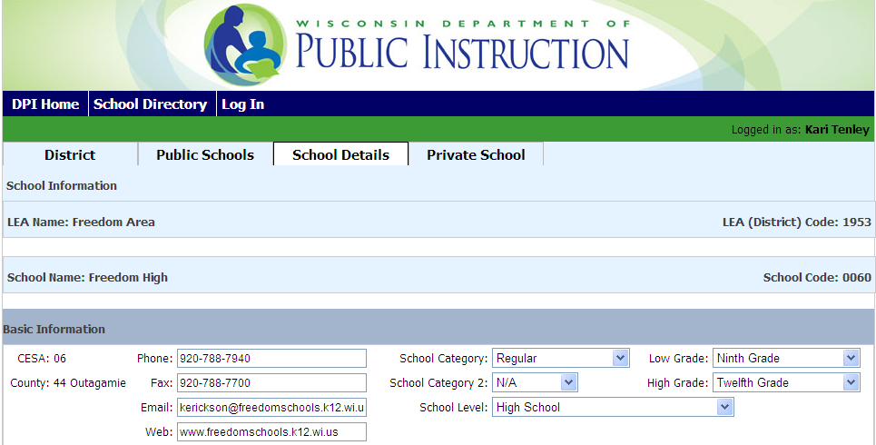

From the Public Schools page:
Select the next school which needs to be edited.

Indicate any Private School closings—This does not apply to private schools.
- Select the Private School Verification tab.

- Uncheck a private school which has closed or will be closed for 2018-2019.

- Select Save on the line for that school in order to save the closed status.

- Repeat for each private school which has closed.

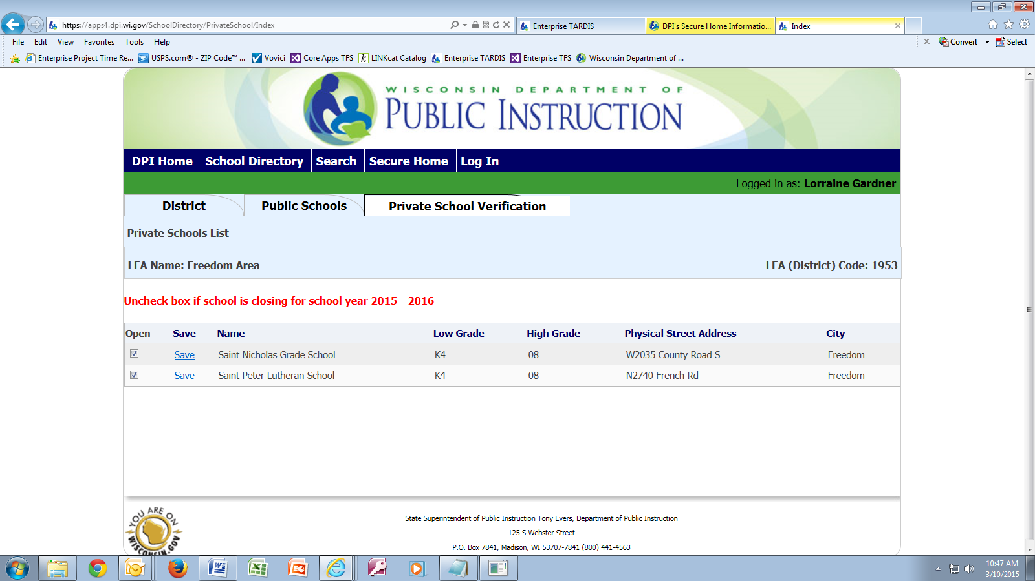

Data Definitions

Data element size is in parentheses after the data element name. The following definitions are not all-inclusive. Some data elements are self-explanatory; e. g., Last Name.

CESA (2): The number of the CESA to which an LEA belongs.

County (2): A code assigned by DPI to a Wisconsin county.

County Name (15): Self-explanatory.

District (4): See LEA Code.

DPI Contact Type (50):
The DPI description of the contact’s title. In general, district-level contacts appear in DPI directories under this DPI Contact Type. School-level contacts in DPI directories appear under their Local Title (see below). District administrators, special education contacts, independent charter school primary contacts, public school primary contacts, and private school primary contacts cannot be deleted. They can be marked Vacant under Position Status (see Position Status below), but DPI would prefer that you mark them Interim under Position Status and provide interim contact information.

District-Level Contacts: DPI collects contact information for: the district administrator, assistant district administrator(s), business services, curriculum and instruction, pupil services, the special education director, and assistant special education director(s). Other district level personnel you may include are contacts for: buildings & grounds, elementary education (director), food services, human resources, media/public relations, nurse, secondary education (director), technology, and transportation (no others).

School-Level Contacts: DPI collects contact information for one primary contact. Other school level personnel you may include are assistant principal, additional public school principal (co-principal), contact person, dean of students, and teacher in charge (no others). (A school secretary is not a contact person for the purposes of the DPI database.) Public schools serving only K4 may have a coordinator if the district has a community-based K4 program.

If a position has been eliminated, delete the contact. If a position is currently vacant but will be filled eventually, edit the contact and choose “Vacant” from the Position Status dropdown.

Email Address (100):

For an LEA, the email address of the LEA which will appear in the Wisconsin School Directory 2018-2019 (not necessarily the same as the email address of the district administrator). For a school, the email address listed for the primary contact for the school (such as the principal) will appear in the Wisconsin School Directory 2018-2019.

Fax (10): Area code and fax number of the LEA or school.

First Day of School (date):

The date of students’ first day of school for the upcoming school year. Must be present by July 1 in order for ISES to be usable. If your LEA has schools with different first days of school, use the most prevalent date. Month must be 08 or 09. Day must not fall on Saturday or Sunday. Year is defaulted by the application.

First Name (16): Self-explanatory.

High Grade (2):

The highest grade served by the LEA or by the school. Grades are listed in ascending order in the dropdown in the application. K4 is a lower grade than PK.

Instrumentality: Yes or No. Applies to charter schools only.

Data Definitions continued:

Kindergarten Program (5-year-olds):

The length of the school day for 5-year-old kindergarten:

Both full and half days

Full day

Half day

Kindergarten Program (4-year-olds) (55):

The length and frequency of the school day for 4-year-old kindergarten:

Full day - 2 or 3 days per week

Full day - 5 days per week

Half day - 4 days per week and Outreach

Half day - 5 days per week

Half day - 5 days per week and Outreach

None

If your K4 program does not exactly fit any of these programs, choose the closest match.

K4 Setting (40): The setting or combination of settings in which your K4 instruction occurs:

Child Care

Head Start

Head Start and Child Care

None - no K4 at all

Other

Private School

Private School and Child Care

Private School and Head Start

Private School and Public School

Private School, Head Start, Child Care

Private School, Public School, Child Care

Private School, Public School, Head Start

Private, Public, Head Start, Child Care

Public School

Public School and Child Care

Public School and Head Start

Public School, Head Start and Child Care

Last Day of School (date):

The date of students’ last day of school for the upcoming school year. Must be present by July 1 in order for ISES to be usable. If your LEA has schools with different last days of school, use the most prevalent date. Month must be 05 or 06. Day must not fall on Saturday or Sunday. Year is defaulted by the application.

Last Name (20): Self-explanatory.

LEA Code (4):
A code assigned by DPI to a public school district, CESA, CCDEB, or independent charter school. Not updatable.

LEA Name (30):

The short version of the agency’s name. Not updatable in the School Directory application.

If the LEA name has changed, send a copy of the school board resolution or other governing body resolution authorizing the change to the Wisconsin Department of Public Instruction, School Management Services, P. O. Box 7841, Madison, WI 53707-7841 prior to the July 1 preceding the upcoming school year.
If DPI does not receive the resolution prior to the July 1 preceding the upcoming school year, the change will be made for the school year after the upcoming school year.

Data Definitions continued:
Local Title (50):

The LEA description of the contact’s title, chosen from a list supplied by DPI. If the list does not contain the contact’s exact title, choose the closest match. In general, district-level contacts appear in DPI directories under this DPI Contact Type. School-level contacts in DPI directories appear under their Local Title (see below).

Low Grade (2):

The lowest grade served by the LEA or by the school. Grades are listed in ascending order in the dropdown in the application. K4 is a lower grade than PK.

Mail Address: Same as Physical Address, below, with the addition of:

PO Box (10): The USPS post office box number (just the number; does not include the phrase “PO Box”. As a rule, PO Box and Street are not both present; fill in one or the other.

Middle Name (16): Self-explanatory.

Phone Extension (6): For an LEA or school, the phone extension of the LEA or school. For a contact, the phone extension of the contact.

Phone Number (10): For an LEA of school, the area code and phone number of the LEA or school. For a contact, the area code and phone number of the contact.

Physical Address:

Bldg Name (30): An optional, seldom-used add-on for an LEA or school name to clarify the LEA or school location; e. g., when there are similar school names within a district. Completion of this field is seldom necessary. Do not enter the school name in this field.

Location (30): (optional) Suite number, room number, and the like.

Street (30): The following items are entered separately in the application and joined together by the application to form the street address:

Number: Commonly called “house number”.

Direction Prefix: E. g., N, S, E, W.

Street Name: Street name without the street type.

Street Type: E. g., Ave, St, Blvd, Dr.

Direction Suffix: E. g., SW, N, NE, W.

City (30): Self-explanatory.

State (2): The US Postal Service (USPS) abbreviation for the state. Defaults to WI.

Zip (5): The USPS zip code which goes with the location, street, city, and state.

Zip+4 (4): The USPS zip code add-on which goes with the location, street, city, and state.

The physical address is used for determining the locale code assigned by the U. S. Census Bureau for the U. S. Department of Education’s National Center for Education Statistics. Some federal grants use this code to determine eligibility (example, REAP Grant). This physical address may also be thought of as the address given for fire and emergency purposes.

Position Status: Vacant, Interim, or None. The application blanks out the name and email address fields if the contact record is marked Vacant.

Data Definitions continued:

Prefix:
A personal title which would precede the full name (Rev, Br, Sr, etc.). Used for private school contacts only.

School Category (3): REG, ALT, VOC, or SPE (regular, alternative, vocational, or special education).

School definition: A school is an administrative unit dedicated to and designed for imparting skills and knowledge to students. A school is organized to efficiently deliver sequential instruction from one or more teachers. In most cases, but not always, a school is housed in one or more buildings. Multiple schools may be in one building. By statute, a home-based private educational program is not a school. See “Clarifying Information for the Definition of a School” at http://dpi.wi.gov/lbstat/defini.html.

Regular school: A regular school is a public school which does not focus primarily on vocational, special, or alternative education.

Special education school: A special education school is a separate public school which primarily serves children with disabilities.

Vocational education school: A vocational education school is a public school which focuses primarily on vocational education, and provides education and training in one or more semi-skilled or technical operations.

Alternative education school: An alternative education school is a public school which:

Addresses student needs which typically cannot be met in a regular school;

Provides non-traditional education; or

Falls outside the categories of regular, special education, or vocational education.

School Category 2 (3): CHR, PAR, MAG, CHC, or N/A (charter, partnership, magnet, choice, or not applicable).

Charter school: A charter school is a school operating under provisions of a contract with a local public school board or authorizer as required under Wis. Stat. sec. 118.40.

Magnet school: Regardless of the source of funding, e. g., federal, state, or local government, a magnet school is defined as a special school designed to:

Attract students of different racial or ethnic backgrounds for the purpose of reducing, preventing or eliminating racial isolation (racial isolation meaning a school has 50% or more minority enrollment); and/or

Provide an academic or social focus on a particular theme (e.g., science and math, performing arts, gifted and talented, or world language).

Partnership school: Any nonsectarian private agency or nonsectarian private school located in the Milwaukee School District operating under contract with the school district to provide educational programs to pupils enrolled in the Milwaukee School District.

Choice: A choice school is a school participating in any of the private school parental choice programs.

School Level: Elementary, middle, junior high, high, or combined elementary/secondary.

Elementary school: A school which generally offers undifferentiated instruction to a self-contained class, usually involving grades no higher than grade 8.

Middle school: A school with a program designed specifically for the early-adolescent learner, usually beginning with grade 5 or 6.

Data Definitions continued:

Junior high school: A school between the elementary and high school levels, usually offering at least some separate classes in different subjects and usually covering grades 7, 8, and 9.

High school: A school offering separate classes in different subjects and usually covering grades 9, 10, 11, and 12.

Elementary/secondary combined school: A school that generally offers instruction at all grade levels through grade 12 in one location due, in most cases, to the size of the district. Although offered at one location, instruction is differentiated as elementary, middle or junior high school, and high school.

School Name: The long version of the school’s name. To change a school name, please follow the directions on Page 1.

Ship Address: Same as Physical Address, above.

Sort Sequence:
A numbering scheme which determines the order in which contacts appear in the printed directory. If your agency lists more than one contact for a given DPI Contact Type, the contacts appear in ascending order by sort sequence. The choices are Primary, Secondary, 3, 4, 5, etc. Some DPI Contact Types allow more sort sequence numbers than others. E. g., if you have two HR people you want listed, you could choose Primary for one and Secondary for the other. As long as the one you want to appear first has a lower sort sequence than the one you want to appear second, the two contacts will appear in the correct order. E. g., Secondary will appear before #5. The following DPI Contact Types have no sort sequence, since there can be only one of each of these contact types per agency: district administrator, public or private school primary contact, independent charter school administrator, and special education director.

Suffix (15): A suffix which would follow the full name (Sr, Jr, I, II, III, IV, V).

Data Definitions continued:

Virtual (3): The level of virtual instruction offered by the school.

Here is an excerpt from the federal specification, including a description of each level. Note that the level called “Supplemental virtual” in the federal description is the same thing as “Primarily Classroom (Supplemental Virtual)” in the DPI description.

Group Name: Virtual school status |  |  |  | DG: 803
Definition | An indication of the extent to which a public school offers instruction in which students and teachers are separated by time and/or location, and interaction occurs via computers and/or telecommunications technologies.
Permitted Values | - Exclusively virtual - All instruction offered by the school is virtual. This does not exclude students and teachers meeting in person for field trips, school-sponsored social events or assessment purposes. All students receive all instruction virtually.  - Primarily virtual - The school’s major purpose is to provide virtual instruction to students, but some traditional classroom instruction is also provided. Most students receive all instruction virtually.  - Supplemental Virtual – Instruction is directed by teachers in a traditional classroom setting; virtual instruction supplements face-to-face instruction by teachers. Students vary in the extent to which their instruction is virtual.  - No virtual instruction - The school does not offer any virtual instruction. No students receive any virtual instruction.
Reporting Period | October 1
Reporting Levels | School  | LEA  | State 
Education Unit Total | 

Web (150): The website address (URL) of the LEA or school.

Common Reporting Errors

Building Name: Putting school name or district name into the Building Name field. If you do this, school name or district name will appear twice in our directories. Building Name is for the unusual situation where a school or district office is located in a named building other than the school or district administration building.

DPI Contact Type: Adding a school secretary as a contact person for a school. A school secretary is not a contact person for the purposes of the DPI database.

Low Grade: In the DPI grade progression, K4 is a lower grade than PK (even though PK can have 3-year-olds in it). If your LEA has low grade K4, do not change low grade to PK. The grades in ascending order are:
K3 = 3-year old Kindergarten (Milwaukee School District and non-district charters only)
K4 = 4-year-old Kindergarten
PK = Pre-Kindergarten
KG = Kindergarten
01 = Grade 1
02 = Grade 2
03 = Grade 3
04 = Grade 4
05 = Grade 5
06 = Grade 6
07 = Grade 7
08 = Grade 8
09 = Grade 9
10 = Grade 10
11 = Grade 11
12 = Grade 12
NOTE: PK (pre-kindergarten): Students in PK are not enrolled in K3, K4, or KG, but receive primary educational services from the district and have not yet enrolled in first grade. Districts receive membership aid for children reported in this grade.
This grade code is predominantly used for students with disabilities ages 3 through 5 who are not enrolled in K3, K4, or KG.

Private Schools: Private schools marked closed which are not really closed. Uncheck only the private schools you think are closed.

For Assistance Contact Us at:
Phone: (800) 507-5744 (You most likely will have to leave a message and wait for a DPI response.)
Helpdesk ticket: https://dpi.wi.gov/wisedata/help/request
Choose “School Directory – Enterprise” from the Application dropdown.

