PI-1202 FALL STAFF REPORT

Data Definitions and Instructions

2009-2010

School Year

DUE: December 15, 2009

Table of Contents
Welcome 1
2009-2010 PI-1202 Fall Staff Report Improvements 3
Data Collection Changes and Reminders 3
Internet Application 3
Browser Versions 4
1202 Staff Listserve 4
Frequently Asked Questions 4
To find answers to frequently asked questions, changes being made to the PI-1202 and the schedule, please check this web site: http://www.dpi.wi.gov/lbstat/fallsf10.html. 4
For Assistance 4
Technical Guide 5
Overview 5
Getting Started 6
General Instructions 7
Main Menu 7
District Contact Information 9
Upload or Create Records Menu 10
Staff & Assignment List 15
Employment Information 19
Assignment Information 20
Get Staff File Number ………………………………………………………………………………………………. 23
Check for Validation Errors 24
Report Menu 25
Locking and Submitting the Fall Staff Report 32
Data Definitions 33
Employee Information Page Field Level Assistance 38
Assignment Information Page Field Level Assistance 40
Common Reporting Errors 42
Upload File Structures 43
Staff File Structure 43
Assignment File Structure 44
Validation Criteria for the Staff & Assignment Files 45

Welcome
Welcome to the PI-1202 Fall Staff Report Help Documentation. This project contains documentation pertaining to the PI-1202 Fall Staff Report web based application. You will find Word version of the online Help documentation at this website: http://www.dpi.wi.gov/lbstat/fallsf10.html

This documentation provides you with all the information you require to be able to operate the online PI-1202 Fall Staff Report application, as well as Tips and Tricks, Frequently Asked Questions and changes made to the report every year.

You can utilize the navigation on the left side to browse to the topic of interest. You can also perform a search on keywords, as well as the index to locate the topic for which you require information. Look up the Glossary terms using the Glossary tab. Alternately, if you wish to read through the entire help, page by page, simply click on the Browse buttons at the top left hand corner of the page.

In order to read information on a topic or section, click on the Book Icon to open it in the left navigation menu. Double click on the Topic icon to load the topic in the right hand side of the page.

For a no-frames version of the help, simply click on the in the left frame. This will close the navigation frame. In order to reopen the navigation frame, click on the tab on the top frame. Note: The ability to hide the table of contents in the left frame is not available in Netscape Navigator.

Text coded in blue, like this example is an expanding hotspot. In order to view the contents of the expanding hotspot, click on the text. Glossary terms within the text are expanding hotspots. Expanding hotspots are text links that expand to display additional information in the topic content when clicked. These hotspots do not display other topics. Rather, they expand to show additional information that can help users accomplish tasks. These hotspots are only available if the user's viewer supports Dynamic HTML.

To close Help, click on the X in the upper right-hand corner.

2009-2010 PI-1202 Fall Staff Report Improvements

Data Collection Changes and Reminders

Modification to the Fall Staff Report and some very specific reminders are listed below. Carefully read the questions and descriptions when creating or modifying staff and assignment data. Refer to the help section 'Field Level Assistance by Page' for further clarification of data elements/ specific questions.

See the position/assignment table (link to Excel file on http://www.dpi.wi.gov/lbstat/fallsf10.html) for new, revised, and deleted code combinations.

A new question has been added to the Employee Information screen (or returned to the staff layout for file uploads) for all individuals where salary data is collected, ‘Is the salary final for this school term? Y = Yes, N = No, blank for individuals in support positions (97, 98, 99) or Short-Term Substitute Teacher (43). The answer here tells DPI if the reported third Friday in September salary and fringe benefits are final or if contracts are not yet settled.

The seven optional fields in 2008-09 that are required in 2009-10 on the assignment record all relate to reporting number of classes. Number of Classes is related to teaching assignments (position 53 and all assignments/area except 0001, 0002, 0003, and 0970). NCLB English, NCLB Math, NCLB Science, NCLB Social Studies, NCLB World Language, and NCLB Arts (six fields) are related to teaching assignments at the secondary level (grades 9-12) in special education only (position 53 and assignments between 0800 and 0862 with the exception of 0808, 0826, 0841, and 0860). See more details in the section for data definition of the fields and file layout.

Use the name from the individual’s Social Security card. This will minimize discrepancies between districts when data is being reported for one individual by multiple districts.

Do not create artificial Social Security Numbers. Use the Social Security Number from the individual’s Social Security card. All employees must have valid Social Security Numbers in order to be employed, so no SSN will be accepted if it contains alphabetic characters or too many strings of zeros.

All licensed staff must have a valid SSN that matches the File Number in the Teacher Licensing database. On the Main Menu there is feature available to Get Staff File Numbers for staff reported in licensed positions. If the district reports an individual in a licensed position but the SSN does not match the Teacher Licensing database, they will display on the Report for Missing/Invalid Staff File Numbers. Be sure new staff members have requested their licenses.

Salary and fringe benefits are no longer being collected for extra curricular duties. Report only the salary and fringe benefits from the contract for regular assignments.

If a field is described as numeric and required, it must be zero-filled if no data is being reported.

Gender, race/ethnicity code, and year of birth are required for all records.

The 1202 data your district uploads or creates will be validated quite precisely and must be free of errors before it can be locked and submitted to the Department. You may validate your uploaded data at any time by clicking on the Validate button. If you did not include the File Number, you must use the Get File Number feature in the application.
Please note there are many reports available to assist you in double-checking your data, either by providing a list of errors or context in which to view the data submitted. Some examples, Statewide District Contacts, PI-1202 Average Salary Summary, Staff Without Experience and Draft Administrative Salary Report.

Internet Application

The Department of Public Instruction collects PI-1202 data using a web-based application on the Internet. The URL for accessing PI-1202 software is https://www2.dpi.state.wi.us/staff. Staff responsible for completing the PI-1202 is able to create records from the previous school year or use a file-upload process to load files. The staff and assignment records may then be modified as needed and additional records may be added. Reports are available to summarize and validate the district data.

Browser Versions

For the PI-1202 software to work properly, use browsers that are W3C compatible: Internet Explorer (IE) 5.5 (or greater) or Netscape 6.0 (or greater). If you need to upgrade your Internet browser, contact your district's technical support team.

1202 Staff Listserve
To subscribe to the 1202 Staff Listserv, send an e-mail to dpistats@dpi.wi.gov. In the subject line, type PI1202 staff listserv. In the message body, type subscribe 1202staff.

Frequently Asked Questions
To find answers to frequently asked questions, changes being made to the PI-1202 and the schedule, check this web site: http://www.dpi.wi.gov/lbstat/fallsf10.html.

For Assistance

For assistance with PI-1202,

• call (608) 267-3166
or
• e-mail barbara.ballweg@dpi.wi.gov or dpistats@dpi.wi.gov
or
set up an account in the HelpDesk Expert Tool http://www.dpi.wi.gov/lbstat/helptool.html and communicate with us through the ticket creation process. Access to the tool can be found on the PI-1202 Main Menu or from URL above.

Your message will be routed to the individual best able to respond to your specific query; if you haven't received a reply by the end of the next business day, please indicate so in a second message.

Technical Guide

Overview
The PI-1202 Fall Staff Reporting System facilitates the collection of agency staff demographic and assignment data. This system, created for school year 2009 - 2010, replaces the previous year’s processing system.

Update the staff files to show staff employed by your agency as of the third Friday in September. Delete records of those no longer employed; add records for new staff members; and update records appropriately. You should be reporting staff that are hired by your agency, or are contracted to provide services to your schools unless they are hired by another public school district, CESA, or CCDEB. If another public school district, CESA or CCDEB hires the individual, they should be reporting an assignment to reflect the FTE working for your agency.

New staff added to the Fall Staff report should show one year of local experience. Total experience should reflect the number of years of educational experience including the current school year.

Be sure to update salary information and verify fringe benefit entries. Fringe benefits reported on the PI-1202 Fall Staff report are the total of all of those listed under Object 200 Employee Benefits in the Wisconsin Uniform Financial Accounting Requirements (WUFAR) Handbook.

Most teachers (position 53) should be reported at a school level, not a district level. Use a school number instead of the 0000, if at all possible. If you prepare a file to import your data, make sure that all teachers are reported at a school level from your source files.

When data entry is complete verify the data with the 'Check for Validation Errors' link and review the reports available on the 'Report Menu'. Once the data has been verified, 'Lock and Submit' the PI-1202 Fall Staff Report to the DPI.

Steps to complete the PI-1202
- Review instructions and changes.
- Update/Complete District Contact Info.
- Upload or Create Staff Records (part of Upload or Create Records).
- Upload or Create Assignment Records (part of Upload or Create Records).
- Add new employee records, delete records for employees that have left, update any necessary data.
- Process Get Staff File Numbers from the PI-1202 Main Menu.
- Review errors from the four Error Reports (Reports Menu); make corrections directly in Staff & Assignment Lists or correct in local system and do another File Upload.
-- Staff Assignment Errors
-- Staff Conflict Errors
-- Missing/Invalid Staff File Numbers
-- Staff Without Assignments
-- Staff Without Experience
- Validate Data (after corrections are made).
- Review the Reports Requiring Approval (Reports Menu). When you are in the specific report, and if the data is correct, select (click in) the approval box.
-- Draft Administrative Salary Report
-- Draft Staff Report by Position, Ethnic Group and Gender
-- Schools - No Teacher Position #53 as Staff
- Lock and Submit

Getting Started
Select the appropriate School Year to continue to Log In.

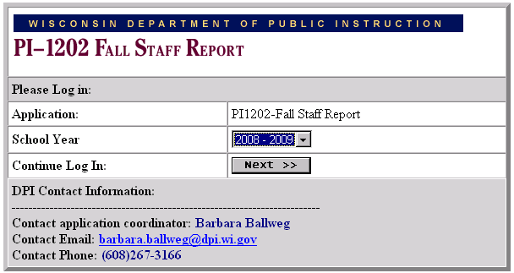

Select the appropriate Education Agency and enter the assigned password to continue to the Main Menu. For an individual agency, only one person should access the system at a time.

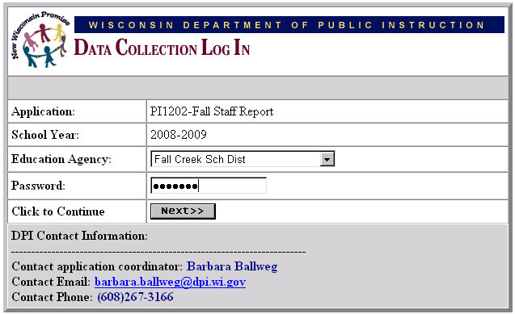

General Instructions

Main Menu
The number of choices available on the main menu will change as sequential steps of the application are completed. Upon first entry to the Fall Staff Reporting System, the following menu will be displayed. Note that a link is 'grayed' when it is not available. For an example, see the 'Lock and Submit' link below.

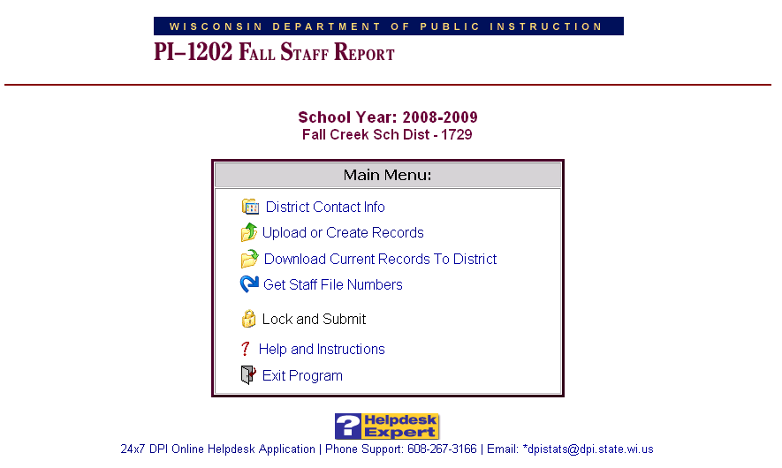

Once the 'District Contact Information' has been entered and saved, the associated link label will change to no longer read 'Please Update'. After data has been loaded, more options will become available and the following menu will be displayed.

Note: email address is now dpistats@dpi.wi.gov

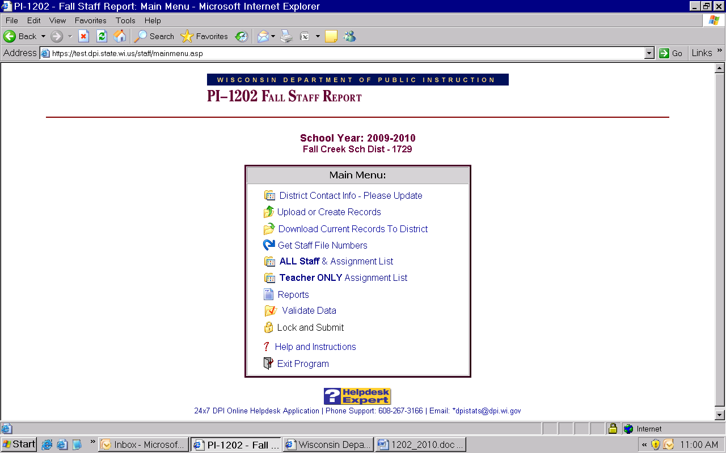

For security reasons, the application will 'time out' or disconnect from the DPI server after 20 minutes of inactivity. 'Use' means that navigation within the application has occurred or data has been specifically saved. If a 'time out' has occurred, a message will appear with the option to 'exit the application and return to the DPI web site' or to' re-enter the application and log in again'.

District Contact Information
In order to facilitate the flow of information to those responsible for filing the PI-1202 Fall Staff Report, it is necessary to update the contact information for the district. If the information is the same as the prior year, click on save to confirm the information. This information must be updated or confirmed before the PI-1202 data can be submitted to DPI.

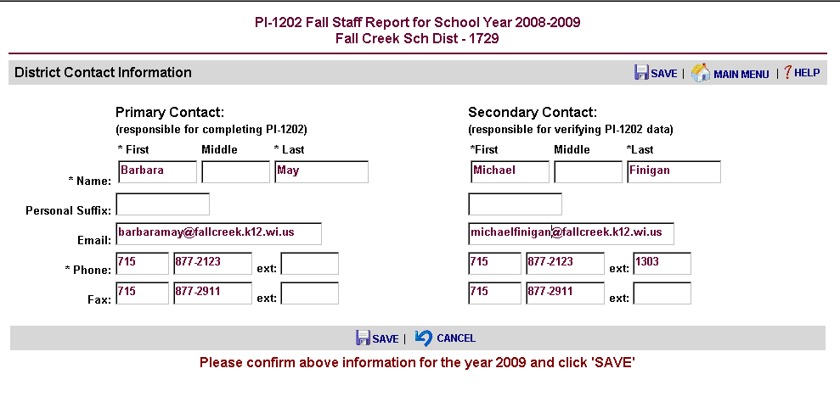

Upload or Create Records Menu
Two options are available to enter fall staff report data. Data may be uploaded into the application in two text files (*.txt) or records may be created from the staff and assignment records on file at the DPI from the previous school year. All data must be either uploaded or created. It is not possible to upload a portion of the data and create the remaining data. Once the initial data has been loaded into the P1202 application, it can be edited or modified from the Staff & Assignment List.

Upon first entry to the 'Upload or Create Records' Menu, the following menu will be displayed. If your agency plans to Upload Staff and Assignment Files, you will need to be familiar with these record structures. Two files should be created, one for personal staff information and another for assignment data. See the 'Upload File Structures' section for detailed information about these files. 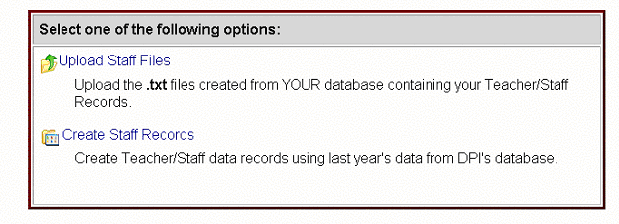

Uploading Records

By clicking the 'Upload Staff Files' link, the following prompt will be displayed. Enter or browse to a file and click the 'Upload File' button. The file name should be stf1202.txt.

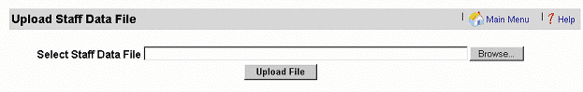

When the upload process is complete, a message will be displayed which shows the number of records inserted. To upload the Assignment File immediately, click the 'Continue' button.

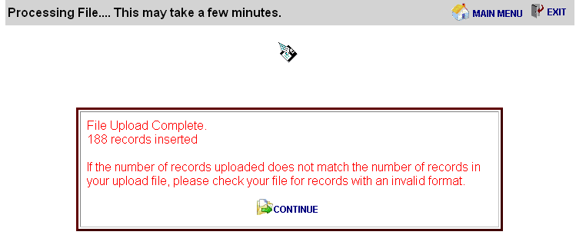

To upload Assignment records, click 'Upload Assignment Files'. The file name should be asn1202.txt

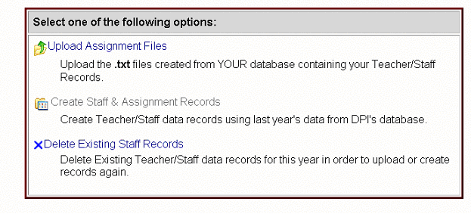

Enter or browse to a file location and click the 'Upload File' button to initiate the upload process.
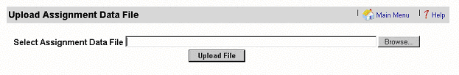

When the upload process is complete, the following message will be displayed. Click the 'Continue' button, to validate the records or click the 'Main Menu' button to exit the upload menu.

Note: Should the user exit the upload process following the upload of the staff file and before uploading the assignment records, the above menu will be displayed upon next entry into the system. The upload of the assignment file must be completed to continue.

Creating Records

Staff and Assignment records can be created from existing DPI data for the previous school year by clicking the 'Create Staff Records' link from the 'Upload or Create Records' Menu. The created records will reflect the most up-to-date data from the DPI database at that point in time, and will have the Local and Total Years of Experience rolled forward one year for each staff member. Any changes made in DPI's data after the time of record creation will not be reflected in the P1202 application.

When the staff records have been completed, the following message will appear. To return to the upload/create records menu, click Continue.

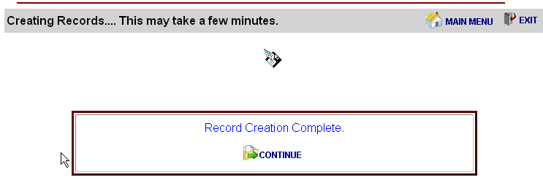

To create assignment records from the DPI database, click 'Create Assignment Records & check for validation Errors.

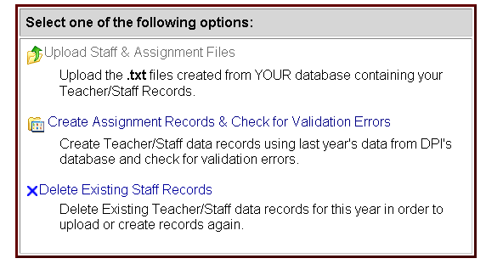

After creation of assignment records, validation is initiated by clicking the 'Continue' Button.

Deleting Records

To delete all records that have been uploaded or created from the DPI database, click "Delete Existing Staff Records" or "Delete Only Assignment Records". Any changes made to these records will be lost when they are deleted. This is not the procedure to use if you wish to delete a record for a single individual or assignment (see page 17 for those procedures).
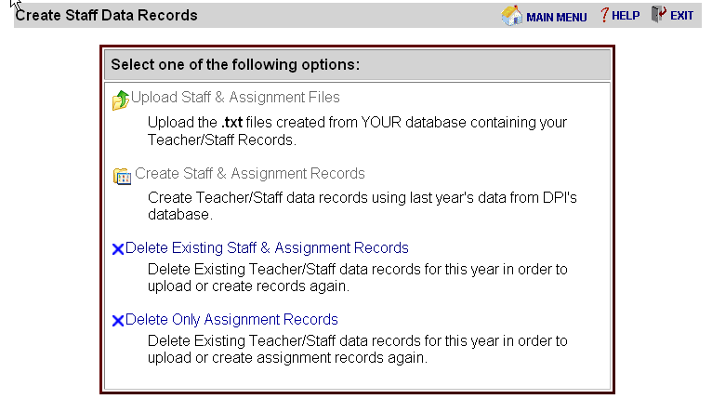

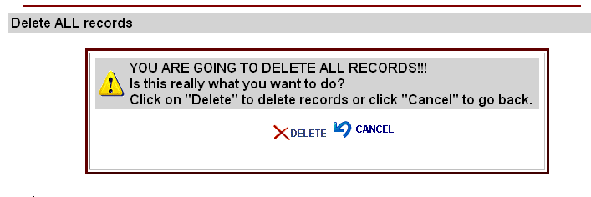

All Staff & Assignment List and Teacher Only Assignment List
From the Main Menu, select the "Staff & Assignment List". The list is available by the first letter of the last name. Only 10 staff records (and all corresponding assignments) are displayed on a page at a time. If a given staff member has more than one assignment, the row colors of assignments will alternate between white and yellow for ease in viewing.

Update the staff files to show staff employed by your agency as of the third Friday in September. Delete records of those no longer employed; add records for new staff members; and update records appropriately. New staff added to the Fall Staff report should show one year of local experience. Total experience should reflect the number of years of educational experience including the current school year.

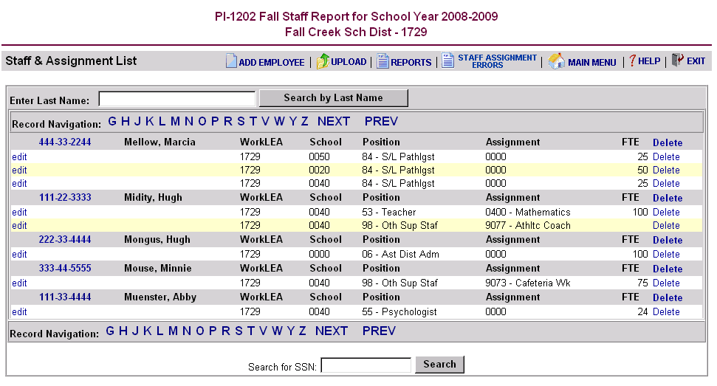

- You can search for an individual by typing the individual’s last name in to the last name search box in the upper left-hand of the Staff & Assignment List screen and selecting the icon to the right labeled ‘search by last name’.
- You can search for an individual by typing the individual’s social security number in the Search for SSN box at the bottom of the Staff & Assignment List screen and selecting the icon to the right labeled ‘search’.
- You can view a list of staff members and assignments using the record navigation bar. See directions below.

The Teacher Only Assignment List functions the same way as the All Staff & Assignment List, but displays only assignments related to position 53. The function was providing for districts when working with only the fields for assignment that report number of classes data.

Record Navigation
- To view a list of staff members and assignments, use the record navigation bar to select the appropriate letter which corresponds to the first letter of the staff member's last name.

- To move within the list of names beginning with the letter that is being viewed, click 'NEXT' or 'PREV'. To view last names starting with a different letter, select the letter from the navigation bar.

- Note that when detail information is saved for a staff member or an assignment, the detail screen will close and return to the Staff & Assignment List with the recently modified record as the first record on the list.

View or Edit Staff Information
To view or edit data for a staff member, click the social security number to the left of the staff member's name. See the 'Employee Information' topic for more information.
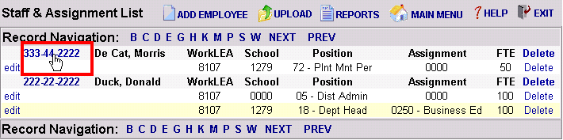

View or Edit Assignment Information
To view or edit assignment data, click 'edit' to the left of the specific assignment. See the 'Assignment Information' topic for more information.

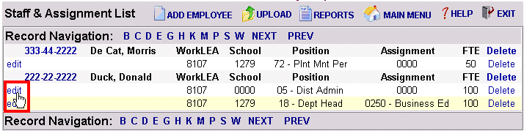

Delete a Staff Member
To delete a staff member, click 'Delete' to the right of the staff member name. All associated assignments will be deleted at the same time.

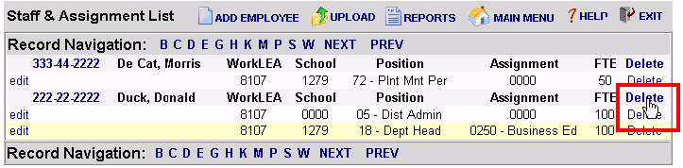

Delete an Assignment
To delete a single staff assignment, click 'Delete' on the right of the assignment information.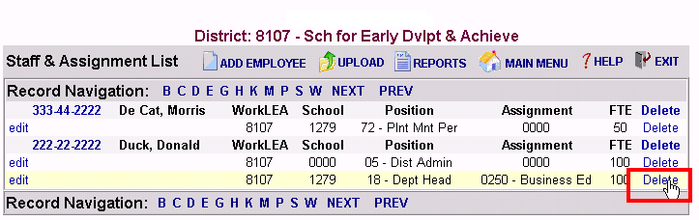

Search by SSN

To search for a staff member by SSN, enter the staff member's social security number in the 'Search for SSN' box and click the 'Search' button to locate a specific staff member.

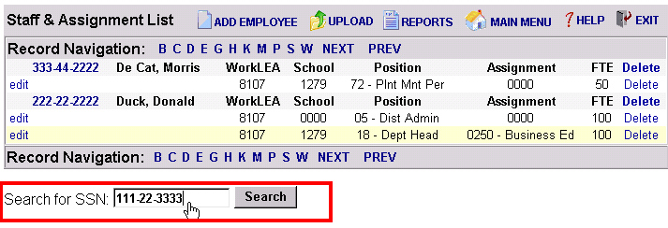

Search by Last Name

To search for a staff member by Last Name, enter the staff member's last name in the 'Enter Last Name' box and click the 'Search by last name' button to locate a staff member.

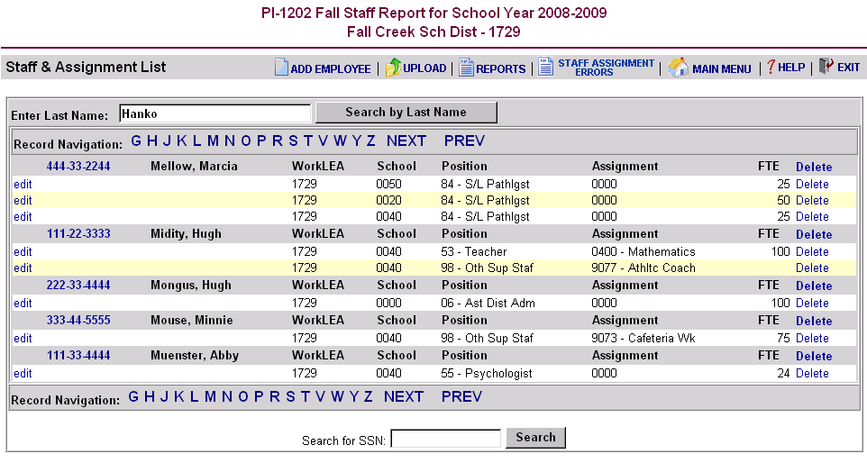

Employment Information
All information except the social security number may be edited. If a staff record has the wrong social security number, the employee and all corresponding assignment records must be deleted and recreated (see instructions under the 'Staff & Assignment List' topic). Add a new record for the individual and add new assignment records. Tips about validation rules are for each field with a red question mark within the Field Level Assistance by Page Guide.

Be sure to update salary information and verify fringe benefit entries. Fringe benefits reported on the PI-1202 Fall Staff report are the total of all of those listed under Object 200 Employee Benefits in the Wisconsin Uniform Financial Accounting Requirements (WUFAR) Handbook.

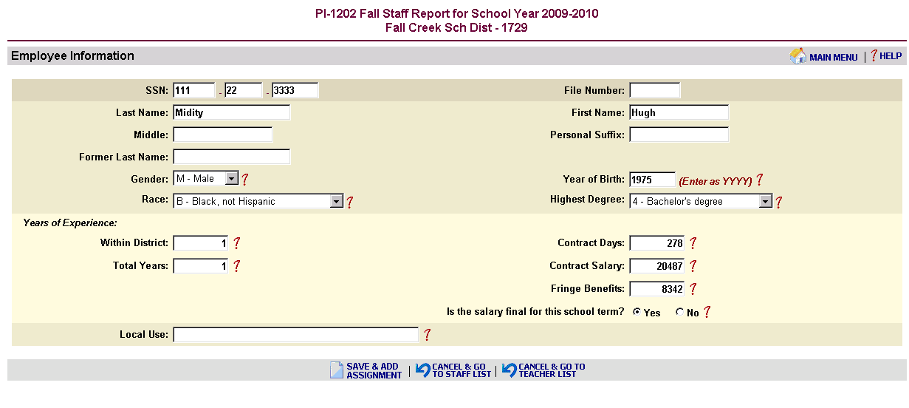

Two options are available to save the Employee Information. Click the 'Save & Add Assignment' Link to save the employee information and add an assignment (for new employees or an existing employee with an additional assignment). Click the 'Save & Return to Staff List' Link to save the employee information and return to the staff list page.

NOTE: The file number will be stored as a 6-digit number until the teacher licensing database has been changed to 7 digits.

Assignment Information
Four criteria are presented to determine the subsequent assignment survey questions. Complete the criteria from top to bottom. To choose a position code, click on the arrow for a drop-down list of choices.

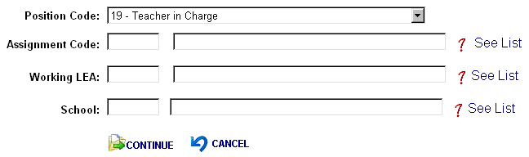

To choose an assignment code, click the “See List” to the right of the Assignment Code line and a list of valid assignments for the chosen position code will be displayed. Double-click the appropriate assignment to add the proper code to the assignment box on the assignment info form. If the assignment code is known, it is not necessary to view the list. Note that selecting a new 'Position Code' will force reentry of the 'Assignment Code'.

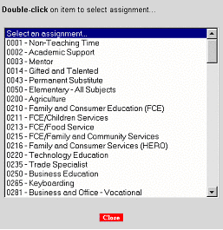

Follow the same procedure to display a list of valid Working LEA's and a list of Valid Schools, to fill the 'Working LEA' and 'School'. Note that selecting a new 'Working LEA' will force reentry of the 'School'.

Teachers (position 53) and principals (position 51) should be reported at a school level, not a district level. Use a school number instead of the 0000 (that is only used for district level reporting). If you prepare a file to import your data, make sure that all teachers and principals are reported at a school level from your source files.

Click 'Continue' to display the next assignment screen.

Depending on the position, assignment and validation rules, a list of questions will be presented about the assignment. This list will vary depending on what information needs to be collected for a given assignment. Refer to the 'Assignment Information' topic in the 'Field Level Assistance by Page' section for further information about the assignment questions.

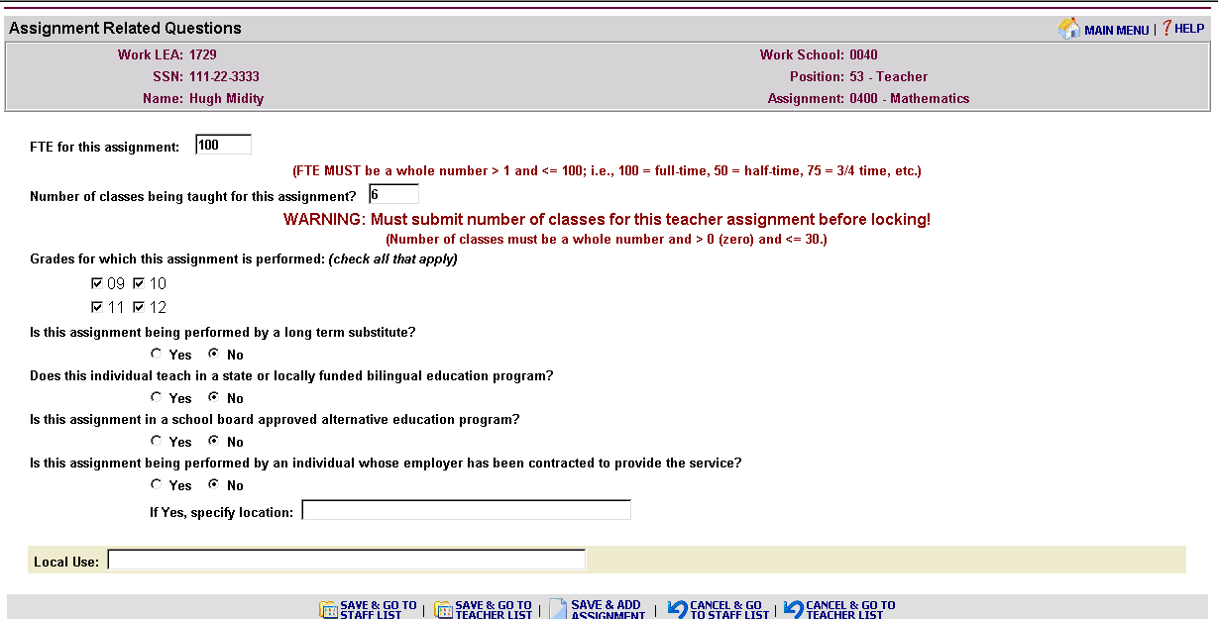

Upon completing the assignment and answering all questions, click 'Save' to save the assignment information and return to the 'Staff & Assignment List'. If the selected staff member has another assignment to add, click on 'Save and Add Assignment' to save the current assignment, and to provide a new assignment screen.

To return to the 'Staff & Assignment List' without saving assignment information, click the 'Cancel' button.

Number of classes taught for Special Education Teachers at the secondary level (grades 09, 10, 11, and 12). A third screen will display requesting the number of courses taught as the primary teacher in the NCLB core subject areas.

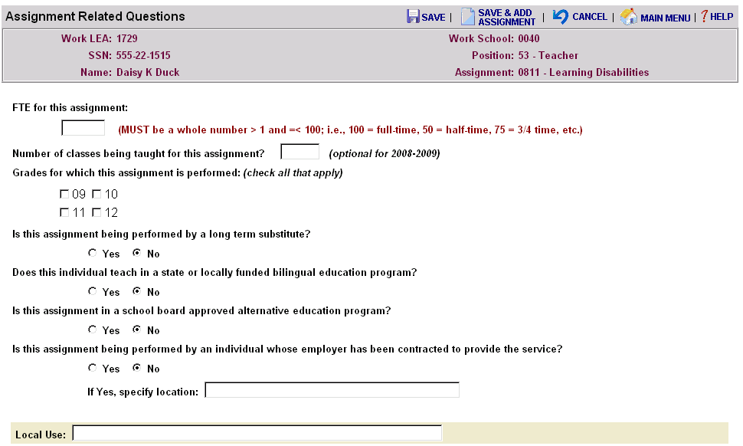

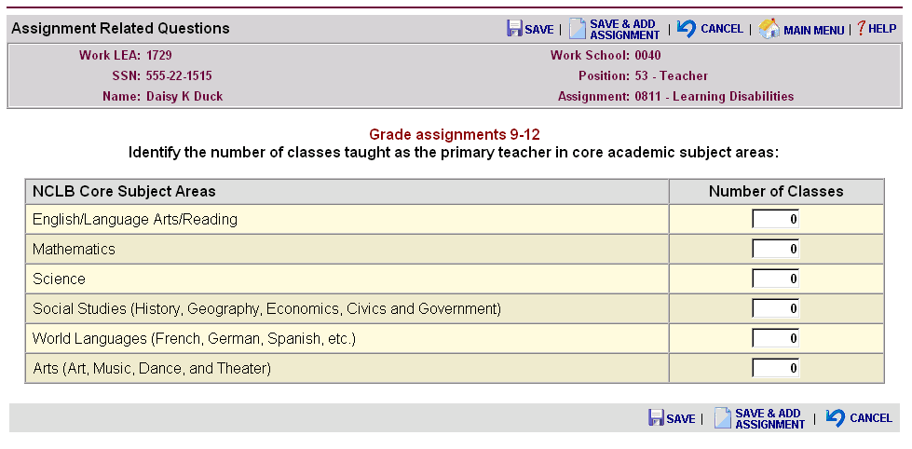

Upon completing the assignment and answering all questions, click 'Save' to save the assignment information and return to the 'Staff & Assignment List'. If the selected staff member has another assignment to add, click on 'Save and Add Assignment' to save the current assignment, and to provide a new assignment screen. To return to the 'Staff & Assignment List' without saving assignment information, click the 'Cancel' button.

Get Staff File Numbers
For districts that use file upload or add new employee staff records and do not have staff file numbers, this step will pull the file number from the DPI’s teacher licensing database based on the social security numbers enter and position/assignment codes. Staff that are in licensed positions and should be licensed but are not yet on the teacher licensing database will display in the Missing/Invalid Staff File Numbers Report (look under the Reports Menu). If file numbers were submitted and do not match the teacher licensing database because of incorrect social security numbers being submitted, will also display on the Missing/Invalid Staff File Numbers Report. From the PI-1202 Main Menu, select the ‘Get Staff File Numbers’.

It will immediately start the search for file numbers.

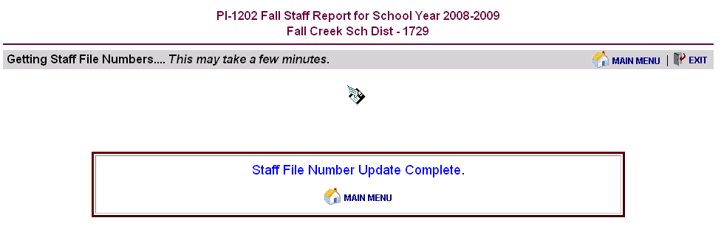
Go to the Reports Menu and click on Missing/Invalid Staff File Numbers to identify any staff records that may have problems.

Check for Validation Errors
Data integrity of staff member and assignment data must be verified prior to submission. The following items must be validated without errors to submit the Fall Staff Report.

Update of District Contact Information
Upload or Creation of Staff & Assignment Records
Missing/Invalid Staff File Numbers
Approval of Administrative Salary Report
Approval of Salary Report by Position, Ethnic Group and Gender
Approval of Schools-No Teacher Position #53 as Staff

Warnings are displayed for questionable data, but do not prevent submission. See the 'Reports Menu' Topic for more information.

Note that errors will NOT appear on the Error and Conflict Reports until 'Check for Validation Errors' has been run. Also, the 'Check for Validation Errors' must be run after error correction to update the Error and Conflict Reports.

Validating Records

Upon completion of the validation process, the following message is displayed. To view a list of assignment errors, go back to the Main Menu, click on "Reports" and then on 'Staff Assignment Errors'. To view a list of staff members and their assignments, go back to Main Menu and click on 'Staff and Assignment List'.

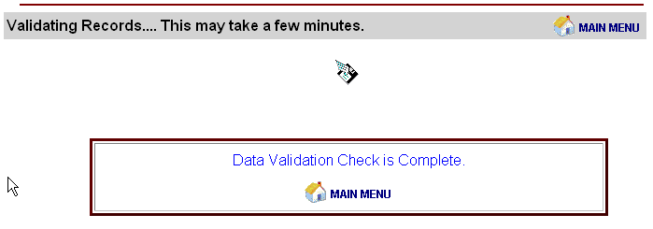

Report Menu
Several reports are available to summarize and prepare Fall Staff Reporting data for submission. In order to submit data to DPI, all errors must be cleared up and the Draft Administrative Salary Report, Draft Staff Report by Position, Ethnic Group and Gender, and Schools – No teacher Position #53 as Staff Report must be viewed and approved.

Note: Errors will NOT appear on the Error and Conflict Reports until 'Check for Validation Errors' has been run from the Main Menu or during the data load process.
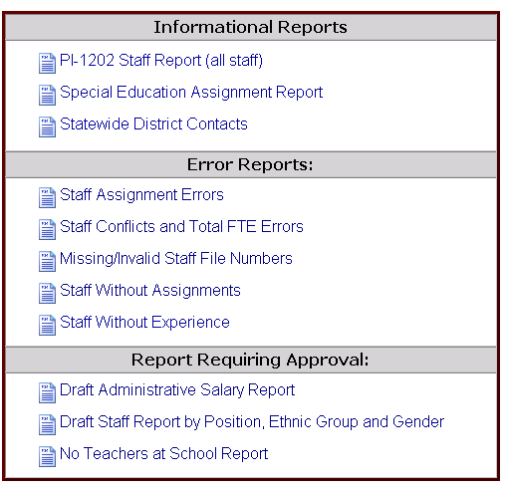

PI-1202 Staff Report and Special Education Assignment Report
The 'PI-1202 Staff Report' and 'Special Education Assignment Report' follow a similar format. The 'Special Education Assignment Report' is a subset of the 'PI-1202 Staff Report'. In both reports, staff will be broken out by the first letter of the last name. The list will vary by the letter selected in the navigation bar at the top of the page. You can filter for specific positions, examples, teachers (position 53) or principals (position 51).
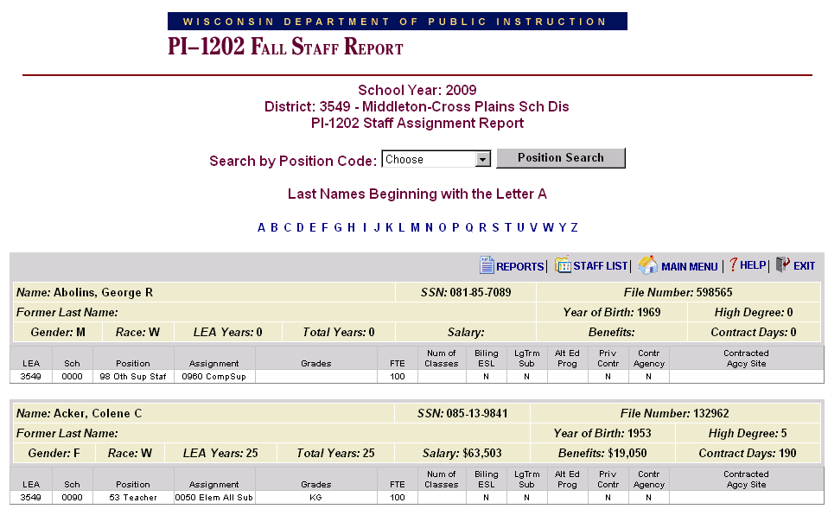

Links at the top of the page will redirect the user back to the report menu or to the main menu.

Statewide District Contacts
This list will provide districts with the names of the individuals completing the PI-1202 Fall Staff Report who can help resolve the name discrepancies between districts errors.
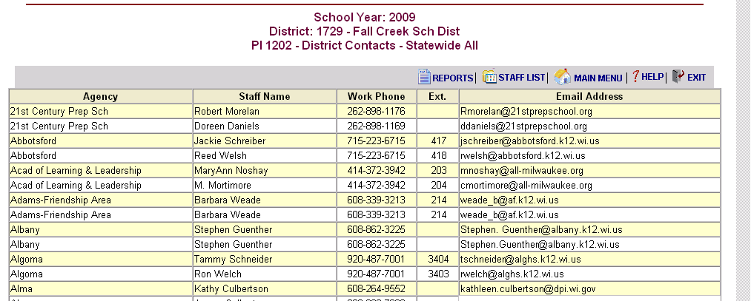

Staff Assignment Errors Report

The 'Staff Assignment Errors' report will list the name, identifying assignment information and the error or warning descriptions. These errors are generated during the data validation check (run after upload or creation of records or from the main menu). After correcting errors, the 'Check for Validation Errors' should be run again to clear out those errors that have been corrected. In order to lock there may be no errors in this report. It is possible to lock with warning messages.
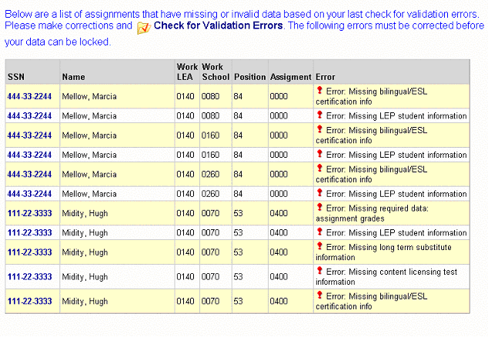

Click on the social security number to continue to the Staff & Assignment List information page to edit employee or assignment information. The navigation bar on top will disappear as the list of staff assignment errors gets smaller.

Staff Conflict Report

The 'Staff Conflict' report lists staff records for individuals who have been reported with the same social security number by multiple districts with different demographic information (name, birth, race, gender, high degree). These conflicts could prevent locking and submission of data. Also if an individual's total FTE across all districts is greater than 200, it will be reported here as well. For assistance, call the DPI, (608) 267-3166 or email dpistats@dpi.wi.gov.

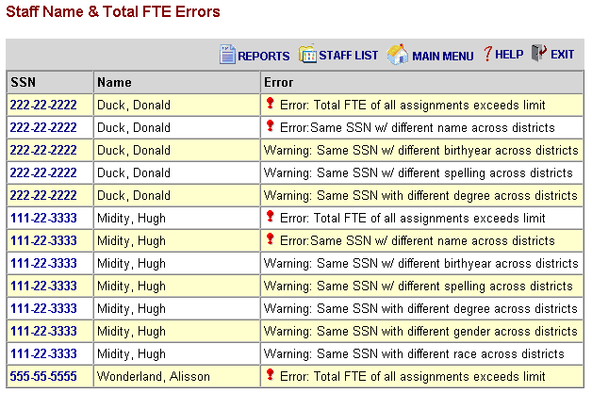

Click on the social security number on a given line to continue to the Duplicate Staff Information page. Demographic information, excluding the name, submitted by all districts for this social security number will be shown. This will help in finding discrepancies in data. For name discrepancies contact the districts listed.

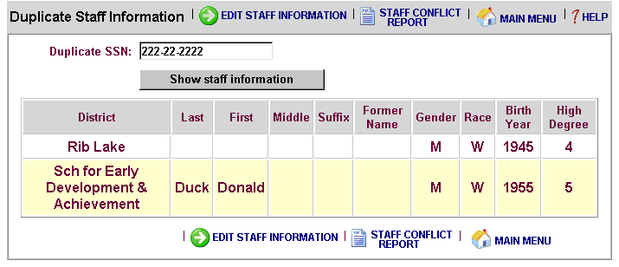

To view duplicate staff information for another person, enter the social security number and click the 'Show Staff Information' button.

Missing/Invalid Staff File Numbers

The Missing/Invalid Staff File Numbers' report displays any staff members that have missing or invalid file numbers based on the social security number reported and the data in the Department of Public Instruction’s Teacher licensing database. All missing or mismatched records will display in the report and must be corrected before locking.

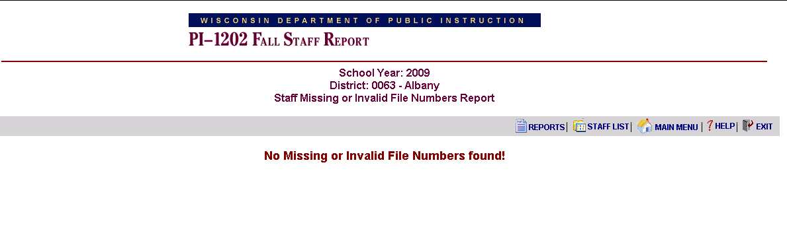

Staff without Assignments Report

The 'Staff without Assignments' report displays any staff members that have no assignments. To add an assignment click 'edit' to the left of the staff member. The 'Employee Information' page will be displayed where the user can choose to add an assignment.

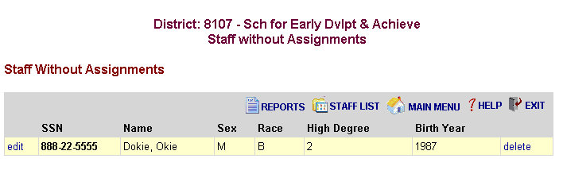

Staff without Experience Report

The 'Staff without Experience' report displays any licensed staff members that have no local or total experience reported. These errors must be corrected before the data can be locked.

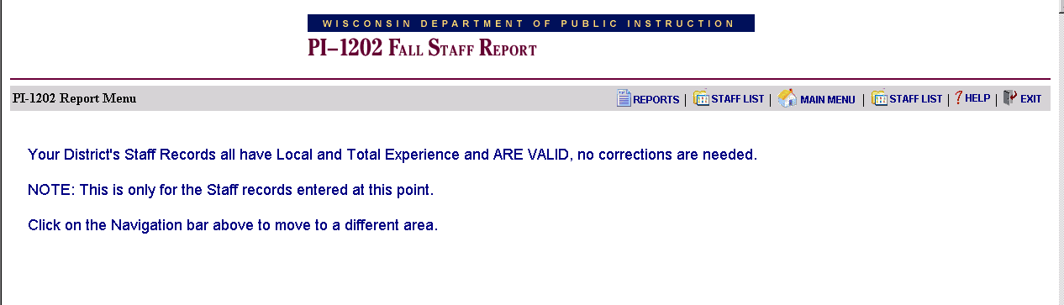

Administrative Salary Report
The 'Administrative Salary Report' displays what the administrative salary report would look like based on the data reported by the district. This can be a tool for catching errors in reporting. In order to lock and submit the data, the district must review this report and select “I accept this report”.

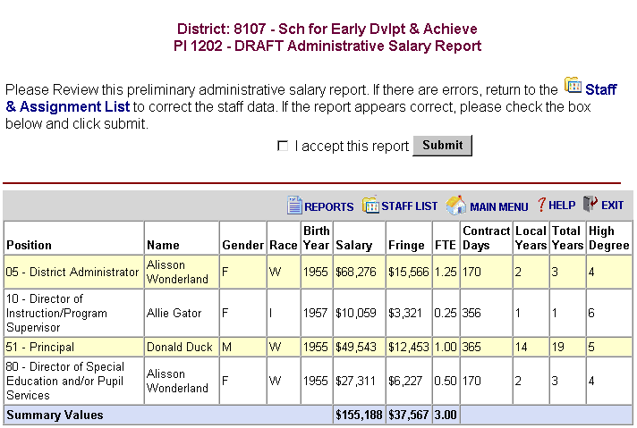

Staff Report by Position, Ethnic Group and Gender
The 'Draft Staff Report by Position, Ethnic Group and Gender' will display FTE reports based on the data provided. This report is broken up into Administrative and Licensed positions. This can be a tool for catching errors in reporting. In order to lock and submit the data, the district must review and approve this report.

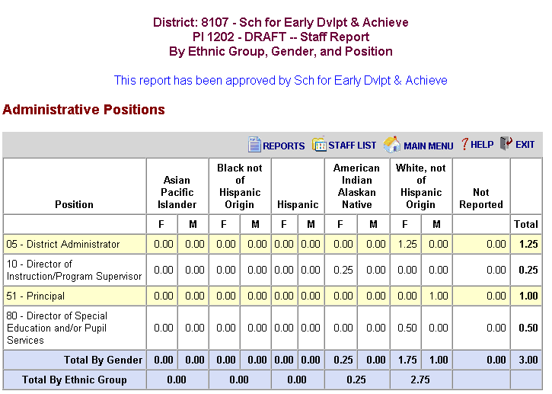

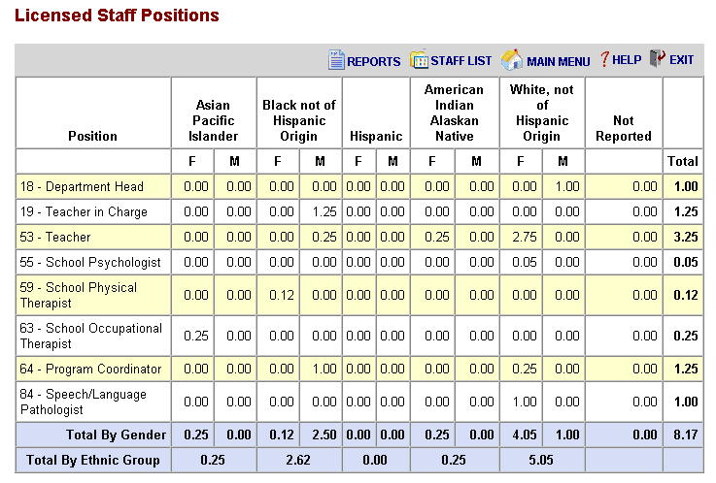

Schools – No Teacher Position #53 as Staff

The ‘Schools-No Teacher Position #53 as Staff' report displays the names of schools that do not have any teachers reported as working at them based on the data reported by the district. This can be a tool for catching errors in reporting. In order to lock and submit the data, the district must review this report and select “I accept this report”.

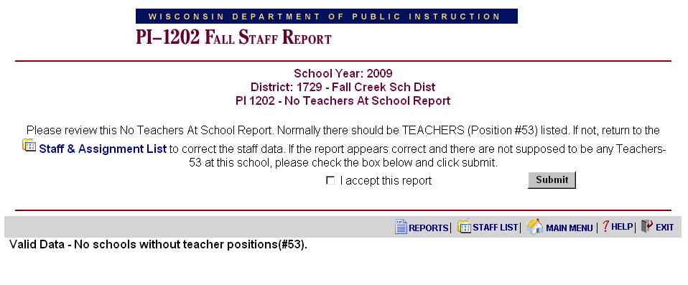

Locking and Submitting the Fall Staff Report
The following items must be completed to submit the Fall Staff Report.

Update of District Contact Information
Upload or Creation of Staff & Assignment Records
Verify that no Validation Errors Exist
Get Staff File Numbers
Review of the Missing/Invalid Staff File Numbers (need to be corrected)
Approval of Administrative Salary Report
Approval of Salary Report by Position, Ethnic Group and Gender
Approval of Schools-No Teachers Position #53 as Staff

Once the Fall Staff Report is submitted, the application is 'locked' meaning modifications may not be made. To "unlock" data for further modification, contact DPI.

Data Definitions
The following definitions are not all inclusive; some data elements are self-explanatory, i.e. Last Name. Conversely, some definitions below are informational only and do not represent a distinct data element, i.e. Staff Type.

Hiring LEA Code: This is the four-digit code that has been assigned by the Wisconsin Department of Public Instruction (DPI) to the agency responsible for completing this report.

School Year: This is the four-digit year that this report represents. For example, school year 2005-2006 = 2006.

Social Security Number: The nine-digit number assigned to the person by the Social Security Administration. This is used to match against DPI license records for auditing data. Invalid numbers will require corrections by the hiring agency.

Staff Types:
Professional - Special Education: All professional staff working with special education programs. This includes: assistant director of special education, director of special education and/or pupil services, school audiologist, school occupational therapist, school physical therapist, school psychologist, school social worker, special education teacher, speech/language pathologist, occupational therapist assistant, physical therapist assistant, educational interpreter and special education program coordinator.

Professional – Regular Education: All staff required to be licensed by DPI other than special education staff. This includes: assistant district administrator, assistant principal, audiovisual/technology specialist, business manager, central office administrator, department head, director of human relations/multicultural education/equity, director of instruction/program supervisor, director of pupil services, district administrator, guidance counselor, librarian, library media specialist, library media supervisor, principal, program coordinator, reading specialist, school nurse, subject coordinator, teacher in charge, and teacher.

Short-Term Substitute Teaching: All people on the active substitute teacher list for an agency as of the third Friday in September. The only qualification for a substitute teacher is that they hold any current teaching license or permit. All assignments will be 20 days or less.

Support – Regular Education: All staff that do not require any license from DPI. This includes: advisor to student club, athletic coach, bookkeeper, bus driver, cafeteria worker, clerical/support staff, director of athletics, director of food services, director of public relations, director of transportation, executive assistant/support supervision, other professional staff in a non-educational role, other support staff, plant maintenance personnel, plant operation personnel, program aide, recreation department, and research.

Support – Special Education:
All support staff working with students with disabilities. This includes: special education program aide, special education bus aide, and early childhood special education aide. These positions require a special education program aide license or a current teaching license or permit.

Personal Suffix: Designations such as Jr, Sr, II, III, etc. Do not use periods or commas as part of the personal suffix.

Gender: Indicates the gender of the staff person.
F = Female
M = Male

Race/Ethnicity Code: Racial/ethnic group with which the staff person identifies.
A = Asian or Pacific Islander: Persons having origins in any of the original peoples of the Far East, Southeast Asia, the Pacific Islands, or the Indian subcontinent. For example, this area includes China, India, Japan, Korea, the Philippine Islands, and Samoa.
B = Black, Non-Hispanic: Persons having origins in any of the black racial groups of Africa.
H = Hispanic: Persons of Mexican, Puerto Rican, Cuban, Central or South American, or other Spanish culture or origin regardless of race.
I = American Indian or Alaskan Native: Persons having origins in any of the original peoples of North America and who maintain cultural identification through tribal affiliation or community recognition.
W = White, Non-Hispanic: Persons having origins in any of the original peoples of Europe, North Africa, or the Middle East.

Year of Birth: The four-digit year in which the staff person was born (must be between 1914 and 1994).

Highest Degree: A code indicating the highest degree of higher learning attained by the staff person regardless of qualifications used on the job.
03 = Associate: A two-year degree from a technical or junior college.
04 = Bachelor’s: Any degree from a four-year program in an accredited college or university.
05 = Master’s: Any master’s degree (such as Master of Arts or Master of Science) from an accredited college or university.
06 = 6-Year Specialist’s: Any degree offered as beyond a Master’s degree but short of a Doctorate, such as is offered in Education Administration.
07 = Doctor’s: Any doctor’s degree (such as Doctor of Philosophy) offered by an accredited university.
08 = Other: Any degree that cannot reasonably be described by any of the other degrees listed here; e.g., School Nurses with a nursing degree (R.N. or L.P.N.) rather than a B.S. degree.

Years of Experience in this LEA: The number of years this person has been employed by this agency, to the nearest half year. The time reported should include time through the school year 2009-2010. (DPI automatically adds one year to this field if records are being created from our database.)

Years of Experience - Total: The number of years this person has been employed by any education agency, to the nearest half year. Private school experience as well as public should be included here. The time reported should include time through the school year 2009-2010. (DPI automatically adds one year to this field if records are being created from our database.)

Note: Both LEA and total years of experience are based on years of experience in education. This may overlap different positions. Example: four years as a teacher at district A and two years as a teacher at district B (B being the reporting district) and six years as a principal at district B would make local years of education experience eight and total experience twelve.

Contract Days: The number of days the individual is contracted to work for the hiring LEA. For teachers, this is the regular school year contract; do not include summer contracts for teachers.

Contract Salary: That amount of money specifically cited in the regular contract between the staff member and the hiring LEA. Do not include pay for extra duties; i.e., coaching, advisor to student, etc. The National Education Association has requested that states report only “regular” salaries for instructional staff. NEA specifically says states should not include salaries for “extra curricular duties” or payments for teaching summer school.

Contract Fringe Benefits: Include the total of all items under Object Code 200 in the WUFAR Handbook. They are 210 Retirement, 220 Social Security, 230 Life Insurance, 240 Health Insurance, 250 Other Employee Insurance, and 290 Other Employee Benefits.

File Number: A required field for all licensed positions since the school year 2008-2009. This is the number found on licenses issued to individuals.

Salary Final: This is a response to the question ‘Is the salary final for the current school term?’ The yes/no answer informs the DPI if the third Friday of September reported salary and fringe benefits are final or if contracts are not yet settled. An answer is required for all employee records except for those reported in positions 43, 97, 98, and 99.

Local Use (Staff): An optional field available for districts to include local codes, etc., that will assist them in submitting and reviewing data.

LEA Code Where This Assignment is Performed: The four-digit code that has been assigned by the DPI for all agencies. This data element is collected for each assignment, and is the LEA code of the agency where a particular assignment is performed. If for example, a teacher is employed by a CESA but has an assignment at a school district, this is the school district’s LEA code.

Working School Code: This is the four-digit code assigned by DPI for the location within the LEA where the assignment is performed. Zeros may be valid for this data element under certain circumstances. Please refer to "Validation Criteria”

Position Code: This is a code that indicates the employee’s classification in the working agency. Please refer to the “Position and Assignment Code List” found at: http://www.dpi.wi.gov/lbstat/fallsf10.html.

Assignment Code: This is a code that indicates the type of assignment being performed for the working agency. Please refer to the “Position and Assignment Code List” mentioned above.

FTE: Full-time equivalency expressed as a whole number. Must be a whole number > 1 and =< 100 (i.e., 100 = full time, 50 = half-time, 75 = ¾ time, etc.). The FTE total for this SSN must be >1 and < 200. Do not include time spent on extra curricular duties such as coaching or as a student advisor.

For professionals:
# of hours the person works in a year
# of hours in the district's standard work year for that employee's classification

For support staff:
# of hours the person works
2,080

Grade Levels for this Assignment: Indicate all grade levels for which this assignment is performed. These data represent the grade levels of the assignment being taught, not the grade levels of the students.

Examples:
If the employee teaches 6th, 7th and 8th grade English, report the grades as 06, 07 and 08.
If the employee teaches 9th grade biology to 9th, 10th and 11th grade students, select grade 09.
If the employee has an elementary special education assignment, the grades may be reported as grades 01, 02, 03, 04, 05, even if there are no students in a particular grade(s).

Note: If grade levels checked are grade 7 or above, and the working school is a middle, junior or high school, then assignment code 0050 is invalid.

Is this assignment being performed by a long-term substitute?: A long-term substitute is an individual who is assigned as a substitute and who is working more than 20 consecutive days in the same assignment.
Y = Yes
N = No

Is this assignment being performed by a contracted individual?: This question is answered for physical or occupational therapists, physical or occupational therapist assistants, and school nurses. Answering this question yes (Y) allows you to skip filling in years of experience, salary and fringe benefits. Privately contracted does not include staff hired through a CESA, CCDEB, or 66.0301.

Does this employee teach in a state or locally funded bilingual education program: Yes (Y) or No (N).

Contracted Agency: Is required, Y, if Yes, N, if No. Default will be set to No. Data element should be answered yes if the assignment being performed is done by an individual that is not an employee of the hiring LEA but is employed by a private agency contracted to provide direct services to students. Examples: a 4-year-old kindergarten teacher hired by a community/private pre-school, head start program, or daycare on behalf of a public school district or a teacher teaching in a partnership school as authorized under Wisconsin Statutes Section 118.153(3)(c)(2) for Milwaukee Public Schools. In both examples the students are reported as public school students in Wisconsin Student Number Locator System (WSLS) and Individual Student Enrollment System (ISES). If this field is reported with a Y, Contracted Agency Site will be required to be completed.

Contracted Agency Site: is required when Contracted Agency is answered Y (yes). The hiring LEA is to report where the individual is providing the service; examples would be the name of the day care facility, Head Start location, private school, or partnership school, etc.

Local Use (Assignment): Local Use is an optional field and can be used for submitting the title of individuals reported as 99-0000, Professional in non-educational related role with no further description/assignment.

Number of Classes? Starting in school year 2009-2010 is required for position 53 except when area/assignment is 0001, 0002, 0003, or 0970. It is number less than 30. Teachers teaching elementary all subjects will be defaulted to 1 if not reported through file upload or on screen entry. Number of classes reported as the middle, junior, and high schools will vary based on the type of schedule used.

Is this assignment part of a School Board approved alternative education Program?
Required for position 53, when assignment is not 0001, 0002, 0003, 0004; Y or N; default will be set to N.

NCLB English: Required only for position 53 when assignment code is between 0800 and 0862 (except when 0808, 0826, 0841, 0860), and is secondary high school teacher serving as the primary/lead teacher of the class. Number of English classes taught. NCLB English includes English, language arts, reading, speech and journalism.

NCLB Math: Required only for position 53 when assignment code is between 0800 and 0862 (except when 0808, 0826, 0841, 0860), and is secondary high school teacher serving as the primary/lead teacher of the class. Number of mathematics courses taught. NLCB Math includes all related courses in the subject area, examples, algebra, calculus, geometry, etc.

NCLB Science: Required only for position 53 when assignment code is between 0800 and 0862 (except when 0808, 0826, 0841, 0860), and is secondary high school teacher serving as the primary/lead teacher of the class. Number of science courses taught. NCLB Science includes all related courses in the subject area, examples, chemistry, physical sciences, physics, earth science, etc.

NCLB Social Studies: Required only for position 53 when assignment code is between 0800 and 0862 (except when 0808, 0826, 0841, 0860), and is secondary high school teacher serving as the primary/lead teacher of the class. Number of social studies classes taught. NCLB Social Studies includes history, geography, economics, and civics and government.

NCLB World Language: Required only for position 53 when assignment code is between 0800 and 0862 (except when 0808, 0826, 0841, 0860), and is secondary high school teacher serving as the primary/lead teacher of the class. Number of world language classes taught. NCLB World Language includes all foreign languages, examples, Spanish, Chinese, French, German, etc.

NCLB Arts: Required only for position 53 when assignment code is between 0800 and 0862 (except when 0808, 0826, 0841, 0860), and is secondary high school teacher serving as the primary/lead teacher of the class. Number of classes taught in the arts area. NCLB Arts includes art, music, dance, and theater.

NOTES: The following position/assignment codes may be reported with a Working School Code of 0000, only if the individual worked at more than five locations. DPI will be monitoring these cases closely and may rescind this waiver in the next reporting period:

- 53/0001 Teacher Non-Teaching Time
- 53/0002 Academic support
- 53/0003 Mentor
- 53/0312 Title I Reading
- 53/0506 Music Instrumental
- 53/0511 Music Choral, grades 6-12
- 53/0515 Music General
- 53/0800 Cross Categorical
- 53/0805 Hearing Impairment
- 53/0808 Early Childhood Special Education
- 53/0810 Cognitive Disability
- 53/0811 Learning Disability
- 53/0815 Orthopedic Impairment
- 53/0825 Visual Impairment
- 53/0826 Orientation and Mobility
- 53/0830 Emotional Behavioral Disability
- 53/0832 Other Health Impairment
- 53/0840 Special Education Hospital Program
- 53/0841 Special Education Homebound Program
- 53/0860 Adaptive Physical Education
- 53/0933 Homebound Instruction
- 53/0935 At-Risk Tutor
- 53/0952 Alternative Education
- 84/0000 Speech/Language Pathologist

Employee Information Page Field Level Assistance
SSN:
Required. Numeric. Nine digits.

Last Name:
Required. A-Z, apostrophe and hyphen only.

First Name:
Required. A-Z, apostrophe and hyphen only.

Middle:
Optional. Can be middle name or just initial. A-Z, apostrophe and hyphen only.

Personal Suffix:
Optional.

Former Last Name:
Optional. A-Z, apostrophe and hyphen only.

Gender:
Required; F = female, M = male.

Race/Ethnicity:
Required. ; must be A, B, H, I, or W.

Year of Birth:
Required, Four-digit century/year combination. Use the following formula to validate: School Year minus Birth Year must be <= 99 and >= 15.

Highest Degree:
May be blank for: Contracted individual; position/assignment code 43/0000; and assignment types of “Support”, both regular and special education.

Years Experience - Within District:
One to three numeric digits, expressed as a decimal, nn.n. Must be >= 1 and <= 99.5. May be blank for: Contracted individual; position 43/0000; and assignment types of “Support”, both regular and special education.

This can be determined asking the Human Resources staff for this LEA, by reviewing the employee's personnel files, and/or by asking the employee.

Years Experience - Total Years (in Education):
One to three numeric digits, expressed as a decimal, nn.n. Must be >= 1 and <= 99.5. May be blank for: Contracted individual; position/assignment code 43/0000; and assignment types of “Support”, both regular and special education. Must be => “Years of Experience in this LEA”.

This can be determined asking the Human Resources staff for this LEA, by reviewing the employee's personnel files, and/or by asking the employee.

Contract Days:
One to three numeric digits, no decimal. May be blank for: Contracted individual; position/assignment code 43/0000; assignment types of “Support”, both regular and special education.

Contract Salary:
Three to six numeric digits, no decimal, <= 200000. May be blank for: Contracted individual; position/assignment code 43/0000; and assignment types of “Support” both regular and special education.

Contract Fringe Benefits:
Three to six numeric digits, no decimal, <= 99999. May be blank for: Contracted individual; position/assignment code 43/0000; and assignment types of “Support”, both regular and special education.

File Number:
Seven numeric digits, no decimal, <= 99999. Optional for 2007-08; Required for all licensed individuals starting in 2008-09. May be blank for: individuals that do not need to hold a license for their assignment.

Salary Final:
Required for records that have assignment records reported for licensed assignments. Y = Yes, N = No; blank if positions 43, 97, 98, and 99. This is a response to the question ‘Is the salary final for the current school term?’

Local Use (Staff):
50 characters. May be blank. Optional field for districts to use to include local codes, etc., that will assist them in submitting and reviewing data.

Assignment Information Page Field Level Assistance
Position Code:
Required. Must be a valid Position code as found in the Position/Assignment table for the year being reported.

Assignment Code:
Required. Must be a valid Assignment code as found in the Position/Assignment table for the year being reported.

Working LEA:
Required. The DPI assigned LEA number of the agency where this assignment is being performed.

Working School:
Required. The DPI assigned school number where this assignment is being performed. Must be a valid school number for the “Working LEA”.

If the hiring LEA is a CESA or CCDEB and the working LEA is a CESA or CCDEB, the school number = zeros.

If the working LEA is not a 2R charter, zeros are a valid school number for 53/002, 53/003, 53/0840, 53/0841 and 53/0935 but not for any other 53/assignment combination, nor for positions 19, 51, 52 and 84. Zeros are valid for all other positions not mentioned here.

Zeros are not a valid number for the 2R charter schools.

FTE percentage for this assignment:
Required except for position/assignment 43/0000, and position codes 98/9077 and 98/9078. The FTE total for this SSN must be > 1.00 and < 200.00.

Is this assignment being performed by a long-term substitute?:
Required when Position = 53, and for position/assignment combinations 54/0000, 62/0884, 84/0000 or 85/0000. Y or N.

Does this employee teach in a state or locally funded bilingual education program?
Required only for positions 53 and 84/0000. Y or N.

Is this assignment being performed by a contracted individual?:
Required only for position and assignment code combinations: 59/0888, 59/0886, 63/0888, 63/0885, 75/1000 or 75/8000. Default to ‘Y’ when Hiring LEA Numbers are 7000 or 7100. Yes or No.

Grades for which this assignment is performed:
Required for positions 51, 52, 53, 80, 83 and 84.

Default to the district’s grade range when working school equals zeros or position is 80 or 83.

Default to the school’s grade range when position is 51 or 52.

NOTE: Assignment code 0050 is not valid if grade levels checked are 7 or above, and the school is a Middle, Junior, or High School.

Contracted Agency:
Required Y or N; default will be set to N.

Contracted Agency Site:
Required if Contracted Agency answered as Y, else blank.

Local Use:
Optional. Note: can be used for providing additional information for titles when reporting assignments as 99/0000.

Number of Classes:
Required only for position 53 except if assignment is 0001, 0002, 0003, or 0970, a number less than 10. Teachers teaching elementary all subjects will be defaulted to 1 if not reported through file upload or on screen entry Number of classes reported as the middle, junior, and high schools will vary based on the type of schedule used.

School Board Approved Alternative Education Program:
Required for position 53, when assignment is not 0001, 0002, 0003, 0004; Y or N; default will be set to N.

NCLB English:
Required only for position 53 when assignment code is between 0800 and 0862 (except when 0808, 0826, 0841, 0860), and is secondary high school teacher serving grades 09-12 as the primary/lead teacher of the class. 2 digits, a number no greater than 10.

NCLB Math:
Required only for position 53 when assignment code is between 0800 and 0862 (except when 0808, 0826, 0841, 0860), and is secondary high school teacher serving grades 09-12 as the primary/lead teacher of the class. 2 digits, a number no greater than 10.

NCLB Science:
Required only for position 53 when assignment code is between 0800 and 0862 (except when 0808, 0826, 0841, 0860), and is secondary high school teacher serving grades 09-12 as the primary/lead teacher of the class. 2 digits, a number no greater than 10.

NCLB Social Studies:
Required only for position 53 when assignment code is between 0800 and 0862 (except when 0808, 0826, 0841, 0860), and is secondary high school teacher serving grades 09-12 as the primary/lead teacher of the class. 2 digits, a number no greater than 10.

NCLB World Language:
Required only for position 53 when assignment code is between 0800 and 0862 (except when 0808, 0826, 0841, 0860), and is secondary high school teacher serving grades 09-12 as the primary/lead teacher of the class. 2 digits, a number no greater than 10.

NCLB Arts:
Required only for position 53 when assignment code is between 0800 and 0862 (except when 0808, 0826, 0841, 0860), and is secondary high school teacher serving grades 09-12 as the primary/lead teacher of the class. 2 digits, a number no greater than 10.

Common Reporting Errors
Duplicate staff records: If the same year, LEA and SSN appear on separate records within the upload, only the first record will be added. A message will be displayed upon completion of the upload process that there were multiple records for a single SSN in the file.

Duplicate assignment records: If the same year, SSN, hiring agency, working agency, school, position and area appear on separate records, a message will be displayed upon completion of the upload process that there were multiple records for a single assignment. If a staff member holds the same assignment for different grades, all the grades should appear in a single assignment listing.

Name Conflicts: If the name is different (first three letters of first or last name is different) than names with SAME SSN across ALL districts, there will be an error and the data cannot be locked. If there is a misspelling (first three letters are the same, but the rest is different) then it will result in a warning. Data can still be locked but it is recommended that data is corrected in the districts' records (on line and in their offices).

Other staff errors: if race, gender or birth year are different for same SSN across districts an error will be generated. These errors will have to be resolved before data can be locked.

Assignment Records without corresponding Staff Records: Any assignments within that district which do not have a corresponding staff record will be deleted during the validation process. A message will appear upon completion of the validation process listing the SSN of the assignments that were deleted.

Upload File Structures

Staff File Structure
The file name is stf1202.txt. The file contains information for each individual employed or contracted by the reporting (hiring) agency.

The record is 199 bytes long. For specific information for valid fields entry, see the 'Validation Criteria' topic.

 | Data Type | Start  Position | Length | Format
Filler | spaces | 1 | 1
Social Security Number | numeric | 2 | 9
Filler | space | 11 | 1
Hiring LEA Number | numeric | 12 | 4
Last Name | alphanumeric | 16 | 20
First Name | alphanumeric | 36 | 16
Gender | alpha | 52 | 1
Race Code | alpha | 53 | 1
Year of Birth | numeric | 54 | 4
Highest Degree | numeric | 58 | 2
School Year | numeric | 60 | 4
Filler | spaces | 64 | 4
Local Years Experience | numeric | 68 | 3 | 99v9
Total Years Experience | numeric | 71 | 3 | 99v9
Contract Salary | numeric | 74 | 6
Contract Fringe Benefits | numeric | 80 | 6
Generation | alphanumeric | 86 | 10
Filler | spaces | 96 | 2
Final Salary Code* | alpha | 98 | 1
Filler | spaces | 99 | 1
Former Last Name | alphanumeric | 100 | 20
Middle Initial or Name | alphanumeric | 120 | 20
Contract Days | numeric | 140 | 3
File Number | Numeric | 143 | 7
Local USE | Alphanumeric | 150 | 50

*Final Salary Code was collected prior to 2004 and is being added back into the collection for 2010. The actual question in the application: “Is the salary final for the school term?”

Assignment File Structure
The file name is asn1202.txt. This file contains all the assignment information for each individual employed or contracted by the reporting (hiring) agency. It should contain one record for each reportable activity a person is assigned. Position codes are designed to cover all employees of education agencies and assignment codes for all activities that need to be reported.

The record is 266 bytes long. For specific information for valid fields entry, see the 'Validation Criteria' topic.
Note that 'Grade Levels' is an array of 22 2-byte fields. Beginning in position 43, store two characters for each grade for which this assignment is performed, i.e., 020305.

 | Data Type | Start  Position | Length | Format
Filler | spaces | 1 | 1
Social Security Number | numeric | 2 | 9
Working LEA Number | numeric | 11 | 4
Filler | spaces | 15 | 3
Position Code | numeric | 18 | 2
Assignment Code | numeric | 20 | 4
Hiring LEA Number | numeric | 24 | 4
FTE (percentage) | numeric | 28 | 3 | 999
Number of Classes** | numeric | 31 | 2
Bilingual Program | alpha | 33 | 1
Working School Number | numeric | 34 | 4
Long Term Sub | alpha | 38 | 1
Sch Board Approved Alternative Educ Prog | alpha | 39 | 1
Contracted Assignment | alpha | 40 | 1
Contracted | alpha | 41 | 1
Filler | spaces | 42 | 1
Grade Levels | alphanumeric | 43 | 44
School Year | numeric | 87 | 4
NCLB English** | Numeric | 91 | 2
NCLB Math** | Numeric | 93 | 2
NCLB Science** | Numeric | 95 | 2
NCLB Social Studies** | Numeric | 97 | 2
NCLB World Language** | Numeric | 99 | 2
Arts** | Numeric | 101 | 2
Filler to fixed length (note change in length) | spaces | 103 | 14
Contracted Agency Site | alphanumeric | 117 | 50
Local Use | alphanumeric | 167 | 100
**These fields were optional in 2009; they are required for the appropriate assignments in 2010.

Validation Criteria for the Staff & Assignment Files

Staff File:

SSN:
Required. Numeric. Nine digits.

Hiring LEA:
Required. The DPI assigned LEA number of the agency responsible for reporting this data.

Last Name:
Required. A-Z, apostrophe and hyphen only.

First Name:
Required. A-Z, apostrophe and hyphen only.

Gender:
Required: F = female, M = male.

Race/Ethnicity Code:
Required: A=Asian or Pacific Islander; B=Black, not Hispanic; H=Hispanic; I=American Indian or Alaskan Native; W=White, not Hispanic.

Year of Birth:
Required: Four-digit century/year combination. Use the following formula to validate: School Year minus Birth Year must be <= 99 and >= 15.

Highest Degree Received:
Codes 03, 04, 05, 06, 07 or 08. May be blank for: Contracted individual; position/assignment code 43/0000; and assignment types of “Support”, both regular and special education. 03=Associate, 04=Bachelor’s, 05=Master’s, 06=6-Year Specialist’s, 07=Doctorate, 08=Other.

School Year:
Four-digit century/year combination for the current school year. For example, school year 2002-2003 = 2003.

Years of Experience in this LEA:
One to three numeric digits, expressed as a decimal, nn.n. Must be >= .5 and <= 99.5. May be blank for: Contracted individual; position 43/0000; and assignment types of “Support”, both regular and special education.

This can be determined asking the Human Resources staff for this LEA, by reviewing the employee's personnel files, and/or by asking the employee.

Years of Experience in Education:
One to three numeric digits, expressed as a decimal, nn.n. Must be >= .5 and <= 99.5. May be blank for: Contracted individual; position/assignment code 43/0000; and assignment types of “Support”, both regular and special education. Must be => “Years of Experience in this LEA”.

This can be determined asking the Human Resources staff for this LEA, by reviewing the employee's personnel files, and/or by asking the employee.

Contract Salary:
Three to six numeric digits, no decimal, <= 200000. May be blank for: Contracted individual; position/assignment code 43/0000; and assignment types of “Support” both regular and special education.

Contract Fringe Benefits:
Three to six numeric digits, no decimal, <= 99999. May be blank for: Contracted individual; position/assignment code 43/0000; and assignment types of “Support”, both regular and special education.

Generation:
Optional.

Former Last Name:
Optional. A-Z, apostrophe and hyphen only.

Middle:
Optional. Can be middle name or just initial. A-Z, apostrophe and hyphen only.

Contract Days:
One to three numeric digits, no decimal. May be blank for: Contracted individual; position/assignment code 43/0000; assignment types of “Support”, both regular and special education.

File Number:
Seven numeric digits, no decimal, <= 99999. Optional for 2007-08; Required for all licensed individuals starting in 2008-09. May be blank for: individuals that do not need to hold a license for their assignment.

Salary Final:
Required for records that have assignment records reported for licensed assignments. Y = Yes, N = No; blank if positions 43, 97, 98, and 99. This is a response to the question ‘Is the salary final for the current school term?’

Local Use (Staff):
50 characters. May be blank. Optional field for districts to use to include local codes, etc., that will assist them in submitting and reviewing data.

Assignment File:

SSN:
Required. Numeric. Nine digits.

Working LEA Number:
Required. The DPI assigned LEA number of the agency where this assignment is being performed.

Position:
Required. Must be a valid Position code as found in the Position/Assignment table for the year being reported.

Assignment:
Required. Must be a valid Assignment code as found in the Position/Assignment table for the year being reported.

Hiring LEA:
Required. The DPI assigned LEA number of the agency responsible for reporting this data.

FTE for this assignment:
Required except for position/assignment 43/0000, and position codes 77 and 78. The FTE total for this SSN must be > 1.00 and < 200.00.

Working School Number:
Required. The DPI assigned school number where this assignment is being performed. Must be a valid school number for the “Working LEA”.

If the hiring LEA is a CESA or CCDEB and the working LEA is a CESA or CCDEB, the school number = zeros.

If the working LEA is not a 2R charter, zeros are a valid school number for 53/0840, 53/0841 and 53/0935 but not for any other 53/assignment combination, nor for positions 51, 52 and 84. Zeros are valid for all other positions not mentioned here.

Zeros are not a valid number for the 2R charter schools.

Is this assignment being performed by a long-term substitute?:
Required when Position = 53, and for position/assignment combinations 54/0000, 62/0884, 84/0000 or 85/0000. Y or N.

Does this employee teach in a state or locally funded bilingual education program:
Required only for positions 53 and 84/0000. Y or N.

Is this assignment being performed by a contracted individual?:
Required only for position and assignment code combinations: 59/0888, 59/0886, 63/0888, 63/0885 or 75/0000. Default to ‘Y’ when Hiring LEA Numbers are 7000 or 7100. Yes or No.

Grades for which this assignment is performed:
Required for positions 51, 52, 53, 54, 80, 83 and 84.

Default to the school's grade range when position is 51 or 52.

Default to the district's grade range when working school equals zeros or positions is 80 or 83.

Position/assignment code combination 53/0050 is not valid if grade levels checked are 07 or above, and the school is a Middle, Junior, or High School.

Position/assignment code combination 53/0050 is not valid if grade levels checked are 09 or above, and the school is a PK-12 school.

Position/assignment code combination 53/0050 is invalid if reported with > four grades. A warning will be issued if 53/0050 is reported with three or four grades.

Position/assignment code combination 53/0808 is invalid if reported with any grades > 03.

School Year:
Four-digit century/year combination for the current school year. For example, school year 2002-2003 = 2003.

Contracted Agency:
Required Y or N; default will be set to N.

Contracted Agency Site:
Required if Contracted Agency answered as Y, else blank.

Local Use:
Optional. Note: can be used for providing additional information for titles when reporting assignments as 99/0000.

Number of Classes:
Required only for position 53 except if assignment is 0001, 0002, 0003, or 0970, a number less than 10. Teachers teaching elementary all subjects will be defaulted to 1 if not reported through file upload or on screen entry Number of classes reported as the middle, junior, and high schools will vary based on the type of schedule used.

School Board Approved Alternative Education Program:
Required for position 53, when assignment is not 0001, 0002, 0003, 0004; Y or N; default will be set to N.

NCLB English:
Required only for position 53 when assignment code is between 0800 and 0862 (except when 0808, 0826, 0841, 0860), and is secondary high school teacher serving grades 09-12 as the primary/lead teacher of the class. 2 digits, a number no greater than 10.

NCLB Math:
Required only for position 53 when assignment code is between 0800 and 0862 (except when 0808, 0826, 0841, 0860), and is secondary high school teacher serving grades 09-12 as the primary/lead teacher of the class. 2 digits, a number no greater than 10.

NCLB Science:
Required only for position 53 when assignment code is between 0800 and 0862 (except when 0808, 0826, 0841, 0860), and is secondary high school teacher serving grades 09-12 as the primary/lead teacher of the class. 2 digits, a number no greater than 10.

NCLB Social Studies:
Required only for position 53 when assignment code is between 0800 and 0862 (except when 0808, 0826, 0841, 0860), and is secondary high school teacher serving grades 09-12 as the primary/lead teacher of the class. 2 digits, a number no greater than 10.

NCLB World Language:
Required only for position 53 when assignment code is between 0800 and 0862 (except when 0808, 0826, 0841, 0860), and is secondary high school teacher serving grades 09-12 as the primary/lead teacher of the class. 2 digits, a number no greater than 10.

NCLB Arts:
Required only for position 53 when assignment code is between 0800 and 0862 (except when 0808, 0826, 0841, 0860), and is secondary high school teacher serving grades 09-12 as the primary/lead teacher of the class. 2 digits, a number no greater than 10.

