Portfolio

Wisconsin Cooperative Education Skill Certification
Health Science Occupations-Career Foundations
Coop Areas Completed | Student Information
- Core Employability Competencies  - Health Science Occupations  - Academic Foundation  - Communications  - Systems  - Legal Responsibilities  - Ethics  - Safety Practices  - Teamwork  - Health Maintenance Practices
  Start Date:
  End Date:
  Student | Phone
  School | Phone
  Teacher Coordinator | Phone
  Workplace Mentor | Phone
  Other Information: | 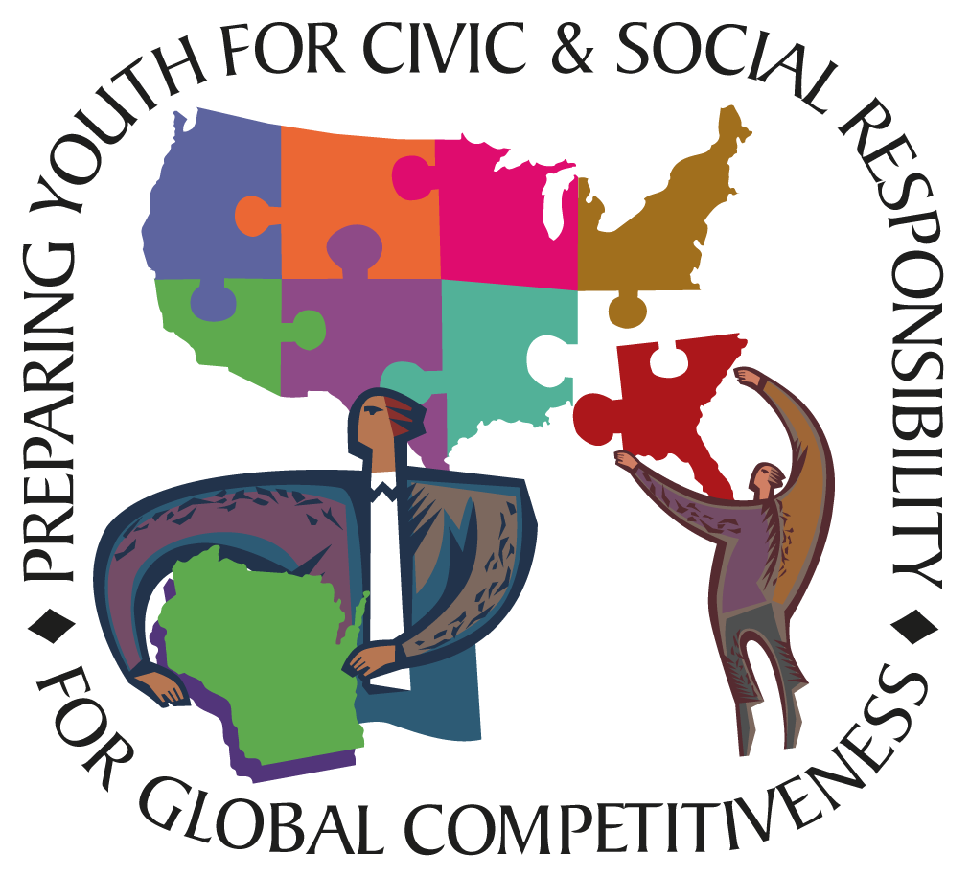

Health Science Occupations Skill Standards Rating Scale

3 Proficient—able to perform entry-level skills independently.
2 Intermediate—has performed tasks; however, may need additional training or supervision.
1 Introductory—is familiar with process but is unable, or has not had the opportunity, to perform task; additional training is required.
SB School Based
WB Work Based
Rating |  |  |  |  |  |  |  |  |  |  | Initials
Description of Skills |  |  |  | 3 |  |  |  |  | 2 |  |  |  | 1 |  | SB | WB |  |  | Comments
PART ONE: Core Employability Competencies
23 competencies must be achieved at level 2 or 3
Basic Skills
- Reading⎯locates, understands, and interprets written information in prose and in documents such as manuals, graphs, and schedules.
- Writing⎯communicates thoughts, ideas, information, and messages in writing; and creates documents such as letters, directions, manuals, reports, graphs and flow charts.
- Mathematics⎯Performs basic computations and approaches practical problems by choosing appropriately from a variety of mathematical techniques.
- Listening⎯receives, attends to, interprets, and responds to verbal messages and other cues.
- Speaking⎯organizes ideas and communicates orally.
- Career Development⎯understands application process, develops personal career goals, understands individual potential.
Personal/Interpersonal Skills: Displays responsibility, self-esteem, sociability, self-management, integrity and honesty, and extends these skills to facilitating working well with others
- Demonstrates integrity/honesty and chooses ethical courses of action.
- Serves clients/customers, working to satisfy customer’s expectations.
- Participates as a member of a team, contributing to group efforts.
- Demonstrates leadership skills, including teaching others new skills.
- Works well with women and men from diverse backgrounds.
- Accepts criticism and applies suggestions for improvement.
- Identifies needs and communicates in appropriate manner.
- Manage time, prioritize responsibilities, and meet completion dates as specified by employer and client.
- Shows enthusiasm and commitment by meeting expectations and priorities of the organization.
Thinking/Information Processing Skills: Thinks creatively, makes decisions, solves problems, visualizes, knows how to learn and reason, and acquire and utilize information to aid these processes where necessary
- Organizes, maintains, interprets, communicates information, using computers to aid this task where necessary.
- Recognizes problems and devises and implements plans of action.
- Generates new ideas through creative thinking.
- Makes decisions through specifying goals and constraints, generating alternatives, considering risks, and evaluating and choosing the best alternatives.
- Uses efficient learning techniques to acquire and apply new knowledge and skills.
Systems/Technology: Understands complex interrelationships of systems and works with a variety of technologies
- Knows how social, organizational, and technological systems work and operates effectively within them.
- Understands relationships among technological functions, pinpoints errors in technologies’ performance and corrects problems in operations.
- Selects the appropriate tools or equipment for a task, including computers and related technologies.
- Understand the function and proper procedures for technologies related to a task.
- Prevents, identifies, or solves problems with equipment, including computers and other technologies.
- Understands basic safety precautions and takes measures to implement them.
PART TWO: Health Science Occupations Competencies/Academic Foundation
8 competencies must be achieved at level 2 or 3
Human Structure and Function
- Describe the basic structures and functions of cells, tissues, organs, and systems as they relate to homeostasis.
- Compare relationships among cells, tissues, organs, and systems.
- Explain body planes, directional terms, quadrants, and cavities.
- Analyze the interdependence of the body systems as they relate to wellness, disease, disorders, therapies, and care rehabilitation.
Diseases and Disorders
- Compare selected diseases/disorders including respective classification(s), causes, diagnoses, therapies, and care/rehabilitation to include biotechnological applications.
- Analyze methods to control the spread of pathogenic microorganisms.
- Contrast various types of immunities.
- Analyze body system changes in light of diseases, disorders, and wellness.
- Compare the aging process among the body systems.
Communications
11 competencies must be achieved at level 2 or 3
Oral Communications Skills
- Adjust communication to other’s ability to understand.
- Apply the elements of communication using the sender-receiver model.
- Apply active listening skills using reflection, restatement and clarification techniques.
- Demonstrate courtesy to others including self introduction.
- Interpret verbal and non-verbal behaviors to augment communication and within scope of practice.
- Demonstrate skills for interviewing clients.
Written Communication Skills
- Report relevant information in a timely manner.
- Report subjective information.
- Report objective information.
- Interpret technical materials used for healthcare practices and procedures.
- Organize, write and compile technical information and summaries.
- Use medical terminology within a scope of practice in order to interpret, transcribe and communicate information, data and observations.
Health Care Delivery Systems
7 competencies must be achieved at level 2 or 3
Delivery Trends
- Summarize important milestones in the history of health care..
- Identify major trends affecting modern-day health care..
- Predict the impact of major trends on health care costs.
Delivery Systems
- List the types of health care facilities and the services provided by each
- Describe the ways in which agencies influence community and world health..
Payment Systems
- Explain the various ways that payment is made for the costs of healthcare..
- Identify populations served by each type of payment system.
System Change
- Discuss changing environmental factors (cost, technology, access to care, etc.).
Legal Responsibilities
14 competencies must be achieved at level 2 or 3
Legal Implications
- Analyze legal responsibilities, limitations, and implications of actions.
- Use problem solving techniques when confronted with legal dilemmas or issues.
- Compare and contrast behaviors and practices that could result in malpractice, liability, or negligence.
- Comply with policies and requirements for documentation and record keeping.
- Comply with established risk management criteria and procedures.
- Determine when an incident is reportable.
- Comply with non-discriminatory laws.
- Comply with institutional policy and procedures.
Legal Practices
- Perform duties according to regulations, policies, laws, and legislated rights of clients.
- Maintain clients’ rights according to the Patients’ Bill of Rights.
- Maintain confidentiality.
- Practice within licensure, certification, registration, and legislated scope of practice.
- Apply the doctrine of informed consent.
- Evaluate technological threats to confidentiality.
- Follow mandated standards for workplace safety, i.e., OSHA, CDC, CLIA.
- Identify mandated standards for harassment, labor, and employment laws.
Ethics
13 competencies must be achieved at level 2 or 3
Legal and Ethical Boundaries
- Differentiate between morality and ethics and the relationship of each to health care outcomes.
- Differentiate between ethical and legal issues impacting health care.
- Contrast personal, professional, and organizational ethics.
- Analyze legal and ethical aspects of confidentiality.
- Discuss bio-ethical issues related to health care.
- Analyze and evaluate the implications of medical ethics.
Ethical Practice
- Demonstrate professionalism when interacting with fellow students, co-workers, and the organization.
- Respect interdisciplinary roles of team members.
- Report activities and behaviors by self and others that adversely affect the health, safety, or welfare of students, clients, or co-workers.
- Demonstrate fairness and equal treatment of all persons.
- Practice responsibly within the ethical framework of the Patients’ Bill of Rights.
- Value clients’ independence and determination.
Cultural, Social, and Ethnic Diversity.
- Discuss the impact of religious and cultures on those giving and receiving health care with an understanding of past and present events.
- Demonstrate respect of individual cultural, social, and ethnic diversity within the health care environment.
Safety Practices
17 competencies must be achieved at level 2 or 3
Infection Control
- Practice infection control procedures.
- Practice appropriate cleaning, disinfecting, and sterilizing processes.
- Contrast medical and surgical asepsis.
Personal Safety
- Evaluate a personal exposure incident for compliance with OSHA regulations.
- Apply principles of body mechanics and ergonomics.
- Use personal protective equipment as appropriate to the environment.
Environmental Safety
- Modify the environment to create safe working conditions.
- Demonstrate methods of fire prevention in the health care setting.
- Prevent accidents by using proper safety techniques.
- Practice good housekeeping in order to maintain a safe work environment.
Common Safety Hazards
- Explain the purpose of Materials Safety Data Sheets (MSDS).
- Adhere to hazardous labeling requirements.
- Comply with safety signs, symbols, and labels.
- Identify appropriate action when observing a hazardous material problem.
- Apply safety principles within given environments.
- Handle hazardous chemicals commonly used in the health care environment in an appropriate manner.
Emergency Procedures and Protocols.
- Interpret the evacuation plan for the health care setting.
- Construct an emergency plan for a health care setting in response to a natural disaster or other emergency.
- Follow the facility procedure for a fire or natural disaster drill.
Teamwork
7 competencies must be achieved at level 2 or 3
Health Care Teams
- Apply the team concept in providing quality patient care.
- Recognize characteristics of effective teams.
- Analyze roles of various team participants.
- Respond to given critical situations appropriately as a member of a team.
- Accept compromise when necessary to ensure best client outcome .
Team Member Participation
- Communicate verbally and non-verbally with team colleagues to assure a best result for the client.
- Collaborate with others to formulate team objectives.
- Respect and value the expertise and contributions of all team members.
Health Maintenance Practices
5 competencies must be achieved at level 2 or 3
Healthy Behaviors
- Apply behaviors that promote health and wellness.
- Advocate available preventive health screening and examinations.
- Use practices that promote the prevention of disease and injury.
- Evaluate the validity of alternative health practices.
- Adopt personal appearance and hygiene habits appropriate to the health care environment and industry expectations.

The Competencies in This Portfolio Have Been Endorsed By:

 | Wisconsin Department  of Health and Family  Services | 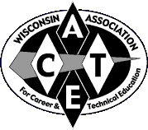 | Wisconsin Association for Career and Technical Education
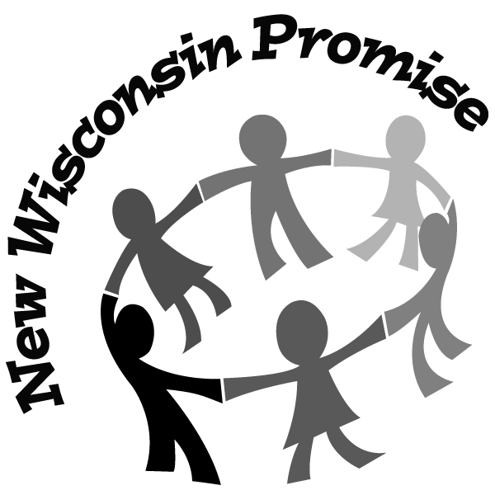 | Wisconsin  Department  of Public Instruction | 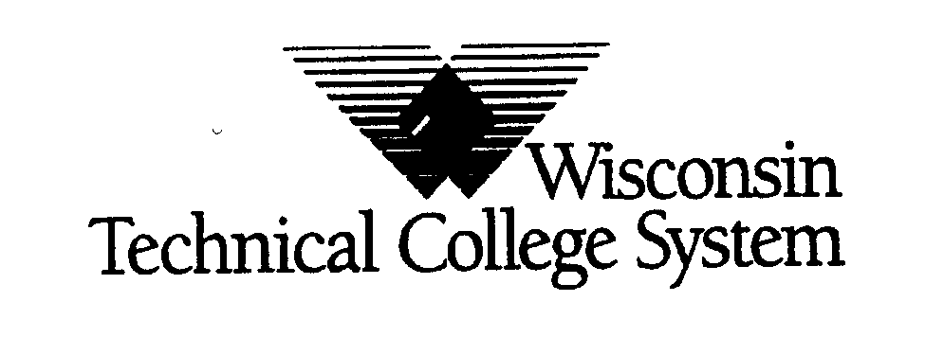 | Wisconsin  Technical College  System
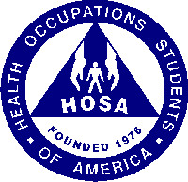 | Health Occupations Students of America |  | Wisconsin Association for Leadership in Education and Work

