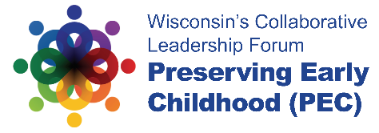
PEC 2019 Regional Session Guidelines
Thursday March 14, 2019
2:00-3:00

Session Information:

Goals for the session:
Regional Networking/Resource sharing, and, discussion and collection feedback related
the discussion topics and key early childhood information related to the region.
Information gained will be used to guide regional planning for the next year.

Outline:
2:00-2:10 (send around regional contact list sign-up)
Introductions, Name and Title, location

2:10-2:25: Small Group Discussion
What questions do you have about the updates provided by Sheila Briggs and
Carolyn Stanford Taylor’s morning remarks on play and expansion of 4K from the
Regional Perspective?
Questions on keynote?

2:25-2:45: Small Group Share-Out and larger room facilitate Discussion
As a region-what supports/resource can you identify that may already support this work?
What might be needed to support this work from a regional perspective?

2:45-2:55 Within the next year what are 1-2 things that the DPI can do to support your work from a state perspective?

2:55-3:00 Closing and next steps
Think about ongoing communication, scheduling of regional meeting, information
sharing.

Regional Early Childhood Contact Information Form
(https://docs.google.com/forms/d/e/1FAIpQLScrDXrk8aN2N-KtL_GbOS6o5MYNC1Pd4e3U38dIVxdd8H67qA/viewform)
Regional Map

