Who | Slide # | Trainer Notes | Materials
 | 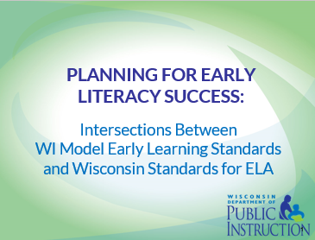 | Screen Notes: Say: (Introduce self as necessary) Welcome to today’s professional learning opportunity: Planning for Early Literacy Success: Intersections between Wisconsin Model Early Learning Standards and Wisconsin Standards for English Language Arts.  We are here today to improve the transition of our students from 4K to 5K by providing time and space for 4K and 5K educators to collaborate, gain a better understanding of the work that educators at each level engage in, and to collaboratively begin the process of making local decisions about learning expectations for each level.
 | 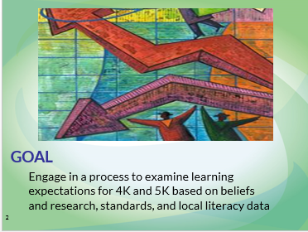 | Screen notes: Say: This professional learning opportunity is intended to engage participants in a process of examining learning expectations for 4K and 5K based on beliefs and research, standards, and local literacy data.  It is important to realize at the outset that participants will get a taste of each part of this process, but will need more time and space in order to establish complete literacy learning expectations for 4K and 5K.
 | 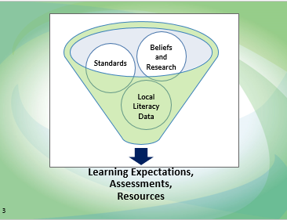 | Screen notes: Say: Learning expectations inform assessments and resources. Three distinct sets of information lead to the setting of literacy learning expectations:  - Beliefs and research  - Standards  - Local literacy data
 | 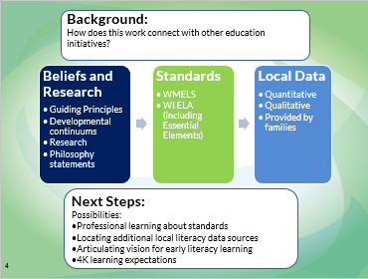 | Screen notes: Say: This graphic provides a map for today’s professional learning.  The materials and process for this module were a joint effort between DPI’s Wisconsin Standards Implementation Team and the Office of Early Learning. In addition, the materials were experimented with and reviewed by a pilot group of practicing early literacy experts. This group was a critical part of helping to ensure that these materials are practical, easy to use, and relevant.  We will start by providing some background and a context by connecting today’s work to other Wisconsin education initiatives. Then we will examine beliefs and research, which form the foundation of our work educating young children. Next, we will review both Wisconsin’s Model Early Learning Standards and the Wisconsin Standards for English language arts. After reviewing both sets of standards, we will examine where these standards intersect in order to guide our decisions on learning expectations for 4K and 5K. After engaging in this process to guide decisions on learning expectations, we will identify local data we have to inform our instructional decisions. Finally, we will identify next steps for continuing the work of planning for early literacy success.
 | 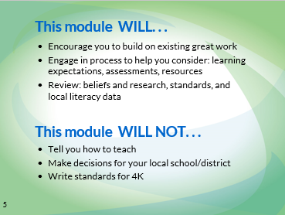 | Screen notes: Say: This module is not intended to be prescriptive about teaching or standards. It is intended to provide a process for districts to engage in to make well-informed local decisions.  (Read through what this module will and will not do.)
 | 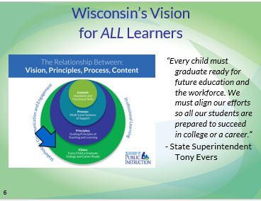 | Screen notes: Say: This module is also connected to Wisconsin’s vision for ALL learners.  The vision of these nested circles illustrates how the various education initiatives in Wisconsin fit together to ensure State Superintendent Evers’s vision of every child a graduate, with the skills and dispositions necessary to be college and career ready.
 | 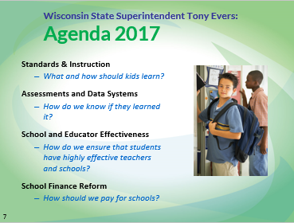 | Screen notes: Say: State Superintendent Tony Evers established Agenda 2017: Every Child a Graduate. Agenda 2017 serves as a vision for our work with Wisconsin’s Students.  Agenda 2017 becomes a reality through work in four areas of concentration:  1. Standards and Instruction  2. Assessments and Data Systems  3. School and Educator Effectiveness  4. School Finance Reform  The work in this module focuses heavily on standards and instruction.
 | 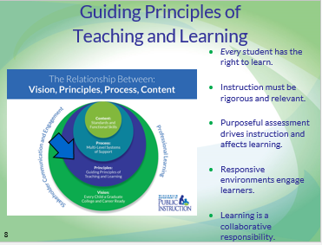 | Screen notes: Say: All educational initiatives are guided and impacted by important and often unstated attitudes or principles for teaching and learning. The Guiding Principles for Teaching and Learning emerge from research and provide the touchstone for practices that truly affect the vision of every child a graduate prepared for college and career. When made transparent, these principles inform what happens in the classroom, the implementation and evaluation of programs, and most important, remind us of our own beliefs and expectations for students. These guiding principles are the underpinnings of effective teaching and learning for every Wisconsin teacher and every Wisconsin student. They are larger than any one initiative, process, or set of standards. Rather, they are the lens we look through as we identify teaching and learning standards, design assessments, and determine what good instruction looks like. These principles recognize that every student has the right to learn.  This module includes an in-depth at these principles.
 | 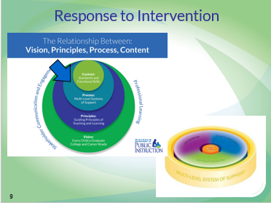 | Say: The work in this module also connects to Response to Intervention (RtI), the process for ensuring student success.  The Wisconsin Response to Intervention (RtI) framework helps to organize the components of a system designed to support student learning. The three essential elements of high quality instruction, balanced assessment, and collaboration interact within a multi-level system of support to ensure each student receives what he or she needs to access higher levels of academic and behavioral success. At the school or district level, programs, initiatives and practices related to high quality instruction, balanced assessment, and collaboration can be more powerful when organized or braided to function systemically to support all students. The focus must be on a comprehensive approach to student learning.
 | 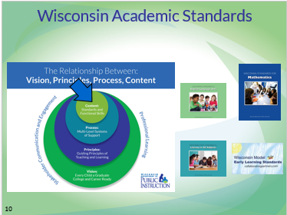 | Screen notes: Say: Academic standards are the heart of our work today – both Wisconsin Standards for ELA and WMELS.  On June 2, 2010, Superintendent Evers formally adopted the Common Core State Standards for Mathematics and English Language Arts, including the Literacy in History/Social Studies, Science, and the Technical Subjects for Wisconsin. Wisconsin led the nation as it extended the adoption of the literacy standards to all content areas – music, art, and math – and to all grade levels. Adoption of the standards, however, is the easy task. Implementing them through engaging instruction coupled with rigorous learning activities and assessment is the hard work. The standards tell us what we are aiming for, but not how to get there. The Common Core State Standards was a collaborative initiative of the National Governor’s Association and the Council of Chief State School Officers intended to raise student achievement

 | 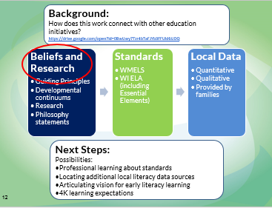 | Screen notes: Say: Now that we have provided some background and set a context for today’s work we will transition to examining beliefs and research. Before we transition to the next portion of the module, let’s revisit the goal and agenda.  This module aims to:  Engage participants in a process to examine learning expectations for 4K and 5K based on beliefs and research, standards, and local literacy data  That process includes:  Considering how this work connects with other education initiatives  Examining beliefs and research  Understanding standards  Analyzing local literacy data  Planning next steps  The first portion of our module focuses on beliefs and research that impact our early literacy practices.  https://drive.google.com/open?id=0B6ortiTqcycIUXEwUExwOXBHd1E
 | 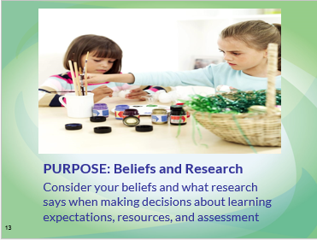 | Screen notes: Say: Beliefs and research shape our implementation of standards and selection of resources and assessments, so it is important to reflect on and consider the beliefs and research we adhere to when making education decisions for 4K and 5K students.  We will examine beliefs and research including:  - National beliefs and research  - Guiding principles from your Department of Public Instruction  - Local beliefs and research (including philosophy statements and research selected by your district)
 | 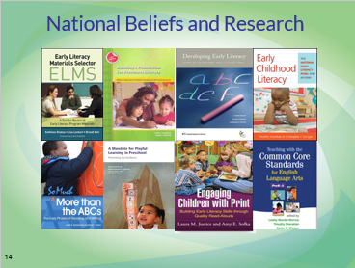 | Screen notes: Say: An increased emphasis on education from birth through age 8 has resulted in numerous resources about early literacy published at the national level. This list of national level resources is not intended to be exhaustive. It is simply a sampling of what has been offered recently by professional organizations and publishers. What resources does your district value?  The National Early Literacy Panel released its report, “Developing Early Literacy,” in 2008. This report or its summary can be downloaded in its entirety at http://lincs.ed.gov/publications/pdf/NELPReport09.pdf. This link is also included in the bibliography provided your resources.  Also in 2008, A Mandate for Playful Learning in Preschool which purports that children need unstructured free play and playful learning under the gentle guidance of adults, both social and academic development need to be addressed, and that learning and play are not incompatible.  In 2009, the International Reading Association published Building a Foundation for Preschool Literacy which emphasizes the process of learning to read and write, environments for literacy, building a daily schedule, reading aloud, and the role of parents.  In 2010, Justice and Sofka published Engaging Children with Print which includes information about scaffolding young learners.  In 2012, Tim Shanahan and Chris Lonigan edited a collection of responses to the Early Literacy Panel Report, Early Childhood Literacy.  In 2012, Corwin Press published Early Literacy Materials Selector (ELMS). This provides a guide for sorting through the proliferation of curriculum, assessments, and materials available for preschool and kindergarten.  Recently, a proliferation of materials about the Common Core State Standards for English Language Arts have been published. Teaching with the Common Core State Standards for English Language Arts: PreK – 2 (by Lesley Morrow, Tim Shanahan, and Karen Wixson, 2012) is an example of one such title.  In 2013, NAEYC (National Association for the Education of Young Children) published So Much More than the ABCs. This recent publication discusses the process of learning to read and write, including the reading informational text with young children and instructional suggestions.  For more information, consult the bibliography and resources included with this module.
 | 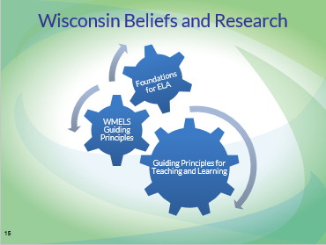 | Screen notes: Say: Besides considering national beliefs and research, your Department of Public Instruction has several sets of guiding principles that are relevant to this module. We will look at these principles in depth.  (Guide participants to where they can find these 3 sets of guiding principles – either virtually, or in printed hand-outs you have copied.)  DPI’s Guiding Principles for Teaching and Learning were established by Wisconsin educators shortly after Wisconsin’s adoption of ELA Standards in 2010. These Guiding Principles for Teaching and Learning apply to all students in all Wisconsin classrooms. These evidence-based principles are intended to guide our implementation of ELA Standards and other education initiatives. They can be downloaded at: http: //dpi.wi.gov/standards/guiding-principles. A one-page summary document is available; however, a research brief is also provided for each principle.  Other principles and foundations exist related to specific subgroups and/or disciplines. These are all consistent with the Guiding Principles for Teaching and Learning.  Wisconsin Model Early Learning Standards were created based on a set of guiding principles specific to children aged birth through five years.  And, the Foundations for English Language Arts make specific statements about reading, writing, speaking and listening, and language instruction in Wisconsin.
 | 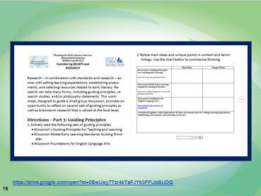 | Screen notes: Locate this thinksheet in the materials for this module.  Guide participants to this handout. Directions are on the following slide.  https://drive.google.com/open?id=0B6ortiTqcycIOGtpd0xPQ2h5eTQ
 | 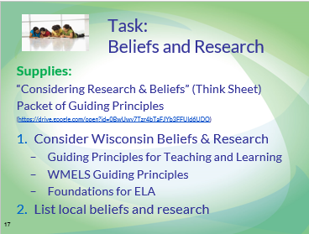 | Screen notes: Say: This thinksheet engages participants in a process of examining Wisconsin’s beliefs – based on research – and beliefs and research that are important at the school/district level.  (Locate the guiding principles from the module materials and follow the directions on the thinksheet. Allow small groups to engage in the activity, consider a larger share-out or share-out by table at the conclusion of the activity.)  https://drive.google.com/open?id=0B6ortiTqcycIOGtpd0xPQ2h5eTQ | Wisconsin Guiding Principles for Teaching and Learning;  WMELS Guiding Principles;  WI Foundations for ELA;  Beliefs and Research Thinksheet:
 | 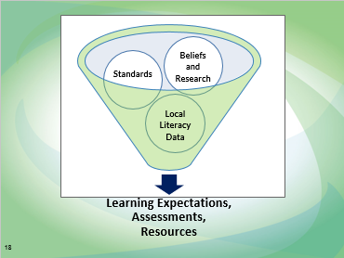 | Screen notes: Say: Before continuing in the learning of this module, let’s take a minute to review our process for today.  Learning expectations for 4K and 5K are influenced by based on beliefs and research, standards, and local literacy data.  These learning expectations inform assessments and resources.

 | 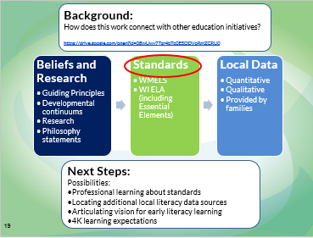 | Screen notes: Say: We discussed beliefs and research that serve as the foundations for our educational decisions. The next influencing factor we will discuss are standards.  https://drive.google.com/open?id=0B6ortiTqcycIRXVMWUNBMkdQM1k | - Copy of/Access to Wisconsin Model Early Learning Standards (WMELS)  - Copy of/Access to Wisconsin Standards for English Language Arts (WI ELA)  - Copies of “Guidance for Reading Correlation Charts” handout for participants  - Copies of “Implications of Standards” thinksheet for participants  - Copies of all 4 correlations charts for participants (Language, Reading, Speaking & Listening, and Writing)  - Copies of “Local Literacy Data Sources” thinksheet for participants  - Copies of “Summary and Next Steps” thinksheet for participants
 | 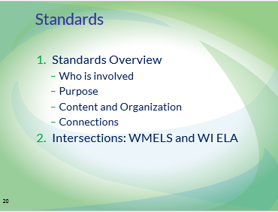 | Screen notes: Say: Our work with standards is divided into two portions.  First, the module includes an overview of WMELS and WI ELA, including who is involved, purpose, content and organization, and connections.  Next, a large portion of time will be spent on considering the intersections between the WMELS and WI ELA.
 | 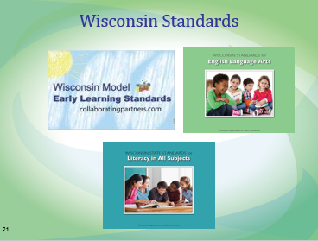 | Screen notes: Say: Wisconsin teachers work from many different sets of standards.  Three sets of standards are pertinent for today’s work:  WI Model Early Learning Standards (WMELS)  Wisconsin Standards for ELA and Literacy in All Subjects
 | 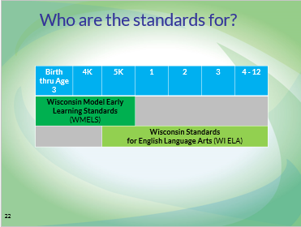 | Screen notes: Say: The work in this module focuses on the overlap between two particular sets of standards.  Wisconsin Model Early Learning Standards (WMELS) describe expectations for children from birth through entrance to first grade. Wisconsin Standards for English language arts (WI ELA) describe expectations from 5K through grade 12.  Obviously there is an overlap between these sets of standards. Examining this overlap is an important focus of our work today.  What needs to occur prior to 4K, in 4K, and in 5K to ensure that all standards are being addressed through instruction and assessment practices that match our beliefs and research? These are local decisions that we will do some work on today.
 | 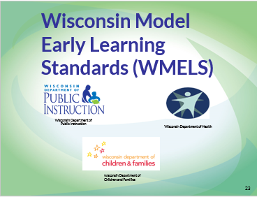 | Screen notes: Say: The Wisconsin Model Early Learning Standards are supported by the following state departments:  - Department of Public Instruction  - Department of Children and Families  - Department of Health Services

 | 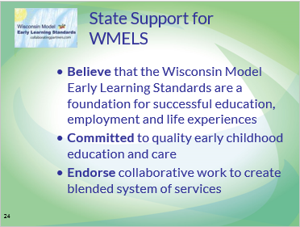 | Screen notes: Say: The Wisconsin Model Early Learning Standards reflect the shared values, beliefs and commitments of the citizens of Wisconsin to prepare young children for success in school. They reflect attention to all the domains of a child’s early learning and recognize that these domains are interrelated and interdependent.  Wisconsin has experienced tremendous progress in efforts to best meet the needs of young child and their families. We are continuing to strengthen Wisconsin’s system of early childhood services, care and education. The Wisconsin Model Early Learning Standards serve as a core foundation of our efforts to help children learn and to grow up healthy in Wisconsin.  State support has grown through:  - expansion of four-year-old kindergarten;  - establishment of the Wisconsin Department of Children and Families;  - establishment of YoungStar the quality childcare rating system;  - expansion of access to health care through BadgerCare Plus;  - creation of the Governor’s Early Childhood Advisory Council (ECAC)  - establishment of the Office of Early Learning at the Department of Public Instruction
 | 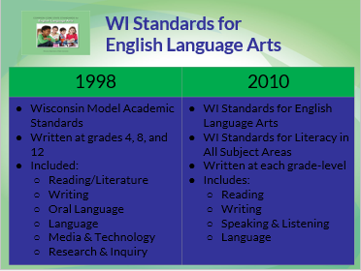 | Screen notes: Say: Wisconsin adopted Model Academic Standards for English Language Arts in 1998. These standards were written at grades 4, 8, and 12. Districts had to do the work of creating their own standards for the other grade levels in between.  Wisconsin adopted our current Wisconsin Standards for English Language Arts in 2010. These include standards at each grade-level (with bands in grades 9-10 and 11-12). These standards include Wisconsin Standards for Literacy in All Subject Areas, which apply reading, writing, speaking, listening, and language as ways to acquire information and communicate in each discipline.
 | 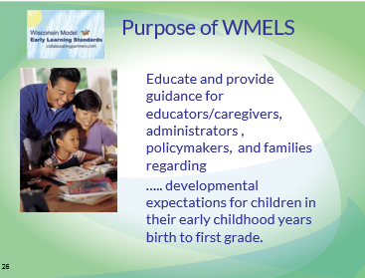 | Screen notes: Say: The Wisconsin Model Early Learning Standards (WMELS) share a common language and responsibility for care and education of children birth to first grade.  The WMELS reflect attention to developmental expectations in all the domains of a child’s learning and development including: Health and Physical Development; Social and Emotional Development; Language Development and Communication; Approaches to Learning; Cognition and General Knowledge.
 | 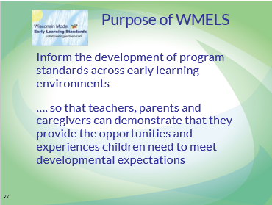 | Screen notes: Say: Everyone in in Wisconsin who is interested in providing quality care and education for ALL children will have a common understanding and find common uses for the Wisconsin Model Early Learning Standards.  - Parents, grandparents and other key people in a child’s life  - Community: Family Support Organizations, Family Resource Centers, Libraries  - Family and Group Child Care Centers and Preschool  - Head Start and Early Head Start  - 4 and 5-year Old Kindergarten  - Birth to 3 Early Intervention  - 3 through 5-year Old Special Education  - Higher Education  - Medical Community  - Advocates, Policymakers
 | 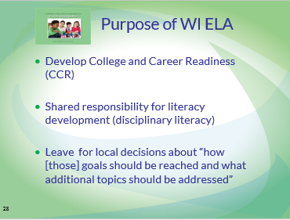 | Screen notes: Say: The WI ELA tell us what students should know and be able to do by the end of each grade level but doesn’t tell us how to achieve those standards. WI ELA exists to provide consistency in education between school districts and between those states that have chosen to adopt them.  It also aims to move students toward college and career readiness, share responsibility for literacy development between disciplines, and leave room for local decisions about how the goals (standards) should be addressed.  The CCSS are for 98-99% of all students, including those with IEPs. The Common Core Essential Elements are standards for the 1-2% of students most cognitively disabled.
 | 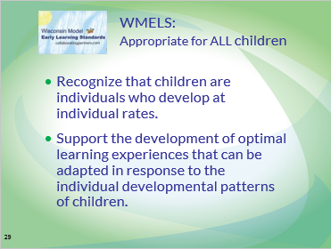 | Screen notes: Say: The Wisconsin Model Early Learning Standards contain Performance Standards in each of the Developmental Domains. Each of the Performance Standards has a Developmental Continuum. The Developmental Continuum is NOT age referenced. It is a general guide to help early care and education professionals and parents to observe a continuum of development that recognizes children are unique and develop at individual rates.  The Wisconsin Model Early Learning Standards can be used as a guide for ALL children birth to the entrance of First Grade.
 | 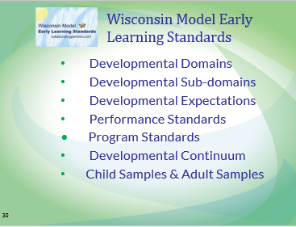 | Screen notes: Say: Turn to page 3 in your Wisconsin Model Early Learning Standards Book. The Framework you see on page 3 is the same Framework used throughout the book for each of the WMELS Domains. Each of the Developmental Domains have Developmental Sub-domains, Developmental Expectations, Performance Standards, Program Standards, a Developmental Continuum, Sample Behaviors of Children and Sample Strategies for Adults. Note that there is a “broken-line box” that says “Benchmarks, Curriculum, and Assessment.” Benchmarks, curriculum and assessment are local decisions. The Wisconsin Model Early Learning Standards are intended to be a guide to determining local benchmarks, learning targets or learning expectations that guide local curriculum and assessment decisions.
 | 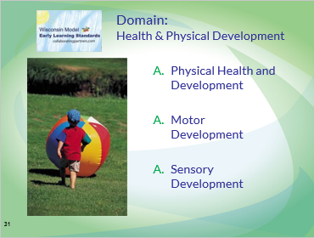 | Screen notes: Say: Turn to page 12. The first WMELS Domain is Health and Physical Development. A description of the Health and Physical Development Domain is at the top of the page along with a “Rationale.” Notice the three Sub-domains of Physical Health and Development, Motor Development and Sensory Development. Under each of the Sub-Domains are Performance Standards and a Program Standard. Note at the bottom of page 13 is a box of “Important Reminders” with statements about young children’s development and the developmental continuums and sample behaviors.  Turn to page 14. At the top of page 14 you will see the first Performance Standard in the Domain of Physical Health and Development. On page 14 you will notice boxes containing a Developmental Continuum, Sample Behaviors of Children and Sample Strategies for Adults. The first box in the continuum is light blue indicating that this is an early stage of development in “Demonstrates Behaviors to Meet Self-Help and Physical Needs.” Note that the last box on page 14 is a darker blue which indicates that this stage in development is a later stage that may happen about age 5
 | 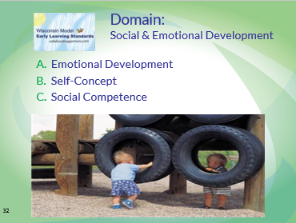 | Screen notes: Say: The domain of Social Emotional Development begins on page 26. You will notice that the format of each of the WMELS Domains is the same with the description and rationale at the top of the page. The Sub-Domains, Performance Standards and Program Standards are on pages 26 and 27. Pages 28 and 29 are the Developmental Continuum for the first Performance Standard e.g. AEL.1 Expresses a Wide Range of Emotions. Again, you will notice the lighter blue designating early stages of development on page 28 and the darker blue on page 29 designating later stages of development. In addition to the developmental continuum, are sample behaviors of children and sample strategies for adults.
 | 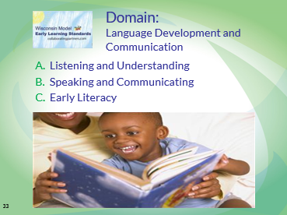 | Say: You will find the Language Development and Communication Domain on pages 42 and 43. The sub-domain C. Early Literacy was reviewed in the fall of 2011 when the (Common Core State Standards – now WI ELA) was adopted by the Wisconsin Department of Public Instruction. You will notice that there is an insert in your book entitled “2011 Edition Early Literacy Update” (Early Literacy Section Only). Today we will be focusing on Domain III of Language Development and Communication.
 | 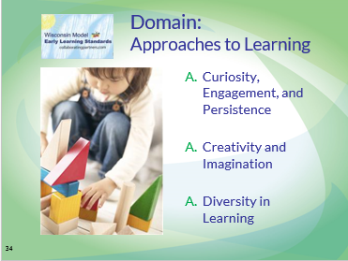 | Screen notes: Say: The Domain of Approaches to Learning is the fourth domain and can be found starting on pages 68 and 69. This domain focuses on how we learn as well as what we learn. Curiosity, Engagement, and Persistence; Creativity and Imagination; and Diversity in Learning are sub-domains of Approaches to Learning.
 | 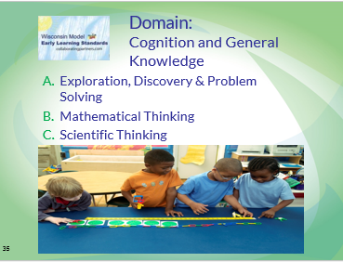 | Screen notes: Say: The fifth and last domain of the Wisconsin Model Early Learning Standards is Cognition and General Knowledge which begins on pages 80 and 81. This domain focuses on the ability to acquire, organize and use information in increasingly complex ways.  As we have looked at each of the five domains of the Wisconsin Model Early Learning Standards you have noticed that the format of each of the domains is the same. Each has a description, rationale, sub-domains, performance standards with a developmental continuum, sample behaviors of children, sample strategies for adults, and program standards.  The Wisconsin Model Early Learning Standards reflect attention to ALL domains of a child’s learning and development including Physical Health and Development, Social and Emotional Development, Language Development and Communication, Approaches to Learning, Cognition and General Knowledge.
 | 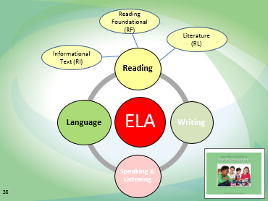 | Screen notes: Say: Let’s talk about how the WI ELA are organized. As we saw in Wisconsin’s Foundations for English language arts, we believe that literacy is an integrated discipline. The WI ELA reflects that belief by including four strands: Reading, Writing, Speaking & Listening, and Language.  The reading strand is applied to both informational text and literature. Reading also includes Reading Foundational Skills (K – 5).  These strands are designed to be taught in an integrated manner. Students develop as readers while they develop as writers. They talk and listen to learn and practice information they will later be able to write about.  Technology is infused in all four strands.

 | 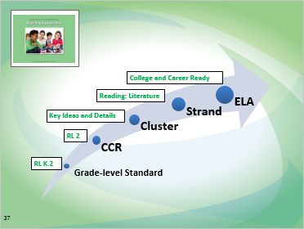 | Screen notes: Say: The standards begin with the large concept of college and career readiness in the area of ELA.  This goal is reached through proficiencies in four strands - reading, writing, speaking and listening, and language.  Each strand contains clusters, or groups, of related standards. The reading strand contains four clusters.  Key Ideas and Details  Craft and Structure  Integration of Knowledge and Ideas  Range of Reading and Text Complexity  Clusters include anchor standards. The anchor standards articulate what college and career readiness looks like.  Each anchor standard includes a staircase of grade-level standards. These standards articulate what college and career readiness looks like at each particular grade-level K, 1, 2, 3, 4, 5, 6, 7, and 8 and grade band at 9 – 10 and 11 – 12.
 | 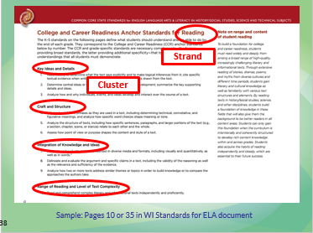 | Screen notes: Say: This is a screen shot from the Wisconsin Standards showing the clusters for reading.  There are four clusters:  Key Ideas and Details  Craft and Structure  Integration of Knowledge and Ideas  Range of Reading and Level of Text Complexity
 | 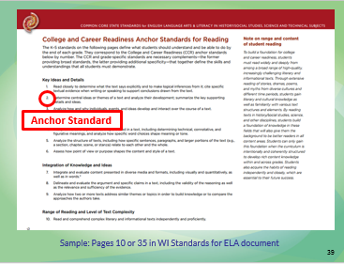 | Screen notes: Say: This is a screen shot from the Wisconsin Standards showing the clusters for reading.  There are four clusters:  Key Ideas and Details  Craft and Structure  Integration of Knowledge and Ideas  Range of Reading and Level of Text Complexity
 | 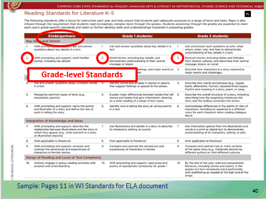 | Screen notes: Say: This is a screen shot of a page from our standards illustrating grade-level standards. The grade-level appears across the top. The grade-level equivalent of each standard read down the column.
 | 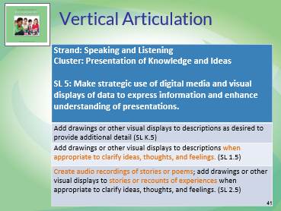 | Screen notes: Say: The grade-level standards provide a staircase. They build upon each other to ensure that students reach the level of college and career readiness by the end of grade 12.  This slide provides an example of what one anchor standard (SL 5) looks like in kindergarten, grade 1, and grade 2. The portions of the standard that appear in orange indicate how the standard changes between grades.
 | 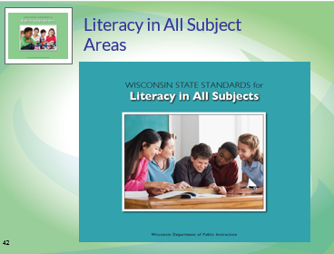 | Screen notes: Say: One purpose of the WI ELA is to share responsibility for literacy development between all disciplines.  Mathematics, science, social studies, art, physical education, health, and other subjects are all responsible for teaching reading, writing, speaking and listening, and language in the ways that are authentic to their disciplines.
 | 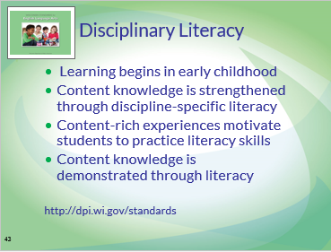 | Screen notes: Say: Earlier, we reviewed Wisconsin’s foundations for English language arts.  These are Wisconsin’s foundations for disciplinary literacy. Wisconsin’s approach to disciplinary literacy applies the Wisconsin Standards for ELA to all subject areas at all grade-levels.  - Academic learning begins in early childhood and develops across all disciplines.  - Content knowledge is strengthened when educators integrate discipline-specific literacy into teaching and learning.  - The literacy skills of reading, writing, listening, speaking and critical thinking improve when content-rich learning experiences motivate and engage students.  - Students demonstrate their content knowledge through reading, writing, listening, and speaking as part of a content-literate community.
 | 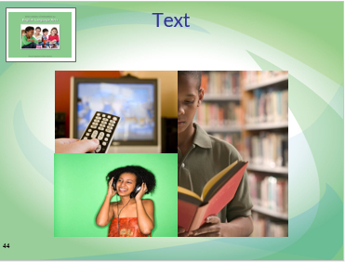 | Screen notes: Say: When considering WI ELA it is also important to remember that these standards promote a very robust definition of “text.”  A text is any medium that communicates a message. That could be visual, audio, or word-based.
 | 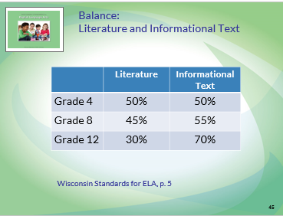 | Screen notes: Say: This chart, taken from the 2009 NAEP Framework and included in the WI Standards for ELA, shows recommended time spent studying literature and informational text. It is important to realize that these ratios should be spread throughout a student’s day.  For example, about 70% of the reading a high school student does across his/her day should involve informational text. This is across the student’s day – not just in his/her English class.  Also, this framework pushes toward an even blend of literature and informational text by the time a student reaches the end of fourth grade. Literature has a very prominent place in our early grades. The equal blend of literature and informational text does not need to be achieved until the end of fourth grade.
 | 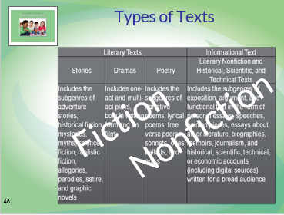 | Screen notes: Say: WI ELA uses literary text and informational text to refer to the types of texts students interact with.  Literary texts are – generally - fiction. (Some poetry may be non-fiction.) They can be in the format of a story, drama, or poetry. Literary text includes many genres, such as adventure stories, historical fiction, mysteries, mythology, science fiction, or realistic fiction. Literary text can include allegory, parody, satire, and/or graphic novels.  Informational text is non-fiction. It includes literary non-fiction and historical, scientific, and technical texts. Literary non-fiction refers to non-fiction writing that is composed with an emphasis on beauty of language and other aesthetics valued in the discipline of English language arts. Memoir is often a good example of literary non-fiction. Informational text also includes historical, scientific, and technical text that may take the form of speeches, opinion pieces, essays, biographies, or journalism written for a specific and highly-knowledgeable audience.
 | 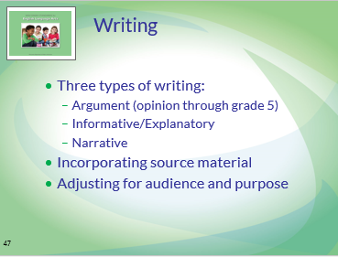 | Screen notes: Say: WI ELA explicitly includes three types of writing:  Argument (opinion through grade 5)  Informative / Explanatory  Narrative  When engaging in any of these types of writing, it is important that students consider audience and purpose. In addition, WI ELA emphasizes incorporating source material into writing. Therefore, the writing standards include a cluster of standards (Research to Build and Present Knowledge) that focus on the research process. These standards, like all WI ELA, begin in kindergarten.
 | 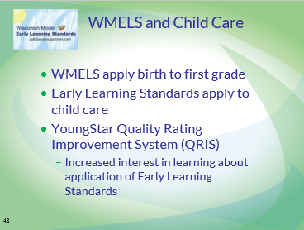 | Screen notes: Say: The Wisconsin Model Early Learning Standards apply to ALL children birth to 1st grade and therefore apply to ALL children who attend childcare. The YoungStar Quality Rating Improvement System has increased the attendance of childcare providers at WMELS Trainings held within the state. Child Care providers throughout the state are using the Wisconsin Model Early Learning Standards as a guide to determine expectations for children, as a guide for selection of curriculum and assessment and to inform instruction.
 | 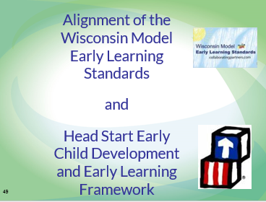 | Screen notes: Say: The Wisconsin Model Early Learning Standards and the Head Start Early Child Development and Early Learning Framework are aligned.
 | 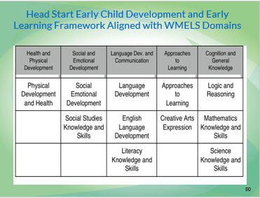 | Screen notes: Say: On this slide you will see the Five Domains of the Wisconsin Model Early Learning Standards in the boxes across the top of the chart. You will notice the Head Start Early Child Development and Early Learning Framework in the boxes below the Domains closely align with the Wisconsin Model Early Learning Domains and Performance Standards.
 | 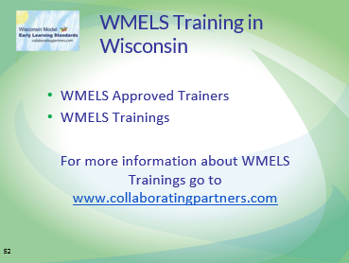 | Screen notes: Say: There are 95 Wisconsin Model Early Learning Standards Approved Trainers who provide 15 to 18 hour trainings across the state of Wisconsin. The WMELS Training is offered in both non-credit and for-credit delivery options. Many University, Private and Technical Colleges are utilizing the current WMELS Training Materials in early care and education coursework. 1,567 childcare providers, 4K and 5K teachers, Head Start teachers, Early Childhood Special Education Teachers and administrators attended WMELS Trainings in 2012.  For more information about WMELS Approved Trainers and Trainings visit the Wisconsin Early Childhood Collaborating Partners Website.
 | 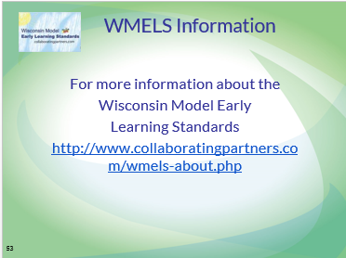 | Screen notes: Say: Additional information that can be found on the Wisconsin Early Childhood Collaborating Partners include: Ordering WMELS Books; Stories (how the WMELS are being used in practice); FAQs; Curriculum and Assessment, Resources, Alignment with Standards, Training Descriptions and Opportunities, Find a trainer, Training Reports, Trainer Login
 | 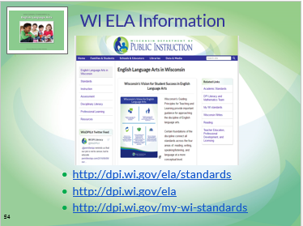 | Screen notes: Say: For more information about the WI ELA, visit the website of the Wisconsin State Standards Implementation Team. The site includes specific information about mathematics, English language arts, and reading.
 | 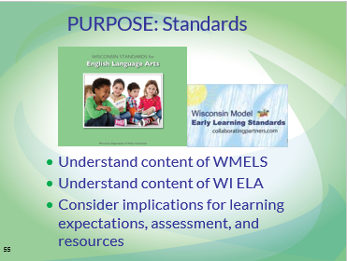 | Screen notes: Say: The next portion of this module gives participants an opportunity to examine the overlap and intersections between WMELS and WI ELA. Understanding the overlap and intersections between WMELS and WI ELA is necessary to have a collaborative conversation about learning expectations at 4K and 5K.  Neither set of standards sets learning expectations for 4K. Neither set of standards provides information on how to meet the standards. At the local level, you need to make decisions about learning expectations, assessments, and resources. These decisions should be based on standards, local data, and research. The first part of our day will be spent reviewing what the standards require students know and are able to do.
 | 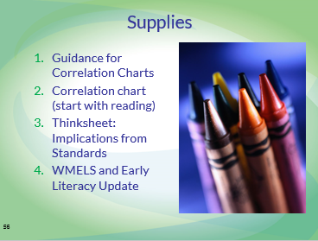 | Screen notes: Locate the materials listed on the slide from the module materials, and guide participants to these supplies.  Do we still need item 4 or is it already part of the standards? (At the original time of the training it was a separate handout) Barb Novak, 6/28/16
 | 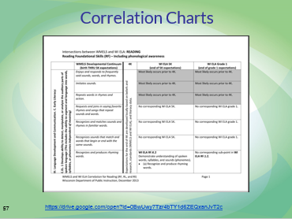 | Screen notes: Say: In order to understand the intersections between the two sets of standards, there are correlation charts to guide participants through the process of examining the overlaps and gaps between the WMELS and WI ELA. The charts have been organized according to the WI ELA, and include both the 5K and grade 1 WI ELA standards, as well as the birth through age 5 WMELS.  Reading – these standards encompass Phonological awareness, phonics, and comprehension  Writing  Speaking and Listening – these standards encompass deriving meaning through listening, listen and respond, follows directions, uses gestures and movement, syntax, semantics, pragmatics  Language – these standards encompass using gestures and movement, syntax, semantics, pragmatics  No area of ELA is developed in isolation. As a result, there is some overlap between charts particularly between the speaking and listening and language charts.

 | 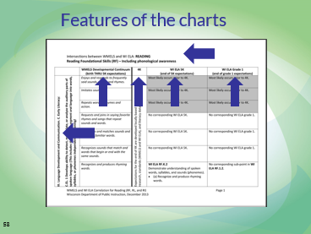 | Screen notes: Say: Let’s take a closer look at these charts so we better understand how to read them.  Title:  The first part of the title is the WI ELA strand, such as “Reading.”  The second part of the title indicates the specific area of the strand that is being focused on. This part of the title is a hybrid of information from the WMELS and WI ELA. An example is “Reading Foundational Skills (RF) – Including phonological awareness.”  Footer:  The footer may also be helpful in navigating and talking about today’s paperwork. It reminds you which WI ELA strand you are looking at and includes a page number.  WMELS Domain, Sub-Domain, and Standard:  The domain, sub-domain, and standard from the WMELS are listed in the left columns of the correlation chart. Most charts are more than one page long. Looking at the domain, sub-domain, and standard in the left column help you be sure the pages you are looking at fit together.  Our work today is only about the Language domain of the WMELS. Other domains definitely impact a young child’s language development. Other domains are developed in conjunction with language. However, language is the focus of our work today.  WMELS Developmental Continuum:  Each WMELS standard includes a developmental continuum. This continuum contains the stages that a typically developing child will follow from birth through 5K. The steps are not labeled with ages or numbered as individual standards, benchmarks, or learning targets.  It is expected that children move through the developmental continuum from birth THRU 5K. As such, there are areas of overlap between the developmental continuum and the 5K WI ELA. This column does NOT reflect 4K standards. It reflects stages of development that students are likely to move through between birth and age 5. As a school/district you make decisions about what this continuum implies for local learning expectations.  4K: Learning expectations for the end of 4K are developed locally based on beliefs and research, standards (WMELS and WI ELA), and literacy data. As a result, the correlation charts do not include learning expectations for 4K.  WI ELA 5K and WI ELA Grade 1:  These columns contain 5K and grade 1 WI ELA standards. Each standard appears next to a corresponding step in the developmental continuum. These are end of grade expectations.  Although most of our work today focuses on 4K and 5K, the grade 1 standards are included on the correlation charts. The grade 1 standards are helpful in understanding how much depth and, in many cases, independence needs to be achieved with a particular standard in 5K.
 | 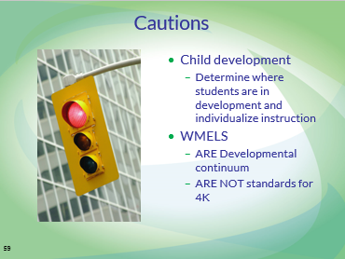 | Screen notes: Say: Before we start considering how to read and use the correlation charts, it’s important to remember what we know about child development.  Each child develops at his/her own rate. As educators, we use formal and informal assessment to understand where a child is in a developmental continuum and individualize our instruction to help that child continue moving forward. In preparing the correlation charts, we made some generalizations about steps in the WMELS developmental continuum that are most likely completed prior to 4K. Some children may not have moved through these stages prior to 4K. That’s okay.  In addition, it cannot be emphasized enough that the stages in the WMELS developmental continuum are NOT intended as 4K standards. The continuum includes development through age 5. Therefore, some of the stages may be part of expectations for prior to 4K, some may be part of expectations for 4K, and others may be part of expectations for 5K.
 | 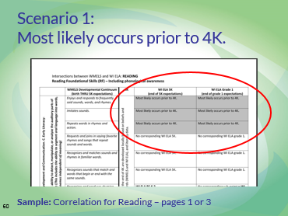 | Screen notes: Say: Scenario 1: “Most likely occurs prior to 4K.” This wording appears in the WI ELA 5K and WI ELA grade 1 columns. See a sample in the Reading chart on pages 1 or 3.  It indicates that the step in the developmental continuum most likely occurs prior to 4K. Note that it says, “Most likely.”  Remember, children develop at unique rates. Some children may enter your 4K classroom with these skills. Other children may not have developed these skills yet.  With your small group and/or on your thinksheet, you would consider what these steps in the developmental continuum imply for students at the end of 4K.  In this example, one step in the continuum says, “Imitates sounds.” Based on what is listed in WMELS as sample behaviors of children and strategies for adults, this is indicated as “Most likely occurs prior to 4K.” You might indicate this skill in the “WMELS only” column of your thinksheet by simply writing, “Imitates sounds – prior to 4K.” You might also write some notes about how your school/district determine whether students already exhibit this ability.
 | 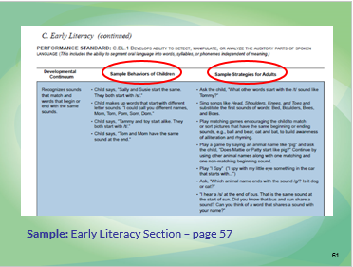 | Screen notes: Say: To better understand a step in the WMELS developmental continuum indicated as “Most likely occurs prior to 4K,” refer to the standards for more information.  The standards include “Sample Behaviors of Children” and “Sample Strategies for Adults.” These samples were consulted in making the decision about what to indicate as, “Most likely occurs prior to 4K.”  You can look back at this portion of the WMELS to get more information about any step in the continuum.  Check page # - this would apply on many slides. Barb Novak, 8/1/16.
 | 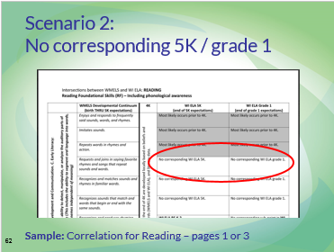 | Screen notes: Say: Scenario 2: “No corresponding WI 5K,” or “No corresponding WI grade 1.” See a sample in the Reading chart on pages 1 or 3.  This step in the WMELS developmental continuum is not a clear match for any standard (or portion of a standard) in 5K or grade 1.  With your small group and/or on your thinksheet, you would consider what these steps in the developmental continuum imply for students at the end of 4K and/or 5K.  What are the implications of a step in the developmental continuum that does not correspond with a WI ELA standard? Answering this question involves local decisions. Maybe this is step that is expected to be complete by the end of 4K. If so, it should be addressed through universal instruction in 4K. Maybe this is a step in the developmental continuum that is continued in 5K and/or grade 1 through local standards, benchmarks, or learning targets.  In this example, one step in the continuum says, “Requests and joins in saying favorite rhymes and songs that repeat sounds and words.” Review the sample behaviors of children and strategies for adults in the WMELS. You might indicate this skill in the “WMELS only” column of your thinksheet by simply writing, “Requests and joins in rhymes.” You might also write some notes about how your school/district already addresses this stage through instruction, resources, or assessment.
 | 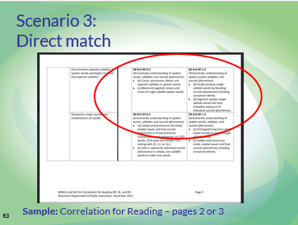 | Screen notes: Say: Scenario 3: A direct match happens with a WI ELA 5K and/or grade 1 standard appears directly beside a step in the developmental continuum. See a sample on the Reading chart pages 2 or 3.  With your small group and/or on your thinksheet, you would consider what these steps in the developmental continuum imply for students at the end of 4K and/or 5K.  What are the implications of a step in the developmental continuum that corresponds directly with a WI ELA standard? This step in the developmental continuum needs to be complete to the extent indicated by the WI ELA 5K by the end of 5K and the extent of WI ELA grade 1 by the end of grade 1. What steps, if any, will be taken in 4K to prepare students for meeting the end of 5K expectations?  Answering this question involves local decisions. In this example, the developmental continuum says, “Discriminates separate syllables in spoken words and begins to blend and segment syllables.” Maybe your school/district’s work in 4K includes singing songs or reciting poetry with motions, dances, or activities to emphasize syllables and rhythm in language.  On your thinksheet, you can record your thinking about this stage in the WMELS and WI ELA column. You might write, “Understands spoken words, syllables, and sounds” in the “WMELS and WI ELA” column.

 | 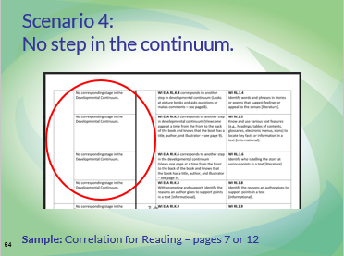 | Screen notes: Say: Scenario 4: “No corresponding step in the developmental continuum” indicates that a particular CCSS ELA standard doesn’t fit clearly with any particular step in the WMELS continuum. See a sample in the Reading chart on pages 7 or 12.  With your small group and/or on your thinksheet, you would consider what these steps in the developmental continuum imply for students at the end of 4K and/or 5K.  What are the implications of CCSS ELA standards that do not directly correspond to a step in the developmental continuum? These standards need to be completed to the extent indicated by the CCSS ELA 5K by the end of 5K and the extent of CCSS ELA grade 1 by the end of grade 1. What steps, if any, will be taken in 4K to prepare students for meeting the end of 5K expectations?  Answering this question involves local decisions. In this example (Correlation for Reading – page 12), the Reading Informational standards for kindergarten and grade 1 are about describing the connection between two individuals, events, ideas, or pieces of information in a text. Maybe your school/district chooses not to include this specific idea in 4K learning expectations or assessments but does deliberately incorporate some informational texts into read alouds and shared reading. As a regular practice, teachers engage students in interactive activities involving sequencing events or noticing relationships between ideas (such as cause and effect).  On your thinksheet, you can record your thinking about this stage in the WMELS and CCSS ELA column. You might write, “Informational text – describes connections (individuals, events, ideas, information)” in the “CCSS ELA only” column.
 | 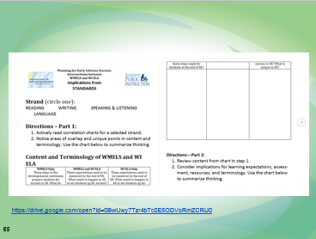 | Screen notes: Say: To guide your work in understanding the overlap and intersections of the two sets of standards, locate the “Implications from Standards” worksheet from your materials. This sheet is a place to record your school/district conversations from today. Remember, this stage in the process is NOT about making decisions regarding learning expectations, which eventually go into your local decisions about learning expectations. It is about noticing details of the standards. Decisions regarding learning expectations are made based on beliefs and research, standards, and local literacy data.  There are two parts. Page 1 is a place to record what you noticed from the correlation charts.  Page 2 is a place to consider implications for your work.  https://drive.google.com/open?id=0B6ortiTqcycIRXVMWUNBMkdQM1k
 | 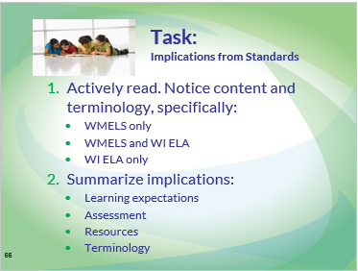 | Screen notes: Say: Use the thinksheet, “Implications from Standards,” to guide your group’s discussion of the intersections of WMELS and WI ELA.
 | 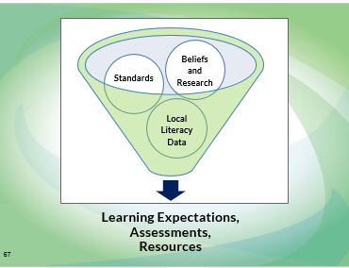 | Screen notes: Say: Before we begin the next portion of this module, let’s review our goal and progress so far.  Our goal is, “Engage in a process to examine learning expectations for 4K and 5K based on beliefs and research, standards, and local literacy data.”  So far, we have discussed beliefs and research and standards. The next portion of our learning is about local literacy data. Together these factors influence local decisions about learning expectations, assessments, and resources. | “Local Literacy Data” thinksheet (see Local Literacy Data sub-tab)  For optional activity:  Chart paper, markers, tape, and wall space
 | 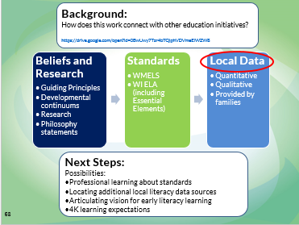 | Screen notes: Say: Next, we will consider local literacy data sources. We will not be reviewing actual data. Instead, we will discuss what data sources you want and what standards your current data sources measures.  https://drive.google.com/open?id=0B6ortiTqcycIMVpxd051NkdVUjQ
 | 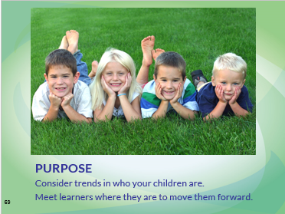 | Screen notes: Say: The purpose of identifying and examining local literacy data is to consider local trends in who your children are, and to meet your learners where they are in order to move them forward.
 | 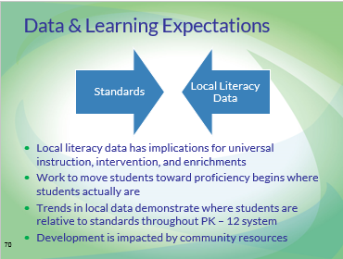 | Screen notes: Say: Why is it important that we examine local literacy data when making decisions about learning expectations, assessments, and resources for 4K and 5K?  Local literacy data tells us where students actually are in their development as literate individuals. As a system, we take students where they are and move them forward toward (and hopefully beyond) proficiency in standards. Trends in local literacy data help us understand where students generally or typically are at points throughout our PK – 12 system.  Our universal instruction, intervention, and challenges need to address students’ actual point of development and/or understanding. For example, the 5K WI ELA indicate that students should be able to recognize and name all upper- and lowercase letters of the alphabet by the end of 5K. If local literacy data suggests that students are generally able to do this upon entering 5K, it may be appropriate to make this 5K standard a 4K expectation, and to set more rigorous 5K learning expectations informed by grade 1 standards. When making such choices, also consider beliefs and research about early literacy learning.  In addition, local literacy data can also influence how we engage parents and other community partners. For example, if local literacy data suggests that students generally struggle with concepts of print, including handling books, upon entering 4K, a school and/or district could develop a partnership with a public library to find ways to emphasize this idea during library story times.
 | 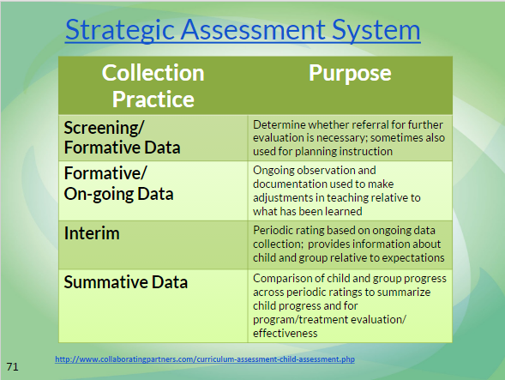 | Screen notes: Say: It is important to remember that we are talking very broadly about assessment.  A balanced assessment system includes:  Screening/formative data  Formative/On-going Data  Interim  Summative Data  These data sources can take a variety of formats. Both quantitative and qualitative data are valuable parts of a balanced assessment system.  http://www.collaboratingpartners.com/curriculum-assessment-child-assessment.php.
 | 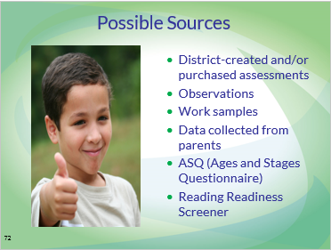 | Screen notes: Say: Some data sources, such as the Forward Exam (beginning grade 3) and a district-selected measure of reading readiness are mandatory assessments. Which WMELS and WI ELA do these assessments measure?  Other data sources are local decisions. Which WMELS and WI ELA do these assessments measure?  What data sources does your district use and value? Which WMELS and WI ELA do these assessments measure?  Your discussion of data doesn’t have to be limited to data collected only in 4K and 5K. Consider including data sources about older students as a reflection of learning in 4K and 5K.
 | 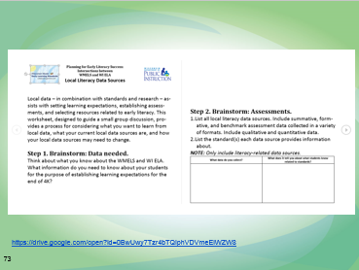 | Screen notes: Say: The “Local Literacy Data Sources” thinksheet will guide your group’s discussion about local literacy data sources. Locate it in your materials for today.  https://drive.google.com/open?id=0B6ortiTqcycIMVpxd051NkdVUjQ

 | 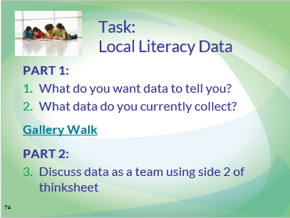 | Screen notes: Say: This thinksheet has two parts.  In the first part, your team brainstorms all of the things you want to know about your students as early literacy learners. What data do you want to collect? Next, your team lists all of the assessment data you already collect about students. In this step, it is important to think about how each of these data sources relates to WMELS and WI ELA, and to tie each data source to what you want to know about your students.  Notice what differences exist between what you want to know and what you actually collect? What redundancies and/or gaps exist in standards that are assessed? Take notes on your conversation to inform your next steps and/or action planning.  Optional activity: Summarize this step – listing current data sources and which standards they measure – on a chart paper. Post it in the room to share with other teams. Visit other team’s charts before moving on to Part 2 to “steal” ideas for use in your school/district. What differences exist between what you want to know and what you actually collect? What redundancies and/or gaps exist in standards that are assessed? Take notes on your conversation to inform your next steps and/or action planning.  In Part 2, engage in a thoughtful discussion about your local literacy data sources.
 | 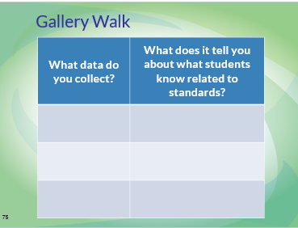 | Screen notes: Optional activity: As you finish Part 1 of your discussion (page 1 of Local Literacy Data Sources thinksheet), summarize your thinking on chart paper similar to what is on the slide.  Post it in the room.  Visit the other teams’ charts to learn more about assessment.
 | 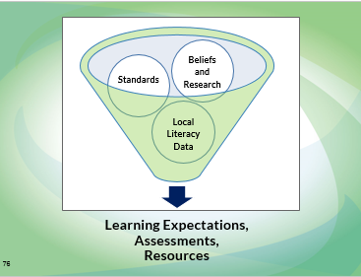 | Screen notes: Say: As we enter the last portion of our learning, let’s review our goal and progress so far.  Our goal is, “Engage in a process to examine learning expectations for 4K and 5K based on beliefs and research, standards, and local literacy data.”  So far, we have discussed beliefs and research, standards, and local literacy data. The final portion of our learning asks us to summarize our thinking so far and develop a process for establishing and/or refining learning expectations, assessments, and resources.  Supplies needed:  “Summary and Next Steps” thinksheet (see Summary and Next Steps sub-tab)
 | 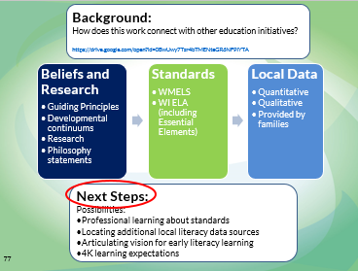 | Screen notes: Say: Your next small group discussion asks you to summarize your thinking from each thinksheet:  -Beliefs and Research  -Implications from Standards  -Local Literacy Data Sources  https://drive.google.com/open?id=0B6ortiTqcycIMHZPSWV4ZW5xLTg
 | 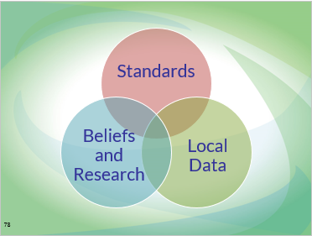 | Screen notes: Say: These three components intersect and interact to inform our decisions about learning expectations, resources, and assessments for 4K and 5K. All three components need to be considered when making decisions.  Standards by themselves set rigorous expectations for student achievement. When standards are considered without beliefs and research, implementation of standards can easily become an experience that is not developmentally appropriate for our youngest learners.  When standards are considered without local literacy data, instruction may not be a match for what students already know and are able to do. In some cases, instructing to only the standards without considering local literacy data may lead us to actually limit student’s progress by teaching skills they are already secure in
 | 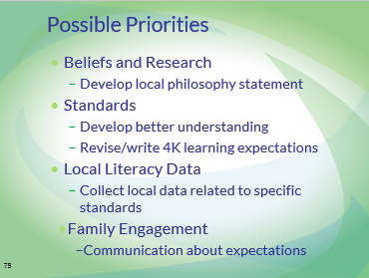 | Screen notes: Say: This work is about facilitating local decisions about standards, assessments, and resources.  As you review your thinksheets, you might consider having discussions about some of the ideas included on this slide. These are definitely not requirements; they are simply examples.  As you review your beliefs and research, maybe you realize your staff has never investigated DPI’s principles of teaching and learning. You might decide to refine your district’s philosophy statement about early literacy learning with these guiding principles in mind.  As you review your standards thinksheet, maybe it becomes clear that your staff needs to develop a better understanding of both WMELS and WI ELA, including 4K teachers working in community sites.  Maybe looking at your local literacy data helped you see that you have many assessments that measure the same cluster of standards in a very similar manner (i.e. they all collect qualitative data). You might decide to revise your assessment calendar to collect data throughout the year.
 | 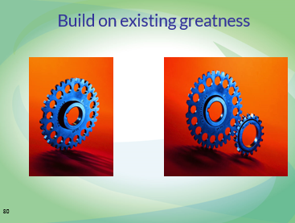 | Screen notes: Say: As you consider next steps, remember everything you already do that works for students and their families. Make your existing work stronger by connecting it to today’s new learning. Make that work even strong by continually connecting it with other initiatives, such as RtI, implementation of the SLD rule, WI ELA implementation, and Educator Effectiveness.
 | 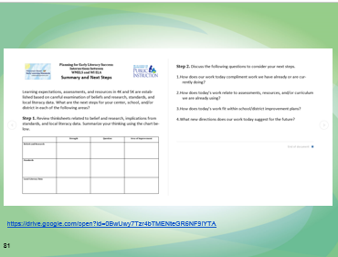 | Screen notes: Say: Locate the “Summary and Next Steps” document in your materials. This will guide your group discussion.  https://drive.google.com/open?id=0B6ortiTqcycIMHZPSWV4ZW5xLTg
 | 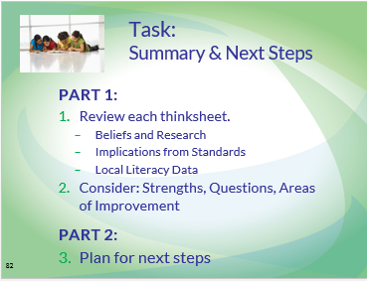 | Screen notes: Say: This thinksheet engages participants in a process of reviewing your work today around research and beliefs, correlation charts, and local literacy data. | Beliefs and Research Thinksheet (completed)  Correlation Chart Thinksheet (completed)  Local Literacy Data Thinksheet (completed)  Summary and Next Steps Thinksheet
 | 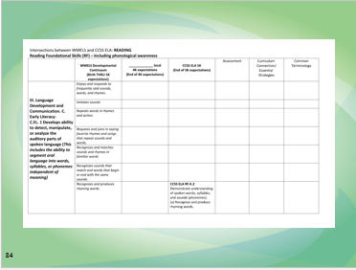 | Screen notes:  You could add columns to the right as an extension of the correlation charts to have further conversations. Examples could include assessments that you are using, your curriculum connections (i.e. “we use HWT to work on this expectation”), common terminology (i.e.”our K teachers use the term Big Letters vs Capital letters” – you are looking for consistency in terminology and academic vocabulary), effective evidence based strategies that support that expectation (i.e. dialogic reading).
 | 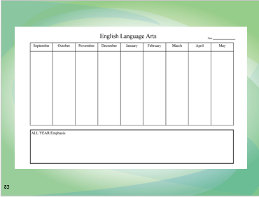 | Screen notes: This would be an example of how to show your scope and sequence of the expectations you are using in your district.
 | 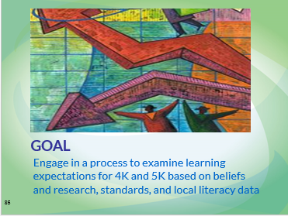 | Screen notes: Say: The goal for our learning was to engage in a process to examine learning expectations for 4K and 5K based on beliefs and research, standards, and local literacy data. We looked at each component individually and then started to consider how these components work together to influence local learning expectations, resources, and assessments.  We haven’t fully reached this goal. It is our hope that your teams continue this process in your school and/or district in a way that makes sense for where you need to go next.
 | 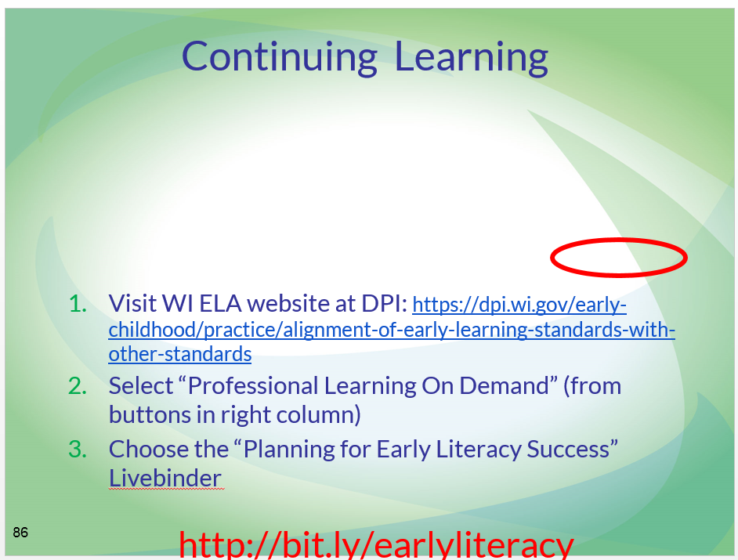 | Screen notes:  Say: It is our hope that your teams continue this process in your school and/or district in a way that makes sense for where you need to go next. The materials for this module can be accessed using the directions on this slide. You can also find them at http://bit.ly/earlyliteracy the materials in the LiveBinder can be used by anyone in non-profit settings. Share freely and widely.
 | 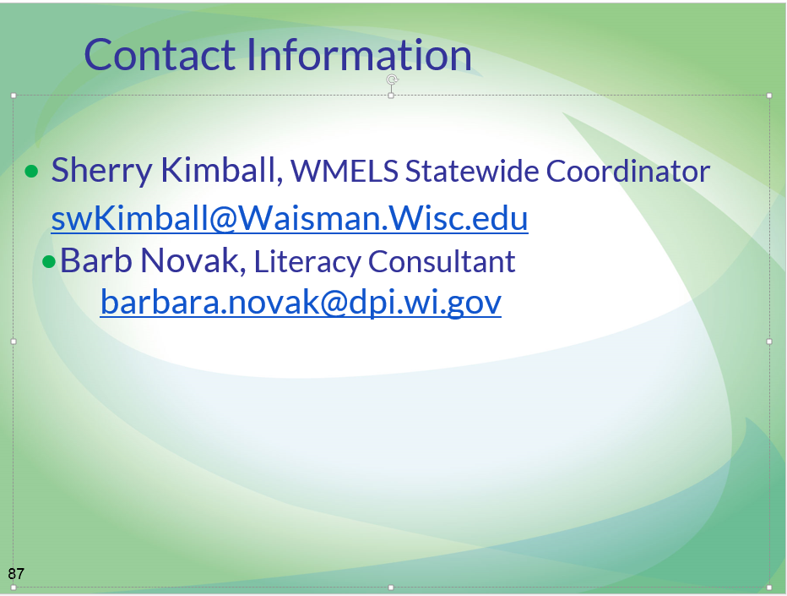 | Screen notes: Any individuals on this slide can be contacted for more information about these materials.  For more information contact: Sherry Kimball, Early Childhood Professional Development, UCEDD, Senior Outreach Specialist,  UW Waisman Center swkimball@wisc.edu

