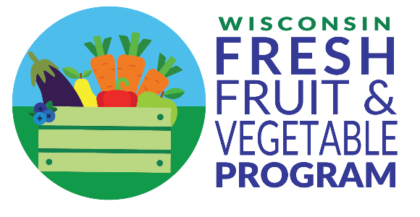
Dear Teachers,
We are happy to announce that Elementary School Name was selected to participate in the U.S. Department of Agriculture’s (USDA) Fresh Fruit and Vegetable Program (FFVP) during the 2023-24 school year. A fresh fruit or vegetable snack will be provided for students approximately [__] times per week. Your support of this program will be integral to its success.
The main goal of the FFVP is to expand the variety of fruits and vegetables children experience and increase the fruit and vegetable consumption of children. Another goal of this program is to provide nutrition education to children and the FFVP snack time is an ideal opportunity. As the coordinator of the FFVP, I will provide you with educational material for each fruit and vegetable snack served. Additional education materials including fact sheets, videos, and songs are found on the DPI FFVP webpage.
Teachers can play a valuable role in modeling positive eating habits by consuming fruits and vegetables along with their students. The USDA allows one adult to enjoy the fresh fruit and vegetable snacks with the children.
In addition, please keep these food safety tips in mind:
- Wash hands and apply gloves before distributing produce to students.
- Ensure the eating area is cleaned and sanitized before students eat.
- Have students wash hands with soap and warm water before eating the snack. Use hand sanitizer if soap and water are not available.
- Keep produce cold or serve as soon as possible after it is delivered to the room.
- Do not serve any cut produce that has been held at room temperature for more than two hours or above 90°F for more than one hour.
- Discard all leftover cut produce such as veggie sticks, sliced apples, sliced oranges, or melon.
Additional information:
- The fresh fruit or vegetable snack needs to be served during the school day and must not be taken home.
- Snack should be provided mid-morning or mid-afternoon (not too close to mealtime so that students are hungry at mealtime).
Thank you for your involvement in this program. If you have questions or suggestions, please contact: [insert name of FFVP contact person].
In accordance with federal civil rights law and U.S. Department of Agriculture (USDA) civil rights regulations and policies, this institution is prohibited from discriminating on the basis of race, color, national origin, sex (including gender identity and sexual orientation), disability, age, or reprisal or retaliation for prior civil rights activity.
Program information may be made available in languages other than English. Persons with disabilities who require alternative means of communication to obtain program information (e.g., Braille, large print, audiotape, American Sign Language), should contact the responsible state or local agency that administers the program or USDA’s TARGET Center at (202) 720-2600 (voice and TTY) or contact USDA through the Federal Relay Service at (800) 877-8339.
To file a program discrimination complaint, a Complainant should complete a Form AD-3027, USDA Program Discrimination Complaint Form which can be obtained online at: https://www.usda.gov/sites/default/files/documents/ad-3027.pdf, from any USDA office, by calling (866) 632-9992, or by writing a letter addressed to USDA. The letter must contain the complainant’s name, address, telephone number, and a written description of the alleged discriminatory action in sufficient detail to inform the Assistant Secretary for Civil Rights (ASCR) about the nature and date of an alleged civil rights violation. The completed AD-3027 form or letter must be submitted to USDA by:
- mail:
U.S. Department of Agriculture
Office of the Assistant Secretary for Civil Rights
1400 Independence Avenue, SW
Washington, D.C. 20250-9410; or
- fax:
(833) 256-1665 or (202) 690-7442; or
- email:
Program.Intake@usda.gov
This institution is an equal opportunity provider.

