Key Information about the USDA Foods Annual Order
The USDA Foods Annual Order for SY 2022-23 is open February 14. It closes March 1.

Quick Steps to Get Started on February 14. Do not wait until the last day to submit your order!

- Go to the USDA Foods Ordering System, and log in.

- Click on Program Year 2023 for the 2022-23 USDA Foods Annual Order.

3. Click on the “Application” tab. SFAs will need to edit the “School Food Authority Contract”. Be sure to click box 47 under “Verification”. Click “Submit” at the bottom.

- Under the Application tab, SFAs will need to edit and submit the “Delivery Location” form.

- Click on the “Survey” tab when you are ready to enter your USDA Foods Annual Order. There are two surveys listed. You will select and complete one survey.

- How to select your survey:

  - If you have been planning to participate in Direct Diversion, select the “Direct Diversion Survey”.

  - If you are not planning to participate in Direct Diversion, select the “State Processing Survey”.

- Tips to ensure that your SFA receives as close to 100% of your entitlement as possible:

- For the SY 2022-23 Wisconsin Annual USDA Foods Order, DPI has programmed the system to allow SFAs to request up to 105% of their yearly entitlement. It is in your SFA’s best interest to request as close to 105% of your entitlement as possible.

- Use the “Extra” rows. Know how to use the Extras Rows. Be sure to read the next page. When your SFA uses the Extra row, DPI can optimize your entitlement allocation.

- If your SFA is committing entitlement to the DoD Fresh Program, enter the dollar value your agency could use for the school year in the Extra row. If DPI has completed truck orders, and your SFA has unused entitlement, DPI will allocate up to 105% of entitlement to DoD Fresh.

After March 1

After the close of the Wisconsin Annual USDA Foods Order (March 1 24, 2022), the DPI will balance USDA Foods requests to equal truck loads. DPI may cut cases or add cases to make truck loads. The only way DPI can add cases to your order is if you enter extra cases on the Extras Rows.

After truck load balancing, it is possible that your agency may not receive exactly what is requested on this order survey. You can review your 2022-23 Annual Order in May.

What is the “EXTRA” Row in the Annual Order?
Q. What is the purpose of the “Extra” row on the Wisconsin Annual USDA Foods Order?

A. For all USDA Foods listed on the Wisconsin Annual USDA Foods Order, there is an “Extra” row. This “Extra”
row is used in the following way:

When entering the order, if your School Food Authority (SFA) can use more cases of a product than what your entitlement allows (due to the 105% entitlement cap), your SFA should enter the extra number of cases needed in this Extra row (in addition to the amounts entered in the “cases” row).

When the Department of Public Instructions (DPI) combines all SFA orders into a state-wide order to order by the truck load, it may be necessary for DPI to cut some SFAs’ orders. Therefore, DPI may have to decrease some SFAs’ product requests, which will free up some entitlement dollars for those SFAs.

If DPI needs to add cases to order a truck load, then DPI will look at SFAs requests in the “Extra” rows. The only way to receive extra cases is to enter cases in the Extra row.

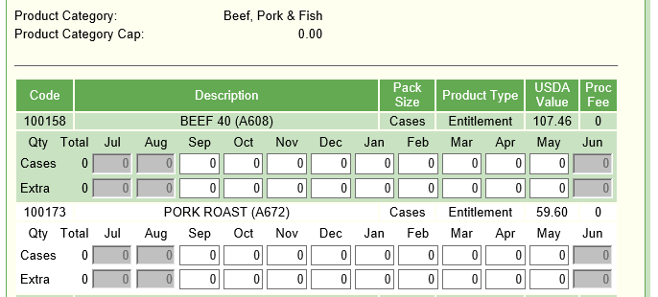
EXTRA
ROWS

Q. If I enter cases into the “Extra” row, does it get calculated into the 105% entitlement cap?

A. No. As you are entering cases into your Annual Order, cases entered in the Extra row do not draw down your entitlement balance, and they do not count toward the 105% entitlement cap.

Q. If I request products in the “Extra” rows, will DPI use these requests throughout the school year for
additional products?

A. No. DPI will only use these requests in March during the truck load ordering process.

Q. Am I required to enter numbers in the “Extra” row?

A. No. However, if DPI decreases any of your product requests during truck load balancing, and your SFA has not entered Extra cases, DPI will be unable to give your SFA any additional products to drawdown entitlement. Therefore, if you choose not to enter any numbers in the “Extra” row, your SFA runs the risk of not receiving 100% of your entitlement.

Timeline for the Wisconsin SY 2022-23 USDA Foods Annual Order
January 7-26: Give DPI your feedback for products you like to have available on the Annual Order. Take the Google USDA Foods Preference survey for SY 2022-23 Annual Order

February 9: Wisconsin Annual USDA Foods Order (annual survey) information is posted to the DPI Annual Order webpage and email notification is sent to School Food Authorities (SFAs). The Department of Public Instruction (DPI) will also post information for participating in the Department of Defense (DoD) Fresh Produce and the Cheese Processing Program.

February 14 – March 1: Participating agencies complete their Online Wisconsin Annual USDA Foods Order for SY 2022-23.

February 24: Deadline for ordering USDA Foods for SY 2022-23.

March 2 – March 16: DPI adjusts SFA orders to create truck loads as necessary. DPI finalizes orders.

End March – The DPI submits USDA Foods orders by the truck load to USDA.

September 2022 through May 2023 – USDA Foods are delivered to SFAs.

August 2022 through April 2023: Each month, participating agencies can access the Wisconsin USDA Foods Ordering System from the 3rd through the 10th to check availability of additional entitlement, entitlement no charge, or bonus USDA Foods products for the upcoming month.

This institution is an equal opportunity provider.

