Today’s Breakfast

Choose at least 3 items, including ½ cup fruit and/or vegetable
Grain and Meat/Meat Alternate Choices:  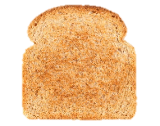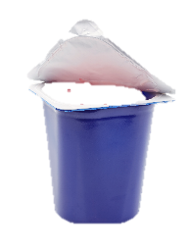 | _______________________ = ___ item(s)  _______________________ = ___ item(s)  _______________________ = ___ item(s)  _______________________ = ___ item(s)
Fruit and/or Vegetable Choices:  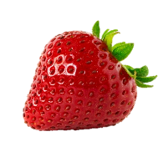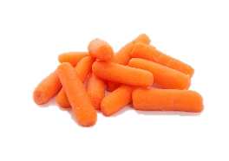 | _______________________ = ___ item(s)  _______________________ = ___ item(s)  _______________________ = ___ item(s)
Milk Choices:  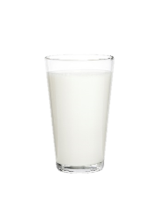 | _______________________ = ___ item(s)  _______________________ = ___ item(s)  _______________________ = ___ item(s)
December 2021

This institution is an equal opportunity provider.

