Special Milk Program
Online Services Claim Manual

Revised May 2016

This manual describes how to enter online claims for
schools and agencies participating in only the Special Milk Program

Department of Public Instruction
125 S. Webster Street
PO Box 7841
Madison, WI 53707-7841


Table of Contents

Pages

Logging on to the Wisconsin Child Nutrition Program Website 3

Navigating the Menu Options 5

Enter or Modify a Claim 7

View or Print a Claim 10

Frequently Asked Questions 12
Logging on to the Wisconsin Child Nutrition Programs Website

- Go to: http://dpi.wi.gov/nutrition

a. Click on the “Online Services” button which will bring you to the Online Services page.
b. If you wish to bookmark the site for future reference, do it at this point in time.

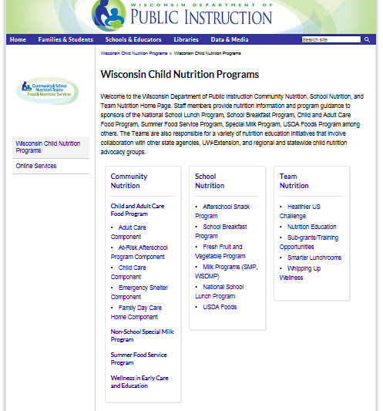

- Click on the Online Services Log-in button in the left column.
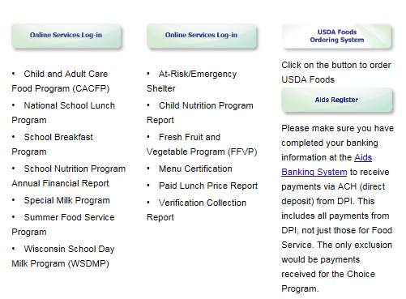

3. This will bring you to a log-in screen where you will be able to log in using your agency code and password, and access your agency’s information, including contract and claims. Do not bookmark this log-in screen – if you wish to make a bookmark, please go back to Step 2 and bookmark at that point.

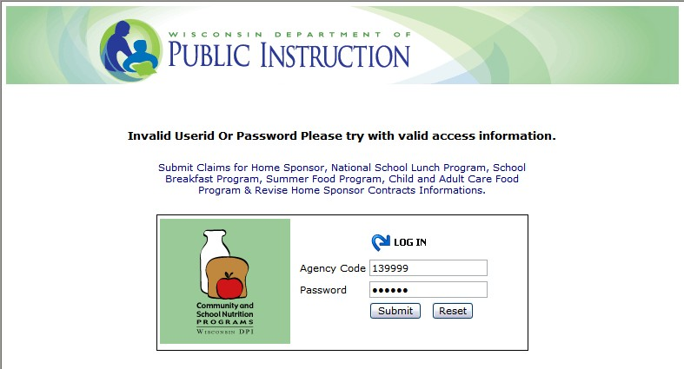

5. Enter your agency code – This is your six-digit agency code/agreement number.
a. Do not use hyphens - use only the numerals in the agency code.
b. Do not enter leading zeroes. For example, if your agency code is “012345“, only enter
“12345”.

6. Type in your agency specific password. (This is the password assigned by DPI for claiming reimbursement and for contract purposes. If you have forgotten this password, please see page 13.)

7. Click the “Submit” button.
The “Reset” button will clear all data entered in fields.

8. A timer starts from the moment you enter the contract and claims site. If no activity occurs for 30 minutes, you will receive an error message and need to return to the main “Log-in” screen. Any activity on a page (such as going from one screen to another or moving to another entry field on the same page) will reset the 30-minute timer.

Navigating the Menu Options

Once you are logged in, a menu of options will appear at the top of the screen.

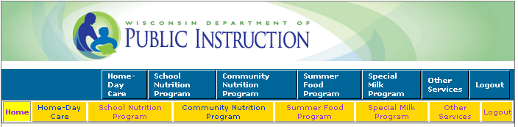

On this screen, you can see the following menu options:

Home Day Care: This is for Home Day Care providers only.
School Nutrition Program: This is for school agencies participating in the National School Lunch Program (NSLP) and additional child nutrition programs.
Community Nutrition Program: This is for agencies participating in the Child and Adult Care Food Program (CACFP).
Summer Food Program: This is for sites participating in the Summer Food Service Program (SFSP).
Special Milk Program: This is for agencies (both schools and childcare programs) participating in the federal Special Milk Program (SMP).
Logout: This is where you can click from any page on the website to logout of your contract account. When you logout, you will need to re-enter your agency code and password to re-enter the FNS web site.

Click on the blue bar where it says “Special Milk Program.” This will change the yellow menu options. Notice that the blue “Special Milk Program” button is now highlighted white.

Select “Claim Reimbursement” from the yellow menu options.

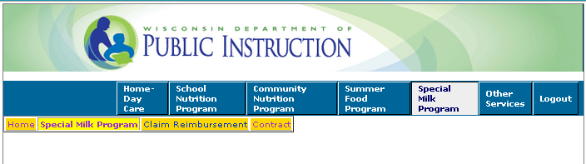

This will again change the yellow menu options. Notice that the yellow “Claim Reimbursement” button is now highlighted in a lighter color to show that this is the page you are viewing.

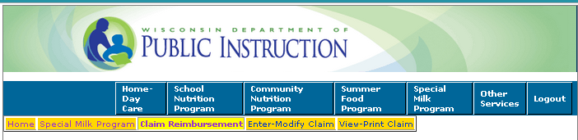

There are two options under Claim Reimbursement: “Enter-Modify Claim” and “View-Print Claim”.

Enter or Modify a Claim
To enter a new claim, select “Enter-Modify Claim”. The following information will be needed when submitting the online SMP claim.

- Claim Date
Enter the month you are claiming for, not the current month. Be sure to select the correct year.
- Number of Sites/Schools Participating
The number of schools participating in the SMP during the claiming month. The number reported on the claim must be consistent with the number submitted on Schedule A of the school agency’s current online contract.
- Total Number of Days Operating
The highest number of days any of the schools served milk during the claiming month.
- Cost Per Half-Pint
The school agency’s actual cost per half-pint of milk, not what is charged to students, carried to four decimal places (e.g., $.2348). To determine the cost per half-pint, divide the total dollar cost of all milk purchased for the SMP during the claiming month by the number of half-pints of milk purchased for the SMP. The number of half-pint equivalents must be calculated if the school agency purchases milk in bulk (e.g., multiply the number of gallons purchased by 16).
Note: The U.S. Department of Agriculture (USDA) established reimbursement rate is the maximum amount the school agency will receive for each reported half-pint of milk served to students in the paid category. If the per half-pint cost is less than this rate for milk, the school agency will be reimbursed at this lower rate. Those school agencies with the free milk option receive the average per half-pint cost. The yearly reimbursement rates can be found on the SMP webpage.

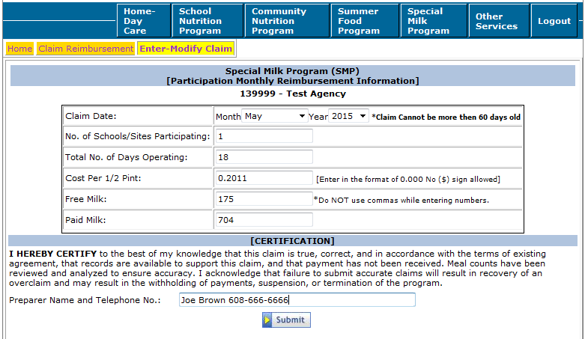
- Free Milk
The number of half-pints or half-pint equivalents served to students who are approved for free milk.
Note: This box is used only by schools that selected the pricing program with the free milk option on the approved online contract. Under a pricing program with the free milk option, milk is provided free to students from households which meet the family size income criteria, are categorically eligible, or have been matched on a direct certification run, and milk is sold at a separate charge to non-eligible children. Enter “0” (zero) in the field if your SFA does not participate in the pricing program with free milk option.
- Paid Milk
The number of half-pints or half-pint equivalents (equal to 8 fluid ounces) served to students who do not qualify for free milk. Note: This box is where non-pricing programs (those who provide milk free to all students) and pricing programs without the free milk option report the total number of half-pints of milk served to students during the claiming month. Pricing programs with the free milk option enter the number of half-pints of milk served during the month to students who do not qualify for free milk.

When finished entering the claim information, preparer information and preparer phone number, click on the “Submit” button. Do NOT use commas when entering numbers.

Points to Remember:
- There is no limit on the number of half-pints of milk that can be served to students per day.
- There is no minimum portion size for milk (e.g., students may be served less than a half-pint of milk to minimize waste). However, as previously stated, school agencies must convert milk served to half-pint equivalents when submitting the monthly reimbursement claim.
- Only milk served to students may be claimed for reimbursement. Schools may not include the number of half-pints of milk served to adults, including staff, and to non-enrolled children. The half-pints served to adults or non-enrolled students are not reimbursable by USDA.
- These count documents must be kept to support reimbursement claims.
- School agencies must also keep monthly invoices or billing statements to show the quantity of milk purchased and the total cost of milk purchased.

To modify a claim that has not yet been paid, select “Enter-Modify Claim”.
After entering a claim for reimbursement, agencies may modify the claim until the time the claim is processed. Processing of claims is completed in most cases, on Tuesday mornings.

NOTE: After a claim has been processed (“Paid” Status) by DPI it CANNOT be modified online. To submit a revision, after the claim is in “Paid” status, print-off a copy of the submitted claim. Write “Revised Claim” at the top of the page. Cross-off any incorrect numbers and write in what they should be. Sign and date the copy. Email it to Jacque Jordee (jacqueline.jordee@dpi.wi.gov) or fax it to her attention at (608)267-9207 for revision to be processed. Note: claim adjustments for claims that have been paid must be made within the 90-day period after the end of the claiming month unless a one-time exception is granted. An agency can only have one exception per program each 36-months/3-yrs per USDA.

The website will show the unpaid claim for modification after selecting Enter-Modify Claim. All data is modifiable except date claim. If no such claim is found, a relevant message will be displayed. When finished updating the claim, click on the “Submit” button at the bottom to submit the claim to DPI to be processed.

After you have submitted the claim, the following message will appear.

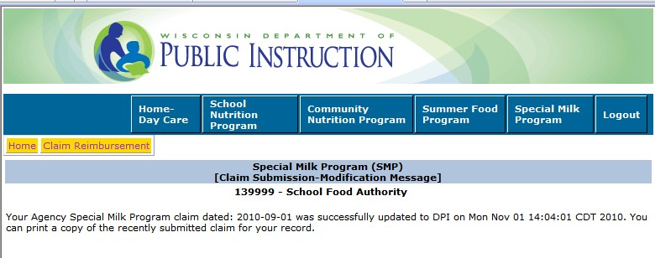

If any data is entered incorrectly, you will receive an error message telling you what to correct (make sure your claim is entered within 60 days of the end of the claiming month and make sure that you are not entering any commas or symbols).

NOTE: You can only have one claim pending in the system for each program at any given time. If you have two months of claims to enter, enter the earlier month first. Once the claim has been processed (generally on Tuesday morning), you can then enter the later month for reimbursement.

View and/or Print a Claim:

After submittal of a claim, you will need to print a copy of the submitted claim for your records, select "View-Print". The dollar amount of reimbursement, as well as the “Paid Date” will populate. This is assurance that the claim has been received at DPI. It may be viewed and/or printed anytime after it has been submitted to DPI. The claim does not have to be processed to be viewed.
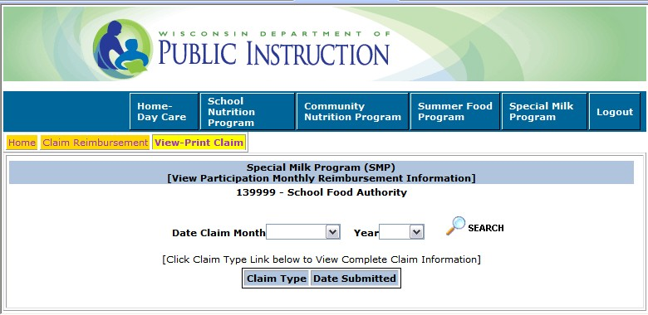

Select Date Claim Month and Year from drop down list box and click the “Search” button.

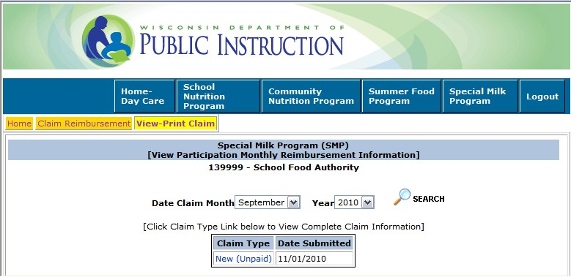
If a claim is found for the given criteria it will show up in the box below.

Click the link under “Claim Type” to view the full claim information.
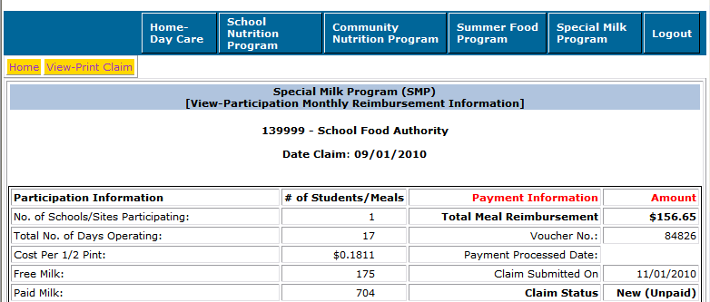

You can print the claim by clicking the print button of your browser. If required, use “Back” button to view more claims.

You cannot modify the claim on this screen. If your claim is unpaid, and you need to modify it, return to the “Claim Reimbursement” menu option, by clicking on “Special Milk Program” in the blue menu bar, and select “Enter-Modify Claim”. If your claim has already been paid, you will need to submit a paper copy of the original entry, with the corrections shown.
Frequently Asked Questions
1. CLAIMS DUE – WHEN?
Claims are due within SIXTY DAYS of the last day of the claiming month. If days of service for final claim month are LESS THAN TEN, the due date of the claim is sixty days from the last day of operation. A calendar is listed below for your convenience.

Claiming Month | Last day for for Submittal/Receipt/Postmark
January | April 1 (March 31 on leap years)
February | April 29
March | May 30
April | June 29
May | July 30
June |  | August 29
July | September 29
August | October 30
September | November 29
October | December 30
November | January 29
December | March 1 (February 29 on  leap years)

If for any reason you are unable to submit your claim online, please make sure to email it to jacqueline.jordee@dpi.wi.gov or fax it (608)267-9207 to meet these deadlines.

2. IS THERE ANY TIME WHEN I CANNOT ENTER A CLAIM?
Yes. When the DPI Payment Process Package that pays the claims is running, we cannot take claims.
This process usually lasts only a short time and is usually done on Tuesday mornings. If this process is running you will get an error message telling you to wait one hour, and then retry. Other than while we are processing payments, the claims area of the Internet site is available anytime from anywhere.

3. CLAIM DATA WILL NOT GO INTO SYSTEM
There are “edit checks” on certain fields on the claim forms. If you think you have valid data and the Internet site will not accept it, please call Jacqueline Jordee at 608-267-9134. A paper claim may need to be submitted in some instances (http://dpi.wi.gov/sites/default/files/imce/forms/doc/pod1409.doc).

4. WHY or WHEN WOULD I MODIFY A CLAIM?
If a previous claim’s data is incorrect and it has NOT been paid, you can change the data so it is correct. Once the claim is paid, it CANNOT be modified online. You will need to submit a paper copy of the original entry, with the corrections shown Note: claim adjustments for claims that have been paid must be made within the 90-day period after the end of the claiming month unless a one-time exception is granted. An agency can only have one exception per program each 36-months/3-yrs per USDA.

5. CAN’T GET INTO PROGRAM TO ENTER INFORMATION
The internet system checks the agency code against our valid contract file. If you do not have a valid contract on file, you will not be able to log-in. For School Programs, call 608-267-9228.

6. TIME LIMITATIONS
A timer starts from the moment the site is entered. If there is no activity at all for 30 minutes, the user will get an error message and have to return to the main “Log-in” screen. Any movement on a page at all, such as going from one screen to another or even just moving to another entry field on the same page will reset the 30-minute timer. If you time-out, the data that you entered will not be saved.

7. LOST or FORGOTTEN PASSWORD?
Contact the DPI Federal and State Grant Programs for assistance: Jacque Jordee at 608-267-
9134 or Jacqueline.Jordee@dpi.wi.gov.

8. CHANGE YOUR PASSWORD
Contact the DPI Federal and State Grant Programs for assistance: Jacque Jordee at 608-267-
9134 or Jacqueline.Jordee@dpi.wi.gov. Changing this password will change the password for all related child nutrition applications including claims for reimbursement, contract access, etc. If you change your agency’s password, you will need to notify other staff in your agency that need to use those functions of the new password.

Prior to contacting DPI with questions related to entering data on your claim, please be prepared to answer the following questions:

a) What is your agency code?
b) What information are you trying to enter? (Example: “October Claim Data”)
c) What screen are you viewing? (Example: “View-Print Claim”)
d) What page/s in this manual are you referring to? Page numbers are listed at the bottom-center of each manual page.
e) Be sure you have the manual with you when you call, so that you can note the answer to your question in the manual for future reference.

School Special Milk Programs

Department of Public Instruction
School Nutrition Team
125 S. Webster Street
Madison, WI 53707

608-267-9228 (phone)
608-267-0363 (fax)
Laura.paella@dpi.wi.gov

