Wisconsin Department of Public Instruction
School Nutrition Team (SNT)

2018-2019 Instructions for Submitting Verification Collection Report

There is a 15 minute time out when submitting this report online. It is recommended to enter the data manually on a printed copy of this document, or a printed version of the report found at http://dpi.wi.gov/school-nutrition/national-school-lunch-program/verification to assist in submitting online.

Contents
Accessing the Verification Collection Report (VCR) 2
Section 1. Total Schools, RCCIs, and Enrolled Students 6
Section 2. For Reporting Community Eligibility Provision and Provision 2 Schools 7
Section 3. Eligibility Based on Direct Certification 8
Section 4. Eligibility Based on Applications 9
Section 5. Results of Verification 10
Submitting the Report 13
Printing Instructions 14
Attachment A. Special situation: Multiple eligibility types on one application due to foster and non-foster students in same household ……………………….15

Additional Information
Information such as State Agency Name; SFA Name, ID Number, Type, City, Zip Code; and School Year is not requested on the online version of the VCR because the information is retrieved when you log in.
Accessing the Verification Collection Report (VCR)
Go to the School Nutrition Team website: http://dpi.wi.gov/nutrition

Select “School Nutrition”

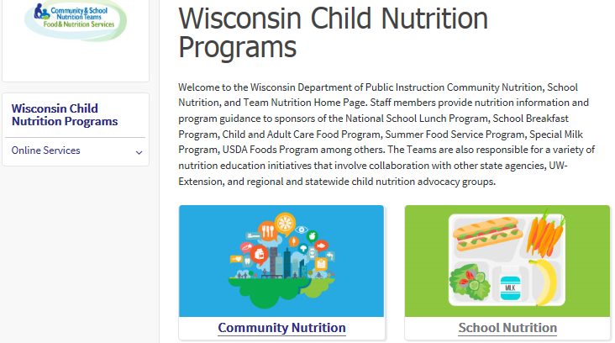

Select “National School Lunch Program”
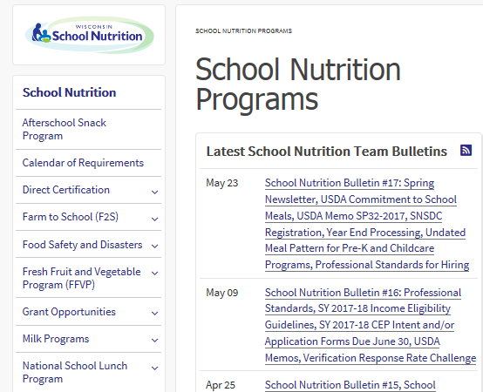
Select “Verification”
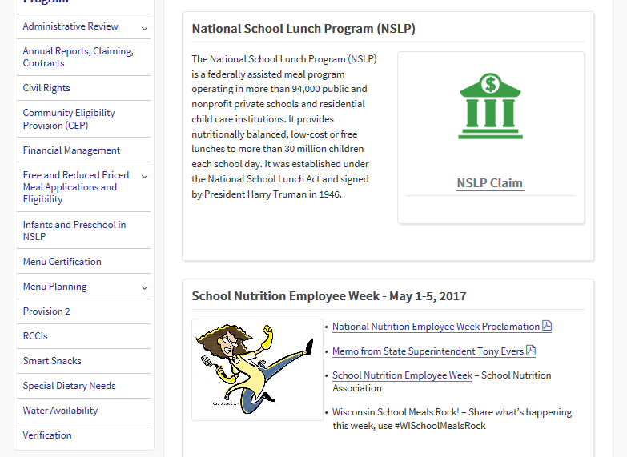

Select “Submit Your Verification Collection Report”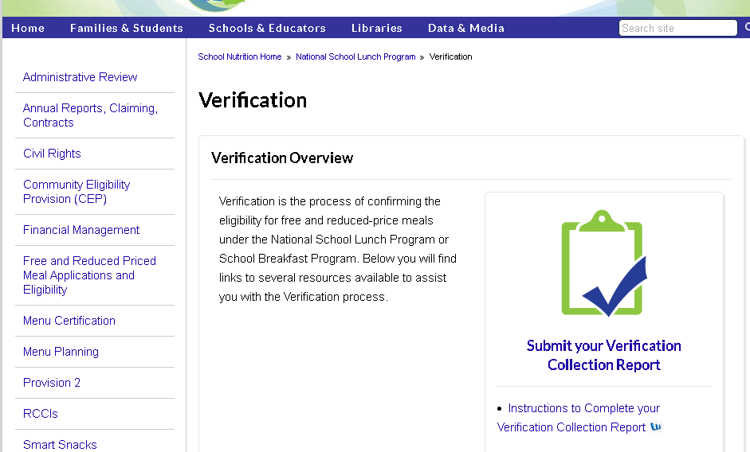
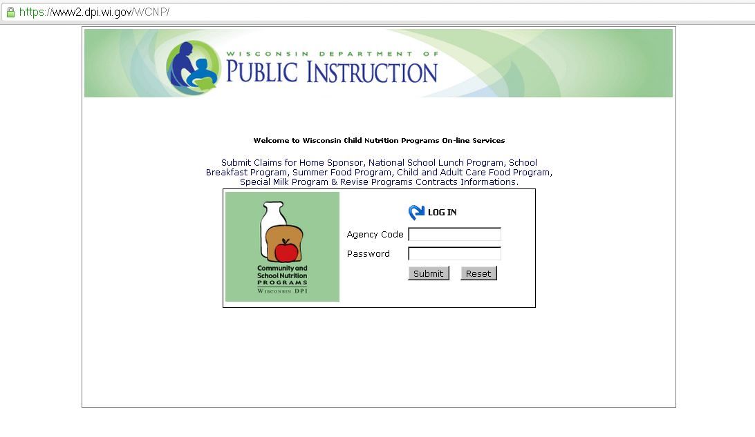
Log in using your SFA’s Agency Code and Password

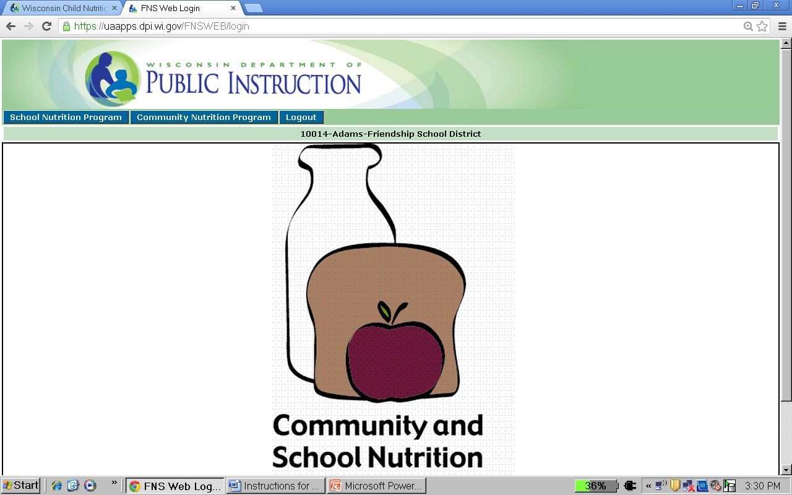

Select “School Nutrition Program”

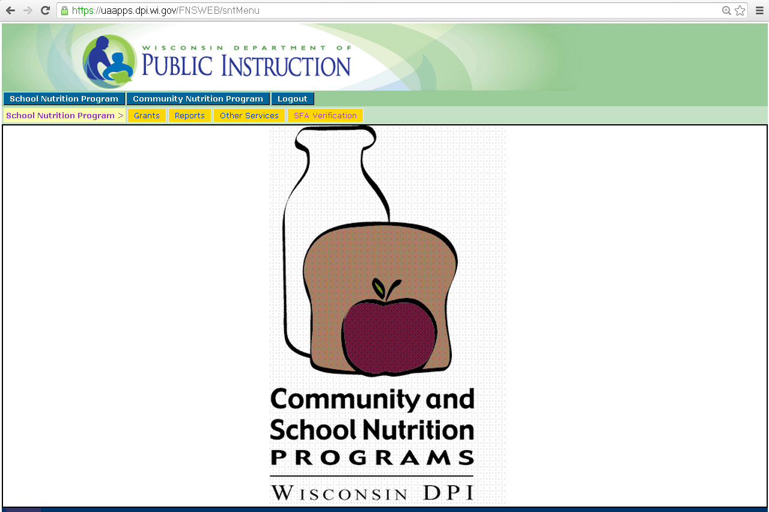

Select “SFA Verification”

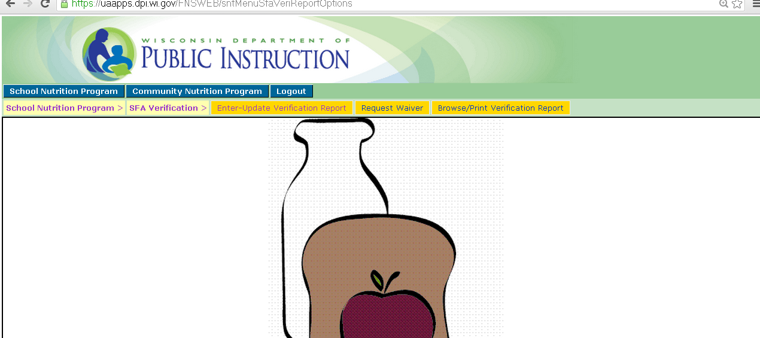

Select “Enter-Update Verification Report”
Section 1 – Total Schools, RCCIs, and Enrolled Students

Section 1 – Total Schools, RCCIs, and Enrolled Students
All SFAs with schools or RCCIs operating in the National School Lunch Program (NSLP) and/or School Breakfast Program (SBP) must complete this section regardless if all schools are exempt from verification. Report the number of schools or institutions operating the NSLP and/or SBP and the number of enrolled students with access to the NSLP and/or SBP as of the last operating day in October.

All SFAs must complete Section 1-1
1-1A: Total number of schools (not including RCCIs) operating in the NSLP and/or SBP
1-1B: Total number of enrolled students with access to the NSLP and/or SBP

All Residential Child Care Institutions (RCCIs) must complete Section 1-2
1-2A: Total number of RCCIs operating in the NSLP and/or SBP
1-2B: Total number of enrolled students with access to the NSLP and/or SBP in RCCIs only
- 1-2aA: Of the RCCIs reported in 1-2A; enter the number of RCCIs with day students
- 1-2aB: Total number of day students with access to the NSLP and/or SBP
(Day students are those students NOT institutionalized and eligibility is determined individually by application or direct certification as applicable.)
- 1-2bA: Of the RCCIs reported in 1-2A; enter the total number of RCCIs with NO day students
- 1-2bB: Total number of students at the RCCIs that DO NOT have day students
Any RCCI that has both day students and non-day students, please contact Karrie Isaacson at karrie.isaacson@dpi.wi.gov or 608-266-2416 for assistance in completing this report.

Section 2 – For Reporting Community Eligibility Provision (CEP) and Provision 2 (P2) Schools.
NOTE: If your SFA does not operate an alternate provision such as Community Eligibility Provision (CEP) or Provision 2, check this box and move on to section 3.

If you check this box, you will get a pop up message. The pop up must be answered for you to continue to the next section. If you do not see the pop up: Turn off your pop up blocker OR if you are using Internet Explorer 10, click on the “Compatibility View” icon.

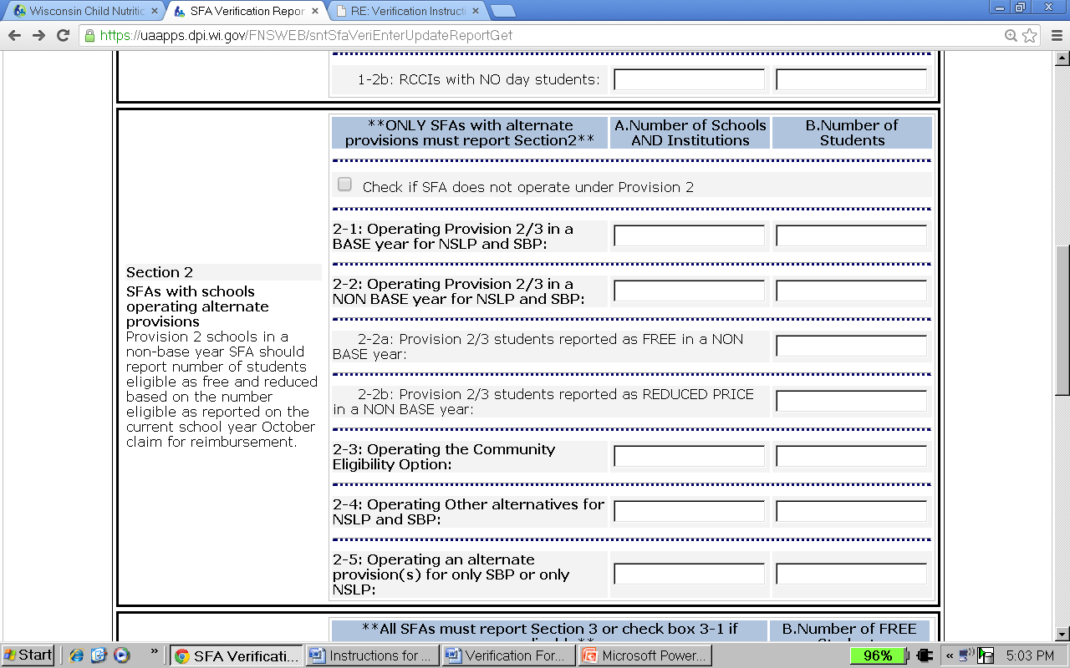
2-3: Operating the Community Eligibility Provision:
Check if SFA does not operate under CEP or Provision 2
Section 2 – SFAs operating an alternate provision, which in Wisconsin includes the Provision 2 or Community Eligibility Provision (CEP), must complete this section.

Report the number of students with access to the NSLP and/or SBP as of the last operating day in October.

Provision 2 Schools
2-1A: Total number of schools/institutions operating Provision 2 in a BASE year for NSLP and/or SBP
2-1B: Total number of students with access to the NSLP and/or SBP at a school/institution in a BASE year

Note: BASE year is when certification procedures are conducted.

2-2A: Total number of schools/institutions operating Provision 2 in a NON-BASE year for NSLP and/or SBP
2-2B: Total number of students with access to the NSLP and/or SBP at a school/institution in a NON-BASE year
Note: NON-BASE year is when no eligibility certification procedures are conducted.

- 2-2aB: Multiply the most recent October FREE percentage from the base year by the enrollment reported in 2-2B to determine 2-2aB
- 2-2bB: Multiply the most recent October REDUCED PRICE percentage from the base year by the enrollment reported in 2-2B to determine 2-2bB

Community Eligibility Provision (CEP) Schools
2-3A&B: Enter the number of schools operating the CEP and number of students. If your agency is CEP district wide, enter the total number of schools in your district and total enrollment (only including students who have access to a meal). If your agency has some schools in CEP, but not all, enter the number of CEP schools and the total enrollment for those schools only in this section. All other non-CEP schools will be reported in sections 3 through 5.

Questions 2-4 and 2-5 will not apply to any Wisconsin schools. If you have questions about these options please contact the School Nutrition Team.

Section 3 – Eligibility Based on Direct Certification

For SFAs in CEP, only check this box if the entire SFA is participating in CEP
ONLY include students with S and O codes in 3-2
Section 3 – Students Approved as FREE Eligible by Direct Certification (DC)

CEP and Provision 2
- If ALL schools in the SFA are participating in CEP or are in a non-base year for Provision 2, check box 3-1.
- Direct Certification data for CEP students reported in the “Special Provision Match Report” submitted separately to the School Nutrition Team is NOT included in this report. CEP students are only reported in section 2-3 of this report.
- If only some schools in the SFA are participating in CEP, complete the remaining fields in Section 3 and all other sections of this report only for the schools NOT participating in CEP.

Note: If a student was on an application and matched on the DC list, that student must be counted in this section as directly certified and their application is not subject to verification. Additionally, if a student is extended eligibility based on a sibling or household member matching on DC, they would also be included in this section.

Report number of students approved as free eligible by DC as of the last operating day in October.

3-2: Number of students who were directly certified through FoodShare:
DC Code | Program
S | FoodShare
O | FoodShare and W-2 Cash Benefits

3-3: Number of students who were directly certified through any of the following:
DC Code |  | Program |  | Other source categorical
T |  | W-2 Cash Benefits |  | Homeless, Migrant, Runaway (Documentation required)
E |  | Foster |  | Head Start or Pre-K Even Start (Documentation required)
G |  | FDPIR |  | Local Official Determination ( Documentation required)
M |  | Medicaid – Free
 | DO NOT report Medicaid – Reduced (Z code) in the VCR at all. Medicaid-Reduced will be collected and reported to USDA through an alternate mechanism since the VCR has not yet been updated to reflect these matches.
Foster children who do not match on DC but are eligible for free benefits based on information from a local agency should also be included in box 3-3. Foster students who qualify for free benefits based on an application must be counted in box 4-1.

3-4: Number of FREE students certified categorically eligible through the FoodShare letter method. This is different than receiving a letter from the FoodShare agency for verification purposes. Leave this box blank; N/A in WI.

Wisconsin does not use this method. Leave box 3-4 blank
DO NOT include students with S or O code or Medicaid-Reduced (Z code) in section 3-3.

Section 4 – Eligibility Based on Applications

T-1 and T-2 will automatically populate based on the numbers listed above

Section 4 – Students Approved as Free and Reduced Eligible through a Household Application
All SFAs with schools and/or RCCIs collecting USDA Free and Reduced Price School Meal Applications must report this section, including schools and/or RCCIs in a Provision 2 base year and schools not participating in CEP.
- Report number of applications in Column A approved as of October 1
(Exclude carry-over applications from previous SY)
- Report number of students in Column B as of the last operating day in October

Categorically Free Eligible
4-1A: Number of applications approved as categorically FREE eligible based on documentation submitted on an application (i.e., case number for FoodShare, W-2 Cash Benefits, or FDPIR on an application) on file as of October 1 (excluding carry-over applications from previous SY).
4-1B: Number of students as of the last operating day in October approved as categorically FREE eligible based on documentation submitted on an application (i.e., case number for FoodShare, W-2 Cash Benefits, or FDPIR number).
Free Eligible based on Income
4-2A: Number of applications approved as FREE eligible based on income information submitted by the household on file as of October 1 (excluding carry-over applications from previous SY).
4-2B: Number of students as of the last operating day in October approved as FREE eligible based on income information submitted by the household.
Reduced Price Eligible based on Income
4-3A: Number of applications approved as REDUCED PRICE eligible based on income information submitted by the household on file as of October 1 (excluding carry-over applications from previous SY).
4-3B: Number of students as of the last operating day in October approved as REDUCED PRICE eligible based on income information submitted by the household.

*For a mixed household application that includes both a foster child(ren) who is not directly certified and income eligible students, do not report the application in two places. Further instructions on reporting mixed household incomes can be found on page 15 of this manual, Attachment A – “Special Situation”.

Section 5 – Results of Verification

Section 5 – (5-1 through 5-5)
All SFAs must report Section 5 or check box 5-1 if applicable.
5-1: Only the SFAs and RCCIs that are exempt from verification should check box 5-1.
Verification activities are NOT required for:
- schools/RCCIs in which all children eligible for free meals have been certified under direct certification procedures including documented as eligible foster, migrant, runaway or homeless children;
- RCCIs which do not have day students;
- schools participating only in the Special Milk Program;
- schools in which all children are served with no separate charge for food service and no special cash assistance is claimed (i.e., non-pricing programs claiming only the paid rate of reimbursement);
- SFAs in which ALL schools participate in CEP or are Provision 2 schools in a non-base year;
- schools which do not have any free or reduced price eligible students;
- other Food and Nutrition Service determined exemptions, on a case-by-case basis.

5-2: Indicate whether the verification activities were performed and completed by the deadline of November 15.

5-3: Check the type of verification process used to comply with the requirements of 7 CFR 245.6a. Please note the qualification requirements in 7 CFR 245.6a(d) must be met to use the two alternate sample sizes.
- Standard: Verify 3% or 3,000 of approved applications, whichever is less, selected from error prone applications on file as of October 1. If there are not enough error prone applications, LEAs must select at random additional applications to complete sample size.
- Alternate One: Verify 3% or 3,000, whichever is less, of all randomly selected approved applications on file as of October 1.
- Alternate Two: Verify the lesser of 1% or 1,000 approved applications as of October 1 selected from error prone applications PLUS the lesser of one-half of one percent or 500 applications approved as of October 1 that provided a case number in lieu of income.

5-4: If Standard or Alternate Two was selected in 5-3, list the total number of error prone applications as of October 1 in section 5-4. Error prone applications are household applications approved as of October 1 indicating monthly income within $100 of the monthly limit or annual income within $1,200 of the annual limit of the applicable income eligibility guidelines.

5-5: Enter the total number of applications selected for the verification sample. If any applications were verified for cause, do not include them in this total, they will be recorded in VC-1, at the end of Section 5.

Section 5 – Results of Verification (cont.)
Note: THIS IS NOT DIRECT CERTIFICATION. See definition of direct verification below.
These numbers will not be included in section 5-8
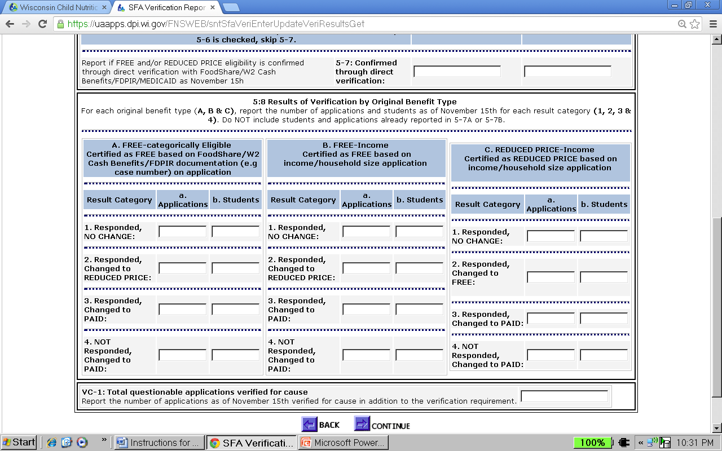
Section 5 – Direct Verification – Verifying Official requests records directly from public agency to verify income and/or program participation – rather than requesting documentation from families. THIS IS NOT DC. This is an optional way to verify case number applications or foster child status that did not show up on any DC run.
5-6: Check this box if direct verification was not conducted by the Verifying Official.

5-7A&B: If direct verification was conducted, only report applications and students if free and/or reduced price eligibility was confirmed through this method. Remember, this is different from DC. Do not include any applications for students directly verified in section 5-8.

5-8: Recording the Results of Verification
This section reports the outcome of the verification process. See the next page for further instructions on reporting results of verification.

Responded is defined as: The household provided sufficient documentation. This includes verbal or written notification that the household declines benefits.

Not responded is defined as: The household did not provide sufficient documentation or the household did not provide a response.

Section 5– Results of Verification (cont.)

Section 5 – Results of Verification (section 5-8 cont.)

Results Categories – Only applications chosen for verification should be recorded in this section.

Results of Verification by Original Benefit Type
For each original benefit type in the following sections (A - Categorically Free; B - Free based on Income; C - Reduced based on Income), report the number of applications and students as of November 15 for each result category (1, 2, 3, and 4).

Do NOT include students and applications that were already reported in box 5-7A or box 5-7B.

A1, B1, and C1: Number of applications with no change and the number of students on these applications.

A2 and B2: Number of applications changed to REDUCED PRICE based on sufficient documentation provided by the household and the number of students on the applications.

C2: Number of applications changed to FREE based on sufficient documentation provided by the household and the number of students on the applications.

A3, B3, and C3: Number of applications for which the eligibility was changed to PAID based on sufficient documentation by the household and the number of students on the applications.

A4, B4, and C4: Number of applications for which the eligibility was changed to PAID because documentation necessary to complete the verification process was NOT provided and list the number of students on the applications.

VC-1: Any applications that were verified for cause outside of the required verification sample size as of November 15 must be recorded in VC-1. The results of the applications verified for cause must also be reported in section 5-8, but they should NOT be included in the number of applications selected for the verification sample reported in
section 5-5.
‘Verification for Cause’ explanation from Eligibility Manual for School Meals
The SFA has an obligation to verify all questionable applications (verification “for cause”). Such verification efforts cannot delay the approval of applications. If an application is complete and indicates that the child is eligible for free or reduced price benefits, the application must be approved. Only after the determination of eligibility has been made can the LEA begin the verification process.
Please refer to the current Eligibility Manual for School Meals for more information regarding when verification for cause should be conducted.

When Section 5 is complete, select “Continue” button:

Submitting the Report

2017-2018
Submit Report
Enter contact information of the person submitting the report, check the “I Agree” box and select “Submit”

Do NOT log off yet.

Make sure this message is received and a copy of the report is printed before logging off.

11/14/2017

**Printing instructions on next page**

Printing Instructions

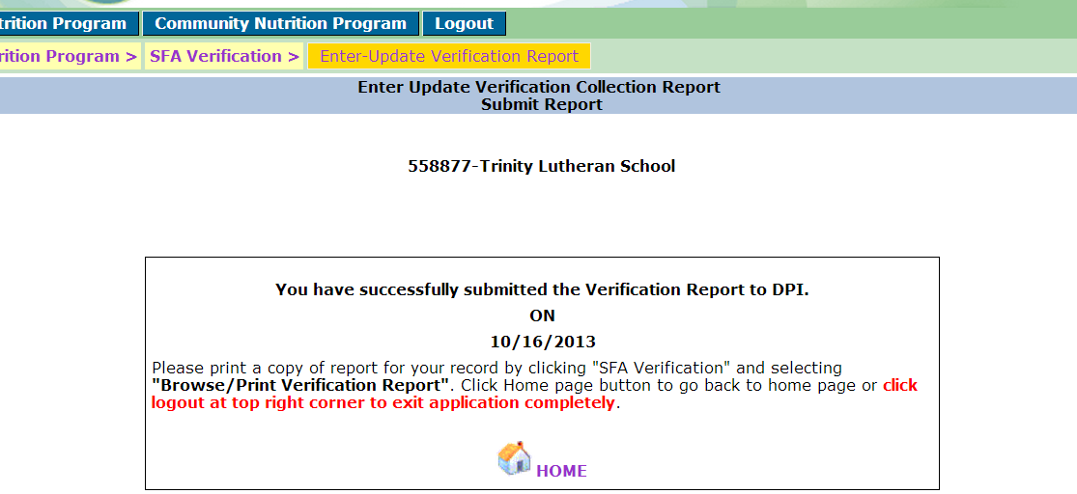
11/14/2017

Select “SFA Verification”

Select “Browse/Print Verification Report”

2017-2018

Click the “Retrieve” Button

Print the 2 pages of the report and keep on file for three years plus the current year. This report, along with the applications verified, proof of income from households and any correspondence with households, will be reviewed during an Administrative Review.
Attachment A – Special Situation
Multiple eligibility types on one application due to foster and non-foster students in same household.

For applications that include both a foster child(ren) who is not directly certified and income eligible students DO NOT REPORT THE APPLICATION IN TWO PLACES.

- Report the foster child in box 4-1B: Number of students approved as categorically FREE eligible based on documentation, for example, on a case number from FoodShare/W2 Cash Benefits/FDPIR on the application.

- Do not include the application in box 4-1A: (Number of applications approved as categorically FREE eligible based on documentation for FoodShare/W-2 Cash Benefits/FDPIR).

For the other income eligible student(s) on the same application as the foster child, the income eligible student(s) AND the application must be reported in the appropriate free and reduced price income eligible box.

- Students:
  - Free: box 4-2B: Number of students approved as FREE eligible based on income/household size information submitted on an application

  - Reduced price: box 4-3B: Number of students REDUCED PRICE eligible reported based on income/household size information submitted on an application

- Applications:
  - Free: box 4-2A: Number of applications approved as FREE eligible based on income/household size information submitted on an application

  - Reduced price: box 4-3A: Number of applications approved as REDUCED PRICE eligible based on household information submitted on an application

If the other children on the application are determined to be ineligible due to not meeting the income requirements, then the foster child must be reported in the following boxes:
- Box 4-1B: Number of students approved as categorically FREE eligible based on FoodShare/W-2 Cash Benefits/FDPIR

- Box 4-1A: Number of applications approved as categorically FREE eligible based on FoodShare/W-2 Cash Benefits/FDPIR
Since the other children on the application do not qualify for benefits, the application is only tied to the foster child.

