Lesson Template - Science Connections in Elementary
Why do seeds look like they do?
By Emily Miller
First and second grade Interdisciplinary Lesson
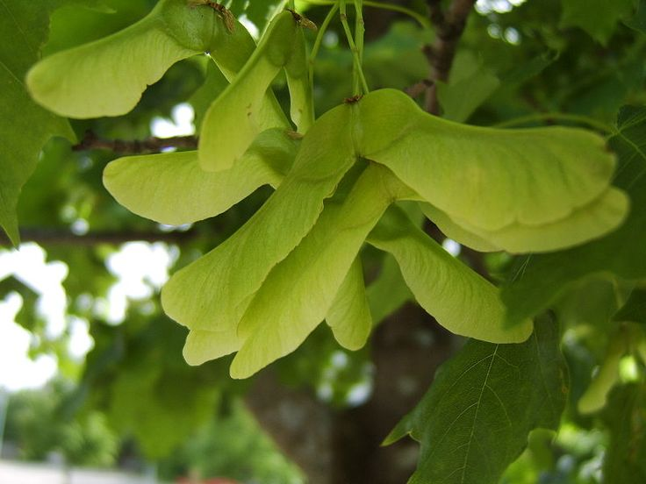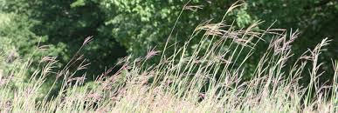

Interdisciplinary Standards
- Science Standards -
1-LS1-1. Use materials to design a solution to a human problem by mimicking how plants and/or animals use their external parts to help them survive, grow, and meet their needs.*
2-PS1-1. Plan and conduct an investigation to describe and classify different kinds of materials by their observable properties.
2-PS1-2. Analyze data obtained from testing different materials to determine which materials have the properties that are best suited for an intended purpose.*
2-LS2-2. Develop a simple model that mimics the function of an animal in dispersing seeds or pollinating plants.*
K-2-ETS1-2. Develop a simple sketch, drawing, or physical model to illustrate how the shape of an object helps it function as needed to solve a given problem.
K-2-ETS1-3. Analyze data from tests of two objects designed to solve the same problem to compare the strengths and weaknesses of how each performs. The performance expectations above were developed using

- CCSS ELA Standards -
CCSS.ELA-LITERACY.L.2.3; CCSS.ELA-LITERACY.L.2.4.A ; CCSS.ELA-LITERACY.L.2.5.A ;CCSS.ELA-LITERACY.L.2.6

Materials:
- https://docs.google.com/presentation/d/1qGS448DUIiW71kUV2iaNnSH7d8b0Yq5uLADGilhurWE/edit#slide=id.g2198a11f6d_0_1
- Paper and tape and other art materials
- Seeds of many different types and shapes. (Some seeds are on the PP)
- Writing material
- Marbles or beads

Background Knowledge

https://en.wikipedia.org/wiki/Seed_dispersal
http://theseedsite.co.uk/dispersal.html
http://www.seedbuzz.com/knowledge-center/article/methods-of-seed-protection

Description of What the Class Does
Introduction:
Introduce the Driving Question: Why do seeds look like they do?
Solicit background knowledge. What experiences do the students have with seeds? Where have they found some seeds? Have they noticed differences?

Lesson: Use the PP to support (*Note: The point of the powerpoint is to show the seeds that the students examine while it is on the plant. So the one here is an example, but the teacher would find and replace photos to show the seeds that the teacher selects).

Investigation: Place a seed in from of the students, or pass it around, and have them describe the seeds. Explain that some of the words describe the shape of the seeds and highlight those words. Observe the first slide and discuss if the seed is shaped better for protection and dispersal.
Explanation: Have students make claims for dispersal and for protection and use reasoning and/ or evidence to back their claim. Accept ideas as plausible and then emphasize what makes sense about each idea.

Teacher Prompt: Can you say more about why you think the seed structure helps it disperse? What do you see in the shape of the seed that makes you think that?

Engineering model: Have students plan and create a seed using a marble as the seed, to construct a structure meant for dispersal or for protection or both. The students can work together or alone.
Argumentation: Have the students share with the class their seed and give evidence for how the structure help the seed disperse and / or protection. Provide room for some feedback among peers.
Alternative: The students may write and draw about their seed.

Wrap up:
Free write: Have the students make connection between some of the actual seeds and the seeds that they build using free writing and drawing. And return to the Driving Question in their free-write: Why do seeds look like they do?

Possible extensions:
- Investigating a solution: Have students make two seed structures meant to accomplish the same purpose. Figure out together how you might test for the purpose.
- Investigation: Go on a seed walk in the neighborhood, and then have the students sort the seeds first for protection vs. dispersal and secondly for their own developed categories.
- Communicating information: Have students write a short story about the life of their seed.
- Engineering design: Have students look for everyday objects that match the same structures in seeds. (called biomimicry).

Resources
- Obtaining and Evaluating and Communicating information: Who will plant a Tree by Jerry Pallotta
- More Literacy extension: Read the Carrot Seed, The Tiny Seed, and Seed, pop, stick, glide, and discuss the features of the seeds. The Garden video by Frog and Toad.

