Chapter 11 – Assistive Technology for Activities
For Daily Living

Introduction 1

Eating and Drinking Continuum 2

Meal Time Continuum 3

Self-Care Continuum 4

Assistive Technology for Control of Environment 5

Multi-Function Electronic Aids to Daily Living Comparison Charts 6

Resource List for Daily Living Continuums 17

Assistive Technology for Activities of Daily Living
Jill Gierach, MSE ATP, Karen Stindt OTR ATP

Introduction
Past versions of the ASNAT manual had one chapter that included Assistive Technology for Recreation and Leisure, Activities of Daily living (ADL), and supports for students with multiple disabilities in the same section. In this edition of the manual we have separated these three areas.

We have created three continuums to assist teams in looking at ADL goals in the areas of eating and drinking, meal time, and self-care. These areas are very specific and well supported by Occupational Therapists (OT). We strongly suggest that you rely on your OT for information on items in these areas. The section includes a chart on electronic aides for daily living.

At the end of the chapter is a very basic resource list of examples of the items mentioned in the continuums.
A CONTINUUM OF CONSIDERATIONS FOR ASSISTIVE TECHNOLOGY

Eating and Drinking

Eating

Nonslip materials to hold things in place (Dycem, rubberized shelf liner)

Placemat templates to position utensils and dishes

Materials to build up handles

Adapted utensils (large handle, angled or bent forks or spoons, rocker knife, safety shield)

Adapted devices to hold utensils (universal cuff, wrist support with universal cuff)

Positioning of the arm (elevated surfaces, suspension arm slings or mobile arm supports)

Adapted dishes (scoop dish, suction cup base, compartment dish, food guard)

Electronic eating aides such as switch controlled motorized feeders

Height adjustable eating surfaces

Drinking

Regular cups (sippy cups, mugs, two handled, cups with covers)

Cup and glasses with modified rims

Adapted handles

Positioning aides for stabilizing cup or glass on table surface (Cup base to place cup into)

Adapted cups (two handles, cut out for the nose area, weighted cups, wide based cups, anti-tip rounded base)

Straws (extra long straw, heavy-duty durable straw, built in straw)

Lids (spouted, recessed, flow adjusted, anti-splash/spill)

A CONTINUUM OF CONSIDERATIONS FOR ASSISTIVE TECHNOLOGY

Meal Time

Food Prep

Adapted utensils (large handles, one-handed knife)

Adapted tools (cutting board with food stabilizer, one handed jar opener, mixing bowl stabilizer)

Adapted way to transfer food, utensils (tray, wheeled cart)

Adapted counters (wheelchair accessible)

Adapted measuring and pouring devices

Cooking

Simplified cookbooks (4 ingredient cookbook)

Modified cookbooks (picture supported)

Visual / verbal directions for using heating equipment (stove, oven, microware)

Visual directions to insure safety (what to do in case of spills, fire, 911 directions)

Adapted timers-visual, talking, large display

Clean up

Adapted directions (picture supported, verbal or voice out put support)

Adapted tools (scrub brush with soap in it, large handle scrub brush, large sponges, cleaning soap in easy to use containers)

A CONTINUUM OF CONSIDERATIONS FOR ASSISTIVE TECHNOLOGY

Self-Care

Dressing

Specifically chosen clothing (elastic waist, pull over tops, easy fasteners)

Adapted clothing (Velcro fasteners, large buttons)

Tools to assist in dressing (button hook, stocking aid, large zipper pulls, dressing stick

Hygiene Self-Care

Adapted tools

Tooth brushes-large handle, vibrating, spinning tooth brushes

Brushes and combs long, large handle or universal cuff hair brushes or combs; hair dryer stands

Pump style containers (toothpaste, soap, shampoo, body wash, lotions)

Adapted bathing aides tools (washcloth mitts, long handle back scrubber, tub chair
Transferring devices (transfer chair, lift)

Toileting aides- (toilet back support, mobile or stationary toilet chair, bath chair)

Accessible bathrooms including non skid surfaces, grab bars, or other environmental safety items

Assistive Technology for Control of the Environment

Electronic aids to daily living (EADLs) enable the person with disabilities to have more control of their environment. They go beyond the technologies described in the previous pages on activities of daily living as they pertain to electronic devices only. By virtue of that characteristic, they tend to be higher, more complex technologies.

When the person lacks mobility, motor, or cognitive skills that prevent them from performing even the simplest tasks, EADLs can provide them with some basic control over their daily life. Individuals control even the smallest amount of movement by using various types of switches. Text or pictures can be used to access the devices. Different types of input (direct, switch, voice) are available. The user can accomplish control by using either X-10, which is a wireless communication "language" that allows compatible products to talk to each other using the existing electrical wiring in the home (on/off control for lights, appliances, door openers, etc.), or infrared (for TVs, VCRs, infrared phone, etc.).

The following charts, developed by Michelle L. Lange, OTR, ABDA, ATP, give the reader valuable information and detail about EADLs. The multi-function electronic aids to daily living comparison charts details the type of access, controls, signal use, portability, display, and battery backup for different devices. The reader can then begin to determine the features that will best match the needs of the person with a disability.
Electronic Aids to Daily Living (EADLs) control devices in the environment using an alternative method, to provide independent control for persons with physical, sensory and/or cognitive impairments.

Direct Access Systems
Remote control models and prices change frequently. Check with the manufacturer.
EADL NAME | PHOTO | ACCESS | CONTROLS | IR  Stord lrn |  | MACROS | PORTABLE | BATRY BKUP | DISPLAY |  | COMMENTS | COST/  PROD#
GEWA Access Prog  Zygo Industries  800-234-6006  www.zygo-usa.com | 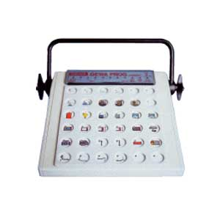 | Direct  One or two switches | IR functions: 205  X10 functions: through IR/X10 converter | no | yes | yes | yes | yes |  | Static overlays | Large 36 keys | $1925  425602
Insteon RemoteLinc Wireless Remote Control  Smarthome  800-762-7846  www.smarthome.com | 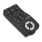 | Direct | Insteon functions:  6 scenes  417 devices | n/a | n/a | yes | yes | yes |  | Buttons | Remote works up to 150’ from access point. Access Point required: #2443, $39.99. | $59.99  2440
Maxi Controller  X-10 (USA), Inc.  800-675-3044  www.x10.com | 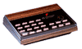 | Direct | X10 functions: 16 devices through powerline | n/a | n/a | yes | no | no |  | Text | Preset macros: all lights on, all lights off | $24.99  SC503-HA
Universal 5-in-1 Learning Remote  X-10 (USA), Inc.  800-675-3044  www.x10.com | 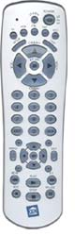 | Direct | IR functions: 5 devices  X10 functions: 16 devices through RF and powerline | yes | yes | no | yes | yes |  | Backlit buttons  Text |  | $49.99  UR74A
Vizia RF Z-Wave Programmer  Smarthome  800-762-7846  www.smarthome.com | 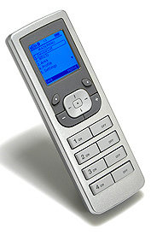 | Direct | Z-Wave functions:  256 devices  Can create scenes | n/a | n/a | yes | yes | yes |  | Display  Buttons |  | $145.99  45020
Wireless Remote Control System  X-10 (USA), Inc.  800-675-3044  www.x10.com | 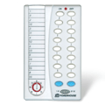 | Direct | X10 functions:  8-16 devices through RF and powerline | n/a | n/a | yes | yes | yes |  | Text | To control more than 8 X-10 functions, must slide lever. Kit includes transceiver, receiver, 2 modules. | $39.99  HR12A-SP-LAT-PS18

Switch Access Systems
Choices are scanned and selected by a switch activation
EADL NAME | PHOTO | ACCESS | CONTROLS | IR  Stord lrn |  | MACROS | PORTABLE | BATRY BKUP | DISPLAY | COMMENTS | COST/  PROD#
Angel FX  Angel ECU  772-834-1989  www.angelecu.com | 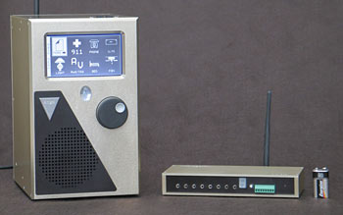 | Switch: 1 - 2 | IR functions: 1300  X10 functions: 18 devices  Phone, bed, nurse call | no | yes | yes | option | yes | Dynamic graphic  display | Auditory scanning, speech output, serial and relay output. Formerly Solo Act by Taplink. | $6200
GEWA Control Prog  Zygo Industries  800-234-6006  www.zygo-usa.com | 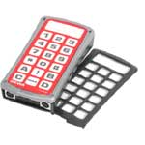 | Direct  Switch: 1 - 2 | IR functions: 241  X10 functions:  through IR/X10 converter | no | yes | yes | yes | yes | Static overlays | 15 levels, keyguard | $870  425700
GEWA Progress  Zygo Industries  800-234-6006  www.zygo-usa.com | 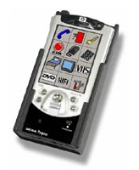 | Direct  Switch: 1 - 2 | IR functions: over 100  X10 functions: 256  through IR/X10 converter | no | yes | yes | yes | yes | Dynamic graphic display | Auditory scanning with recorded speech. Different scanning options available. 30 pre-built pages or can customize, various languages, graphics based, can back-up program. | $5295  4253
Imperium 200H  - Basic  - With Bed Control  - Complete  Ablenet, Inc.  800-322-0956  www.ablenetinc.com | 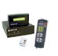 | Switches: 2 | IR functions: 6 devices  X10 functions: 256  Integrated phone  Bed control and nurse call on 2nd & 3rd models | yes | yes | no | MobileLink  option | yes | Dynamic display | Complete version is portable using Mobile Link. Auditory scanning with prerecorded words for most commands.  Bed control and nurse call optional on Basic. | $3580  86200  $4200  86100  $7200  86000
James  SAJE Technology  847-756-7603  www.safe-tech.com |  | Direct  Switch: 1 |  | no | yes |  | yes | yes | Static paper | Row/column or step scanning  Levels: paper display must be changed for visual feedback if level is changed  Options: telephone, cell phone, bed, lights | $2000  $3000 with phone
- Relax II  - Relax III  Ablenet, Inc.  800-322-0956  www.ablenetinc.com | 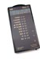 | Switch: 1 - 2 | IR functions:  II: 40, 4 devices  III: 30, 3 devices + phone  X10 functions: 10 devices through RF | no | yes | no | yes | yes | Text | X-10 radio transceiver required.  adjustable scanning (auto, hold, step).  Relax III includes IR phone. | $600  82000  $1700  83000
Simplicity Switch  Quartet Technology  978-957-4328  www.qtiusa.com | 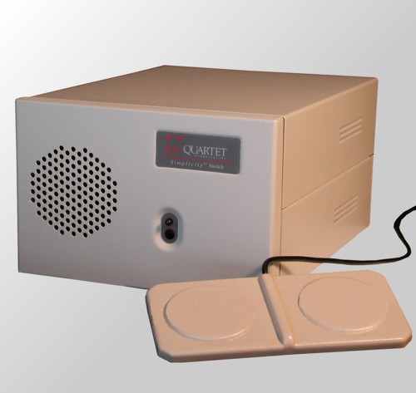 | Switches: 2 | IR functions: 240, 6 devices  X10 functions: 64 devices  Phone, nurse call | yes | yes | no | no | yes | no | Nurse call option. UL, CSA, CE approved. Speech feedback. | $call  9164

Voice Access Systems
Switch back-up access is critical in case voicing is not recognized.
EADL NAME | PHOTO | ACCESS | CONTROLS | IR  Stord lrn |  | MACROS | PORTABLE | BATRY BKUP | DISPLAY | COMMENTS | COST/  PROD#
POWERHOUSE Home  SAJE Technology  847-756-7603  www.saje-tech.com | 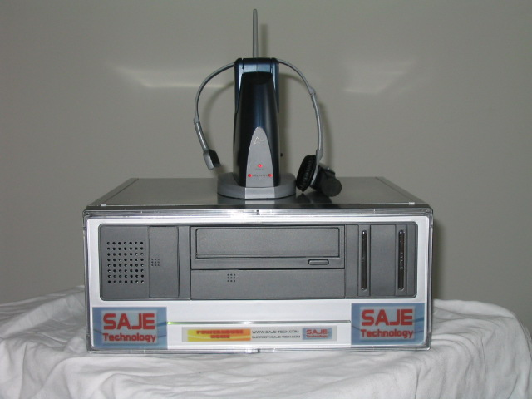 | Switch: 1  Voice | IR functions: unlimited  X10 functions: unlimited  phone | no | yes | yes | yes  wirless  headst | yes | no | Can use headset for computer voice commands, auditory feedback, 500’ range | $4500
- Sicare Standard  - Sicare Light II  Ablenet, Inc.  800-322-0956  www.ablenetinc.com | 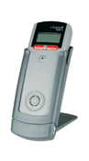 | Switch: 1 – 2  Voice | IR functions:  Standard: unlimited  Light: 7 devices  X10 functions:  Standard: 256, RF  Light II: 4, IR/X10 converter required | no | yes | yes | yes | yes | Dynamic display  Large font | Optional IR phone, IR bed control, external microphone, mount. Speech feedback.  Standard: 96 words, can customize menus, auditory scanning.  Light II: 15 pre-set menus. | $5700  88450  $2100  88460
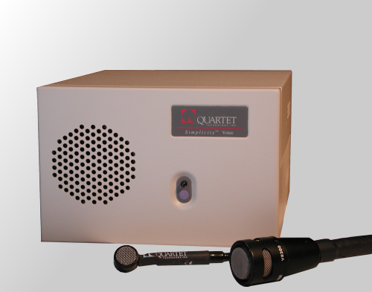  Simplicity  - Voice/Plus  - All in One(AIO)/Plus  Quartet Technology  978-957-4328  www.qtiusa.com |  | Switches: 1 – 2 (AIO)  Voice | IR functions: 240, 6 devices  X10 functions: 64  Phone, nurse call | yes | yes | no | yes  wirless  headst | yes | no | Nurse call option. UL, CSA, CE approved. Speech feedback.  Plus model provides full keyboard and mouse control. | $call  9161/  9162  $call  9165/  9166
VoiceIR Infrared Voice Controller  Broadened Horizons  612-851-1040  www.broadenedhorizons.com | 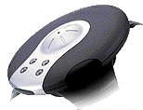 | Direct: remote  Voice: 1 – 4 users | IR functions: 120  X10 functions: through IR/X10 converter | no | yes | yes | yes | yes, limited | no | Optional IR phone, IR bed control, switch output.  Limited battery time. Can use one in each room or power off wheelchair batteries. | $349

Computer Access Systems

Home Automation Packages | Many Home Automation software/hardware packages are available that are primarily designed to set-up scheduled events in the home using X10 technology. Some of these also send IR signals. To control individual devices and functions, the consumer must be at the computer. These are not specifically designed for people with disabilities. Common examples include X10 Active Home, Hal 2000, Home Vision, Home Director and JDS Time Commander.
EADL NAME | PHOTO | ACCESS | CONTROLS | IR  Stord lrn |  | MACROS | PORTABLE | BATRY BKUP | DISPLAY | COMMENTS | COST/  PROD#
CINTEX 4  NanoPac, Inc.  800-580-6086  www.nanopac.com | 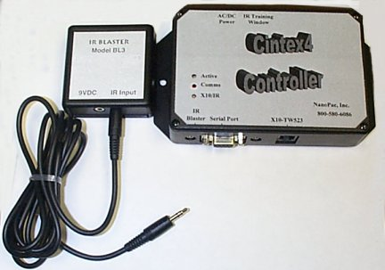 | Computer access method, including voice | IR functions: 416  X10 functions: 255 devices  Phone | no | yes | no | Phone hdset | no | Computer screen | Bed controls and A/C optional. Phone headset options, including wireless. | $2190  Base  C40-30
EADL IR Package  RJ Cooper & Assoc.  800-752-6673  www.rjcooper.com | 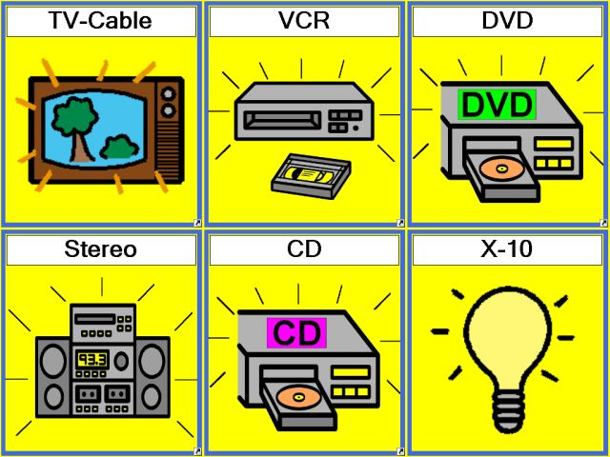 | Computer access method | IR functions  X10 functions | no | yes | yes | no | no | Computer screen | Option: X10/IR converter and 1 module $129  Software also runs on some SGDs | HW-4-6F  $249
MEDIAssistant 200/200V  Convergence Concepts  303-907-3050  www.convergenceconcepts.com | 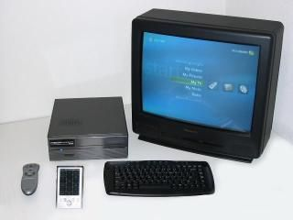 | Computer access method, touchscreen remote control  200V - voice | IR functions  X10 functions  Phone | no | yes | no | remte | 10-15 minutes | Remote control screen | Remote control is very small | 200  $3200  200V  $4200
MotivAid  908-781-6595  www.motivaid.com | 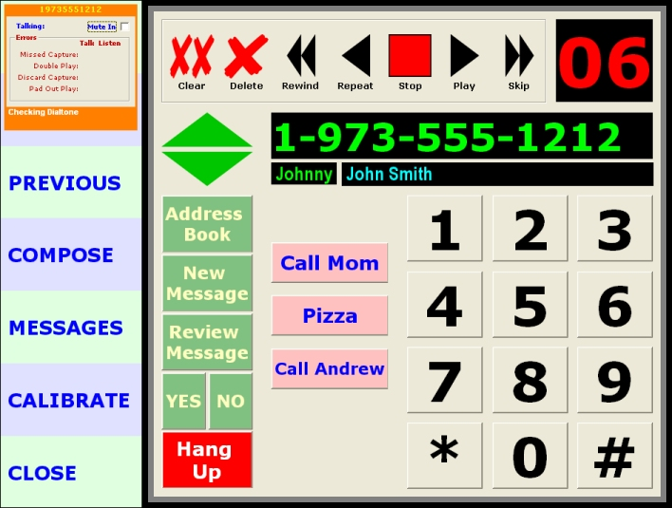 | Computer access method, touch screen, voice, switch scanning | IR functions  X10 functions  Phone | no | yes | no | no | no | Computer screen | Dedicated computer | ?
MultiMedia Max  Multimedia Designs  888-353-3996  www.multimediadesigns.com | 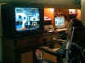 | Computer access method. Includes Dragon Naturally Speaking for voice input. | IR functions: unlimited  X10 functions: 256 devices  Phone | no | yes | yes | no | yes | Computer screen:  graphics of rooms | Includes computer, Dragon NS, hardware, software, installation, training, 1 yr. warranty. Optional bed control, thermostat, security camera | $8995
Progress Star  Zygo Industries  800-234-6006  www.zygo-usa.com | 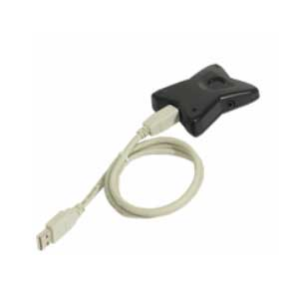 | Switch scanning | IR functions  X10 functions through IR/X10 converter | no | yes | yes | laptop | no | no | Progress dynamic display software uses onscreen graphic displays.  Mini Progress Star does not include switch jack. | ?
REACH  Break Boundaries  513-645-4203  www.breakboundaries.com | 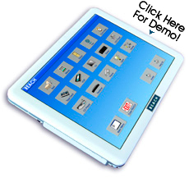 | Touch screen, voice, head control, switch scanning | IR functions  X10 functions  Phone | no | yes | yes | yes | yes | 12” screen | Can customize screen | $6400

Speech Generating Devices
Most high end SGDs send IR signals.
- DynaVox M3  - DynaVox V/VMax  - DynaWrite  DynaVox Technologies  866-396-2869  www.dynavoxtech.com | Each of these communication devices sends nearly unlimited IR signals. X10 commands can be accomplished with an IR/X10 converter. Each offers a variety of access methods (direct, single and dual switch, joystick, mouse), customizable dynamic displays, auditory scanning for switch access, graphics and speech output. Each learn IR signals and can store macros. Auditory scanning means that the client just has to listen to scanned options, the auditory cue can be customized to the client’s needs and no reading or even vision is required. The DynaWrite is a direct access device.  The DynaVox V/VMax and the DynaVox M3 have an optional PhoneIT feature for phone control ($315).  The DynaVox M3 is the least expensive option (price listed) and can be used even by verbal consumers to provide reasonably priced switch accessed control of devices in the environment. | $3285  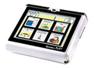
- ECO-14  - Pathfinder  - Springboard Lite  - Springboard Plus  - Vanguard Plus  - Vantage Plus  Prentke Romich Co.  800-262-1984  www.prentrom.com | Each of these communication devices sends nearly unlimited IR signals. X10 commands can be accomplished with an IR/X10 converter. Each offers a variety of access methods (direct, single and dual switch, joystick, mouse), customizable dynamic displays, auditory scanning for switch access, graphics and speech output. Each learn IR signals and can store macros. Auditory scanning means that the client just has to listen to scanned options, the auditory cue can be customized to the client’s needs and no reading or even vision is required.  The ECO-14 has an optional Air Card to allow wireless control of a landline phone.  The Springboard Lite is the least expensive option (price listed) and can be used even by verbal consumers to provide reasonably priced switch accessed control of devices in the environment. | $2195  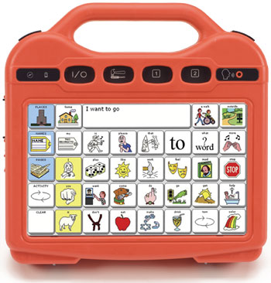
Power Wheelchair electronics
Some power wheelchair electronics packages send IR through the display. Invacare and PG Drives Technology are pending
Quantum QLogic | The QLogic display (generally ordered when the consumer cannot use a joystick) sends multidirectional IR signals from the back of the display. It can learn up to 288 codes and store up to 3 macros. It can control X10 devices through a converter (4 devices per converter, 256 max.). The consumer uses the directional drive switches to scroll through and choose device and function options.
Quickie iQ | The iQ display (generally ordered when the consumer cannot use a joystick) sends IR signals from the back of the display. It uses pre-set codes and can learn up to 22 codes. It can control X10 devices through a converter (4 devices per converter, 10 max.). The consumer uses the directional drive switches to scroll through and choose device and function options.

IR: infrared control of audio/visual equipment, IR phone or other IR controlled device
X-10: on/off control for lights, appliances, fan, buzzer, door opener, drapery control, more. Uses existing house wiring (powerline) and, if remote, radio (RF) or infrared (IR) transmission to a converter.
Insteon: like X10, uses powerline and RF, more reliable, can control more devices. Can be given X10 address.
UPB: like X10, uses single band technology, powerline.
ZigBee and Z-Wave: like X10, single band RF wireless network.
Bed control can be accomplished with 6 X10 signals by X-10 System Electric Bed Operator #304, Jantek Home Controls, Inc., 416-620-5255, $430.
Bed control can be accomplished with IR signals using the Ablenet IR Bed Control, $1000.
Door Openers can usually be controlled with an X10 module. If the EADL is not portable, you cannot open the door from outside. IR Door openers are available, as well.
Any EADL transmitting IR may be programmable to send to an IR telephone. Check with the manufacturer.

Michelle L. Lange, OTR, ABDA, ATP, Access to Independence, MichelleLange@msn.com, 7/08.
BASIC ELECTRONIC AIDS TO DAILY LIVING – Battery and Simple Electrical Devices
NAME | PHOTO | CONTROL MODE  Direct Latch Time sec Time min |  |  |  | SWITCH INPUT | SWITCH OUTPUT | COST | PROD. # | DIMENSIONS | COMMENTS
Battery Transmission
Single SLAT  Ablenet | 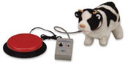 |  | X | 0 - 60 | 0 - 60 | 1 | 1 | $75 | 100-SSLAT | 2.25 x 3.75 x 1
Choice SLAT  Ablenet | 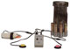 |  | X | 0 - 60 | 0 - 60 | 2 | 2 | $95 | 100-CSLAT | 2.25 x 3.75 x 1 | 2nd device will not activate until 1st device stops
Dual SLAT  Ablenet | 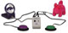 |  | X | 0 - 60 | 0 - 60 | 2 | 2 | $95 | 100-DSLAT | 2.25 x 3.75 x 1 | allows 2 people to use at one time
Tash Switch Latch  Ablenet | 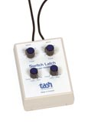 | X | X | 2 - 52 |  | 2 | 2 | $125 | 43880 | ?
LinkSwitch  Adaptivation | 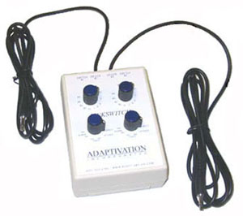 | X | X | 1-60 | 1-60 | 1-2 | 1-2 | $106 | DLT-202 | 3 x 4.5 x 2.5 | alarm mode
Switch Scanner  Adaptivation | 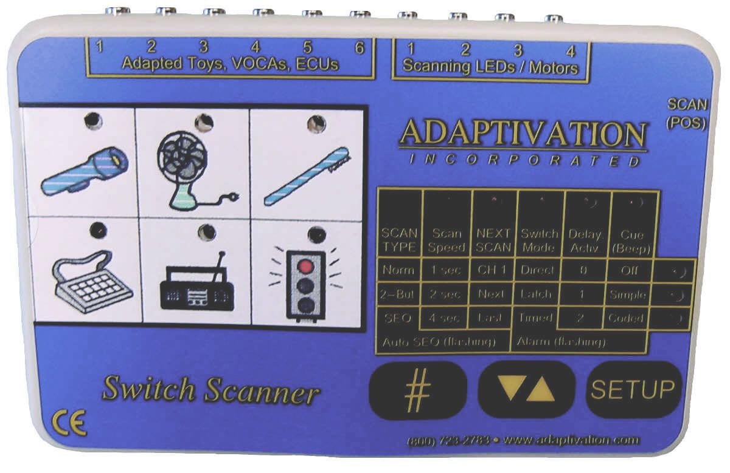 | X | X | 1-60 | 1-60 | 1-2 | 1-6 | $159 | SWSC | 5.75x3.75  x 1.25 | scans up to 6 outputs
5-in-1 Switch Modifier  Enabling Devices | 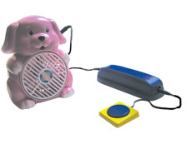 | X | X | 0-120 |  | 1 | 1 | $89.95 | 566 | 6.75 x 2.5 x 1.5 | intention mode (adjusts activation time). Includes adj. pressure switch
Switch Modifier  Enabling Devices | 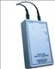 |  | X | 0 - 120 |  | 1 | 1 | $59.95 | 605 | 4.5 x 2.5 x 1

Electrical Transmission
PowerLink 3 Control Unit  Ablenet | 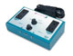 | X | X | 0-60 | 0-60 | 2 | 4 | $189 | 100-PL3D | 9 x 5 ½ x 2 ¼ | up to 1700 watts total  remote switch access with AirLink ($89)
Electralink  Ablenet | 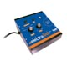 | X | X | 1-60 | 1-60 | 1 | 1 | $200 | 34410 | ? | up to 1500 watts, 15A. Can be used with wireless Ultra One Transmitter
FreeHand  Adaptivation | 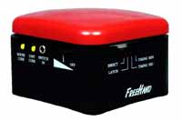 | X | X | 1-60 | 1-60 | 1 | 1 | $115 | FH-ME | 3.5 x 3.5 x 3.5 | with transceiver module $145
FreeSwitch Max  Adaptivation | 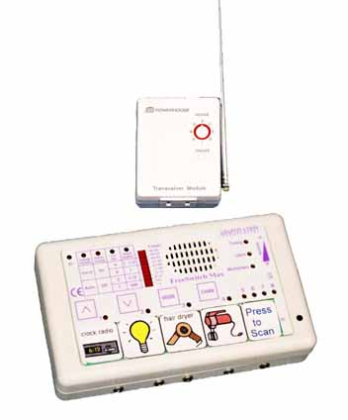 | X | X | 1-60 | 1-60 | 1-4 | 1-8 | $299 | FSM-100 | 4 x 6.5 x 1.8 | visual and auditory scanning (speech)  X10 modules required  Direct access option
Wireless Pal Pad  Adaptivation | 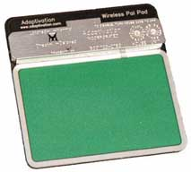 | X | X |  |  | 1 | 1 | $95 | WPP | 3.5 x 4 | with transceiver module $125
1-Switch Single-Appliance Unit  Enabling Devices | 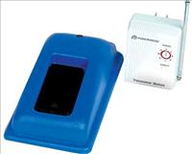 | X | X |  |  | 1 | 1 | $107.95 | 1490 | 3 x 2.5 x 2 | remote  up to 600 watts
Environmental Controls  Enabling Devices | 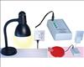 |  | X |  |  | 1 | 4 | $149.95 | 591 | 4.5 x 2.5 x 1 | Includes 2 receivers. 2 more $63.95.
Basic EADLs provide direct, latched or timed on/off switch control of battery operated toys or simple electrical appliances. For control of more devices and features, please refer to the Multifunction EADLs chart.

Infrared Transmission
a. Mini Relax - Scanning  b. Mini Relax with Jacks  c. Mini Relax with X-10  Ablenet | 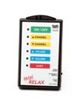 | a. 1  b. 1-6  c. 1 | a.6 IR cmds  b.6 IR cmds,  c.6 IR cmds  1 X-10 | $300  $325  $400 | 82050  82060  82070 | 6 x 3.5 x 1.5 | a. auditory and visual feedback, auto scan  b. one switch required for each function  c. includes X-10 radio transceiver
Wireless TV Remote  Enabling Devices | 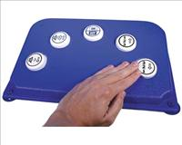 | direct or 5 switches | TV | $142.95 | 1521 | 15.75 x 10.5 x 3.5 | 2” buttons or any 5 switches to control power, channels, volume
TV Remote Module  Enabling Devices | 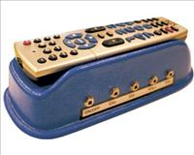 | 1-5 switches | TV | $72.95 | 5150 | 10 x 4 x 2.5 | switch for each desired function: power, volume up, volume down, channel up, channel down

Basic EADLs send a limited amount of infrared signals to a limited amount of devices. For control of more devices and features, please refer to the Multifunction EADLs chart.

Infrared Controlled Telephones

An infrared controlled telephone can be used by virtually any Electronic Daily Living Aid (EADL, formally Environmental Controls) that can send infrared signal. Here is a comparison of features:

Features | GewaTel 200  ZYGO Industries, Inc.  800-234-6006  www.zygo-usa.com | Infrared Home or Office Accessible Landline Telephone  Broadened Horizons  612-851-1040  www.broadenedhorizons.com | Prism  Prism D  Ablenet, Inc.  800-322-0956  www.ablenetinc.com | SiPhone  Quickphone  Quickphone f  Dr. Hein  www.SiCare.de  (Germany) | TS Phone with TS Controller  Technical Solutions  03 9737 9000  www.tecsol.com.au  (Australia)
Photo | 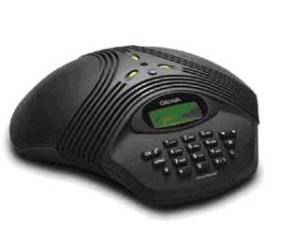 | 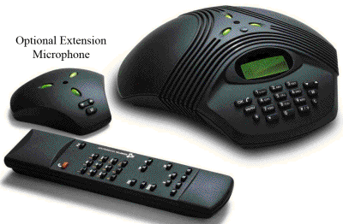 | 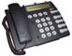 | 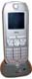 | 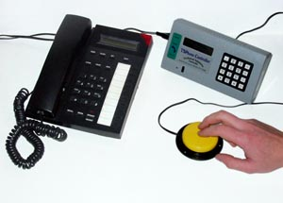
cost | $1,380.00 | $699.00 | To be determined | ? | $360 (GST) phone only
access | -IR signal  -Keypad | -IR signal  -Keypad  -Voice with voice dialer | -IR signal  -Keypad | -IR signal  -Keypad | -Single switch for answer and hang-up only  -IR signal with TS Controller  -Keypad
user can build #s | Yes | Yes | Yes | Yes | Yes
prestored #s held | 50 | 50 | 5 speed dial  Prism relies on directory in SGD  Prism D adds directory of 100 | SiPhone 200  Quickphone 50 | 20
redial | Yes | Yes | Yes | Yes | Yes
call waiting | Yes | Yes | Yes | Yes | Yes
battery back-up | Yes | Yes | Yes | Yes | Yes
Display | Yes | Yes | Yes | Yes | Yes
Volume Control | Yes | Yes | Yes | Yes | Yes
Privacy headset | $115 earphone  $340 microphone | Wired privacy headset  $29.95  Wireless headset $349.95  Expansion Microphone  $149.95 | Pending | Optional | 2 Options  $297 or $498 (GST)
Interfaces | -any learning IR  transmitter  -any IR transmitting EADL  -GEWA Prog | -any learning IR transmitter  -any IR transmitting EADL  -VoiceIR Voice Controller | -any learning IR transmitter  -any IR transmitting EADL  -SiCare Standard, Light II, Relax III | -any learning IR transmitter  -any IR transmitting EADL  -SiCare Standard | -any learning IR transmitter  -any IR transmitting EADL
Transmission | Analog landline | Analog landline | Analog landline | Analog  ISDN | ?
Other | -can be used as standard phone.  -commands pre-programmed into Quickie iQ electronics. | -can be used as a standard phone  -voice dialer $249.95  -same base phone as GewaTel 200 | -same base phone as Quickphone  -Prism D | SiPhone is cordless  SiPhone takes pictures, sends via MMS  “f” version has emergency call function, requires remote button press  -can be used as a standard phone | -can be used as a standard phone
The GEWATel200 and Infrared Home or Office Accessible Landline Telephone are a Konftel 200 phone with remote. These are often available through various internet retailers for a lesser cost.

Michelle L. Lange, OTR, ABDA, ATP, Access to Independence, MichelleLange@msn.com, 7/08.

Resources List for DL continuums | This is a sample of some resources. It is not meant to endorse any one product over another. It is meant as a starting point when looking for examples.
Eating , drinking, and  Food prep  Resources | Nonslip materials-  Built up handles,  adapted plates, cups, straws | http://www.dycem-ns.com/  http://www.sammonspreston.com/app.aspx?cmd=get_sections&id=100000  http://enablingdevices.com/catalog/useful-devices/household-products
Meal time, cooking,clean-up | Transfer items, carts, tools  Simplified cook book | http://www.sammonspreston.com/app.aspx?cmd=get_subsections&id=100844
 | Support for kitchen shopping and cooking | http://www.infinitec.org/live/kitchens/Cookshop.html
Electronic feeder | Self feeder | http://www.mealtimepartners.com/
 | Picture based cook books | http://picturecookbook.com/  http://www.attainmentcompany.com/xcart/search.php?mode=search
Dressing | Resource with multiple links to adaptive clothing sites. | http://www.familyvillage.wisc.edu/at/adaptive-clothing.html
Hygiene | Assist in toileting  Bathing, bathroom supports  Oral care | http://www.medicaldepartmentstore.com/Self-Wipe-Toilet-Aid-p/725062000.htm  http://www.sammonspreston.com/app.aspx?cmd=get_sections&id=100001  http://www.sammonspreston.com/app.aspx?cmd=get_subsections&id=100831

