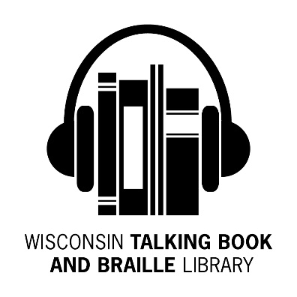
Bulletin Board
Summer 2017 Newsletter
What’s Been Happening at WTBBL!

Hello Readers!

Frequent phone callers have noticed some staff changes.

Jill and James have joined the WTBBL staff. Jill is a Reader’s Advisor and James is our new Office Assistant II. They are new to Talking Book Library service, but learning fast.

In August, we said good-bye to Dwight, a longtime Audio Machine Technician, who retired after working for the City of Milwaukee for 32 years.

Becky, formerly WTBBL’s Outreach Librarian, has taken the position of Children’s Librarian at the Milwaukee Public Library’s Bay View Library. We miss her, but know the community there is enjoying her energy and creativity.

In this newsletter, look for a list of new Wisconsin books produced by ABLE (Audio & Braille Literacy Enhancement) and a new group of audio-described DVDs available for checkout.

Some patrons have been asking about the distribution of refreshable braille displays from the National Library Service (NLS). In August, the Perkins School for the Blind began a pilot program with displays they

purchased. The National Library Service pilot program is still a few years away.

Keep reading and talking about us to your friends, Linda

Experiencing the Solar Eclipse

On 8/21/17, a total solar eclipse passed across the United States.

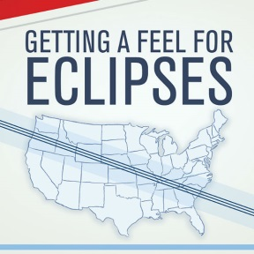
For a non-visual experience, WTBBL has copies of a tactile-graphic guide, Getting a Feel for Eclipses, (BRW23450) with details surrounding the August total solar eclipse. Tactile graphics provide an illustration of the interaction and alignment of the Sun with the Moon and the Earth.

Also of interest are the app and website for the Eclipse Soundscapes Project (eclipsesoundscapes.org). The Project provides an opportunity to experience the eclipse non-visually through haptic feedback using a rumble map.

Facebook Pages

WTBBL and the National Library Service for the Blind and Physically Handicapped have Facebook pages. Log onto Facebook, find and like us today!

Annual Banned Books Week Celebrates Freedom to Read September 24th - September 30th , 2017
- The Adventures of Huckleberry Finn by Mark Twain. Fiction. DB057349

Originally banned with the complaint that it was “trash and suitable only for the slums,” the most-banned book of all time follows young Huck Finn on his adventures along the Mississippi River.

- Fahrenheit 451 by Ray Bradbury. Fiction. DB034963

Dystopian sci-fi story about a firefighter set in a future where owning or reading books is a crime. Challenged for its language and subversive themes.

- In Cold Blood by Truman Capote. Fiction. DB022726

True crime, non-fiction classic recounting the 1956 quadruple murder of the Herbert Clutter family in small-town Kansas and the subsequent investigation and trial. Celebrated for its originality and style but banned for sex, violence and profanity.

- The Call of the Wild by Jack London. Fiction. DB049486

Classic man-and-dog story about the adventures of sled dog Buck, a tough St. Bernard, and John Thornton, his outdoorsman master, during the 1890’s Klondike Gold Rush in Canada. Banned for adult themes and violence.

- The Great Gatsby by F. Scott Fitzgerald. Fiction. DB055714

Glamorous and tragic jazz age novel about wealthy Jay Gatbsy’s pursuit of Daisy Buchanan and the American Dream. Banned for language and references to sex.

- The Naked and the Dead by Norman Mailer. Fiction. DB053839

World War II novel about an American platoon’s invasion of the Japanese-held Anopopei Island, partly based on the author’s own Pacific experiences in the 112th Cavalry. Banned for language.

- Gone With the Wind by Margaret Mitchell. Fiction. DB007069

A classic Civil War epic following iconic southern heroine Scarlett O’Hara’s love affair with Rhett Butler. Banned for language and dark themes related to war.

- To Kill a Mockingbird by Harper Lee. Fiction. DB077672

Beloved Pulitzer prize-winning story about Scout Finch’s childhood in small town Alabama with her attorney father Atticus. Banned for profanity and adult themes.

- The Kite Runner by Khaled Hosseini. Fiction. DB057457

Bestseller about the friendship between a wealthy boy and the son of his father’s servant set in America and Afghanistan over a thirty year period. Challenged for its depiction of rape, vulgar language, and religious content.

- The Immortal Life of Henrietta Lacks by Rebecca Skloot. Non-Fiction. DB70661

Award-winning chronicle of African American Henrietta Lacks who, in 1951, had cervical tissue removed and grown in culture -- without her permission -- producing the first continuously replicating human-cell samples for research. Challenged because it “has too much graphic information.” Recently turned into a movie starring Oprah!

WTBBL Outreach

Remember WTBBL when scheduling resource fairs, conferences, speakers and local events. Here are some events on the Summer/Fall WTBBL Outreach schedule:

- 15th Annual Ozaukee County Senior Conference
- Wisconsin Lions Camp
- Wisconsin Occupational Therapy Association's 96th Annual Conference
- Walk MS: Oshkosh
- Appleton Lions 20th Annual Senior Living Expo
- Milwaukee County Zoo Senior Celebration
- Wisconsin Library Association Annual Conference
- Rock County Senior Fair
- Institute on Aging's Annual Colloquium

Please contact WTBBL to schedule a speaker or ask WTBBL staff to exhibit at your event. Call 414-286-3045 or email wtbbl@milwaukee.gov.

WTBBL Adult Book Club

The next book discussions will take place on Tuesday, October 10th. The book, Me Before You by Jojo Moyes (12 hours 58 minutes) DB76161/ Available on BARD, is the story of working class English girl Louisa “Lou” Clark who is hired as an aide to wealthy Will Taynor, a former mogul who has been paralyzed since a road accident. Lou tries to keep the embittered Will engaged with the world, while Will encourages Lou to expand her horizons. Some strong language. Romance. Bestseller. 2012.

The last book discussions of 2017 will take place on Tuesday, December 5th. The book is Come, Let Me Guide You: A Life Shared with a Guide Dog by Susan Krieger (12 hours 5 minutes) DB82649/Available on BARD. After relating her first years with guide dog Teela in Traveling Blind: Adventures in Vision with a Guide Dog by My Side (DB71184), Stanford professor Krieger returns with another book about her now-aging companion. She discusses her blindness and the many ways her relationship with Teela has enriched her life. Biography. Disability Interest. 2015.

The book club meets on the phone using a toll free phone number, every other month on a Tuesday. There are two sessions from which to choose: 1:30 to 2:30 pm or 6:30 to 7:30 pm. The same book is discussed at both sessions.

For more information or to sign up, please contact WTBBL at 414-286-3045 or email wtbbl@milwaukee.gov.

New Wisconsin Titles Available

ABLE (Audio & Braille Literacy Enhancement) has produced more Wisconsin books for your reading pleasure. These titles are available on digital cartridge (DB) or as BARD downloads.

Recent additions include:

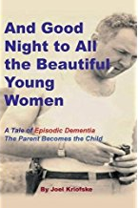
- And Good Night to All the Beautiful Young Women: a Tale of Episodic Dementia : the Parent Becomes the Child by Joel Kriofske. Non-Fiction. DBC08271

This book explores with remarkable humor the relationship the Wisconsin author has with his father, a former FBI Special Agent, and the compassion and understanding in caring for him as he struggles with dementia.

- The Christmas Carriage and Other Writings of the Holiday Season by Alice Jane-Marie Massa. Fiction. DBC08305
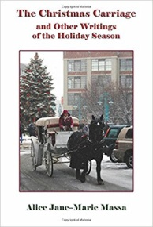
Holiday memoirs, short stories, and poetry by a Wisconsin author. This collection includes remembrances of holidays in Indiana and Wisconsin, sure to put you in the holiday spirit.

- Jews in Wisconsin by Sheila Cohen. Non-Fiction. DBC08236

The stories of the struggles and successes of the Jews of Wisconsin.

- Dead water by Victoria Houston. Fiction. DBC08228

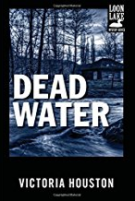
When two puzzling deaths stalk the fly fishermen of Loon Lake, Wisconsin, Police Chief Lewellyn Ferris must cease casting
and catch the killer. Dead Water is number 3 in the Loon Lake Fishing Mystery series.

Technology Resources
AFB's Technology Resources for People with Vision Loss free site (http://www.afb.org/info/living-with-vision-loss/using-technology/12) may help you improve your knowledge and use of a host of technologies. Topics include: Using a Computer; Cell Phones, Tablets, and Other Mobile Technology; Using Social Media, Online Shopping and Banking; Using Technology for Reading; Entertainment; Prescription, Health, and Fitness Management Tools; Smartphone GPS Navigation; Accessible Identification Systems.

Words About WTBBL Services

“I’d be lost without you people. Please spread the word.” – Joan

“Let me begin by saying what a treat your service is! I cannot express to you what a difference this has made in my life. I can be a bookworm again!” – Joni
“This service has really been a blessing, as Bev has always enjoyed reading!”
“THANK YOU SO MUCH. I JUST BROKE MY BACK AND DON’T KNOW WHAT I WOULD DO WITHOUT YOU!” – Juanita

“My husband recently passed and our family suggested memorials to the Library. The Library provided my husband with talking books for at least 17 years - I am not sure how he would have spent his time without your service.”

John says that “Talking Books is the best government-funded program there is.” He asked one our Readers Advisors “Do you think there are talking books in heaven?”
“Suzanne is very pleased and feels like this service has greatly enhanced her quality of life. Thank you!!!”

“What a wonderful service you offer! I can't tell you how many times Dad said how much he enjoyed the books. A new arrival gave him something to look forward to.” – Barbara

“I can’t tell you how much this service is a life-saver. You people are doing God’s work. The only complaint I have is that I can’t possibly read all the books I want to that you offer in your library.”

“Lawrence loved listening to his talking books, and looked forward to every new book in the mail. I’m confident these books significantly extended his life and kept he and my mother together for several extra years. Thank you for the wonderful service you provide.”

“These talking books are changing Angela’s life. Thank you so much for everything you do.”
“I just want to tell you how much we appreciate this service. My husband relies on your books. I am able to download them from the website on blank digital drives which I purchased from your service. He reads many books per week and we are so grateful your service exists. Keep up the good work!”- Ellen

“Our mother looked forward to receiving books and you always came through.”

Print/Braille Picture Books
WTBBL has print/braille picture books that are great for sharing with a child. The new books are contracted braille using the Unified English Braille Code.

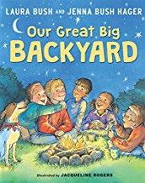
- BR 21094- Our Great Big Backyard [braille] by Laura Bush and Jenna Bush Hager ; illustrated by Jacqueline Rogers. For grades K-3. 2016.

When her parents announce an epic road trip for their family’s summer vacation, Jane’s previous plans of playing video games and watching movies with her friends vanish. Instead, Jane experiences the wonders of the national parks and has a change of heart about the outdoors.

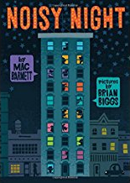
- BR 22017 Noisy Night [braille] by Mac Barnett; pictures by Brian Biggs. For preschool-grade 2. 2017.

A glimpse into what a multilevel apartment building’s occupants and their many nighttime noises are like.

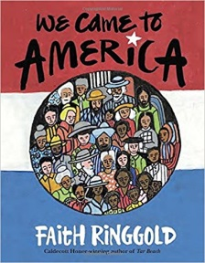
- BR 21092 We Came to America [braille] by Faith Ringgold. For grades K-3. 2016.

Celebrates United States immigration and the country’s diverse immigrant heritage.

- BR 21098 Trombone Shorty [braille] / words by Troy "Trombone Shorty" Andrews ; pictures by Bryan Collier. For grades K-3 and older readers. 2015.

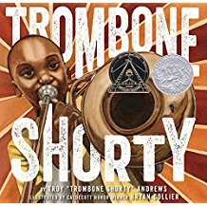
Autobiography of music prodigy Troy "Trombone Shorty" Andrews, who was leading his own band by age six. Today this Grammy-nominated artist headlines the legendary New Orleans Jazz Fest. Coretta Scott King Award.

- BR 22014-Tidy [braille] by Emily Gravett.
For preschool-grade 2. 2016.
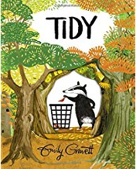
Pete, a badger who tidies up the forest, takes things a bit too far. He learns to love his woodsy home just the way it is.

- BR 21099-Nobody Likes a Goblin [braille] by Ben Hatke. For grades K-3. 2016.
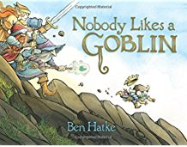
Goblin and his best friend, Skeleton, live with the treasure in their dungeon home. But when a gang of adventurers swoops in and steals the loot and kidnaps Skeleton, Goblin finally ventures outside to save his friend.

DB Cartridges for Sale

The Perkins Library, through www.amazon.com, is selling several products to support use of "talking books" and BARD (Braille & Audio Reading Download). These cartridges work with the NLS player, as well as with the APH (American Printing House for the Blind) BookPort DT, and APH's Joy Player (Note: the APH Joy Player is not enabled to play NLS Talking Books). Digital cartridges are also compatible with Humanware's Victor Reader Stream (adapter or cable required). DAISY, MP3, and WAV files (often used for music) can also be placed on digital cartridges.

Featured DB cartridge sizes are:
- 4GB Blank Cartridge for Talking Book Players (holds 768 hours of audio/35-45 average sized books) at $9.99 each
- 8GB Blank Cartridge for Talking Book Players at $10.99 each NEW SIZE!
- 16GB Blank Cartridge for Talking Book Players (holds 180 average-size books) at $13.99 each NEW SIZE!

To download books from BARD (the NLS book download website), you must:

- Be an authorized "Talking Book" patron; and

- Use a data transfer cable to connect a cartridge to your computer’s USB slot. You can request a cable from WTBBL.

If you wish to purchase products, but do not have access to Amazon.com, contact Perkins directly at (617) 972-7240 / (800) 852-3133 or Library@Perkins.org.

New Audio Described DVDs

WTBBL has audio described movies and TV shows available on DVD and VHS. You may have three movies checked out at one time. The loan period for each is one month. The movies will be mailed to you in an oversized plastic container. The DVDs and VHS will play on a standard DVD player or VCR. The audio description turns on automatically with a VHS movie. To turn on audio description on a DVD, move from the Main Menu to Settings (or Other Languages) and Select the Audio Described Option.

A new movie catalog is available from WTBBL in large print, braille, or digital cartridge format.

Here are some of the new DVDs by genre:

Action
- DVD00924 – The Accountant
- DVD00925 – Allied
- DVD00939 – Allegiant

Biographical
- DVD00950 – Loving
- DVD00928 – I’m Not Ashamed
- DVD00933 – Bleed For This
- DVD00935 – Whiskey Tango Foxtrot
- DVD00956 – Queen of Katwe

Children’s
- DVD00952 – Middle School: The Worst Years of My Life
- DVD00953 – Moana
- DVD00958 – Sing
- DVD00959 – Super Why ! Puppy Power
- DVD00961 – Trolls

Documentary
- DVD00941 – The Eagle Huntress
- DVD00946 – Invitation to Dance

Drama
- DVD00949 – The Light Between Oceans

Fantasy
- DVD00940 – Doctor Strange

Horror
- DVD00932 – Blair Witch

Musical
- DVD00928 – Annie (Starring Jamie Foxx)
- DVD00948 – La La Land

NOVA
- DVD00923 – Absolute Zero
- DVD00954 – Naturalist E.O. Wilson, Lord of the Ants

Romance
- DVD00943 – How to Be Single (Romantic Comedy)
- DVD00957 – Rules Don’t Apply

Science Fiction
- DVD00929 – Arrival

Thriller
- DVD00942 – The Girl on the Train
- DVD00960 – The Take
- DVD00936 – Deepwater Horizon
- DVD00937 – Desierto

War
- DVD00927 – American Sniper

Holiday & Post Office Closings
BULLETIN BOARD is available in large print, braille and audio editions, and is also available electronically via email and through NFB-NEWSLINE®, a newspaper by phone service.

Wisconsin Talking Book and Braille Library (WTBBL)
813 W. Wells Street
Milwaukee, WI 53233-1436

1-800-242-8822 (in Wisconsin)
1-414-286-3102 (FAX)
wtbbl@milwaukee.gov (email)
dpi.wi.gov/talkingbooks

October 9th No Mail (Columbus Day)

November 10th No Mail (Veterans Day)

November 23rd & 24th WTBBL Closed (Thanksgiving)

December 22nd-25th WTBBL Closed (Christmas Eve & Christmas Day)

December 29th-January 1st, 2018
Wisconsin Talking Book and  Braille Library  813 W. Wells St.  Milwaukee, WI 53233-1436 |  | FREE MATTER FOR THE BLIND OR HANDICAPPED
WTBBL Closed (New Year’s Eve & Day)

January 15th, 2018 WTBBL Closed
(Martin Luther King, Jr. Day)

