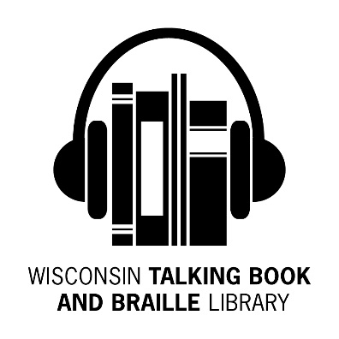
Bulletin Board
Winter 2016 Newsletter

What’s Been Happening at WTBBL!

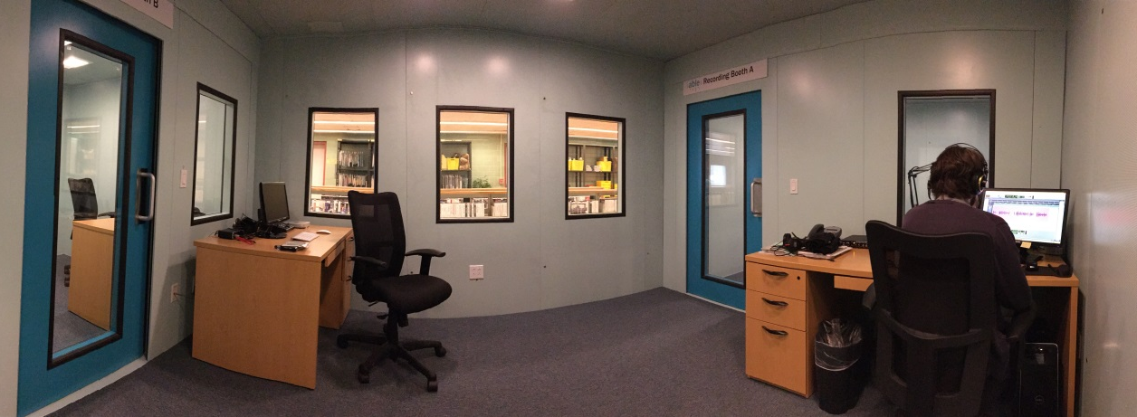
Hello Readers!

ABLE’s new Sound Center is in use!

Included here are two images to help you imagine what the new space is like.
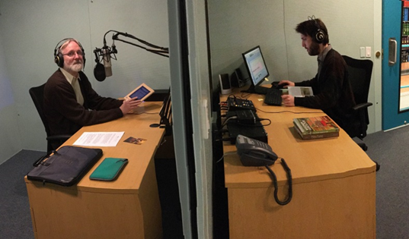
The entire space is about 360 square feet. There is a central section with desks for two audio engineers (or monitors). In the image above Andrew, one of the audio engineers, is pictured sitting at a desk. The photo is not to scale because it is a panoramic view.

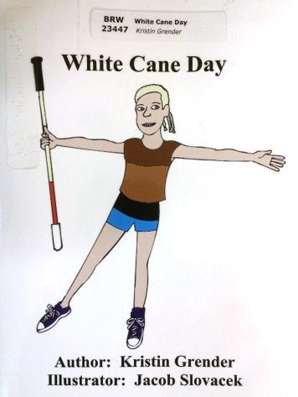
On each side of the engineering area, there is a soundproof audio booth where a reader sits. Between the booth and the engineer’s area, there is a window to enable the engineer and reader to easily gesture to each other. The second image shows a reader in a booth on the left side and Andrew on the right side.

The first book recorded in the new studio was DBC04709 White Cane Day by Kristin Grender.

This upbeat children's book was written by an Orientation and Mobility Instructor. It covers the serious points of why the white cane is important and how to follow the white cane law. It is also available in Braille as BRW23447 and in a kit as KIT00231.
You’ve already started to see books with the DBC prefix. A book number beginning with DBC is digitally recorded by a regional or local library (not the National Library Service). From now on, most of WTBBL’s digital audiobook productions will have DBC prefixes and will be available for download on BARD. Likewise, the DBCs from other Talking Book programs around the country are available for WTBBL patrons to download from BARD.

There have been some staff changes in WTBBL. Robin (Front Desk) and Amanda (Circulation) accepted promotions and moved into other library departments. Trevonna (Circulation) moved out of state. Kathy (Circulation) is starting in WTBBL in February.

In January, NLS implemented the Unified English Braille (UEB) code. New books on BARD will be in the UEB format and are searchable using the keyword: Unified English Braille code. WTBBL’s new UEB braille/audio kits are still in process.

Please note the holiday and post office closings for 2016 at the end of the newsletter.

Keep reading and talking about us to your friends, Linda

BARD Mobile App News
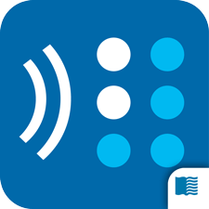
In October 2015, BARD Mobile app for iOS devices version 1.1 was released.

The update works with iOS 9. It includes:

- a built in sleep timer;
- a new setting to keep the device from sleeping while downloading;
- a new braille search function;
- a new braille shortcut key;
- improved Magic Tap response.

There is now an app for Kindle Fire Devices (2nd Generation) available from the Amazon Appstore. [NOTE: BARD Mobile will NOT work on Kindle e-book readers.]

WTBBL Outreach

Last year WTBBL staff reached out to 29,291 people at 117 events and presentations throughout the state. The WTBBL staff loves to share information about our library’s services with interested groups.

We enjoy exhibiting at resource fairs, fundraisers, conferences, and veterans’ events. We also provide speakers for events at schools, support groups, nursing homes, senior centers, and libraries throughout Wisconsin.

Look for WTBBL in upcoming months at the Wisconsin Academy of Ophthalmologists’ Wisconsin Eye MD Symposium in Green Bay, the American Diabetes Association’s Diabetes Education Conference in Appleton, Braille Games in Milwaukee, and the National Multiple Sclerosis Society’s MS Summit in Pewaukee.

Please contact Becky, WTBBL’s Outreach Librarian, to schedule a speaker or ask WTBBL to exhibit at your event this year. You can contact Becky at 414-286-6918 or ramanz@milwaukee.gov.

New Magazines Available

Magazines distributed on cassette ended in 2015. The National Library Service (NLS) has added some new titles to the list of magazines available on digital cartridge.

If you order more than one magazine, all the titles may come together on ONE cartridge and you will need to use the Bookshelf feature to jump from magazine to magazine.

How to use the Bookshelf feature:

- Insert cartridge in player.

- Listen to the number of items that are listed on the cartridge.

- Press and hold the green square Play/Stop button until you hear the player say Bookshelf.

- Then press the white triangle RW button or the white triangle FF button to select the book or magazine on the cartridge you want to listen to.

- After that, press the green square Play button to listen to the magazine.
Weekly magazines can be checked out for three weeks. Monthly magazines can be checked out for seven weeks. If your cartridge contains weekly and monthly magazines, you may check out the cartridge for seven weeks.

The new magazines listed on the insert may be found on BARD. Login to BARD for a complete listing of magazines available to download at https://nlsbard.loc.gov.

As long as you keep returning your cartridges, a new cartridge will be sent to you with new issues of all your requested magazines.

WTBBL Adult Book Club

Participating in the WTBBL book club is entertaining! You talk with friendly people. You read books that you may not otherwise consider. It can be fun to chitchat about books, movies, tips and tricks to help in everyday life, questions about WTBBL, and common interests.

On Tuesday, December 1st, the WTBBL Book Club discussed the book The Light Between Oceans by M. L. Stedman (DB75192). We discussed how some of the events from Lucy’s childhood, both good and bad, stuck with her as an adult. Similarly, we remembered a family move, or the birth of a sibling, or the death of a loved one when we were young children.

Many of the book club members enjoyed the book, but admitted it was not one they would have chosen to read on their own. We agreed that it was better to read the book with its interwoven plot lines before seeing the movie. The Light Between Oceans is being directed by Derek Cianfrance and stars Michael Fassbender as Tom, Rachel Weisz as Hannah, and Alicia Vikander as Isabel. It will be released this year.

Our first meeting in 2016 was on Tuesday, February 9th. We discussed the book Go Set a Watchman by Harper Lee (DB81896). As this book was a first draft of To Kill a Mockingbird (DB77672), we discussed how much Maycomb had changed from the 1930s to the 1950s as well as how Jean Louise and Atticus differed from one book to the next. Opinions differed on which book was better. Most agreed reading or rereading To Kill a Mockingbird was well worth it.

Next we will meet on Tuesday, April 12th when we discuss The 100-Year-Old Man Who Climbed Out the Window and Disappeared by Jonas Jonasson (DB75820 / Available on BARD).

Book Synopsis: Sweden. On his 100th birthday, former demolitions expert Allan Karlsson escapes from an old folks' home, steals a suitcase filled with money, and begins a madcap adventure running from criminals and the police. Originally published in Swedish in 2009. Some strong language. 2012.

Here is the schedule for 2016:

Tuesday, June 21, 2016

My Beloved World by Sonia Sotomayor

(12 hours 32 minutes) DB76059 / Available on BARD

Tuesday, August 23, 2016
Dear John by Nicholas Sparks
(9 hours 20 minutes) DB65315 / Available on BARD

Tuesday, October 25, 2016
Orphan Train by Christina Baker Kline
(8 hours 23 minutes) DB76746 / Available on BARD

Tuesday, December 13, 2016
Still Alice by Lisa Genova
(8 hours 6 minutes) DB68429 / Available on BARD
The book club meets on the phone using a toll free phone number. We meet on a Tuesday, every other month. You may participate from 1:30 to 2:30 pm and/or from 6:30 to 7:30 pm. Both book clubs will read the same book and discuss it at different times on the same day.

For more information or to sign up to participate in the book club, please contact Becky at 1-414-286-6918 or ramanz@milwaukee.gov.

New Wisconsin Titles Available

ABLE (Audio & Braille Literacy Enhancement) has produced more Wisconsin books for your reading pleasure. These titles will also be available on BARD.

Here are the recent additions:

- DBC04730 Muskrat for Supper: Exploring the Natural World with the Last River Rat by Kenny Salwey

- Salwey shares stories of the Upper Mississippi River. This book inspires young people to explore nature’s life cycles and understand the concept of the circle of life, as told through the tale of a family that embarks on a hunting and trapping adventure. Non-Fiction. For Ages 9-12.

- DBC04705 Wheel Fever: How Wisconsin Became a Great Bicycling State by Jesse J. Gant and Nicholas J. Hoffman

- A detailed account of Wisconsin's "first bicycle boom" in 1869 to the end of the "national phenomenon" in the 1890s. Non-Fiction.

Why Am I Not Receiving More Books – Or Get Books I Don’t Like?

Here are some tips to help tailor the Talking Books program to your needs:

- Number of books: The library starts you off with six books at a time. Some people want fewer and some want more. Please let us know if you would like to change the number of books we are sending you.

- Overdue items: If you receive an overdue letter in the mail and you have already mailed back the item, please contact us. Overdue items fill up a spot in your quota of books or movies.

- Few subject interests: If you only told us you like sea stories or books about frogs, it is possible you may have read every book the library has. Add more subjects so we can send you books.

- Tell us what you do like: It is fine to tell us you do not like mysteries, westerns, or romance books or books by Agatha Christie or Bill O’Reilly. However, if you do not tell us what subjects or authors you do like, we do not know what to send you.

- Exclusions: There are various levels of sex, violence, and strong language exclusions. If you find some acceptable, please let us know. Excluding violence excludes many westerns or mysteries.

- Unrated, commercial titles: NLS is continuing to add commercially produced books. These books are

unrated so sex, violence, and strong language are not noted. If you receive such a book and do not like the subject matter, we can exclude that author.

- Caught up with favorite series or favorite authors: Some of our patrons have read every Alex Cross book in the James Patterson series or every book we own by Danielle Steel. Tell us other series or authors you like or those you may be willing to try. We can also offer suggestions based on your interests.

- Returning all your items at once: If you return all of your books at once, you will not have any books to listen to. Try to return your books as you finish them. That way there will be books coming and going in the mail.

- List only service: If you have not given us any titles, we do not know what to send you. If the titles you request are all checked out or new titles with waiting lists, we can’t send you those books immediately. Try to have a healthy list of books on your request list, so we will always have books to send you.

- Auto Select: You could switch to Auto Select and give us favorite authors or subjects to ensure you always have books coming or going. You can still request particular titles at any time.

- Overdue magazines: Magazines must be returned on time in order to receive the next issue. Too many overdue magazines will result in a freeze on your magazine cartridges.

- Outdated address or contact info: Sometimes mail is returned to us. It is important to notify WTBBL if your address, phone number, or alternate contact information changes so we can continue to send you books.

- Postal holidays and weekends: The library is open Monday through Friday and is closed for major holidays. We will mail available items the following day. If you request items on Friday or the day before Christmas Eve, items won’t be mailed out until the next day the library is open. Contact us about a week before a holiday and we can send you extra books.

- Contact the library: We are happy to suggest authors, titles or series. We can also see if the library owns books that you hear about on TV or on the radio. We want to make sure you are receiving books that you enjoy.

Notable Upcoming Anniversaries

There are a handful of much-loved books and authors with notable anniversaries or birthdays this year. Now is a good time to read these treasures.

- 10 Years -- DB62431 The Book Thief by Markus Zusak
- 35 Years -- DB19685 Ramona Quimby, Age 8 by Beverly Cleary
- 50 Years – DB22726 In Cold Blood by Truman Capote
- 75 Years -- DB47946 The Complete Adventures of Curious George by Hans Augusto Rey and Margret Rey
- 90 Years -- DB48132 The Complete Tales of Winnie the Pooh by A. A. Milne
- 100th Birthday of Roald Dahl -- DB32548 James and the Giant Peach by Roald Dahl
- 150th Birthday of Beatrix Potter -- DB48836 The Complete Tales by Beatrix Potter
- 200th Birthday of Charlotte Bronte – DB22747 Villette by Charlotte Bronte

WTBBL on Facebook

WTBBL has a Facebook page to share news, photos, reviews and updates about the library. Log onto
Facebook, find Wisconsin Talking Book and Braille Library and like us today!

New Individual Application

To anyone who often signs up people for WTBBL services –

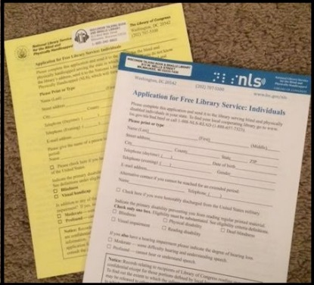
Be aware that WTBBL is transitioning to a new application for individuals. The image to the right shows the yellow (OLD) form and the blue and white (NEW) form.

WTBBL expects to have the NEW blue and white individual application as a fillable form on our website very soon. A person can type into the form, and then print it out to submit by mail, fax, or scan and email.

Do You Know Who Wrote That?

Authors have used pseudonyms since Julius Caesar’s time to disguise their identities or try out a different genre.
Dame Agatha Christie, the Queen of Crime, wrote romance novels under the name Mary Westmacott. Try her romantic suspense book Unfinished Portrait (DB22842).

M. C. Beaton, the author of the Agatha Raisin series and Hamish Macbeth series, has also published mysteries as Marion Chesney and romance novels under five different names. Try her romance novel The Constant Companion (DB52015).

There are a number of mystery and suspense writers using alternate names. Stephen King and Richard Bachman are one and the same. J.K. Rowling of Harry Potter fame also writes the Cormoran Strike series as Robert Galbraith.

Mystery writer Ruth Rendell wrote psychological thrillers as Barbara Vine. Romance author, Nora Roberts, writes the In Death suspense series as J. D. Robb.

Children’s authors also publish under pen names. Lemony Snicket, author of A Series of Unfortunate Events, also writes as Daniel Handler. The Secret Series children’s books are written by Pseudonymous Bosch whose true identity is unknown.

Over the years authors have used pen names to mask their being female. George Eliot was really Mary Ann Evans. Try her classic Silas Marner (DB52397). The 1937 bestseller Out of Africa (DB23011) was

published listing the author as Isak Dinesen, but was really written by Karen Blixen.

End of Cassette Tape Books and Yellow Players

The National Library Service (NLS) ceased production and distribution of the cassette book collection and players.

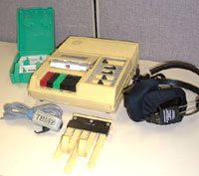
Most of our library patrons have only used the BLACK digital player and digital cartridges since 2010. Digital cartridges (DBs) have one hole. An entire book fits on one cartridge. WTBBL continues to circulate DB books on digital cartridge using the black digital player.

WTBBL stopped circulating books and magazines on cassette tape using the YELLOW cassette player at the end of
2015.

NOTE: Cassettes (RCs) have two holes. Most RC books come on multiple cassettes in green cases. Most patrons WERE NOT receiving cassettes in 2015.

Please return your cassette player now if you are no longer using it. If you no longer have the original box, contact us and we will be happy to send you a box that includes prepaid postage.

Holiday & Post Office Closings

March 25th WTBBL Closed (Good Friday)
BULLETIN BOARD is available in large print, braille and audio editions, and is also available electronically via email and through NFB-NEWSLINE®, a newspaper by phone service.

Wisconsin Talking Book and Braille Library (WTBBL)
813 W. Wells Street
Milwaukee, WI 53233-1436

1-800-242-8822 (in Wisconsin)
1-414-286-3102 (FAX)
wtbbl@milwaukee.gov (email)
dpi.wi.gov/talkingbooks

May 30th WTBBL Closed (Memorial Day)

July 4th WTBBL Closed (Independence Day)

September 5th WTBBL Closed (Labor Day)

October 10th No Mail (Columbus Day)

November 11th No Mail (Veterans Day)

November 24th & 25th WTBBL Closed (Thanksgiving)

December 23-26th WTBBL Closed (Christmas Eve & Christmas Day)

December 30-January 2nd, 2017
WTBBL Closed (New Year’s Eve & Day)

Wisconsin Talking Book and  Braille Library  813 W. Wells St.  Milwaukee, WI 53233-1436 |  | FREE MATTER FOR THE BLIND OR HANDICAPPED

