**School Meals During COVID-19**

Healthy Meals for All Students

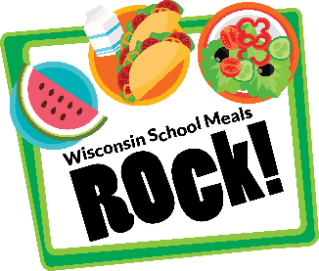

School Meals are Available

We are committed to providing meals to **all** our students during this public health crisis. Meals include a variety of fruits, vegetables, whole grains, proteins, and milk.

School Meals are Safe

Our school nutrition professionals follow all national, state, and local guidelines for safe food preparation during the COVID-19 pandemic. This includes frequent handwashing and wearing face coverings.



Red barn on green plate

School Meals Support U.S. Farmers

School meals feature products grown in the United States. Many foods, such as fruits, vegetables, and dairy, are grown and produced by farmers in Wisconsin. Participating in our school meal programs helps support local agriculture.

Meal Service at {ENTER SCHOOL/DISTRICT NAME}

Use this section to enter school-specific details regarding school meal participation. Examples of information to include are:

* Meal Prices; F/R benefits and/or application information
* Meal Service Model (pick-up times and locations; meal delivery; in-school meal service)
* Instructions related to types of foods being served
* Order/sign-up information
* Information about local foods being featured